PROJECT REPORTON

**BookShop**

USING

PHP & MYSQL

**CONTENTS**

1. OVERVIEW OF ORGANIZATION
2. PREFACE
3. INTRODUCTION
4. NEED OF ONLINE SHOPPING PORTAL
5. PROFILE OF THE PROBLEM
6. STRUCTURE OF THE PROJECT
7. SOFTWARE DEVELOPMENT LIFE CYCLE
8. PROBLEM ANALYSIS
9. PROJECT PLAN
10. AVTIVITIES DURING SOFTWARE PROJECT PLANNING
11. HARDWARE AND SOFTWARE REQUIREMENT
12. FRONT-END DETAILS
13. BACK-END DETAILS
14. SYSTEM DESIGN
15. DESIGN NOTATIONS
16. PRODUCT FUNCTION
17. DETAILED DESIGN
18. E-R DIAGRAMS
19. DATA FLOW DIAGRAMS
20. TESTING
21. METHODOLOGY USED FOR TESTING
22. IMPLEMENTATION
23. A DATABASE DRIVEN ONLINE SHOPPING PORTAL
24. ABOUT THE CURRENT SYSTEM
25. ADVANTAGES
26. DEFFICIENCY OF MANUAL SYSTEM
27. GOALS OF PROPOSED SYSTEM
28. USER REQUIREMENTS
29. LIMITATIONS
30. PROJECT LEGACY
31. USER MANUAL
32. ABBREVIATIONS/ ACRONYMS
33. BIBLOGRAPHY
34. SCREEN-SHORTS OF THE PROJECT
35. CD OF THE PROJECT(ON END OF THE PAGES)

**INTRODUCTION**

Computer plays an important role in our daily life. Anything we want we can get only in one mouse click. Speed, reliability and accuracy of the computer make it a powerful tool for different purposes. A very important and basic need of today’s modern business world is the quick availability and processing of information using computer. One can easily get the type of required information within a fraction of a second. The project that I have taken is also in this category which is used in our daily life whenever we want to purchase some items we can easily get them at our home.

## Objective:

## The objective of project on Book Shopis to developing a GUI based automated system, which will cover all the information Related to the all products which is used in our daily life. For example – Mobiles Phones, Laptops, Clothes, Books, Electronic Items and many more. So by this GUI based automated system a user want to purchase something then it only a mouse click away to purchase these products.

## Need of ONLINE SHOPPING PORTAL

The “**Book Shoop**” is developed according the current need in different Fields. This is online shopping Website which provides facility for purchasing Book and many more items. So by using this Book Shopusers which want to purchase some products will first Register an account on this portal then Login through their Username and Password, and then Select items which they want to purchase and add them to cart and finally checkout by giving payment details. So by using this portal users can easily purchase products from their home.

**PROFILE OF THE PROBLEM**

One must know what the problem is before it can be solved. The basis for the online shoppingportal is to buy products online and save the timing.

A Online shopping portal, who want to buy any product of their need, has to contact different Shoppers, before deciding upon a particular Product that best suit his needs, requirements and satisfaction. Moreover, most of the work involved in this development process has to be done manually which is very time consuming and cumbersome and also, it reduces the efficiency, accuracy.

To know the facts and understanding of the problem in detail, ***System Analysis*** is carried out. It is the process of studying the business processes and procedures, generally referred to as business systems, to see how they can operate and whether improvement is needed.

STRUCTURE OF PROJECT

* Before Login
  + Login
  + Register
  + Forget Password
  + Administrator Login
  + About Us
  + Contact Us
* After Administrator Login
  + Edit Website Details
  + Add Brands
  + Add Category
  + Add Items
  + Delete Brands
  + Delete Category
  + Delete Items
  + Manage User
    - * See Users
      * Users Shopping
      * Add Users
      * Delete Users
  + Logout
* After User Login
  + My Profile
    - * Edit Profile
      * Change Password
  + Buy Products
    - * Categories (Controlled by Admin. Which can be add it dynamically according to their needs)
  + My Cart
  + My Shopping’s
  + Checkout
  + Logout

**SOFTWARE DEVELOPMENT LIFE CYCLE**

The software development life cycle, as outlined by Edward Yourdon in his book Modern Structured Analysis (1989) has been followed in this project with minor modifications. The modified life cycle is shown overleaf:-

The activities in the life cycle are explained in brief below:

## 1) SURVEY PROJECT SCOPE AND FEASIBILITY

This activity is also known as the feasibility study. It begins with a request from the user for a new system. It involves the following:

* Identify the responsible user for a new system
* Clarify the user request
* Identify deficiencies in the current system
* Establish goals and objectives for the new system
* Determine the feasibility for the new system
* Prepare a project charter that will be used to guide the remainder of the Project

## 2) SYSTEMS ANALYSIS

The objective of the system analysis activity is to develop structured system specification for the proposed system. The structured system specification should describe what the proposed system would do; independent of the technology, which will be used to implement these requirements. The structured system specification will be used to implement these requirements. The structured system specification will be called the essential model (also know as logical model).

The essential model may itself consist of multiple models, modeling different aspect of the system. The data flow diagrams may model the data and there relationships and the state transition diagram may model time dependent behavior of the system. The essential model thus consists of the following.

* Context diagram
* Leveled data flow diagrams
* Process specification for elementary bubbles
* Data dictionary for the flow and stores on the DFDs.

## 3) PRELIMINARY DESIGN

The activity deals with certain design issues, which are to be finalized in consultation with the user. The two most important design issues of relevance to the user are the automation boundary and the human –machine interface. The output of the activity is the user implementation model. The major part of the user implementation model is the specification for the user interface of the proposed system. The user implementation model is also referred to as the physical model of the proposed system. The user implementation model is also referred to as the physical model of the proposed system. The model, in addition to the essential model, defines the following for the proposed system:

* Automation boundary
* Report layouts
* Layouts of the source documents
* Screen layouts for the data entry forms
* Menu

## 4) SYSTEM DESIGN

System design involves transformation of the user implementation model into software design. The design specification of the proposed system consists of the following:

* Database scheme
* Structure charts
* Pseudo codes for the modules in structure charts

## 5) IMPLEMENTATION

This activity includes programming, testing and integration of modules into a progressively more complete system. Implementation is the process of collect all the required parts and assembles them into a major product.

## 6) TEST GENERATION

This activity generates a set of test data, which can be used to test the new system before accepting it. In the test generation phase all the parts are come which are to be tested to ensure that system does not produce any error. If there are some errors then we remove them and further it goes for accepting.

**PROBLEM ANALYSIS**

**Product definition**

Book ShopSystem is a computerized, online solution to the various problems faced by the Product buyer and seller wishing to outsource their software development work to a Provider at an economical cost, thus achieving high performance, accuracy, reliability and high speed of data retrieval.

In this system, there is a registration process each for the Product buyer and seller. The Administrator of the site verifies the Provider after his registration and if satisfied, assigns him a user name and password.

Our site can be used by anyone who is searching for Products whether he/she is first time visiting our site. Our site also provides some discounted Products as same u get on any shop.

**The software covers the following point while keeping in mind user’s requirement-:**

* Fast online access of information about various Products.
* Search Products by keywords like functional area, experience and also by initials of the Product’s name.
* Administrator will maintain the database and perform all process.

**There are 2 categories of users-**

1. General User

2. Registered Users

**FEASIBILITY ANALYSIS**

The feasibility study of this project comprise of the following

**Economic Feasibility**

The cost centers in the system development as well as operation are trivial. The major can benetwork, internet and the software required for coding.The software used for the development of the proposed system is PHP and MySQL.In terms of wallet our product is in well reach of pocket.

**Technical Feasibility**

Technical feasibility centers on the current system and to what extent it can support the proposed system, it includes current computer system specifications such as hardware, software etc. it also involves financial considerations to accommodate the technical enhancements. If the budget is serious constraint then the project is judged not feasible.

Though the system is developed in the generalized form, which covers all the procedures and operations carried out in an internet based solution. The version used in the system is PHP and MySQL.

MySQL can manage large amount of data and is simple and secure. Using PHP helps us to design the look of our application.

**Operational Feasibility**

In this we determine what change will be brought in system, new skills required and other human organization and political aspects.

Each user can easily use our site. However it is desirable that the user has the basic knowledge of the computers.

Without making any changes in the rules and regulations of the existing system proposed system can easily adopted.

**PROJECT PLAN**

**DEFINING A PROBLEM**

* Define a problem.
* Justify the needs for a computerized solution.
* Identify the functions to be provided by the systems along with the constraints.
* Determine goal and requirements of the system.
* Establish the high level acceptance criteria.

**DEVELOPING A SOLUTION STRATEGY**

* Outline several solution strategies. Do not consider constraints for the time being.
* Conduct a feasibility strategy, including why the other strategies are rejected.
* Develop a list of priorities for the product characteristics.

PLANNING THE DEVELOPMENT PROCESS

* Define a life cycle model and an organizational structure for the project.
* Plan the configuration management, quality assurance and validation activities.
* Establish the preliminary cost estimates, the schedule and the staffing estimates for System development.
* Develop preliminary estimates for the computing resources required to operate and maintain the system.

**ACTIVITIES DURING SOFTWARE PROJECT PLANNING**

COST

ESTIMATION

DEVELOPMENT

TIME

SIZE

ESTIMATION

RESOURCES

REQUIREMENT

PROJECT

SCHEDULING

**SIZE ESTIMATION**

The estimation of size is very critical and difficult area of the project planning. It has been recognized as a crucial step from the very beginning. The difficulties in establishing units for measuring size lie in the fact that the software is essentially abstract; it is difficult to identify the size of the system. Many attempts have been made at establishing a unit for measure size. They are given as-:

* **Lines Of Code**

A line of code is any line of program that is not a comment or blank line, regardless of the number of statements or fragments of statements on the line. This specifically includes all lines containing program header, declarations and executable and non executable statements.

* **Function Count**

It measures functionally from user point of view that is on the basis of what the user requests and receives in return. Therefore it deals with the functionality being delivered, and not with lines of code, source modules etc. Measuring size in this way has the advantage that size measure is independent of the technology used to deliver the functions.

**COST ESTIMATION**

For any software project, it is necessary to know how much it will cost to develop and how much development time it will take. These estimates are needed before development is initiated. In many cases estimates are made using past experience as the only guide. A number of techniques have been developed and are having following attributes in common:

* Project scope must be established in advance.
* Software metrics are used as a basis from which estimates are made.
* The project is broken into small pieces which are estimated individually.HARDWARE & SOFTWARE REQUIRMENTS

## At Developer Side

During system development, i have to design both static and dynamic website interfaces, create website functions and a database system, edit photos and pictures, so its has a set of software and hardware requirements.

|  |  |
| --- | --- |
| Hardware Used  * Intel Dual Core Processor * 160 GB Hard Disk Drive. * 1GB RAM. * O.S. – Windows XP SP2 | Software Used  * WAMP SERVER * MYSQL Database * NOTEPAD * MS PAINT |

## At System Users Side

The following is the requirements for the system users including members and administrators.

|  |  |
| --- | --- |
| Hardware Requirements  * Intel Pentium 4 Processor * 20 GB Hard Disk Drive. * 256MB RAM. * O.S. – Windows XP | Software Requirements  * Browser (IE 7.0 or Above, Mozilla Firefox, Google Chrome * Browser Must be JavaScript Enabled |

**Front End Details**

Front End tool is used for give a Graphical user interface to system. By this we can make a system user friendly and more capable. I have chosen PHP as front end tool. Because it is an Open Source Technology, freely available and more familiar with any type of database.

**ABOUT PHP:**

PHP: Hypertext Preprocessor is a widely used, general-purpose [scripting language](http://en.wikipedia.org/wiki/Scripting_language) that was originally designed for [web development](http://en.wikipedia.org/wiki/Web_development) to produce [dynamic web pages](http://en.wikipedia.org/wiki/Dynamic_web_page). For this purpose, PHP code is embedded into the [HTML](http://en.wikipedia.org/wiki/HTML) source document and interpreted by a [web server](http://en.wikipedia.org/wiki/Web_server) with a PHP processor module, which generates the [web page](http://en.wikipedia.org/wiki/Web_page) document. As a general-purpose programming language, PHP code is processed by an interpreter application in [command-line](http://en.wikipedia.org/wiki/Command-line) mode performing desired operating system operations and producing program output on its standard output channel. It may also function as a graphical application. PHP is available as a processor for most modern web servers and as standalone interpreter on most [operating systems](http://en.wikipedia.org/wiki/Operating_systems) and [computing platforms](http://en.wikipedia.org/wiki/Platform_(computing)).

PHP stores whole numbers in a platform-dependent range. This range is typically that of 32-bit [signed](http://en.wikipedia.org/wiki/Signed_number_representations) [integers](http://en.wikipedia.org/wiki/Integer_(computer_science)). Unsigned integers are converted to signed values in certain situations; this behavior is different from other programming languages. Integer variables can be assigned using decimal (positive and negative), [octal](http://en.wikipedia.org/wiki/Octal), and [hexadecimal](http://en.wikipedia.org/wiki/Hexadecimal) notations. Point numbers are also stored in a platform-specific range. They can be specified using [floating point](http://en.wikipedia.org/wiki/Floating_point) notation, or two forms of [scientific notation](http://en.wikipedia.org/wiki/Scientific_notation). PHP has a native [Boolean](http://en.wikipedia.org/wiki/Boolean_datatype) type that is similar to the native Boolean types in [Java](http://en.wikipedia.org/wiki/Java_(programming_language)) and [C++](http://en.wikipedia.org/wiki/C%2B%2B). Using the Boolean type conversion rules, non-zero values are interpreted as true and zero as false, as in [Perl](http://en.wikipedia.org/wiki/Perl) and [C++](http://en.wikipedia.org/wiki/C%2B%2B). The null data type represents a variable that has no value. The only value in the null data type is NULL. Variables of the "resource" type represent references to resources from external sources. These are typically created by functions from a particular extension, and can only be processed by functions from the same extension; examples include file, image, and database resources. Arrays can contain elements of any type that PHP can handle, including resources, objects, and even other arrays. Order is preserved in lists of values and in hashes with both keys and values, and the two can be intermingled. PHP also supports [strings](http://en.wikipedia.org/wiki/String_(computing)), which can be used with single quotes, double quotes, or [heredoc syntax](http://en.wikipedia.org/wiki/Heredoc).

**Why PHP?**

PHP is one of the most popular server side scripting languages running today. It is used for creating dynamic WebPages that interact with the user offering customized information. PHP offers many advantages; it is fast, stable, secure, easy to use and open source (free).

* User friendly
* GUI
* Separation of work (designing &coding)
* Written once run anywhere

PHP API

**Back End Details**

Back end part of a system is more important because it controls all the internal process of a system. I have choose oracle database as back end. Because it is word’s Most Capable relational database and provide more security than others.

**Why MySQL?**

MySQL is the world's most popular open source database software, with over 100 million copies of its software downloaded or distributed throughout its history. With its superior speed, reliability, and ease of use, MySQL has become the preferred choice for Web, Web 2.0, SaaS, ISV, Telecom companies and forward-thinking corporate IT Managers because it eliminates the major problems associated with downtime, maintenance and administration for modern, online applications.

Many of the world's largest and fastest-growing organizations use MySQL to save time and money powering their high-volume Web sites, critical business systems, and packaged software — including industry leaders such as Yahoo!, Alcatel-Lucent, Google, Nokia, YouTube, Wikipedia, and Booking.com.

The flagship MySQL offering is MySQL Enterprise, a comprehensive set of production-tested software, proactive monitoring tools, and premium support services available in an affordable annual subscription.

MySQL is a key part of WAMP (Window, Apache, MySQL, PHP), the fast-growing open source enterprise software stack. More and more companies are using WAMP as an alternative to expensive proprietary software stacks because of its lower cost and freedom from platform lock-in.

**REQUIREMENT ANALYSIS STEPS**

Draw context

Diagram

Draw Prototypes

Model The Requirement

Requirement

Finalize The Requirement

Requirement

**Draw Context Diagrams**– The context diagram is a simple model that defines the boundaries and interfaces of the proposed system with the external world. It identifies the entities outside the proposed system that interact with the system

**Development Of Prototype**– One effective way to find out what the customer really wants is to construct a prototype, something that looks and preferably acts like a part of the system they want.

**Model The Requirement** – This process really consist of various graphical representations of functions, data entities, external entities and the relationship between them. The graphical view may help to find incorrect, inconsistent, missing and superfluous requirement.

**Finalize The Requirements** – After modeling the requirements we will have better understanding of the system behavior. The inconsistencies and ambiguities have been identified and corrected.

**FUNCTIONAL REQUIREMENTS**

Functional requirements define the fundamental actions that must take place in the software in accepting the inputs and in processing and generating the outputs. These are listed as “shall” statements starting with “The system shall….

**Login Module**– This module is provided for administrator and users such as Product buyer and seller who have registered themselves in the system. These login are provided according to the need of the systems.

* + - **Input –** User id and password
    - **Process** – After entering user id and password by user process of validation occur to identify whether user id and password is available in database or not.
    - **Output** – Registered user can access website and can use the services.

**Administrator Module** – The administrator is provided with password and login-id with which he/she can access the system. Administrator is provided right of maintaining the database, verifies registered users.

* + - **Input** – Login id and password.
    - **Process** – Process of validation will occur.
    - **Output**– Administrator will maintain the database and will perform Product seller process.

**Search Module–** In this module we are going to provide facility for Product buyer to search for Products according to their specified categories so that users can search for Products easily.

* + - **Input-** Initial letter of Product, with the help of keywords and with the help of Brand name.
    - **Output-** Information about Products.

**User Module–** As users are the main visitor of site, the following facilities are available through this module.

Can search the Products according to their need

Can order online books and pay via credit or atm card or PayPal.

Can get information about Products.

* + - **Input** – User Id and password
    - **Process**– Process of validation will occur.
    - **Output**– Only genuine user can access services provided by website.

**NON FUNCTIONAL REQUIREMENT**

## Performance Requirement

The performance of the product mainly depends on the speed of Internet connection. If the user wants hard real time response, then this is definitely not the product to go for.

## Safety Requirements

The electrical connection to the devices is critical and should be done according to the standards to avoid any short circuits.

**Security Requirements**

We aim to provide high security features like encryption to the user accounts to provide security from illegal hacking and gaining access to the system.

**SYSTEM DESIGN**

The most creative and challenging phase of System Development Life Cycle (SDLC) is Software Design. SDS is systematic documentation of design. A design process involves “conceiving and planning out in the mind” and “making drawing pattern or sketch”. The term “design” describes a final system and the process by which it is developed. It assist in catching potential errors before the implementation phase itself which had been very costly to remove otherwise.

System Design is a solution how to translate the system requirement into a blue print for constructing the software. The goal of SDS is not only to produce a correct design but the best possible one within the limitation imposed by the requirements and the physical and social environment in which the system will operate.

The system architecture description found in this document provides the reader a clear sense of how the system will be organized, how the components will interact and how the users will interface with the running software.

**DESIGN NOTATIONS**

The DFD also known as the Bubble Chart is a simple graphical formalism that can be used to represent a system in terms of the input data to the system. Various processing carried out on these data, and the output data generated by the system. The main reason why the DFD technique is so popular is probably because of the fact that DFD is a very simple formalism-it is simple to understand and use. A DFD uses a very limited number of primitive symbols to represent the functions performed by a system and the data flow among these functions. Starting with a set of high-level functions that a system performs, a DFD model hierarchically represents various sub functions. The five different types of primitive symbols used for constructing DFDs are:

**SYMBOLS USED:**

**PROCESS:**

A function is represented using a circle. This symbol is called a process or a bubble. Bubbles are annotated with the names of the corresponding functions.

**EXTERNAL ENTITY:**

An external entity such as a librarian, a library member, etc. is represented by a rectangle. The external entities are essentially those physical entities external to the software system that interact with the system by inputting data to the system or by consuming the data produced by the system. In addition to the human users, the external entity symbols can be used to represent external hardware and software such as application software.

**DATA FLOW:**

A directed arc or an arrow is used as a data flow symbol. A data flow symbol represents the data flow occurring between two processes, or between an external entity and a process, in the direction of the data flow arrow. Data flow symbols are usually annotated with the corresponding data names.

**DATA STORE:**

A data store represents a logical file. It is represented using two parallel lines. A logical file can represent either a data store symbol, which can represent either a data structure, or a physical file on disk. Each data store is connected to a process by means of a data flow symbol. The direction of the data flow arrow shows whether data is being read from or written into a data store. A arrow flowing in or out of a data store implicitly represents the entire data of the data store and hence connecting to a data store need not be annotated with the name of the corresponding data items.

**OUTPUT SYMBOL:**

The output symbol is used when a hard copy is produced and the user of the copies cannot be clearly specified or there are several users of the output.

**PRODUCT FUNCTION**

The complete product is comprised of various functions-

**Function available to general user-**

* User can access the information about various Products and Brands.
* User can become a member of site by registering himself.
* User can buy a Product online.
* Selected categories can be explored by user.

**Registered user has some other function like**-

* Log –in page to log into the application.
* He will get email from administrator sending him information about new Products in the store.
* Can change his/her password.

**Function available to Administrator**

* Administrator will add or delete the Products in the database.
* Administrator also provides the discount on the Products.
* It enables or disables the user after fill the user registration form.
* Administrator will send new password to the user email address.

**USER CHARACTERISTICS**

This subsection of SRS should describe whose characteristics of the eventual user of the product that will affect the specific requirement.Our website will be intended not only for authorized user but also for general user.

**ADMINISTRATOR**

* Administrator should know how to access internet and must have good knowledge of English.
* He must be aware of how to respond feedback and queries fired by user.

**GENERAL USER**

* We assume that user knows English & user need not be computer professionals.
* User should be aware of internet.
* User can access information through hyperlink such that navigation of various pages.

**CONSTRAINTS**

Only administrator will be able to make entries in the database and can modify it.

**DETAIL DESIGN**

* **Search**

On this web site two type of user can search the book one is registered and another is unregistered. Registered user have to fill the form and then he/she can search or buy the Products but unregistered can only search the Products not buy the Product until they did not get the registered user.

* **Registration Form**

Shop will place registration form on the site. In this buyer interact with the shop. Buyer will get registration form from the site and fill those forms and submit on the site. Shop will store these registration forms in their database. In this we have to fill first name, last name, address, e-mail, etc.

**Entity Relationship Diagram**

Entity relationship diagramsare a way to represent the structure and layout of a database. It is used frequently to describe the database schema. ER diagrams are very useful as they provide a good conceptual view of any database, regardless of the underlying hardware and software. An ERD is a model that identifies the concepts or entities that exist in a system and the relationships between those entities. An ERD is often used as a way to visualize a relational database: each entity represents a database table, and the relationship lines represent the keys in one table that point to specific records in related tables.

ERDs may also be more abstract, not necessarily capturing every table needed within a database, but serving to diagram the major concepts and relationships. This ERD is of the latter type, intended to present an abstract, theoretical view of the major entities and relationships needed for management of electronic resources. It may assist the database design process for an e-resource management system, but does not identify every table that would be necessary for an electronic resource management database.

**Objects**

There are three main objects on an ER Diagram:

1. Entities
2. Relations
3. Attributes.

**Entities**

An entity is a concept or object in the database. Entities are concepts within the data model. Each entity is represented by a box within the ERD. Entities are abstract concepts, each representing one or more instances of the concept in question. An entity might be considered a container that holds all of the instances of a particular thing in a system. Entities are equivalent to database tables in a relational database, with each row of the table representing an instance of that entity.

**Attributes**

The Supplier Name, Supplier Address, Telephone Number etc. A given attribute belonging to a given entity occurrence can only have one value. Therefore, if a supplier could have more than one address or telephone number then this should be determined before defining the attributes of that entity type. In this example the defined entity may require two or three address and/or telephone number attributes. It is the maximum practical instances of a given attribute that should be catered for in the entity type definition.

**Relationships**

Relations are the connections between two or more entities. Relationship lines indicate that each instance of an entity may have a relationship with instances of the connected entity, and vice versa. Each entity type can always be described in terms of attributes, and these attributes will apply to all occurrences of that given entity type

**FLOWCHART**

*Request*

*reply*

*Operation/data processing*

Products / Cart / Shopping

Login / Index

*Authentication*n

**Online Shopping Portal Database**

*(Acknowledgement*)

*(Approved/Reject)*

*Payment / Submission*

*(Acknowledgement)*

Payment / Checkout

**(0 level DFD)**

**For Registration**

User

Details

Username Exists

Success

**For Login**

Access Denied

User Request

Not Authenticate

Authenticate

Buy Products

**For Buying Product:**

User Request

User’s Cart

Checkout

**E-R Diagram**

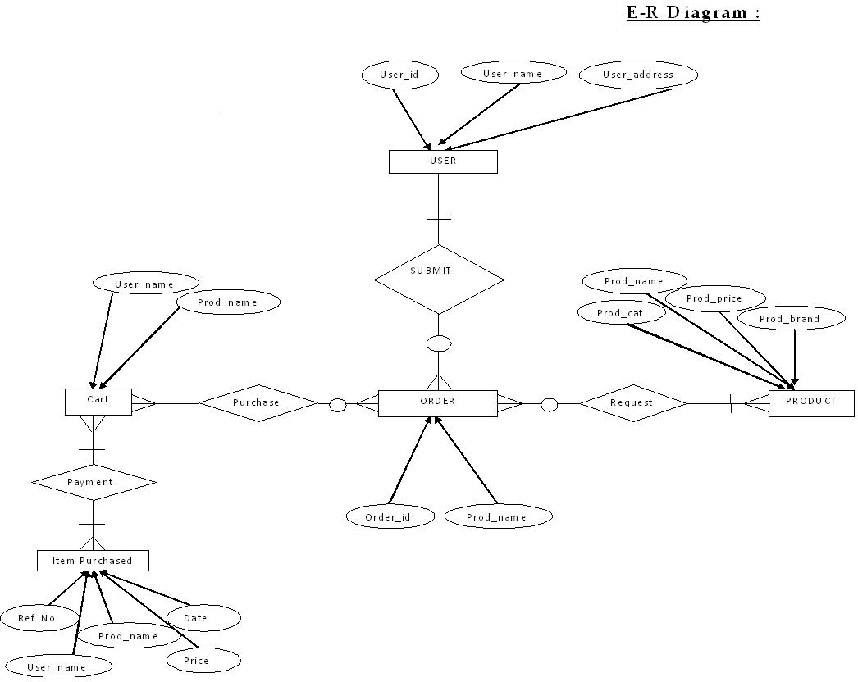

**TESTING**

Testing is the process of executing a program with the intent of finding errors. Although software testing is itself an expensive activity, yet launching of software without may lead to cost potentially much higher than that of testing, especially in systems where human safety is involved. Effective software testing will contribute to the delivery of higher quality software products, more satisfied users, and lower maintenance costs, more accurate and reliable results. Software testing is necessary and important activity of software development process.

**STRUCTURAL TESTING**

Structural Testing takes into account the internal mechanism of a system or component. Fatigue Testing is carried out with the objective of determining the relationship between the stress range and the number of times it can be applied before causing failure. So when your product’s structural durability needs to be predicted, verified and validated, turn to DTB's Structural Testing and Fatigue Testing experts. We provide you with the necessary structural testing and fatigue testing equipment and personnel to test the design and manufacturing integrity of your product. Call upon our vast experience in commercial and military applications.

#### Software Structural Testingis a 2-day course designed to provide an excellent knowledge base and practical skills for anyone interested in improving Software Structural Testing techniques and practices in their organization. This course starts with an overview of software testing basics, including discussions of the importance of software testing, the different levels of testing and basic testing principles.  Basic testing terminology is defined.  Techniques for ensure test coverage of requirements, different types of testing documentation and various test activities are discussed.

Course attendees will learn how to utilize various techniques for performing systematic structural testing, including decision/condition coverage, loop testing and basis path testing.  Strategies for performing software and system integration testing are also covered.

**FUNCTIONAL TESTING**

It is very useful and convenient in support of functional testing. Although JMeter is known more as a performance testing tool, functional testing elements can be integrated within the Test Plan, which was originally designed to support load testing. Many other load-testing tools provide little or none of this feature, restricting themselves to performance-testing purposes. Besides integrating functional-testing elements along with load-testing elements in the Test Plan, you can also create a Test Plan that runs these exclusively. In other words, aside from creating a Load Test Plan, it also allows you to create a **Functional Test Plan**. This flexibility is certainly resource-efficient for the testing project.

This will give a walkthrough on how to create a Test Plan as we incorporate and/or configure its elements to support functional testing. This created a Test Plan for a specific target web server. We will begin the chapter with a quick overview to prepare you with a few expectations; we will create a new Test Plan, only smaller. The Test Plan we will create and run at the end of this chapter will incorporate elements that support functional testing, exclusively.

**METHODOLOGY USED FOR TESTING**

**ACCEPTANCE TEST GENERATION**

The objective of this step is to produce a set of test data that may be used to test the system. Whenever a new system is developed it need to be tested to confirm its validity and to determine whether it meets the user requirements. The system was also tested with some sample records. The records were entered into the system and various reports were generated to check the system.

System testing is a critical phase of implementation. Testing of the system involves hardware devices and debugging of computer programs and testing information processing procedures. Testing can be done with test data, which attempt to simulate all possible condition that may rise during processing. The testing methods adopted during the testing of system are unit testing and integration testing.

**UNIT TESTING**

Unit testing focuses on the modules independently locate the errors. This enables the tester to detect errors in coding. It is the process of taking a module and running it in isolation from rest of the software product by using prepared test cases and comparing the actual result with the result redirected with the specifications and design of the module. One purpose of testing is to find and remove as many errors in the software as practical. There are number of reason in support of unit testing-:

* The size of module single module is small that we can locate an error fairly easily.
* The module is small enough that we can attempt to test it in some demonstrably exhaustive fashion.
* Confusing interactions of multiple errors in widely different parts of software are eliminated.

There are problem associated with testing a module in isolation. How do we run a module without anything to call it, to be called by it, possibly to output intermediate values obtained during execution? One approach is to construct an appropriate driver routine to call it, and simply stubs to be called by it, and to insert output statements in it. Stubs serve to replace modules that are subordinate to the module to be tested. A stub or dummy subprogram uses the subordinate module’s interface, may do minimal data manipulation, prints verification of entry and returns.

**INTEGRATION TESTING**

This is a systematic technique for constructing the program structure while at the same time to uncover the errors associated with the interface. The objective is to take unit tested module and build a program structure that has been detected by designing. The main purpose of integration testing is to determine that the interfaces between modules are correct or not. One specific target of integration testing is the interface: whether parameter matches on both sides as to type, permissible ranges, meaning & utilization. There are 3 types of integration testing-

* **Top Down Approach**- Top Down integration proceeds down the invocation hierarchy, adding one module at a time until an entire tree level is generated.
* **Bottom Up Approach** – The Bottom up strategy works similarly from the bottom to up.
* **Sandwich Strategy** – A sandwich strategy runs from top and bottom simultaneously.

**TEST DATA USED**

The proper selection of the data is very important. If the test data is not appropriate or representative of the data to be provided by the user, the reliability of the output is susceptible.

Two different sources were during testing of the system-:

* **Using Live Test Data** – Live test are those that are actually extracted from the organization files. Use of the live data make testing easier by obtaining most expected outputs and if it is found that the program can handle the entries processing of the system accurately.
* **Using Artificial Test Data**  - Live data is difficult to obtain insufficient amount to conduct extensive testing. It does not test all the combination or formats that can be done by entering to the system. Therefore artificial test data were used at the time of unit testing. Artificial test data was created solely for test purposes which provide extreme values for testing the limit of candidate system.

**TEST CASES**

* **System is properly linked or not -** Whether they are redirected to desired page or not.
* **Information passed** – If a page passes some parameter to another page then it should be checked that the page get the correct information, whatever is passed by the previous page.
* **Output should be correct** – Every functionality of the system should be checked properly whether it gives the right result or not generally test is performed with known results. If the output of the system is matched with that result the system is working fine.

**TEST CASES**

**LOGIN FOR USER**

|  |  |  |  |  |
| --- | --- | --- | --- | --- |
| **Serial No** | **Description** | **Expected Result** | **Actual Result** | **Result** |
| **1.** | This page contains 2 fields user name and password and a login button to submit the information. User is entering correct information. | User home page should open after successful login. | Respective user home page is opening after successful login by user. | Passed |
| **2.** | If either user name or password is filled incorrect or left blank. | An error message should be displayed and user should be asked fill the information again. | When wrong information is entered by user then an error message is displayed. | Passed |

**USER REGISTRATION PAGE**

|  |  |  |  |  |
| --- | --- | --- | --- | --- |
| **Serial No** | **Description** | **Expected Result** | **Actual Result** | **Result** |
| **1.** | User registration page 1 consist of detail information about User and a submit button to submit the information .Here user is entering correct information. | After submitting information User registration page 2 should be displayed. | After submitting information User registration page 2 is displayed. | Passed |
| 2. | If the information entered by user in incorrect or left somewhere blank. | An error message should be displayed and ask the user to fill the information again. | An error message is occurred if the information is incorrect or left blank. | Passed |

**IMPLEMENTATION**

Implementation is the stage in the project where the theoretical design is turned into the working system and is giving confidence to the new system for the users i.e. will work efficiently and effectively. It involves careful planning, investigation of the current system and its constraints on implementation, design of method to achieve the change over, an evaluation, of change over methods. A part from planning major task of preparing the implementation is education of users. The more complex system is implemented, the more involved will be the system analysis and design effort required just for implementation. An implementation coordinating committee based on policies of individual organization has been appointed. The implementation process begins with preparing a plan for the implementation for the system. According to this plan, the activities are to be carried out; discussions may regarding the equipment have to be acquired to implement the new system.

Implementation is the final and important phase. The most critical stage is in achieving a successful new system and in giving the users confidence that the new system will work and be effective. The system can be implemented only after thorough testing is done and if it found to working according to the specification. This method also offers the greatest security since the old system can take over if the errors are found or inability to handle certain types of transaction while using the new system.

At the beginning of the development phase a preliminary implementation plan is created to schedule and manage the many different activities that must be integrated into plan. The implementation plan is updated throughout the Development phase, culminating in a changeover plan for the operation phase. The major elements of implementation plan are test plan, training plan, equipment installation plan, and a conversion plan.

**There are three types of implementation:**

* **Implementation of a computer system to replace a manual system.**
* **Implementation of a new computer system to replace an existing system.**
* **Implementation of a modified application to replace an existing one, using the same computer.**

Successful implementation may not guarantee improvement in the organization using the new system, but improper installation will prevent it. It has been observed that even the best system cannot show good result if the analysts managing the implementation do not attend to every important detail. This is an area where the systems analysts need to work with utmost care.

**Conversion Methods**

A conversion is the process of changing from the old system to the new one. It must be properly planned and executed. Four methods are common in use. They are Parallel Systems, Direct Conversion, Pilot System and Phase In method.

**Parallel systems:**

The most secure method of converting from an old to new system is to run both systems in parallel. This method is safest one because it ensures that in case of any problem in using new system, the organization can still fall back to the old system without the loss of time and money.

**The disadvantages of parallel systems approach are:**

* It doubles operating costs.
* The new system may not get fair trial.

**Phase –IN- method:**

This method is used when it is not possible to install a new system throughout an organization all at once. The conversion of files, training of personnel or arrival of equipment may force the staging of the implementation over a period of time, ranging from weeks to months.

**Post Implementation Review**

After the system is implemented and conversion is complete, a review should be conducted to determine whether the system is meeting expectations and where improvements are needed. A post implementation review measures the systems performance against predefined requirement. It determines how well the system continues to meet the performance specifications.

**A Database-driven Online Shopping Portal:**

The shopping portal that I have build for our store makes use of several advance features that the cart contain all the selected products until checkout and My Shopping by which user can track their previous shopping on this portal. For doing so shopping portal uses a Database by which all these information stored in this database and when required then it is fetched from it. So I use MYSQL Database in this project.

So this shopping portal contains dynamic effects by using this database. Some parts of this project which use database are following:

* Firstly when user Register an account on this website the user give their information which are stored in database.
* Then when users want to login on this website then they give their username and password as they choose at registration time, if both are matched with database’s username and password then user can successfully logged in the website otherwise Access Denied.
* The Objects which users can see on homepage, after login page, buy products page are also come from database.
* Now After login user can modify their profile and password. The modified profile details and password details altered in the database.
* In Buy Products Section Product and Their Prices also fetched from database’s table. When user select a product and push Add to cart then items added to database’s cart table.
* Then in My Cart section the products displayed which are in the cart table of the database following by user.
* Checkout section takes the carts item and their total price and then payment details are given by the user and these details store in separate database table. After Successful entry in this table users cart empty automatically because all items purchased by him.
* In My Shopping section the products a user puSrchased are displayed.

**ABOUT THE CURRENT SYSTEM**

## Advantages of the Current System:

The project Book ShopSystem is GUI based system so that it is easy to handle. It also increases the efficiency of the end user, because it will reduce the redundant job, which is tedious to complete. The Online System also has automated capability to complete job, so it reduces the work manually.

## Advantage of Online Shopping Portal:

1. **This online program will take less time and gives better results.**
2. **It reduces the tedious jobs Like (Redundant work, long procedures, Up to Date Information).**
3. **It will improve the online shopping system, since all the information is available whenever required.**
4. **It provides quick processing thus helps in transaction and updating in Edit personal view can perform in few seconds.**
5. **It provides accurate Output.**
6. **It gives fast answer of queries.**
7. **The amount of paper work is reduced.**

**8. Better Control.**

## Deficiencies of the manual system:

## 1) Lack of immediate retrieval of information

In manual system, lot of time is wasted in retrieving information. Much searching is required before required information is found. This wastes a lot of time of the user as well as the person.

## 2) Lack of immediate information storage

In manual system, it is difficult to store information at proper place at that very moment. This is because the person is unable to quickly locate the place where the information is to be stored.

## 3) Prompts updating not possible

Changes are quite natural in all walks of life. Information and stored data also changes from time to time. These changes should be incorporated in the working also to keep the information up to date. However, bringing about changes through the manual system is a slow and tedious process because of which inaccurate information storage occurs.

## 4) Unplanned working

The manual system lacks the element of planned working. Records are not properly maintained. This creates a lot of problems at times like during information retrieval and storage.

**5) Insignificant generation of managerial and Strategic reports.**

In manual system, reports for management are difficult to be generated and strategic reports are almost impossible. This is because for these reports proper storage of information, its retrieval and it’s filtering (i.e. choosing information that meets criteria are very important and are very tough in manual system.

**6) Accuracy**

The manual system lacks accuracy in working and a number of operations may be performed incorrectly. The computations that are done in the organization may be incorrect and whatever are generated in the system may be inaccurate.

**7) Reliability**

The reliability of a manual system is considered to be low because of the above given reasons including the fact that ‘To error is human’. Any task that is performed by men, always contain the risk of errors.

**8) Redundancy of information**

In manual system, particular information may be stored at a number of places, lending to redundancy. Redundancy of data or information creates a number of problems storage space is wasted; changes at one place are to be made at a number of places and so on.

GOALS OF THE PROPOSED SYSTEM:

**1) Immediate retrieval of information**

The main objective of the new system is to provide for quick and efficient retrieval of information. Any type of information would be available to the user whenever he requires. Facility would be provided for online query to cut down on the response time greatly.

**2) Immediate storage of information**

In the proposed system, it will be easy to store information at any given time at the correct places. The location of storage would be easily available and user will face no difficulty.

**3) Prompt updating of information**

In the proposed system, the information will always remain up to date as the updating will be prompt and without any efforts. This factor will be of great importance in the proposed system as it determines the integrity of the information stored.

**4) Fast computation of information**

The computation of information will be quite fast in the proposed system. Not only mathematical calculations, but also logical comparisons will be quick in the new system.

**5) Planned approach toward working**

The working in the service center information system will be well planned and organized. The data will be stored properly in the data store, which will help in retrieval of information as well as in its storage.

**6) Generation of managerial and strategic reports**

The new system would provide for regular generation of reports, which would help the management in decisions making work and in controlling the overall working of the organization. The generation, of these reports would be possible only if the system is organized such that retrieval of information can be made on conditions.

**7) Accuracy**

The level of accuracy in the new proposed system would be higher. All operations and computations would be done correctly and this will ensure that whatever information is coming from the center, it is accurate.

**8) Reliability**

The reliability of the proposed system would be high due to the above stated reasons. The reason for the increased reliability of the system is that now there would be proper storage of information, its maintenance would be well managed and retrieval would be possible in the desired manner.

**9) Non Redundant Information**

In the new system, utmost care would be taken that no information is repeated, any usage of storage or otherwise. This would assure economic usage of storage or space and consistency in the data stored. This will also help make those changes easily as the change would have to be made only at that very place and no where else.

**USER REQUIREMENT**

The user requires these features from the proposed system:

* Quick generation of data entry forms
* Quick processing of information
* Quick retrieval of data
* Quick and correct updating of data.
* Least storage requirements
* Secured and controllable data storage
* Full backups of data
* Readable, clean, up to date and timely reports

Note: These are some of the basic requirements, which the system should provide, but additional Requirements can be different for other online program.

**LIMITATIONS**

Although I have tried to do the best and try to do all the things that are possible in an

Online System, but still the system contains some of the limitations.

The reason of these limitations is the time constraints. Time is the major problem. I

Have to deliver the project in a particular time period. That’s way I have to leave

Some of the topics that actually I want to cover, I am still working on this software

And my next goal is to remove these limitations and develop a more efficient and

Elegant system.

**Limitations of the System:**

1. This project does not give the information about the stock (quantity) present within the shop.
2. This project does not create monthly, yearly Reports.

After removing these and other minor limitations I hope this project will very efficient and effective.

**PROJECT LEGACY**

Objective describes what the prospective users of the system want from the system. Being an important part of the system development process, preparation of the requirement specification has been done after studying the existing procedure and personal interaction with prospective users.

The Book Shopis an Intermediate between Product Buyers and Sellers. The purpose is to enable the Product Buyers to search for the Products from any remote location. The Product Buyer can Search for the Productsfrom any remote location.

We are going to design an application which is beneficial for all those who wants to do shopping from home. The main aim of this software is to provide Products according to their area of need. It also provides information about various companies to users and Products of those companies. The administrator will maintain the database and perform all updation and deletion process.

**USER MANUAL**

**DEFINITION, ACRONYMS, ABBREVIATIONS**

* **Browser**: A software application used to locate and display web pages.
* **Database**: A database that stores data. It is a collection of interrelated data that contains information relevant to enterprise.
* **MYSQL:** Most widely used query language for creating database.
* **Internet**: Worldwide networks of computers from where anyone can take information.
* **Homepage:** The first page when you go to a worldwide website on internet.
* **HTML**: It is a computer language specifying the content & formats of web document .It allows additional text to include codes that define fonts, layouts, graphics & hypertext.
* **PHP:** It is called Hypertext Pre-Processor.
* **Webpage**: pages of information placed on network that may contain text, graphics, images, moving pictures, sound files & other type of electronic information.
* **Website**: Collection of files called webpage, which can contain text & images.
* **DBMS**: A collection of computer program that allow storage, modification, extraction of information from database.
* **SQL**: It is a standard interactive & programming language for getting information & updating database..

**ABBREVIATIONS/ ACRONYMS**

* **SQL**: Structured Query Language
* **SRS**: System Requirement Specification
* **OS**: Operating System
* **DBMS**: Database Management System
* **URL**: Uniform Resource Locator
* **IIS**: Internet Information Server
* **XML**: Extensible Markup Language
* **PHP:** Hypertext Pre-Processor

**BIBLOGRAPHY**

This document contains provisions which, through reference in this text, constitute provisions of the present document.

1. Google Search Engine for various searching
2. Web-Technologies Black Book
3. Keeves PHP- MYSQL
4. Wrox Press – Beginning PHP5
5. Online at [www.w3schools.org](http://www.w3schools.org)
6. Murach’s-PHP/MYSQL

# SCREEN SHORTS OF

**PROJECT**

DATABASE AND TABLES OF PROJECT

VENDORS TABLE

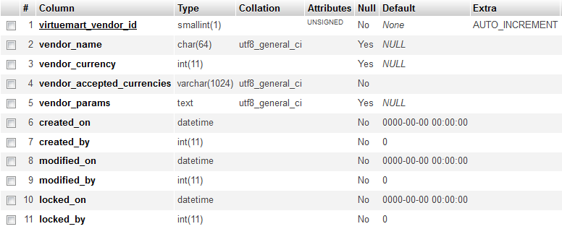

CATEGORY TABLE

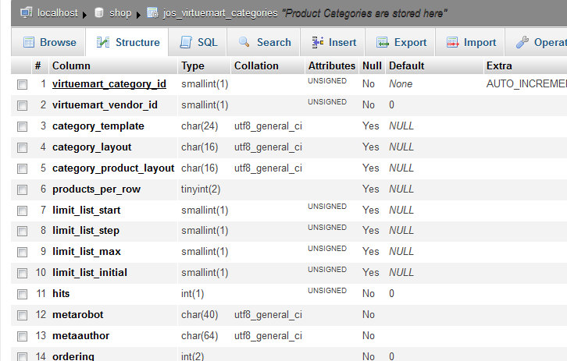

PRODUCT TABLE

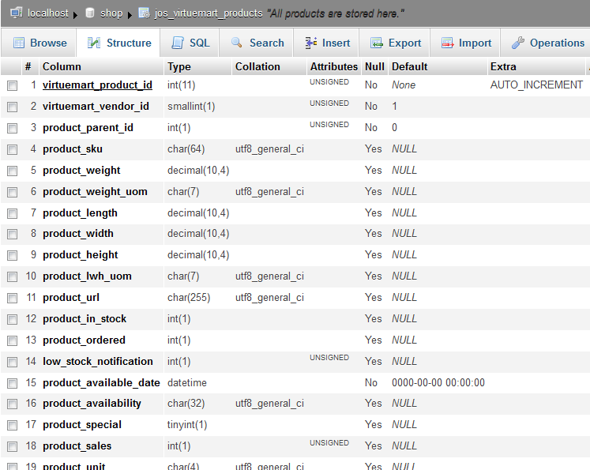

SHIPMENT TABLE

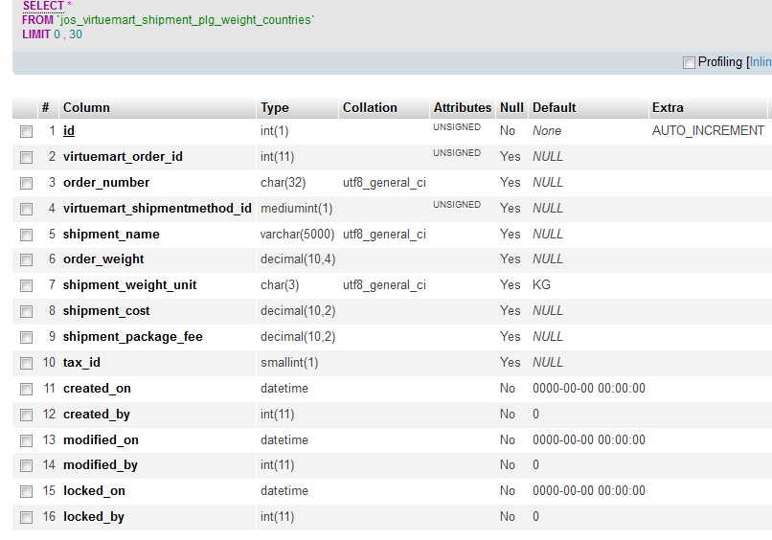

USER INFORMATION TABLE

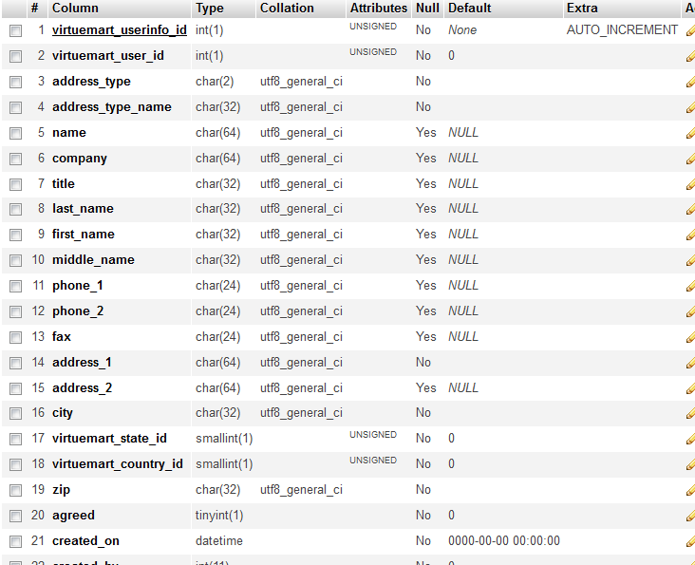

ORDER TABLE

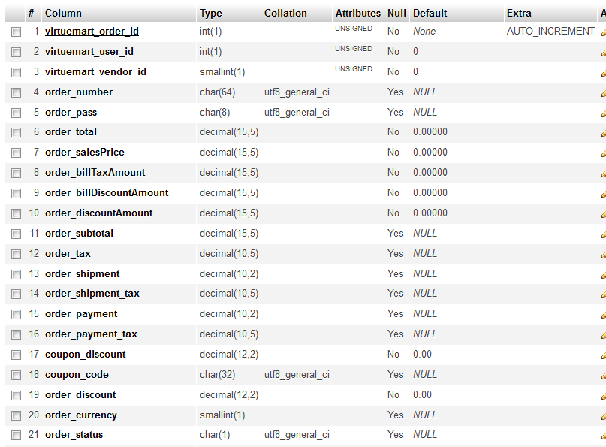

POLL TABLE

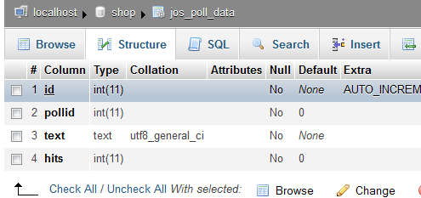

MENU TABLE

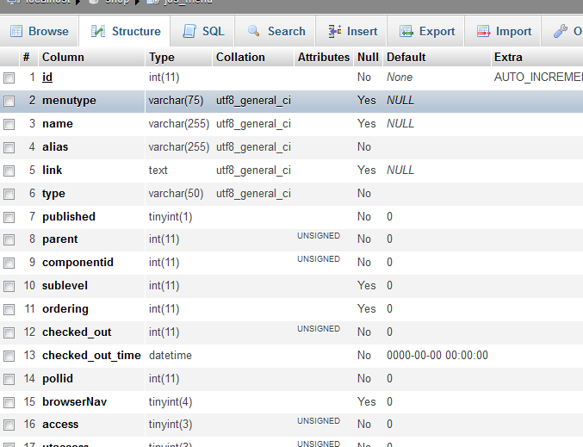

SECTION TABLE

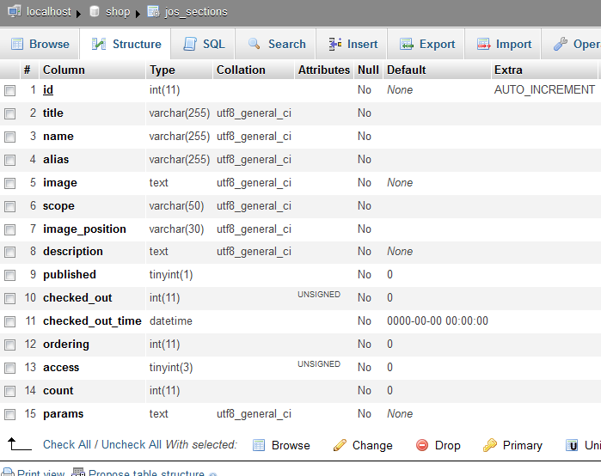

CONTACT DETAILS TABLE

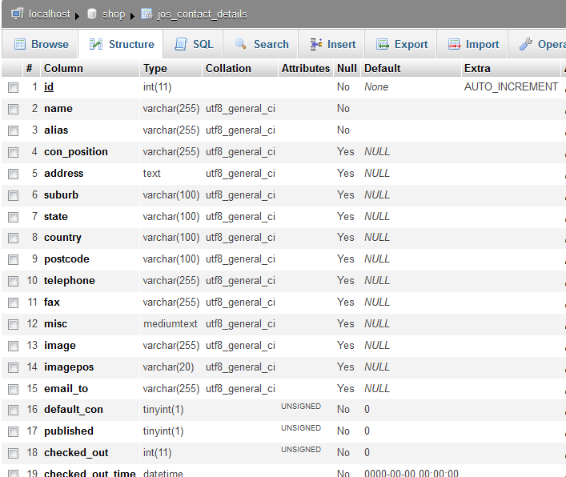

BANNER TABLE

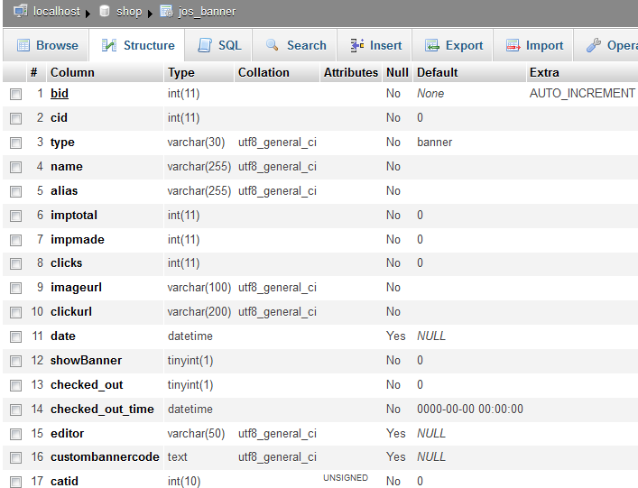

**BIBLOGRAPHY**

This document contains provisions which, through reference in this text, constitute provisions of the present document.

1. Google Search Engine for various searching
2. Web-Technologies Black Book
3. Keeves PHP- MYSQL
4. Wrox Press – Beginning PHP5
5. Online at [www.w3schools.org](http://www.w3schools.org)
6. Murach’s-PHP/MYSQL