**CS1571  
Fall 2019  
11/11 In-Class Worksheet**

Name: Simran Gidwani

Where were you sitting in class today: Back Left

1. **Pre-Reflection**

On a scale of 1-5, with 5 being most confident, how well do you think you could execute these learning objectives:

* + 18.3 Identify independence relationships within a Bayes Net ___
  + 18.5 Explain the complexity of inference by enumeration using Bayes Nets ___
  + 19.1 Describe optimizations to inference using Bayes Nets ___
  + 19.2 Define expected value ___
  + 19.3 Explain how decisions are made using expected value ___

1. **Bayes Nets**
2. Using a Bayes Net, how many products do you have to compute to get the probability that P(J=T).

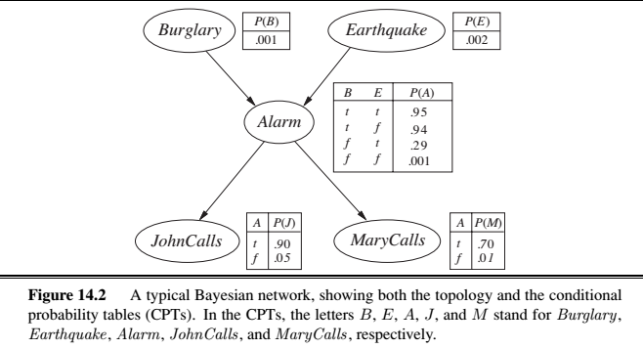

P(J=T) = $\sum_{\{b\}}{\sum_{\{e\}}{\sum_{\{a\}}{\sum_{\{m\}}{P(B=b, E=e, A=a, J=T, M=m)}}}}$

P(J+T|A) *P(M|A) * P(A| B, E) * P(B) * P(E)

4 values and then each of the 4 variables can either be true or false, summing across all

4* 2^4 = 64

1. **Expected Value**
2. Using expected value, compute the rational decision to make in this situation.

Stock 1

Stock 2

110

140

.6

90

.4

.4

80

.6

.6 * 110 + .4 * 90 =102

.4 * 140 + .6 * 80 =104

1. Using Expectimax, compute the rational decision to make in this situatino.

150 .50

Stock

Bank

200

125

.4

100

.6

1.0

Stock

Bank

Bank

Stock

Bank

Stock

130

90

60

140

105

80

150

125

1.0

117

110

117

110

110

105

90

95

95

1. **Post Reflection**

On a scale of 1-5, with 5 being most confident, how well do you think you could execute these learning objectives:

* + 18.3 Identify independence relationships within a Bayes Net ___
  + 18.5 Explain the complexity of inference by enumeration using Bayes Nets ___
  + 19.1 Describe optimizations to inference using Bayes Nets ___
  + 19.2 Define expected value ___
  + 19.3 Explain how decisions are made using expected value ___