**CS1571  
Fall 2019  
11/6 In-Class Worksheet**

Name: Simran Gidwani

Where were you sitting in class today: Back left

1. **Pre-Reflection**

On a scale of 1-5, with 5 being most confident, how well do you think you could execute these learning objectives:

* 1. Describe Bayes Rule ­
  2. Represent knowledge as a Bayes Net
  3. Identify independence relationships within a Bayes Net
  4. Demonstrate how a Bayes Net can be used to make an inference   
      about the probability of a variable.
  5. Explain the complexity of inference by enumeration   
      using Bayes Nets

1. **Bayes Nets**
2. Use Bayes Rule to solve the following problem. In a particular pain clinic, 10% of patients are prescribed narcotic pain killers. Overall, five percent of the clinic’s patients are addicted to narcotics (including pain killers and illegal substances). Out of all the people prescribed pain pills, 8% are addicts. *If a patient is an addict, what is the probability that they will be prescribed pain pills?*

P(addict) = .05 P(prescribed) = .10 P(prescribed|addict) = .8

P(Addict | Prescribed) = P(.01*.08)/.05

1. Given the following conditional probabilities, what is P(Cancer=True | Result = positive)?

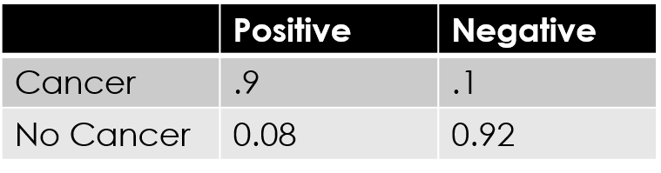



(.9 * .01) / (.9 * .01) + (.08 * .99) = .1

1. Given the following Bayes Net, are these statements true or false:

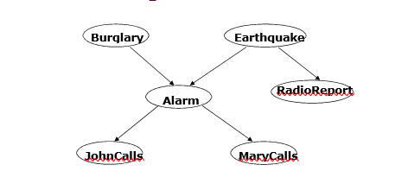

Earthquake and Burglary are independent, given MaryCalls __F_____

Burglary and MaryCalls are independent, given Alarm __T_____

Burglary and RadioReport are independent, given Earthquake ___T____

Burglary and RadioReport are independent, given MaryCalls ___F____

1. Given the chain rule and the above independence relationships, what is a good way to calculate P(B=T,E=T,A=T,J=T,M=F). Assume the following Bayes Net:

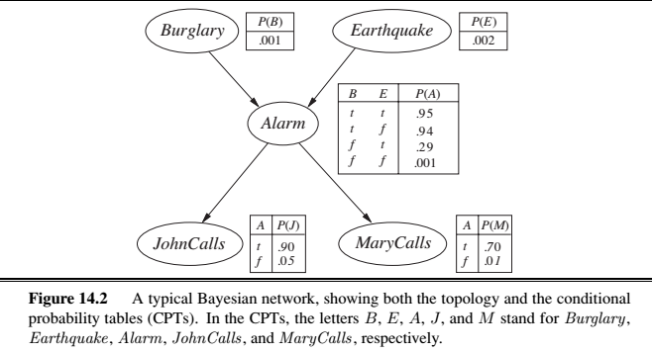

P(Alarm | John) = .90 *

P(Alarm | Burglary & Earthquake) = .95 *

P(Alarm | ~M) = .01 *

P(Burglary) = .001 *

P(Earthquake) = .002

1. For the above scenario (in question 4), how many parameters do we need to define the full joint distribution? What about the Bayes Net?

Full joint distribution – 2^5 = 32 (true or false and 5 random variables)

Bayes Net – 5 * 2 + the graph

1. Using the Bayes Net formulation, how many additions do you have to do and how many products do you have to do to compute the probability that P(J=T)? I’ll be using your solutions (possibly by name) to open the discussion next class.
2. **Post Reflection**

On a scale of 1-5, with 5 being most confident, how well do you think you could execute these learning objectives:

* 1. Describe Bayes Rule ­
  2. Represent knowledge as a Bayes Net
  3. Identify independence relationships within a Bayes Net
  4. Demonstrate how a Bayes Net can be used to make an inference   
      about the probability of a variable.
  5. Explain the complexity of inference by enumeration   
      using Bayes Nets