**Database Assignment 1**

1. Write a SQL statement to display all the information of all salesmen for the following table salesman.

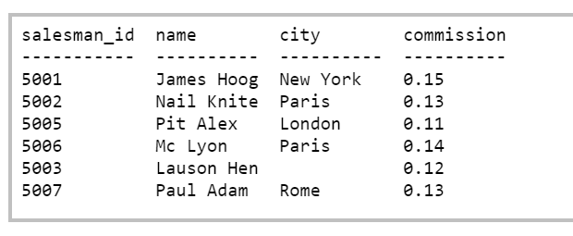

1. Write a SQL statement to display a string "This is SQL Exercise, Practice and Solution".
2. Write a query to display the result of an arithmetic expression.

For example the result of expression 9*10+4

1. Write a query to display ord_date, salesman_id, customer_id, order no, and purchase amount in the sequence from following orders table.

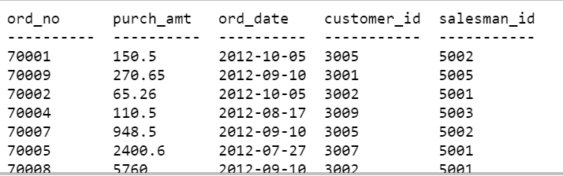

1. For the above table display salesman_id for all the salesman without repetitive value of the salesman_id.
2. Write a SQL statement to display all the information for those customers with a grade of 200.

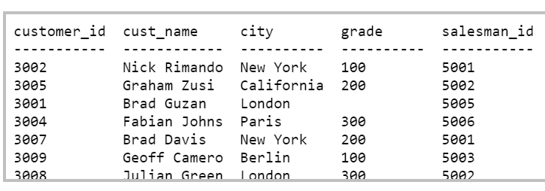

1. List the number, name, credit limit, and balance for customers with credit limits that exceed their balances.

(Where table attributes are number,name,credit limit and balance).

1. Create a table which consists of attributes warehouse id,warehouse branch address,customers numbers and balance for each warehouse. Then List the description of all parts that are not in warehouse 3.
2. Explain the following terms briefly: attribute, domain, entity, relationship, entity set, relationship set, one-to-many relationship, many-to-many relationship, overlap constraint, and weak entity set.
3. What is a foreign key constraint?
4. Answer each of the following questions briefly. The questions are based on the following relational schema:

Emp(eid: integer, ename: string, age: integer, salary: real)

Works(eid: integer, did: integer, pcttime: integer)

Dept(did: integer, dname: string, budget: real, managerid: integer)

1. . Give an example of a foreign key constraint that involves the Dept relation. What are the options for enforcing this constraint when a user attempts to delete a Dept tuple?
2. Write the SQL statements required to create the preceding relations, including appropriate versions of all primary and foreign key integrity constraints.
3. Define the Dept relation in SQL so that every department is guaranteed to have a manager.
4. Write an SQL statement to add John Doe as an employee with eid = 101, age = 32 and salary = 15, 000.
5. Write an SQL statement to give every employee a 10 percent raise.
6. Write an SQL statement to delete the Toy department.