Admission System Flowchart

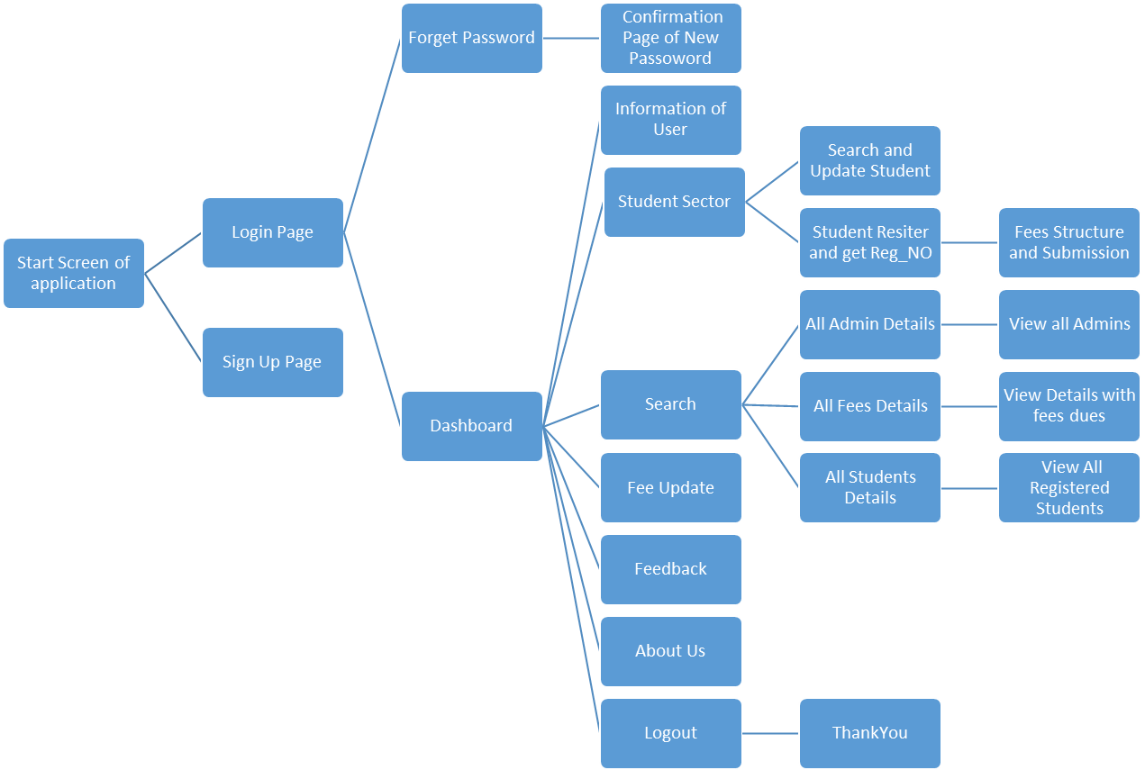

**Tables –**

**Fee-Pay Table –**

Create table feepay

(

Reg_id int, //reg_id is the forgein key of registeration table (reg_no) that is generated //

Name varchar(100),

Course_name varchar(100),

Sem1 varchar(100),

Sem2 varchar(100),

Sem3 varchar(100),

Sem4 varchar(100),

Sem5 varchar(100),

Sem6 varchar(100),

Sem7 varchar(100),

Sem8 varchar(100),

Fees int

);

**Registration Table –**

Create table registeration

(

Reg_no int primary key,

Name varchar(100),

Gender varchar(100),

Fathername varchar(100),

Category varchar(100),

Email varchar(100),

Zip int,

Contact int,

City varchar(100),

State varchar(100),

Address varchar(100)

);

**Sign-Up Table –**

Create table signup

(

Username varchar(100) primary key,

Pass varchar(100),

Email varchar(100),

Sex varchar(100),

Quali varchar(100),

City varchar(100)

);