Vikram’s English Academy (ICSE)

**ENGLISH Paper- 1**

**Set G**

***(Two hours)***

*Answers to this Paper must be written on the paper provided separately.*

*You will* ***not*** *be allowed to write during the first* ***15*** *minutes.*

*This time is to be spent in reading the question paper.*

*The time given at the head of this Paper is the time allowed for writing the answers.*

*Attempt* ***all four*** *questions*

*The intended marks for questions or parts of questions are given in brackets [ ].*

*You are advised to spend not more than* ***35*** *minutes in answering* ***Question 1***

*And* ***20*** *minutes in answering* ***Question 2****.*

**Question 1 [25]**

***(Do not spend more than 35 minutes on this question.)***

**Write a composition (350-400 words) on any one of the following:**

1. You have recently visited a relative in a hostel. You were surprised to the see the difference in the student life there as compared to yours. Describe the difference between the two lives as you see them.
2. ‘The end does justify the means’. Keeping this philosophy in mind write if you support or oppose the logic. You may reflect upon the current political scenario in the country.
3. Write a narrative account on an Indian policeman from his perspective and the issues that he face on and off duty.
4. Freedom of expression is in danger from the menace of trolling. Do you subscribe to the view or believe that trolling too is a mode of freedom of expression.
5. Write a short story which illustrates the truth of the statement: ‘Two things define you: Your patience when you have nothing and your attitude when you have everything.’
6. Study the picture given below. Write a story or a description or an account of what it suggests to you. Your composition may be about the subject of the picture or you may take suggestions from it; however there must be a clear connection between the picture and your composition.

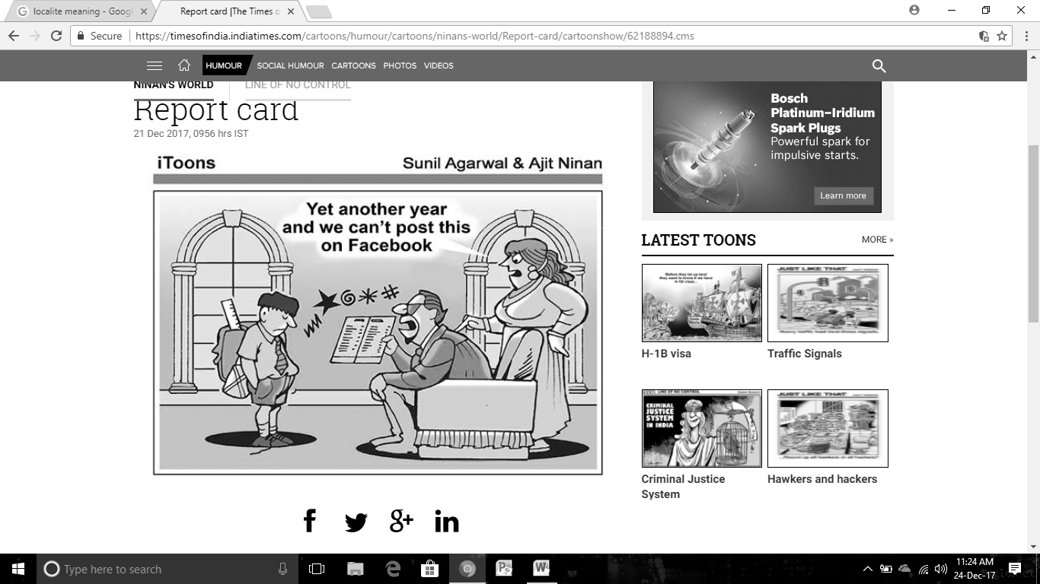

**Question 2 [10]**

***(Do not spend more than 20 minutes on this question.)***

**Select any one of the following:**

1. Write a letter to the Indian Sports Ministry expressing your view and concern over the present state of Sports’ Coaches in India.
2. You have recovered from long illness. It changed your life in many ways. Write a letter to your younger cousin expressing what this period taught you.

**Question 3 [25]**

**Read the following passage carefully and answer the questions that follow:**

It was a **sympathetic** voice that asked the question, and Judith looked up with a smile. Her mother's cousin stood in the doorway--a **prim** little old spinster, who had been their guest for several days. Like Marguerite, she, too, had come back to her native village after an absence of four years, but not to her father's house. She was all alone in the world, save for a few distant relatives who called her Cousin Barbara. After a short visit, she would go away for another long absence, but not, like Marguerite, to a life full of many interests and pleasures. She had only her music pupils in a little Pennsylvania mining town, and a room in a boarding-house.   
  
"Come in, Cousin Barbara," said Judith, **cordially**. "I was sighing over Marguerite's departure. You know she was my best friend at school, and I have missed her so much since her marriage. The other girls in our class have all gone away to teach or take positions somewhere, except the two who married and settled down here in Westbrooke; and they have such different interests now. All they can talk about is their housekeeping or their babies. Most of the boys have gone away, too. I don't wonder. Anybody with any ambition would get away from such a place if it were within the range of possibilities."   
  
Cousin Barbara had seated herself in a low rocking-chair and was pulling the basting threads from a finished garment. "Listen!" she said, "isn't that Amy calling again?" An excited little voice came **shrilly** up the stairs.   
  
"Look, Judith! Mrs. Avery is coming back again! What do you suppose is the matter?"   
  
The omnibus dashing down the road stopped suddenly at the gate opposite. The door burst open, and the dignified Mr Avery, in **undignified** haste, ran breathlessly toward the house, while Marguerite called out a laughing explanation to her friend at the window.  "I left my watch on the dressing-table and my purse with my trunk keys in it, and we've only six minutes to catch the train. Isn't that just my way? Look at Algernon run! I wouldn't have believed it of him. Well, it has given me another chance to remind you that you are to come to me in February. You needn't shake your head. I'll not take 'no' for an answer. You're so good at planning, Judith, I'm sure you can arrange it some way."   
  
Then as her husband returned, red-faced and breathless, she leaned out of the 'bus, and laughingly blew an airy kiss from her fingertips.   
  
"That's just like her!" exclaimed Judith. "She's as irresponsible and careless as a child. She was always late to school, and losing her pencils and forgetting her books. We used to call her 'Daisy Dilly-dally.' She's such a dear little butterfly, though, and it doesn't seem possible that we are the same age--twenty-three. I feel like a patriarch beside her."

**(a) Give the meaning of each of the following words as used in the passage: [5]**

i. sympathetic

ii. prim

iii. cordially

iv. shrilly

v. undignified

**(b) Answer the following questions briefly in your own words:**

i. What was the guest’s name? After how long has she arrived? [2]

ii. What can you suggest about the guest’s profession? Which line in the passage suggests that?

[2]

iii. How was Marguerite’s life? What is her full name? How did her friends address her in the school? Why? [2]

iv. Who came in the omnibus? Why? [2]

v. Explain the line: I feel like a patriarch beside her. [2]

**(c) (i) Describe Marguerite and Judith’s friendship in not more than 60 words [8]**

**(ii) Give a title to your summary in 3 (c). Give a reason to justify your choice. [2]**

**Question 4**

1. **Fill in each of the numbered blanks with the correct form of the word given in brackets. Do not copy the passage, but write in correct serial order the word or phrase appropriate to the blank space. [4]**

Four cars __1___ (damage) following a minor blaze in the Laxmi park society. It ___2__ (learn) that dry leaves and twigs ___3___ (catch) fire which soon spread to the vehicles parked in the bay. The fire brigade officials said that fire ___4___ (grip) the rubber tyres and soon destroyed the interiors as well. Locals said that timely action __5__ (prevent) a major mishap. "It ___6___ (lead) to a major inferno if the fire had touched the fuel tank" an official of the disaster cell said. He __7___ (add) that a live wire caught fire but damage was controlled. No injuries or casualties___8___ (report).

1. **Fill in the blanks with an appropriate word: [4]**
2. The CISF has been guarding the facility____December.
3. ___a brazen violation of norms a school has felled trees.
4. The community has demanded 5 percent reservation___limit.
5. They can claim benefit ___ the amnesty scheme of the government.
6. A subordinate is supposed to take order ____ his superior.
7. Four college students have been booked ____ abetting suicide.
8. We are expecting the rains to pick ___ .
9. Provisions have been made___  help the underprivileged.

1. **Join the following sentences to make one complete sentence without using *and, but* or *so*: [4]**
2. The corporates will provide good facilities. it will not meet the needs of common citizens.
3. Teachers in schools take their job for granted. They have regular salaries. They are hardly ever tested.
4. The distinctive Indian Railways logo will still be spotted by the TTEs on their new uniforms. It symbolises the continuation of tradition
5. He will be participating in his first-ever concert. It is a matter of great pride for him.

**d) Re-write the following sentences according to the instructions given after each. Make other changes that may be necessary, but do not change the meaning of each sentence. [8]**

1. It is the end of the hope. (Begin with ‘There….’)
2. Children almost always hang on to things tighter than their parents think they will.

(Use: tight)

1. "I like to sit still,” she said." I have always been rather quiet."(Begin with :She said that)
2. No one was with her when she died. (Remove: No)
3. The delicacy smelled good. (End with ‘?’)
4. We had given him a rousing welcome. (Begin with: A rousing…)
5. If he hadn't stepped up his game it would have been the end of the world for him

(Begin with: ‘Had… )

1. She was brilliant, beautiful and loyal to the end (Use: not only…. but also…)