Vikram’s English Academy (ICSE)

**ENGLISH Paper- 1**

**Set C**

***(Two hours)***

*Answers to this Paper must be written on the paper provided separately.*

*You will* ***not*** *be allowed to write during the first* ***15*** *minutes.*

*This time is to be spent in reading the question paper.*

*The time given at the head of this Paper is the time allowed for writing the answers.*

*Attempt* ***all four*** *questions*

*The intended marks for questions or parts of questions are given in brackets [ ].*

*You are advised to spend not more than* ***35*** *minutes in answering* ***Question 1***

*And* ***20*** *minutes in answering* ***Question 2****.*

**Question 1 [25]**

***(Do not spend more than 35 minutes on this question.)***

**Write a composition (350-400 words) on any one of the following:**

1. Cricket overshadows other sports. Express your views either for or against this statement.
2. There is only one religion, though there are hundred versions of it. Write an essay on how religion binds the world yet divides it too.
3. Do you believe that we have more than one life and can be born again in a different form? If you could be born again and were given a choice, what would you choose to be born as?
4. Write a short story which illustrates the truth of the statement: ‘Joys and sorrows go hand in hand.’
5. You were studying late at night for your final examination. Suddenly you saw your neighbour’s house on fire. Describe the scene that you saw and the role you played.
6. Study the picture given below. Write a story or a description or an account of what it suggests to you. Your composition may be about the subject of the picture or you may take suggestions from it; however there must be a clear connection between the picture and your composition.

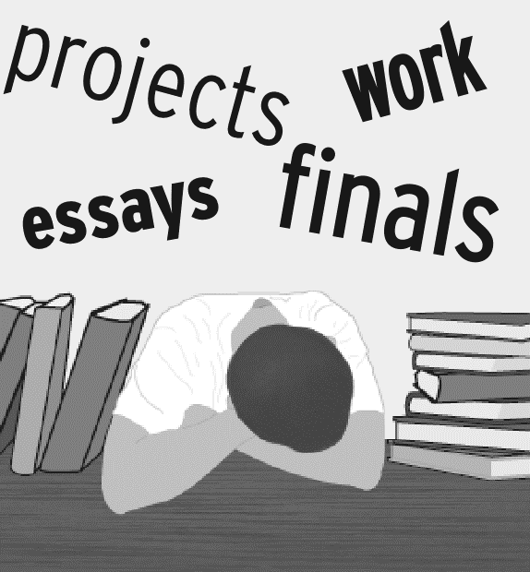

**Question 2 [10]**

***(Do not spend more than 20 minutes on this question.)***

**Select any one of the following:**

1. There is a mushroom growth of public schools in India. These schools have become money shops and ignore the people from the poor strata however intelligent the child may be. This has caught the attention of the government. They have taken certain steps against those schools for not to admitting the poor students. The step on behalf of the government is rather very much praiseworthy. Write a letter to the editor of the national daily highlighting equal opportunities for all and giving due opportunities to the poor for their upliftment.
2. Write a letter to your cousin describing a wildlife safari that you had taken, how you were left behind in the jungle by your troupe and how you managed to contact them again.

**Question 3 [25]**

**Read the following passage carefully and answer the questions that follow:**

Dear Sir,

You will doubtless be surprised to know who has **presumed** to write and ask a favour of you. Let your memory go back to your days in the Humboldt mines- ’62- ’63. You will remember, you and Clagett and Oliver and the old blacksmith Tillou lived in a **lean- to** which was half-way up the **gulch** and there were six log cabins in the camp-strung pretty well separated up the gulch from its mouth at the desert to where the last claim was, at the divide. The lean- to you lived in was the one with a canvas roof that the cow fell down through one night, as told about by you in *Roughing It–* my uncle Simmons remembers it very well. He lived in the principal cabin, half-way up the divide, along with Dixon and Parker and Smith. It had two rooms, one for kitchen and the other for bunks, and was the only one that had. You and your party were there on the great night, the time they had dried-apple-pie. Uncle Simmons often speaks of it. It seems curious that dried-apple-pie should have seemed such a great thing, but it was, and it shows how far Humboldt was out of the world and difficult to get to, and how slim the regular bill of fare was. Sixteen years ago-it is a long time. I was a little girl then, only fourteen. I never saw you, I lived in Washoe. But Uncle Simmons ran across you every now and then, all during those weeks that you and party were there working your **claim** which was like the rest. The camp played out long and long ago, there wasn’t silver enough in it to make a button. You never saw my husband, but he was there after you left, *and lived in that very lean-to*, a bachelor then but married to me now. He often wishes there had been a photographer there in those days, he would have taken the lean-to. He got hurt in the old Hal Clayton claim that was abandoned like the others, putting in a blast and not climbing out quick enough, though he **scrambled** the best he could. It landed him clear down on the train and hit a Piute. For weeks they thought he would not get over it but he did and is all right, now. Has been ever since. This is a long introduction but it is the only way I can make myself known. The favour I ask I feel assured your generous heart will grant: Give me some advice about a book I have written. I do not claim anything for it only it is mostly true and as interesting as most of the books of the times. I am unknown in the literary world and you know what that means unless one has some one of influence (like yourself) to help you by speaking a good word for you. I would like to place the book on royalty basis plan with any one you would suggest. This is a secret from my husband and family. I intend it as a surprise in case I get it published. Feeling you will take an interest in this and if possible write a letter to some publisher, or, better still, if you could see them for me and then let me hear.

I appeal to you to grant me this favour.

With deepest gratitude I thank you for your attention.

**(a) Give the meaning of each of the following words as used in the passage:** **[5]**

(i) presumed

(ii) claim

(iii) scrambled

(iv) gulch

(v) lean- to

**(b) Answer the following questions briefly in your own words:**

(i) What does Uncle Simmons remember very well? **[2]**

(ii) How old was the woman when she wrote this letter? Justify. **[2]**

(iii) What reason does the woman give the author for giving such a long introduction? What favour does she want from him? **[3]**

(iv) What happened as a result of him ‘not climbing out quick enough’? **[3]**

**(c) (i) In not more than 60 words, how the writer makes herself known to the recipient of the letter. [8]**

**(ii) Give a title to your summary in 3 (c). Give a reason to justify your choice. [2]**

**Question 4**

1. **Fill in each of the numbered blanks with the correct form of the word given in brackets. Do not copy the passage, but write in correct serial order the word or phrase appropriate to the blank space. [4]**

He___ (1) ___ (laugh) and resumed his eating his meal which he ___ (2) ___ (start) forty minutes earlier. I ___ (3) __ (watch) him now his hands ____ (4) ___ (work) gingerly as if he was learning ____ (5) ____ (use) them for the first time. He could not press down hard with his knife. His fingers _____ (6) _____ (shake). Each bite ___ (7) ___ (be) a struggle, he __ (8) ___ (chew) the food finely before swallowing.

**b) Fill in the blanks with an appropriate word: [4]**

1. The water spilled all ___ the floor.
2. I forced my hands ___ the dirty water.
3. Whenever I try talking to him about sports, he brings__ politics.
4. The match was called ___due to rain.
5. We called ___you last night but you weren’t home.
6. I turned ___too many books on architecture.
7. This is all I could wish___.
8. I do not believe __such things.

**c) Join the following sentences to make one complete sentence without using *and, but* or *so*: [4]**

1. The king left the wounded man. He went out of the hut.
2. He wished to kill me. You saved my life.
3. I set my face towards home. I made the best use of my legs.
4. He took out something from his pocket. It was a purse.

**d) Re-write the following sentences according to the instructions given after each. Make other changes that may be necessary, but do not change the meaning of each sentence. [8]**

1. Everything would have gone smoothly, if you wouldn’t have interfered. (Begin with ‘But…’)
2. Owing to the lack of money, he couldn’t complete his studies. (Rewrite using a ‘because’)
3. To add to his difficulties, he lost his wife. (Rewrite using ‘which’)
4. He must write fast to complete the paper. (Use ‘or’)
5. It is a sad thing that O’Henry died so young. (Rewrite using the adverb form of ‘sad’)
6. The slaves were tortured and beaten. (Start with ‘Not only…’)
7. As soon as the whistle sounded, marching commenced. (Use ‘No….’)
8. The wife said to her husband, “Can you spare some time for me?” (Start with “The wife asked….”)