Vikram’s English Academy (ICSE)

**ENGLISH Paper- 1**

**Set H**

***(Two hours)***

*Answers to this Paper must be written on the paper provided separately.*

*You will* ***not*** *be allowed to write during the first* ***15*** *minutes.*

*This time is to be spent in reading the question paper.*

*The time given at the head of this Paper is the time allowed for writing the answers.*

*Attempt* ***all four*** *questions*

*The intended marks for questions or parts of questions are given in brackets [ ].*

*You are advised to spend not more than* ***35*** *minutes in answering* ***Question 1***

*And* ***20*** *minutes in answering* ***Question 2****.*

**Question 1 [25]**

***(Do not spend more than 35 minutes on this question.)***

**Write a composition (350-400 words) on any one of the following:**

1. Films just reflect a slice of real life. But the expression of life situations is severely being hampered in our country with the censor board coming down heavily on whatever they perceive as remotely sensitive. Write an argument either for or against the topic ‘Should censorship be done away with?’
2. Write a short story which illustrates the truth of the statement: ‘Celebrities set unrealistic goals for the youth and are bad role models.’
3. You have visited your cousin who lives abroad to celebrate an Indian festival. You were surprised to the see the difference in the celebration in that country and yours. Write an essay to describe the differences and certain similarities that you found out.
4. Write a narrative account on an Indian judge from his perspective about the issues, tribulations, challenges and other problems he faces during a trial especially in a country where cases take years to resolve.
5. Write an essay on the following topic: ‘Beauty Pageants: Objectification of Women.’
6. Study the picture given below. Write a story or a description or an account of what it suggests to you. Your composition may be about the subject of the picture or you may take suggestions from it; however there must be a clear connection between the picture and your composition.

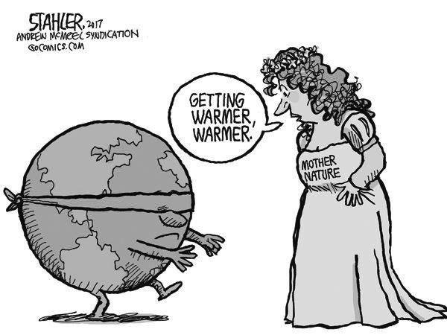

**Question 2 [10]**

***(Do not spend more than 20 minutes on this question.)***

**Select any one of the following:**

1. Write a letter to the Minister of Education to request him to introduce more practical knowledge oriented curriculum in syllabus rather than the current theoretical one. Give reasons for your suggestions.
2. Write a letter to your mother living abroad expressing how begging has become a business and how you fell prey to it.

**Question 3 [25]**

**Read the following passage carefully and answer the questions that follow:**

We were driving along the road from Treguier to Kervanda. We passed at a smart **trot** between the hedges topping an earth wall on each side of the road; then at the foot of the steep ascent before Ploumar the horse dropped into a walk, and the driver jumped down heavily from the box. He flicked his whip and climbed the incline, stepping **clumsily** uphill by the side of the carriage, one hand on the footboard, his eyes on the ground. After a while he lifted his head, pointed up the road with the end of the whip, and said--

"The idiot!"

The sun was shining violently upon the **undulating** surface of the land. The rises were topped by clumps of meagre trees, with their branches showing high on the sky as if they had been **perched** upon stilts. The small fields, cut up by hedges and stone walls that zig-zagged over the slopes, lay in rectangular patches of vivid greens and yellows, resembling the unskilful daubs of a naive picture. And the landscape was divided in two by the white streak of a road stretching in long loops far away, like a river of dust crawling out of the hills on its way to the sea.

"Here he is," said the driver, again.

In the long grass bordering the road a face glided past the carriage at the level of the wheels as we drove slowly by. The **imbecile** face was red, and the bullet head with close-cropped hair seemed to lie alone, its chin in the dust. The body was lost in the bushes growing thick along the bottom of the deep ditch.

It was a boy's face. He might have been sixteen, judging from the size--perhaps less, perhaps more. Such creatures are forgotten by time, and live untouched by years till death gathers them up into its compassionate bosom; the faithful death that never forgets in the press of work the most insignificant of its children.

"Ah! there's another," said the man, with a certain satisfaction in his tone, as if he had caught sight of something expected.

There was another. That one stood nearly in the middle of the road in the blaze of sunshine at the end of his own short shadow. And he stood with hands pushed into the opposite sleeves of his long coat, his head sunk between the shoulders, all hunched up in the flood of heat. From a distance he had the aspect of one suffering from intense cold.

"Those are twins," explained the driver.

The idiot shuffled two paces out of the way and looked at us over his shoulder when we brushed past him. The glance was unseeing and staring, a fascinated glance; but he did not turn to look after us. Probably the image passed before the eyes without leaving any trace on the misshapen brain of the creature. When we had topped the ascent I looked over the hood. He stood in the road just where we had left him.

The driver clambered into his seat, clicked his tongue, and we went downhill. The brake squeaked horribly from time to time. At the foot he eased off the noisy mechanism and said, turning half round on his box--

"We shall see some more of them by-and-by."

"More idiots? How many of them are there, then?" I asked.

"There's four of them--children of a farmer near Ploumar here. . . . The parents are dead now," he added, after a while. "The grandmother lives on the farm. In the daytime they knock about on this road, and they come home at dusk along with the cattle. . . . It's a good farm."

We saw the other two: a boy and a girl, as the driver said. They were dressed exactly alike, in shapeless garments with petticoat-like skirts. The imperfect thing that lived within them moved those beings to howl at us from the top of the bank, where they sprawled amongst the tough stalks of furze. Their cropped black heads stuck out from the bright yellow wall of countless small blossoms. The faces were purple with the strain of yelling; the voices sounded blank and cracked like a mechanical imitation of old people's voices; and suddenly ceased when we turned into a lane.

**(a) Give the meaning of each of the following words as used in the passage: [5]**

i. trot

ii. clumsily

iii. undulating

iv. perched

v. imbecile

**(b) Answer the following questions briefly in your own words:**

i. Where was the narrator travelling? How? [2]

ii. What can you guess about the season? Justify with the evidence. [3]

iii. Why did the driver click his tongue? [2]

iv. Was the driver a localite? Explain. [3]

**(c) (i) Describe the four children and about their family life. [8]**

**(ii) Give a title to your summary in 3 (c). Give a reason to justify your choice. [2]**

**Question 4**

1. **Fill in each of the numbered blanks with the correct form of the word given in brackets. Do not copy the passage, but write in correct serial order the word or phrase appropriate to the blank space. [4]**

Three persons___1____ (include) a woman ___2___ (arrest) for illegally possessing leopard and deer skin. According to the police the ___3___ (accuse) ____4___( catch) red handed from the hotel where they ___5___ (assemble) to strike a deal. The police___6___( receive) a tip off that someone___7___(plan) to sell animal skin. A trap ___8___ (lay) and these three were arrested.

1. **Fill in the blanks with an appropriate word: [4]**
2. We were taken ____ by the development
3. The Indian team has dominated____ the Lankans in this series
4. The final rake arrived __ Mumbai on Friday.
5. The amendment has been sent to the lower house ___ discussion.
6. He kept unwell ___ the weekend and even when he joined work on Monday.
7. They built a villa ___ the cost of 2 crore.
8. In the automobile industry safety measures cannot be compromised____.
9. He kicked ___ his Olympic with a win over his rival.
10. **Join the following sentences to make one complete sentence without using *and, but* or *so*: [4]**
11. The fish lashed back. Then she dodged to one side throwing another fin.
12. He summoned all his strength. He threw himself into the air head first.
13. He could not get into the pen as he wasn't tall enough to jump over the fence. He was not interested in it either.
14. Nothing is absolutely the limit of nothingness. It is the lowest one can go.

**d) Re-write the following sentences according to the instructions given after each. Make other changes that may be necessary, but do not change the meaning of each sentence. [8]**

1. The thing always seems to me so ridiculously simple that I could do it myself (Use ‘too’)
2. "Have you any reason to be dissatisfied with my choice?" I asked. (Make indirect speech)
3. If you need any help he is just a call away. (Begin with:- Should)
4. I cursed my fate for having bumped into him at the party (Begin with :- My )
5. It was as unimaginable a nightmare as I had ever dreamt. (Use the word:- than)
6. The train chugged into the station and I soon saw him. (Begin with: No sooner…)
7. I was never going to believe him. (Begin with : Was)
8. It was a thrilling experience. (Use a question tag)