

DEPARTMENT OF COMPUTER SCIENCE AND APPLICATIONS

SESSION: 2025-2026

Practical: Frontend Development

Submitted to:
Mr. Sahil
(Assistant Professor)
Department: CSA

Submitted by:
Name: Simranjeet Kaur
Class: BCA (Gen, 2NDYEAR)
Roll no: 2401SCS1410019

# Project: - Kudrat cafe
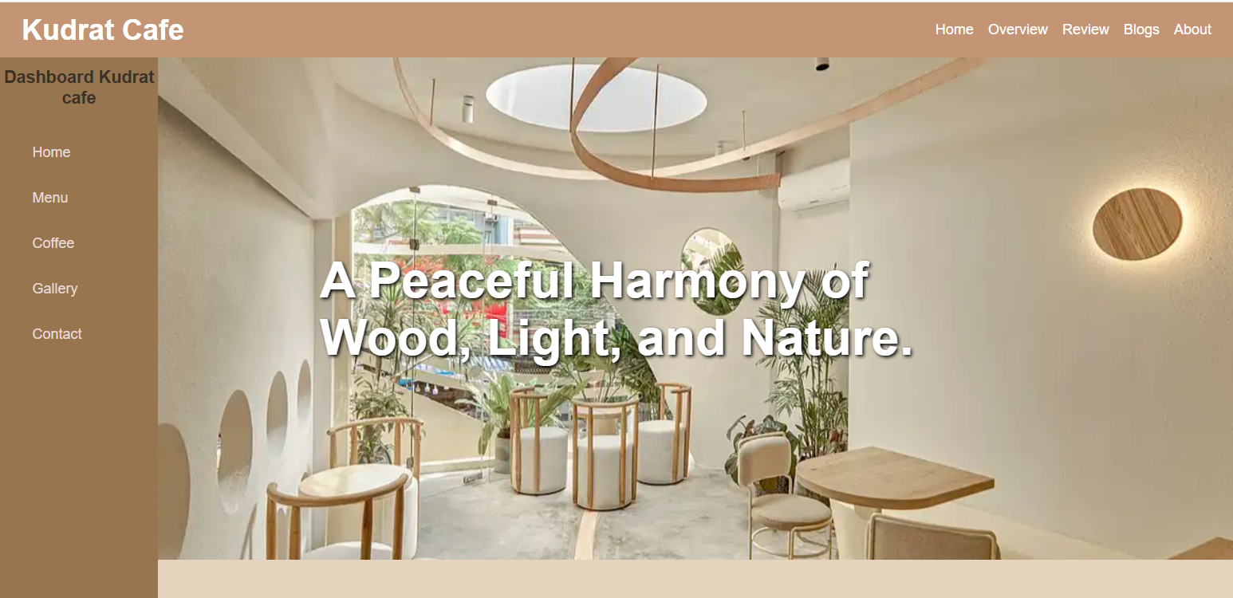
-> Design of webpage: -

-> Overview: -
The webpage is a modern café website name Kudrat café. It uses a clean and minimal layout with a background image and attractive typography to create a calm and aesthetic feel. The webpage includes a navigation bar with sections like Home, Overview, Review, Blogs and About for easy navigation.
-> Main features used in this webpage include: -
Responsive navigation bar
Full- screen background image
Text overlay with stylish typography
Modern UI design using HTML, CSS
Flexbox layout for alignment
Smooth and minimal color theme
This webpage is mainly based on café various features need to used-
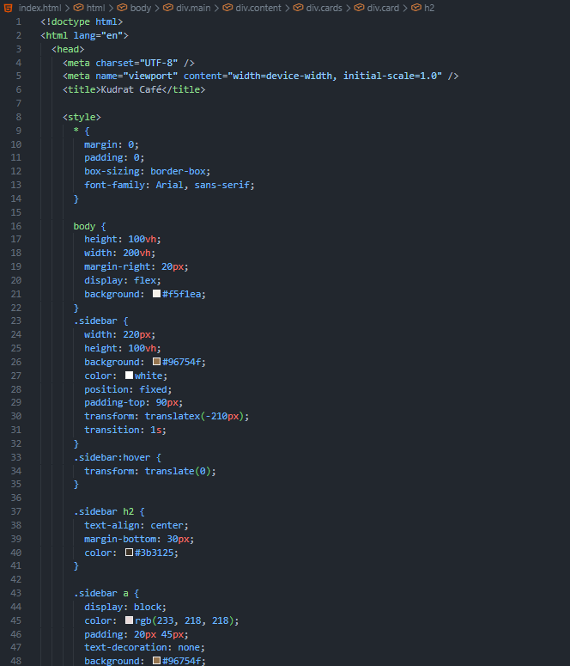
CODE OF HTML, CSS-
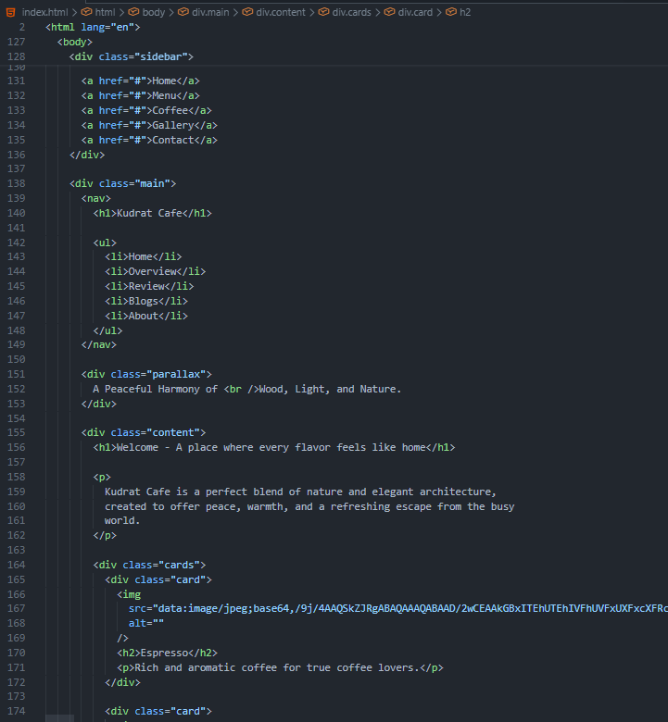
About Code: -
Uses of a css code to design a webpage –
* Applies styles to all elements
body styles whole webpage body
.sidebar create a sidebar as a dashboard
.sidebar:hover To show the effects when mouse hover

