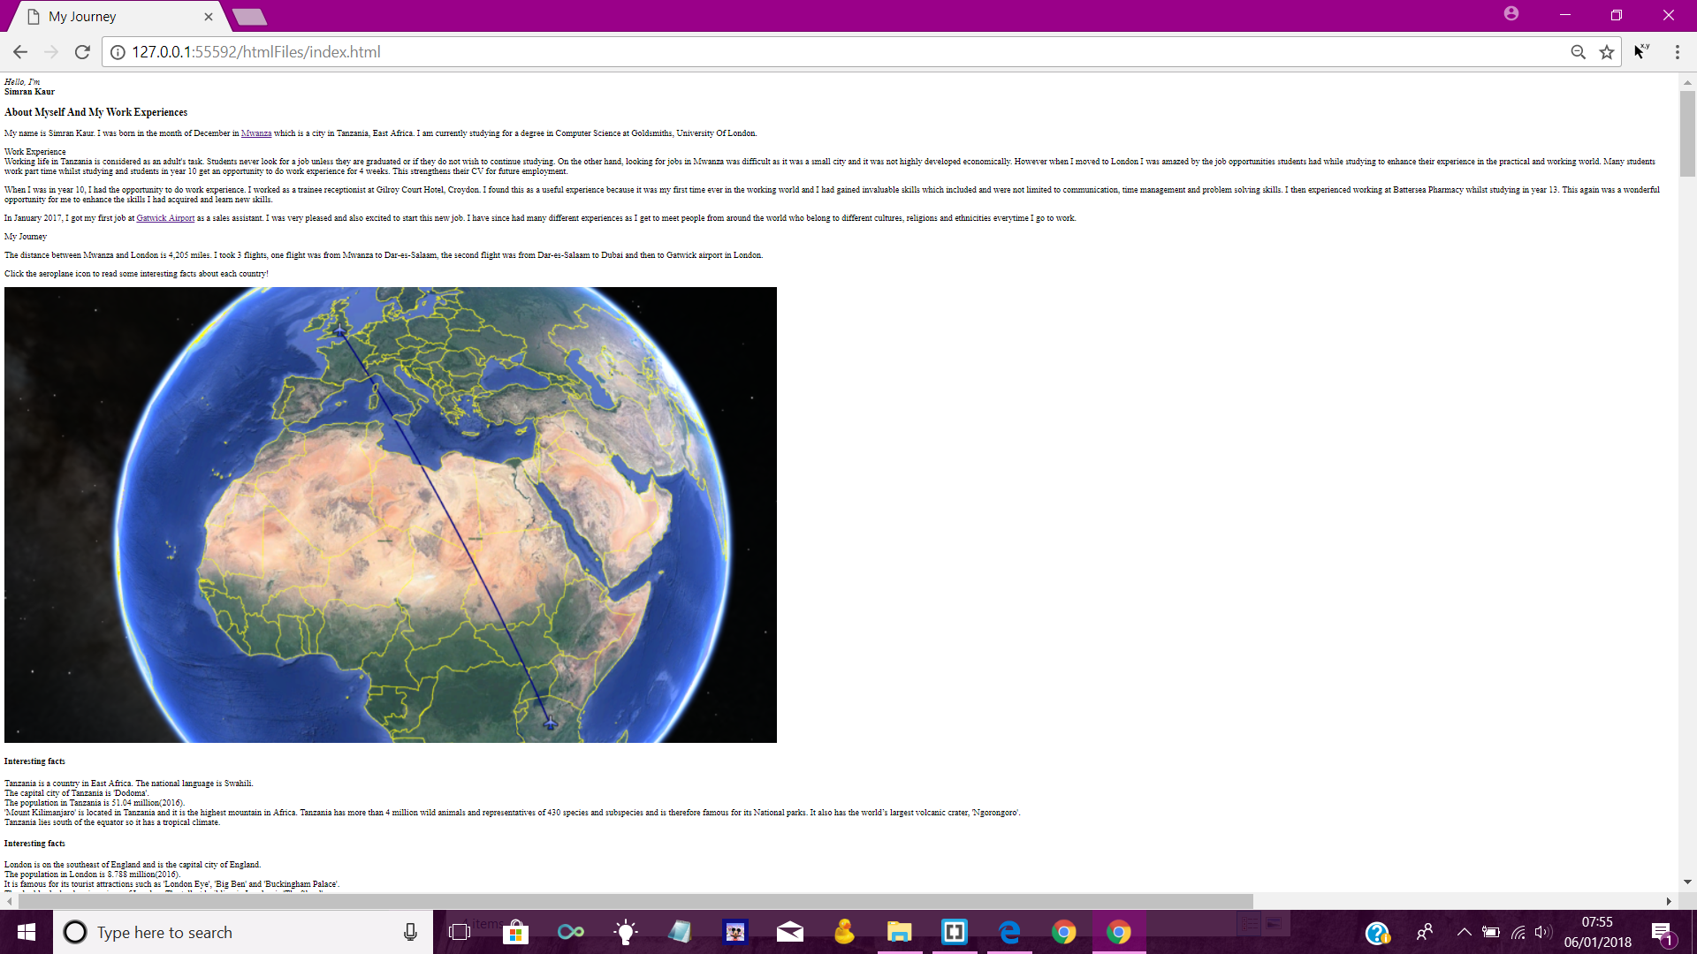

Screenshot of my gallery without any CSS and JS.

Screenshot of the first page of my website without any CSS. Also interesting facts are on this page which were later put in a dialog box using JS.

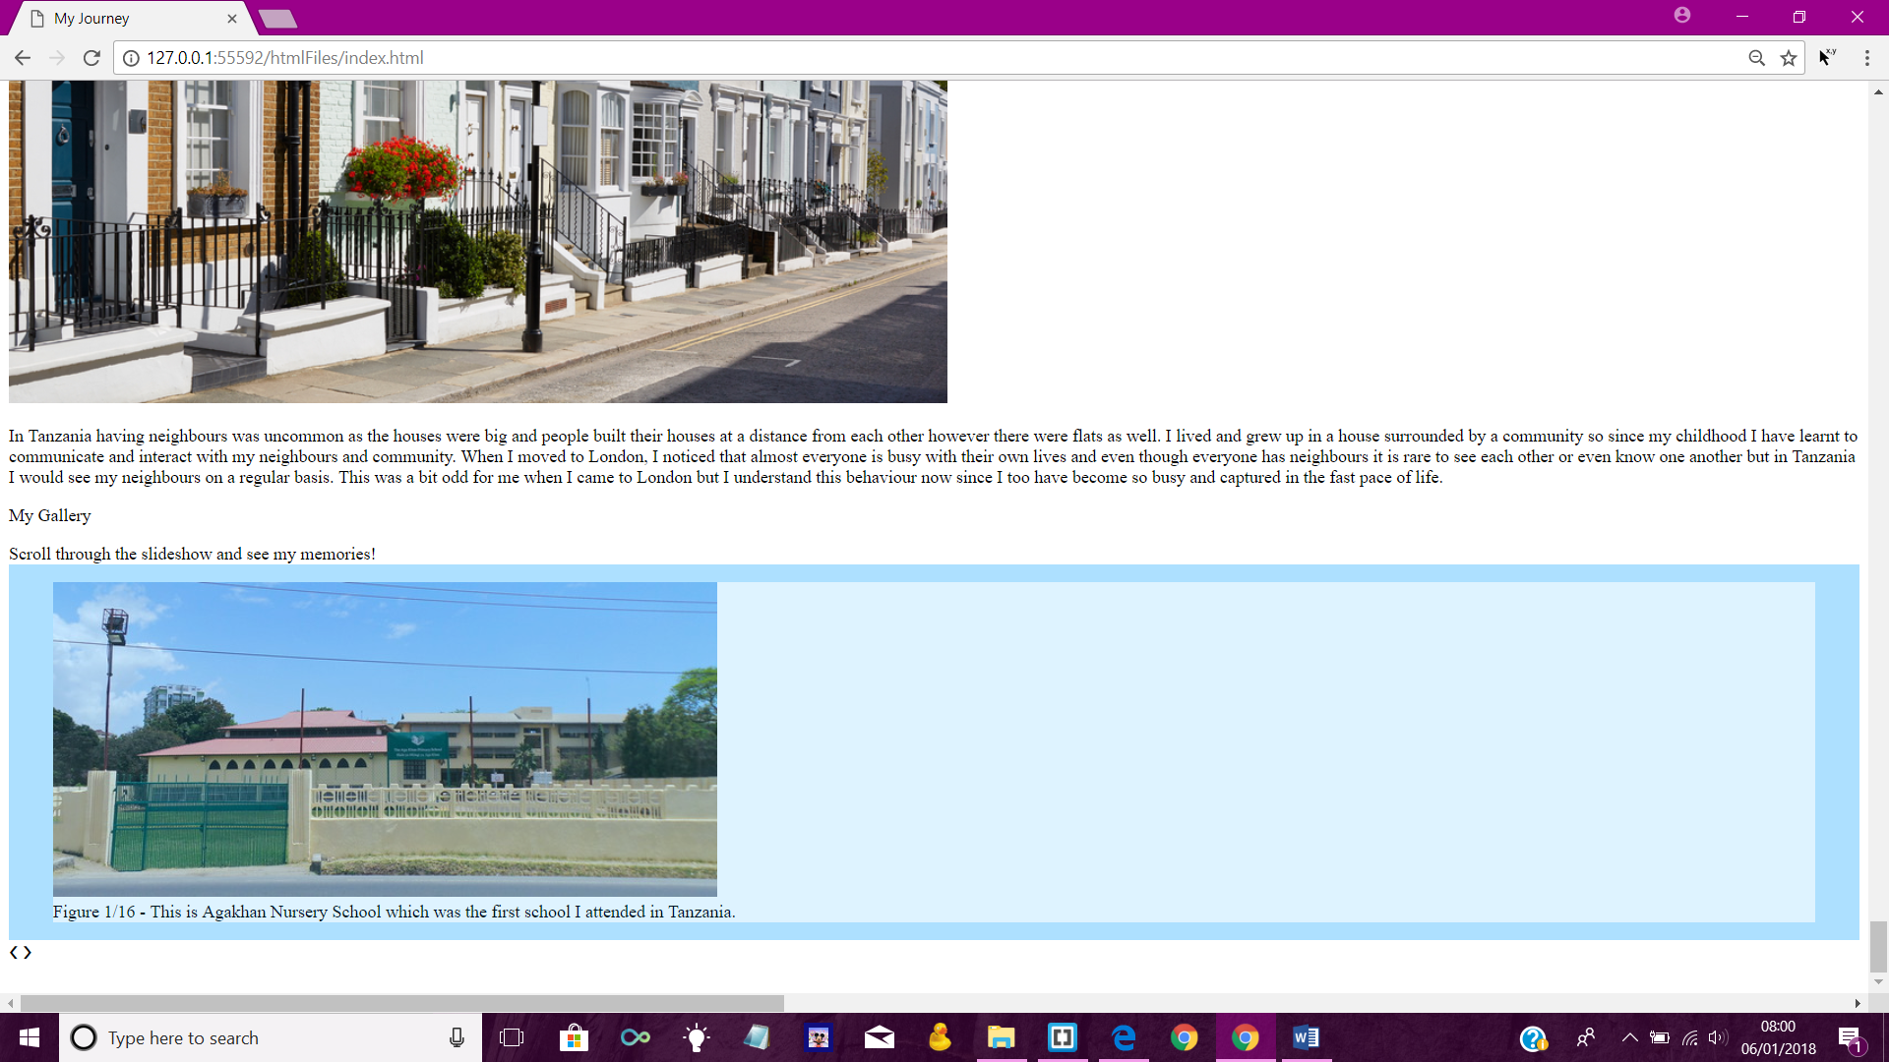

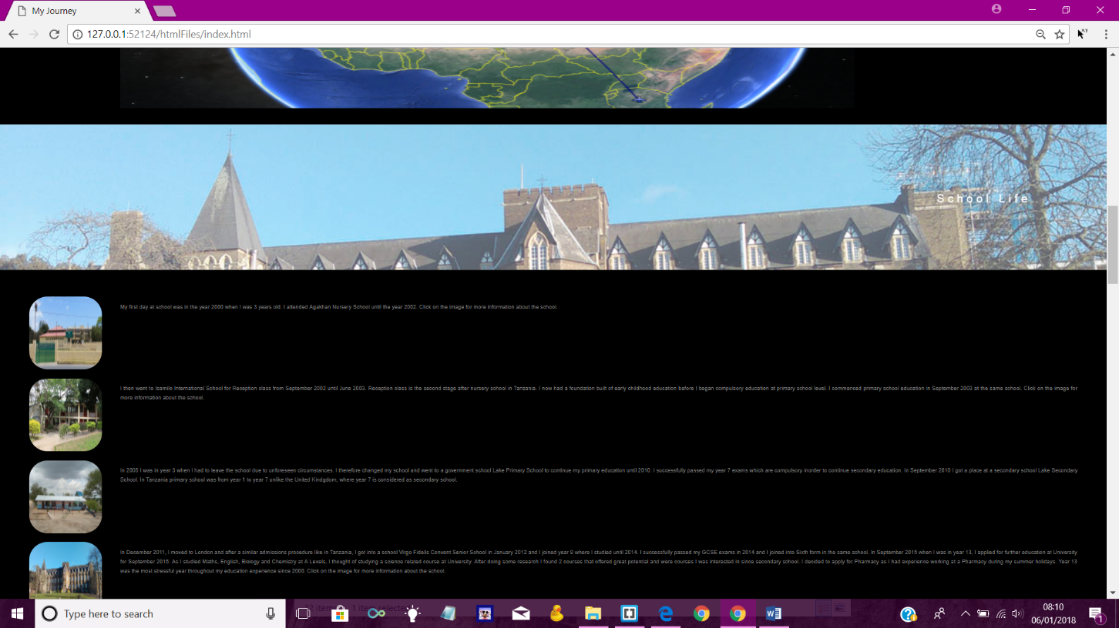

My website has the same layout for all the pages. This a screenshot of the page ‘school life’ with CSS.

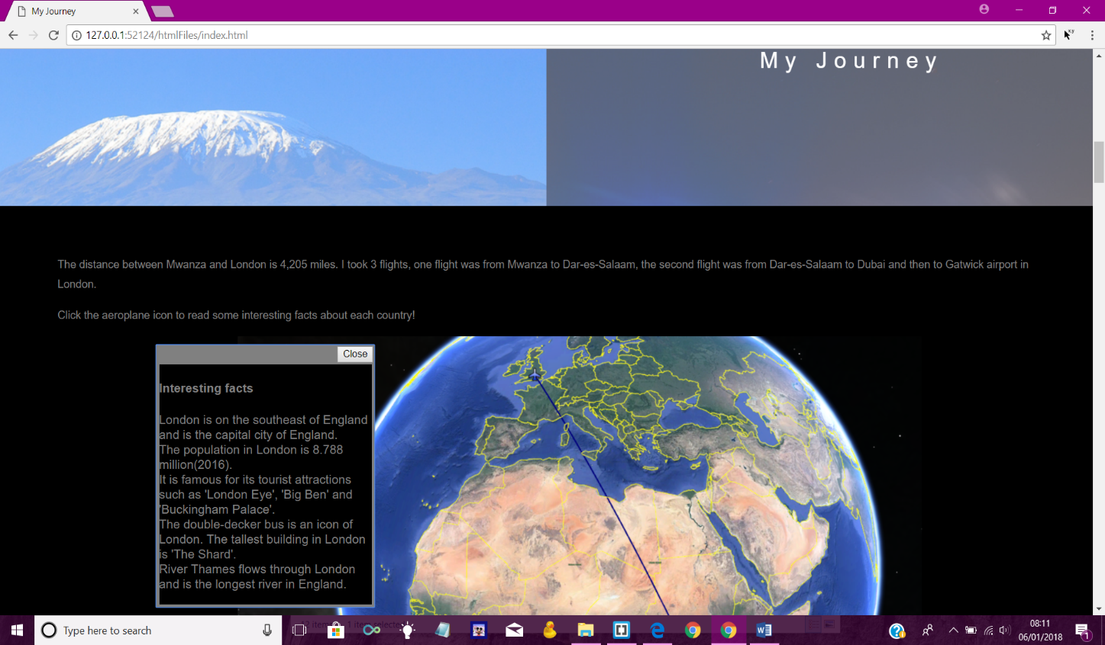

Screenshot of the page ‘my journey’ showing impact of JS. Interesting facts in the dialog box after an aeroplane icon is clicked.