final_project

Simran Kota, Yusef Haswarey

# Packages Used

library(tidyverse)

## -- Attaching packages --------------------------------------- tidyverse 1.3.1 --

## v ggplot2 3.3.5 v purrr 0.3.4  
## v tibble 3.1.5 v dplyr 1.0.7  
## v tidyr 1.1.4 v stringr 1.4.0  
## v readr 2.0.2 v forcats 0.5.1

## -- Conflicts ------------------------------------------ tidyverse_conflicts() --  
## x dplyr::filter() masks stats::filter()  
## x dplyr::lag() masks stats::lag()

library(randomForest)

## randomForest 4.6-14

## Type rfNews() to see new features/changes/bug fixes.

##   
## Attaching package: 'randomForest'

## The following object is masked from 'package:dplyr':  
##   
## combine

## The following object is masked from 'package:ggplot2':  
##   
## margin

library(caret)

## Loading required package: lattice

##   
## Attaching package: 'caret'

## The following object is masked from 'package:purrr':  
##   
## lift

library(ggpubr)

# Research Question

We are attempting to explore the relationship between various features of a house (ex. number of rooms, square footage, year built, etc.) on the future value of the house.

# Data Source and Definitions

The [USA Housing Dataset](https://www.kaggle.com/gpandi007/usa-housing-dataset?select=housing_train.csv) from Kaggle provides data regarding sales prices with respect to various houses in the US. It has 81 features describing each record for 1460 records.

dat <- read.csv("housing_data.csv")  
str(dat)

## 'data.frame': 1460 obs. of 81 variables:  
## $ Id : int 1 2 3 4 5 6 7 8 9 10 ...  
## $ MSSubClass : int 60 20 60 70 60 50 20 60 50 190 ...  
## $ MSZoning : chr "RL" "RL" "RL" "RL" ...  
## $ LotFrontage : int 65 80 68 60 84 85 75 NA 51 50 ...  
## $ LotArea : int 8450 9600 11250 9550 14260 14115 10084 10382 6120 7420 ...  
## $ Street : chr "Pave" "Pave" "Pave" "Pave" ...  
## $ Alley : chr NA NA NA NA ...  
## $ LotShape : chr "Reg" "Reg" "IR1" "IR1" ...  
## $ LandContour : chr "Lvl" "Lvl" "Lvl" "Lvl" ...  
## $ Utilities : chr "AllPub" "AllPub" "AllPub" "AllPub" ...  
## $ LotConfig : chr "Inside" "FR2" "Inside" "Corner" ...  
## $ LandSlope : chr "Gtl" "Gtl" "Gtl" "Gtl" ...  
## $ Neighborhood : chr "CollgCr" "Veenker" "CollgCr" "Crawfor" ...  
## $ Condition1 : chr "Norm" "Feedr" "Norm" "Norm" ...  
## $ Condition2 : chr "Norm" "Norm" "Norm" "Norm" ...  
## $ BldgType : chr "1Fam" "1Fam" "1Fam" "1Fam" ...  
## $ HouseStyle : chr "2Story" "1Story" "2Story" "2Story" ...  
## $ OverallQual : int 7 6 7 7 8 5 8 7 7 5 ...  
## $ OverallCond : int 5 8 5 5 5 5 5 6 5 6 ...  
## $ YearBuilt : int 2003 1976 2001 1915 2000 1993 2004 1973 1931 1939 ...  
## $ YearRemodAdd : int 2003 1976 2002 1970 2000 1995 2005 1973 1950 1950 ...  
## $ RoofStyle : chr "Gable" "Gable" "Gable" "Gable" ...  
## $ RoofMatl : chr "CompShg" "CompShg" "CompShg" "CompShg" ...  
## $ Exterior1st : chr "VinylSd" "MetalSd" "VinylSd" "Wd Sdng" ...  
## $ Exterior2nd : chr "VinylSd" "MetalSd" "VinylSd" "Wd Shng" ...  
## $ MasVnrType : chr "BrkFace" "None" "BrkFace" "None" ...  
## $ MasVnrArea : int 196 0 162 0 350 0 186 240 0 0 ...  
## $ ExterQual : chr "Gd" "TA" "Gd" "TA" ...  
## $ ExterCond : chr "TA" "TA" "TA" "TA" ...  
## $ Foundation : chr "PConc" "CBlock" "PConc" "BrkTil" ...  
## $ BsmtQual : chr "Gd" "Gd" "Gd" "TA" ...  
## $ BsmtCond : chr "TA" "TA" "TA" "Gd" ...  
## $ BsmtExposure : chr "No" "Gd" "Mn" "No" ...  
## $ BsmtFinType1 : chr "GLQ" "ALQ" "GLQ" "ALQ" ...  
## $ BsmtFinSF1 : int 706 978 486 216 655 732 1369 859 0 851 ...  
## $ BsmtFinType2 : chr "Unf" "Unf" "Unf" "Unf" ...  
## $ BsmtFinSF2 : int 0 0 0 0 0 0 0 32 0 0 ...  
## $ BsmtUnfSF : int 150 284 434 540 490 64 317 216 952 140 ...  
## $ TotalBsmtSF : int 856 1262 920 756 1145 796 1686 1107 952 991 ...  
## $ Heating : chr "GasA" "GasA" "GasA" "GasA" ...  
## $ HeatingQC : chr "Ex" "Ex" "Ex" "Gd" ...  
## $ CentralAir : chr "Y" "Y" "Y" "Y" ...  
## $ Electrical : chr "SBrkr" "SBrkr" "SBrkr" "SBrkr" ...  
## $ X1stFlrSF : int 856 1262 920 961 1145 796 1694 1107 1022 1077 ...  
## $ X2ndFlrSF : int 854 0 866 756 1053 566 0 983 752 0 ...  
## $ LowQualFinSF : int 0 0 0 0 0 0 0 0 0 0 ...  
## $ GrLivArea : int 1710 1262 1786 1717 2198 1362 1694 2090 1774 1077 ...  
## $ BsmtFullBath : int 1 0 1 1 1 1 1 1 0 1 ...  
## $ BsmtHalfBath : int 0 1 0 0 0 0 0 0 0 0 ...  
## $ FullBath : int 2 2 2 1 2 1 2 2 2 1 ...  
## $ HalfBath : int 1 0 1 0 1 1 0 1 0 0 ...  
## $ BedroomAbvGr : int 3 3 3 3 4 1 3 3 2 2 ...  
## $ KitchenAbvGr : int 1 1 1 1 1 1 1 1 2 2 ...  
## $ KitchenQual : chr "Gd" "TA" "Gd" "Gd" ...  
## $ TotRmsAbvGrd : int 8 6 6 7 9 5 7 7 8 5 ...  
## $ Functional : chr "Typ" "Typ" "Typ" "Typ" ...  
## $ Fireplaces : int 0 1 1 1 1 0 1 2 2 2 ...  
## $ FireplaceQu : chr NA "TA" "TA" "Gd" ...  
## $ GarageType : chr "Attchd" "Attchd" "Attchd" "Detchd" ...  
## $ GarageYrBlt : int 2003 1976 2001 1998 2000 1993 2004 1973 1931 1939 ...  
## $ GarageFinish : chr "RFn" "RFn" "RFn" "Unf" ...  
## $ GarageCars : int 2 2 2 3 3 2 2 2 2 1 ...  
## $ GarageArea : int 548 460 608 642 836 480 636 484 468 205 ...  
## $ GarageQual : chr "TA" "TA" "TA" "TA" ...  
## $ GarageCond : chr "TA" "TA" "TA" "TA" ...  
## $ PavedDrive : chr "Y" "Y" "Y" "Y" ...  
## $ WoodDeckSF : int 0 298 0 0 192 40 255 235 90 0 ...  
## $ OpenPorchSF : int 61 0 42 35 84 30 57 204 0 4 ...  
## $ EnclosedPorch: int 0 0 0 272 0 0 0 228 205 0 ...  
## $ X3SsnPorch : int 0 0 0 0 0 320 0 0 0 0 ...  
## $ ScreenPorch : int 0 0 0 0 0 0 0 0 0 0 ...  
## $ PoolArea : int 0 0 0 0 0 0 0 0 0 0 ...  
## $ PoolQC : chr NA NA NA NA ...  
## $ Fence : chr NA NA NA NA ...  
## $ MiscFeature : chr NA NA NA NA ...  
## $ MiscVal : int 0 0 0 0 0 700 0 350 0 0 ...  
## $ MoSold : int 2 5 9 2 12 10 8 11 4 1 ...  
## $ YrSold : int 2008 2007 2008 2006 2008 2009 2007 2009 2008 2008 ...  
## $ SaleType : chr "WD" "WD" "WD" "WD" ...  
## $ SaleCondition: chr "Normal" "Normal" "Normal" "Abnorml" ...  
## $ SalePrice : int 208500 181500 223500 140000 250000 143000 307000 200000 129900 118000 ...

We don’t care about the Id column, so we will drop it.

dat <- dat[,-c(1)]  
str(dat)

## 'data.frame': 1460 obs. of 80 variables:  
## $ MSSubClass : int 60 20 60 70 60 50 20 60 50 190 ...  
## $ MSZoning : chr "RL" "RL" "RL" "RL" ...  
## $ LotFrontage : int 65 80 68 60 84 85 75 NA 51 50 ...  
## $ LotArea : int 8450 9600 11250 9550 14260 14115 10084 10382 6120 7420 ...  
## $ Street : chr "Pave" "Pave" "Pave" "Pave" ...  
## $ Alley : chr NA NA NA NA ...  
## $ LotShape : chr "Reg" "Reg" "IR1" "IR1" ...  
## $ LandContour : chr "Lvl" "Lvl" "Lvl" "Lvl" ...  
## $ Utilities : chr "AllPub" "AllPub" "AllPub" "AllPub" ...  
## $ LotConfig : chr "Inside" "FR2" "Inside" "Corner" ...  
## $ LandSlope : chr "Gtl" "Gtl" "Gtl" "Gtl" ...  
## $ Neighborhood : chr "CollgCr" "Veenker" "CollgCr" "Crawfor" ...  
## $ Condition1 : chr "Norm" "Feedr" "Norm" "Norm" ...  
## $ Condition2 : chr "Norm" "Norm" "Norm" "Norm" ...  
## $ BldgType : chr "1Fam" "1Fam" "1Fam" "1Fam" ...  
## $ HouseStyle : chr "2Story" "1Story" "2Story" "2Story" ...  
## $ OverallQual : int 7 6 7 7 8 5 8 7 7 5 ...  
## $ OverallCond : int 5 8 5 5 5 5 5 6 5 6 ...  
## $ YearBuilt : int 2003 1976 2001 1915 2000 1993 2004 1973 1931 1939 ...  
## $ YearRemodAdd : int 2003 1976 2002 1970 2000 1995 2005 1973 1950 1950 ...  
## $ RoofStyle : chr "Gable" "Gable" "Gable" "Gable" ...  
## $ RoofMatl : chr "CompShg" "CompShg" "CompShg" "CompShg" ...  
## $ Exterior1st : chr "VinylSd" "MetalSd" "VinylSd" "Wd Sdng" ...  
## $ Exterior2nd : chr "VinylSd" "MetalSd" "VinylSd" "Wd Shng" ...  
## $ MasVnrType : chr "BrkFace" "None" "BrkFace" "None" ...  
## $ MasVnrArea : int 196 0 162 0 350 0 186 240 0 0 ...  
## $ ExterQual : chr "Gd" "TA" "Gd" "TA" ...  
## $ ExterCond : chr "TA" "TA" "TA" "TA" ...  
## $ Foundation : chr "PConc" "CBlock" "PConc" "BrkTil" ...  
## $ BsmtQual : chr "Gd" "Gd" "Gd" "TA" ...  
## $ BsmtCond : chr "TA" "TA" "TA" "Gd" ...  
## $ BsmtExposure : chr "No" "Gd" "Mn" "No" ...  
## $ BsmtFinType1 : chr "GLQ" "ALQ" "GLQ" "ALQ" ...  
## $ BsmtFinSF1 : int 706 978 486 216 655 732 1369 859 0 851 ...  
## $ BsmtFinType2 : chr "Unf" "Unf" "Unf" "Unf" ...  
## $ BsmtFinSF2 : int 0 0 0 0 0 0 0 32 0 0 ...  
## $ BsmtUnfSF : int 150 284 434 540 490 64 317 216 952 140 ...  
## $ TotalBsmtSF : int 856 1262 920 756 1145 796 1686 1107 952 991 ...  
## $ Heating : chr "GasA" "GasA" "GasA" "GasA" ...  
## $ HeatingQC : chr "Ex" "Ex" "Ex" "Gd" ...  
## $ CentralAir : chr "Y" "Y" "Y" "Y" ...  
## $ Electrical : chr "SBrkr" "SBrkr" "SBrkr" "SBrkr" ...  
## $ X1stFlrSF : int 856 1262 920 961 1145 796 1694 1107 1022 1077 ...  
## $ X2ndFlrSF : int 854 0 866 756 1053 566 0 983 752 0 ...  
## $ LowQualFinSF : int 0 0 0 0 0 0 0 0 0 0 ...  
## $ GrLivArea : int 1710 1262 1786 1717 2198 1362 1694 2090 1774 1077 ...  
## $ BsmtFullBath : int 1 0 1 1 1 1 1 1 0 1 ...  
## $ BsmtHalfBath : int 0 1 0 0 0 0 0 0 0 0 ...  
## $ FullBath : int 2 2 2 1 2 1 2 2 2 1 ...  
## $ HalfBath : int 1 0 1 0 1 1 0 1 0 0 ...  
## $ BedroomAbvGr : int 3 3 3 3 4 1 3 3 2 2 ...  
## $ KitchenAbvGr : int 1 1 1 1 1 1 1 1 2 2 ...  
## $ KitchenQual : chr "Gd" "TA" "Gd" "Gd" ...  
## $ TotRmsAbvGrd : int 8 6 6 7 9 5 7 7 8 5 ...  
## $ Functional : chr "Typ" "Typ" "Typ" "Typ" ...  
## $ Fireplaces : int 0 1 1 1 1 0 1 2 2 2 ...  
## $ FireplaceQu : chr NA "TA" "TA" "Gd" ...  
## $ GarageType : chr "Attchd" "Attchd" "Attchd" "Detchd" ...  
## $ GarageYrBlt : int 2003 1976 2001 1998 2000 1993 2004 1973 1931 1939 ...  
## $ GarageFinish : chr "RFn" "RFn" "RFn" "Unf" ...  
## $ GarageCars : int 2 2 2 3 3 2 2 2 2 1 ...  
## $ GarageArea : int 548 460 608 642 836 480 636 484 468 205 ...  
## $ GarageQual : chr "TA" "TA" "TA" "TA" ...  
## $ GarageCond : chr "TA" "TA" "TA" "TA" ...  
## $ PavedDrive : chr "Y" "Y" "Y" "Y" ...  
## $ WoodDeckSF : int 0 298 0 0 192 40 255 235 90 0 ...  
## $ OpenPorchSF : int 61 0 42 35 84 30 57 204 0 4 ...  
## $ EnclosedPorch: int 0 0 0 272 0 0 0 228 205 0 ...  
## $ X3SsnPorch : int 0 0 0 0 0 320 0 0 0 0 ...  
## $ ScreenPorch : int 0 0 0 0 0 0 0 0 0 0 ...  
## $ PoolArea : int 0 0 0 0 0 0 0 0 0 0 ...  
## $ PoolQC : chr NA NA NA NA ...  
## $ Fence : chr NA NA NA NA ...  
## $ MiscFeature : chr NA NA NA NA ...  
## $ MiscVal : int 0 0 0 0 0 700 0 350 0 0 ...  
## $ MoSold : int 2 5 9 2 12 10 8 11 4 1 ...  
## $ YrSold : int 2008 2007 2008 2006 2008 2009 2007 2009 2008 2008 ...  
## $ SaleType : chr "WD" "WD" "WD" "WD" ...  
## $ SaleCondition: chr "Normal" "Normal" "Normal" "Abnorml" ...  
## $ SalePrice : int 208500 181500 223500 140000 250000 143000 307000 200000 129900 118000 ...

While the full variable descriptions can be found in the data_description.txt file in the repository, we have included a summary below:

MSSubClass: type of house, categorical

MSZoning: zone of house, categorical

LotFrontage: Linear feet of street connected to house, continuous

LotArea: Lot size in square feet, continuous

Street: Type of road access to house, categorical

Alley: Type of alley access to house, categorical

LotShape: General shape of property, categorical

LandContour: Flatness of the property, categorical

Utilities: Type of utilities available, categorical

LotConfig: Type of lot, categorical

LandSlope: Slope of property, categorical

Neighborhood: Physical location, categorical

Condition1: Proximity to various conditions, categorical

Condition2: Proximity to various conditions (if more than one is present), categorical

BldgType: Type of home, categorical

HouseStyle: Style of home, categorical

OverallQual: Rating of the overall material and finish of the house, categorical

OverallCond: Rating of the overall condition of the house, categorical

YearBuilt: Original construction date, continuous

YearRemodAdd: Remodel date (same as construction date if no remodeling or additions), continuous

RoofStyle: Type of roof, categorical

RoofMatl: Roof material, categorical

Exterior1st: Exterior covering on house, categorical

Exterior2nd: Exterior covering on house (if more than one material), categorical

MasVnrType: Masonry veneer type, categorical

MasVnrArea: Masonry veneer area in square feet, categorical

ExterQual: Evaluates the quality of the material on the exterior, categorical

ExterCond: Evaluates the present condition of the material on the exterior, categorical

Foundation: Type of foundation, categorical

BsmtQual: Evaluates the height of the basement, categorical

BsmtCond: Evaluates the general condition of the basement, categorical

BsmtExposure: Refers to walkout or garden level walls, categorical

BsmtFinType1: Rating of basement finished area, categorical

BsmtFinSF1: Type 1 finished square feet, continuous

BsmtFinType2: Rating of basement finished area (if multiple types), categorical

BsmtFinSF2: Type 2 finished square feet, continuous

BsmtUnfSF: Unfinished square feet of basement area, continuous

TotalBsmtSF: Total square feet of basement area, continuous

Heating: Type of heating, categorical

HeatingQC: Heating quality and condition, categorical

CentralAir: Central air conditioning, categorical (binary)

Electrical: Electrical system, categorical

1stFlrSF: First Floor square feet, continuous

2ndFlrSF: Second floor square feet, continuous

LowQualFinSF: Low quality finished square feet (all floors), continuous

GrLivArea: Above ground living area square feet, continuous

BsmtFullBath: Basement full bathrooms, continuous

BsmtHalfBath: Basement half bathrooms, continuous

FullBath: Full bathrooms above ground, continuous

HalfBath: Half baths above ground, continuous

Bedroom: Bedrooms above ground (does NOT include basement bedrooms), continuous

Kitchen: Kitchens above grade, continuous

KitchenQual: Kitchen quality, categorical

TotRmsAbvGrd: Total rooms above ground (does not include bathrooms), continuous

Functional: Home functionality, categorical

Fireplaces: Number of fireplaces, continuous

FireplaceQu: Fireplace quality, categorical

GarageType: Garage location, categorical

GarageYrBlt: Year garage was built, continuous

GarageFinish: Interior finish of the garage, categorical

GarageCars: Size of garage in car capacity, continuous

GarageArea: Size of garage in square feet, continuous

GarageQual: Garage quality, categorical

GarageCond: Garage condition, categorical

PavedDrive: Paved driveway, categorical

WoodDeckSF: Wood deck area in square feet, continuous

OpenPorchSF: Open porch area in square feet, continuous

EnclosedPorch: Enclosed porch area in square feet, continuous

3SsnPorch: Three season porch area in square feet, continuous

ScreenPorch: Screen porch area in square feet, continuous

PoolArea: Pool area in square feet, continuous

PoolQC: Pool quality, categorical

Fence: Fence quality, categorical

MiscFeature: Miscellaneous feature not covered in other categories, categorical

MiscVal: Value of miscellaneous feature, continuous

MoSold: Month Sold (MM), continuous

YrSold: Year Sold (YYYY), continuous

SaleType: Type of sale, categorical

SaleCondition: Condition of sale, categorical

SalePrice: Price the house was sold for, continuous

Although some of the variables were automatically mistyped by R, we don’t need all the variables for our analysis. We will first drop some variables to reduce the dataset to the data required, then retype the variables as needed.

dat <- subset(dat, select=-c(Condition1, Condition2, Exterior2nd, MasVnrType, MasVnrArea, BsmtExposure, BsmtFinType2, BsmtFinSF2, SaleType, SaleCondition, GarageYrBlt))  
dim(dat)

## [1] 1460 69

We are left with 69 features out of the original 81. We still have 1460 records, however, it is highly likely at least some of these have null values. We will examine these and clean them up next.

colSums(is.na(dat))

## MSSubClass MSZoning LotFrontage LotArea Street   
## 0 0 259 0 0   
## Alley LotShape LandContour Utilities LotConfig   
## 1369 0 0 0 0   
## LandSlope Neighborhood BldgType HouseStyle OverallQual   
## 0 0 0 0 0   
## OverallCond YearBuilt YearRemodAdd RoofStyle RoofMatl   
## 0 0 0 0 0   
## Exterior1st ExterQual ExterCond Foundation BsmtQual   
## 0 0 0 0 37   
## BsmtCond BsmtFinType1 BsmtFinSF1 BsmtUnfSF TotalBsmtSF   
## 37 37 0 0 0   
## Heating HeatingQC CentralAir Electrical X1stFlrSF   
## 0 0 0 1 0   
## X2ndFlrSF LowQualFinSF GrLivArea BsmtFullBath BsmtHalfBath   
## 0 0 0 0 0   
## FullBath HalfBath BedroomAbvGr KitchenAbvGr KitchenQual   
## 0 0 0 0 0   
## TotRmsAbvGrd Functional Fireplaces FireplaceQu GarageType   
## 0 0 0 690 81   
## GarageFinish GarageCars GarageArea GarageQual GarageCond   
## 81 0 0 81 81   
## PavedDrive WoodDeckSF OpenPorchSF EnclosedPorch X3SsnPorch   
## 0 0 0 0 0   
## ScreenPorch PoolArea PoolQC Fence MiscFeature   
## 0 0 1453 1179 1406   
## MiscVal MoSold YrSold SalePrice   
## 0 0 0 0

dat$LotFrontage[is.na(dat$LotFrontage)] <- 0  
dat$Alley[is.na(dat$Alley)] <- "None"  
dat$BsmtQual[is.na(dat$BsmtQual)] <- "None"  
dat$BsmtCond[is.na(dat$BsmtCond)] <- "None"  
dat$BsmtFinType1[is.na(dat$BsmtFinType1)] <- "None"  
dat$Electrical[is.na(dat$Electrical)] <- "Unknown"  
dat$FireplaceQu[is.na(dat$FireplaceQu)] <- "None"  
dat$GarageType[is.na(dat$GarageType)] <- "None"  
dat$GarageFinish[is.na(dat$GarageFinish)] <- "None"  
dat$GarageQual[is.na(dat$GarageQual)] <- "None"  
dat$GarageCond[is.na(dat$GarageCond)] <- "None"  
dat$PoolQC[is.na(dat$PoolQC)] <- "None"  
dat$Fence[is.na(dat$Fence)] <- "None"  
dat$MiscFeature[is.na(dat$MiscFeature)] <- "None"

Checking our work:

colSums(is.na(dat))

## MSSubClass MSZoning LotFrontage LotArea Street   
## 0 0 0 0 0   
## Alley LotShape LandContour Utilities LotConfig   
## 0 0 0 0 0   
## LandSlope Neighborhood BldgType HouseStyle OverallQual   
## 0 0 0 0 0   
## OverallCond YearBuilt YearRemodAdd RoofStyle RoofMatl   
## 0 0 0 0 0   
## Exterior1st ExterQual ExterCond Foundation BsmtQual   
## 0 0 0 0 0   
## BsmtCond BsmtFinType1 BsmtFinSF1 BsmtUnfSF TotalBsmtSF   
## 0 0 0 0 0   
## Heating HeatingQC CentralAir Electrical X1stFlrSF   
## 0 0 0 0 0   
## X2ndFlrSF LowQualFinSF GrLivArea BsmtFullBath BsmtHalfBath   
## 0 0 0 0 0   
## FullBath HalfBath BedroomAbvGr KitchenAbvGr KitchenQual   
## 0 0 0 0 0   
## TotRmsAbvGrd Functional Fireplaces FireplaceQu GarageType   
## 0 0 0 0 0   
## GarageFinish GarageCars GarageArea GarageQual GarageCond   
## 0 0 0 0 0   
## PavedDrive WoodDeckSF OpenPorchSF EnclosedPorch X3SsnPorch   
## 0 0 0 0 0   
## ScreenPorch PoolArea PoolQC Fence MiscFeature   
## 0 0 0 0 0   
## MiscVal MoSold YrSold SalePrice   
## 0 0 0 0

Now that we have removed all the nulls, we will retype our variables.

dat$MSSubClass <- as.factor(dat$MSSubClass)  
dat$MSZoning <- as.factor(dat$MSZoning)  
dat$Street <- as.factor(dat$Street)  
dat$Alley <- as.factor(dat$Alley)  
dat$LotShape <- as.factor(dat$LotShape)  
dat$LandContour <- as.factor(dat$LandContour)  
dat$Utilities <- as.factor(dat$Utilities)  
dat$LotConfig <- as.factor(dat$LotConfig)  
dat$LandSlope <- as.factor(dat$LandSlope)  
dat$Neighborhood <- as.factor(dat$Neighborhood)  
dat$BldgType <- as.factor(dat$BldgType)  
dat$HouseStyle <- as.factor(dat$HouseStyle)  
dat$OverallQual <- as.factor(dat$OverallQual)  
dat$OverallCond <- as.factor(dat$OverallCond)  
dat$RoofStyle <- as.factor(dat$RoofStyle)  
dat$RoofMatl <- as.factor(dat$RoofMatl)  
dat$Exterior1st <- as.factor(dat$Exterior1st)  
dat$ExterQual <- as.factor(dat$ExterQual)  
dat$ExterCond <- as.factor(dat$ExterCond)  
dat$Foundation <- as.factor(dat$Foundation)  
dat$BsmtQual <- as.factor(dat$BsmtQual)  
dat$BsmtCond <- as.factor(dat$BsmtCond)  
dat$BsmtFinType1 <- as.factor(dat$BsmtFinType1)  
dat$Heating <- as.factor(dat$Heating)  
dat$HeatingQC <- as.factor(dat$HeatingQC)  
dat$CentralAir <- as.factor(dat$CentralAir)  
dat$Electrical <- as.factor(dat$Electrical)  
dat$KitchenQual <- as.factor(dat$KitchenQual)  
dat$Functional <- as.factor(dat$Functional)  
dat$FireplaceQu <- as.factor(dat$FireplaceQu)  
dat$GarageType <- as.factor(dat$GarageType)  
dat$GarageFinish <- as.factor(dat$GarageFinish)  
dat$GarageQual <- as.factor(dat$GarageQual)  
dat$GarageCond <- as.factor(dat$GarageCond)  
dat$PavedDrive <- as.factor(dat$PavedDrive)  
dat$PoolQC <- as.factor(dat$PoolQC)  
dat$Fence <- as.factor(dat$Fence)  
dat$MiscFeature <- as.factor(dat$MiscFeature)

Checking our work:

str(dat)

## 'data.frame': 1460 obs. of 69 variables:  
## $ MSSubClass : Factor w/ 15 levels "20","30","40",..: 6 1 6 7 6 5 1 6 5 15 ...  
## $ MSZoning : Factor w/ 5 levels "C (all)","FV",..: 4 4 4 4 4 4 4 4 5 4 ...  
## $ LotFrontage : num 65 80 68 60 84 85 75 0 51 50 ...  
## $ LotArea : int 8450 9600 11250 9550 14260 14115 10084 10382 6120 7420 ...  
## $ Street : Factor w/ 2 levels "Grvl","Pave": 2 2 2 2 2 2 2 2 2 2 ...  
## $ Alley : Factor w/ 3 levels "Grvl","None",..: 2 2 2 2 2 2 2 2 2 2 ...  
## $ LotShape : Factor w/ 4 levels "IR1","IR2","IR3",..: 4 4 1 1 1 1 4 1 4 4 ...  
## $ LandContour : Factor w/ 4 levels "Bnk","HLS","Low",..: 4 4 4 4 4 4 4 4 4 4 ...  
## $ Utilities : Factor w/ 2 levels "AllPub","NoSeWa": 1 1 1 1 1 1 1 1 1 1 ...  
## $ LotConfig : Factor w/ 5 levels "Corner","CulDSac",..: 5 3 5 1 3 5 5 1 5 1 ...  
## $ LandSlope : Factor w/ 3 levels "Gtl","Mod","Sev": 1 1 1 1 1 1 1 1 1 1 ...  
## $ Neighborhood : Factor w/ 25 levels "Blmngtn","Blueste",..: 6 25 6 7 14 12 21 17 18 4 ...  
## $ BldgType : Factor w/ 5 levels "1Fam","2fmCon",..: 1 1 1 1 1 1 1 1 1 2 ...  
## $ HouseStyle : Factor w/ 8 levels "1.5Fin","1.5Unf",..: 6 3 6 6 6 1 3 6 1 2 ...  
## $ OverallQual : Factor w/ 10 levels "1","2","3","4",..: 7 6 7 7 8 5 8 7 7 5 ...  
## $ OverallCond : Factor w/ 9 levels "1","2","3","4",..: 5 8 5 5 5 5 5 6 5 6 ...  
## $ YearBuilt : int 2003 1976 2001 1915 2000 1993 2004 1973 1931 1939 ...  
## $ YearRemodAdd : int 2003 1976 2002 1970 2000 1995 2005 1973 1950 1950 ...  
## $ RoofStyle : Factor w/ 6 levels "Flat","Gable",..: 2 2 2 2 2 2 2 2 2 2 ...  
## $ RoofMatl : Factor w/ 8 levels "ClyTile","CompShg",..: 2 2 2 2 2 2 2 2 2 2 ...  
## $ Exterior1st : Factor w/ 15 levels "AsbShng","AsphShn",..: 13 9 13 14 13 13 13 7 4 9 ...  
## $ ExterQual : Factor w/ 4 levels "Ex","Fa","Gd",..: 3 4 3 4 3 4 3 4 4 4 ...  
## $ ExterCond : Factor w/ 5 levels "Ex","Fa","Gd",..: 5 5 5 5 5 5 5 5 5 5 ...  
## $ Foundation : Factor w/ 6 levels "BrkTil","CBlock",..: 3 2 3 1 3 6 3 2 1 1 ...  
## $ BsmtQual : Factor w/ 5 levels "Ex","Fa","Gd",..: 3 3 3 5 3 3 1 3 5 5 ...  
## $ BsmtCond : Factor w/ 5 levels "Fa","Gd","None",..: 5 5 5 2 5 5 5 5 5 5 ...  
## $ BsmtFinType1 : Factor w/ 7 levels "ALQ","BLQ","GLQ",..: 3 1 3 1 3 3 3 1 7 3 ...  
## $ BsmtFinSF1 : int 706 978 486 216 655 732 1369 859 0 851 ...  
## $ BsmtUnfSF : int 150 284 434 540 490 64 317 216 952 140 ...  
## $ TotalBsmtSF : int 856 1262 920 756 1145 796 1686 1107 952 991 ...  
## $ Heating : Factor w/ 6 levels "Floor","GasA",..: 2 2 2 2 2 2 2 2 2 2 ...  
## $ HeatingQC : Factor w/ 5 levels "Ex","Fa","Gd",..: 1 1 1 3 1 1 1 1 3 1 ...  
## $ CentralAir : Factor w/ 2 levels "N","Y": 2 2 2 2 2 2 2 2 2 2 ...  
## $ Electrical : Factor w/ 6 levels "FuseA","FuseF",..: 5 5 5 5 5 5 5 5 2 5 ...  
## $ X1stFlrSF : int 856 1262 920 961 1145 796 1694 1107 1022 1077 ...  
## $ X2ndFlrSF : int 854 0 866 756 1053 566 0 983 752 0 ...  
## $ LowQualFinSF : int 0 0 0 0 0 0 0 0 0 0 ...  
## $ GrLivArea : int 1710 1262 1786 1717 2198 1362 1694 2090 1774 1077 ...  
## $ BsmtFullBath : int 1 0 1 1 1 1 1 1 0 1 ...  
## $ BsmtHalfBath : int 0 1 0 0 0 0 0 0 0 0 ...  
## $ FullBath : int 2 2 2 1 2 1 2 2 2 1 ...  
## $ HalfBath : int 1 0 1 0 1 1 0 1 0 0 ...  
## $ BedroomAbvGr : int 3 3 3 3 4 1 3 3 2 2 ...  
## $ KitchenAbvGr : int 1 1 1 1 1 1 1 1 2 2 ...  
## $ KitchenQual : Factor w/ 4 levels "Ex","Fa","Gd",..: 3 4 3 3 3 4 3 4 4 4 ...  
## $ TotRmsAbvGrd : int 8 6 6 7 9 5 7 7 8 5 ...  
## $ Functional : Factor w/ 7 levels "Maj1","Maj2",..: 7 7 7 7 7 7 7 7 3 7 ...  
## $ Fireplaces : int 0 1 1 1 1 0 1 2 2 2 ...  
## $ FireplaceQu : Factor w/ 6 levels "Ex","Fa","Gd",..: 4 6 6 3 6 4 3 6 6 6 ...  
## $ GarageType : Factor w/ 7 levels "2Types","Attchd",..: 2 2 2 6 2 2 2 2 6 2 ...  
## $ GarageFinish : Factor w/ 4 levels "Fin","None","RFn",..: 3 3 3 4 3 4 3 3 4 3 ...  
## $ GarageCars : int 2 2 2 3 3 2 2 2 2 1 ...  
## $ GarageArea : int 548 460 608 642 836 480 636 484 468 205 ...  
## $ GarageQual : Factor w/ 6 levels "Ex","Fa","Gd",..: 6 6 6 6 6 6 6 6 2 3 ...  
## $ GarageCond : Factor w/ 6 levels "Ex","Fa","Gd",..: 6 6 6 6 6 6 6 6 6 6 ...  
## $ PavedDrive : Factor w/ 3 levels "N","P","Y": 3 3 3 3 3 3 3 3 3 3 ...  
## $ WoodDeckSF : int 0 298 0 0 192 40 255 235 90 0 ...  
## $ OpenPorchSF : int 61 0 42 35 84 30 57 204 0 4 ...  
## $ EnclosedPorch: int 0 0 0 272 0 0 0 228 205 0 ...  
## $ X3SsnPorch : int 0 0 0 0 0 320 0 0 0 0 ...  
## $ ScreenPorch : int 0 0 0 0 0 0 0 0 0 0 ...  
## $ PoolArea : int 0 0 0 0 0 0 0 0 0 0 ...  
## $ PoolQC : Factor w/ 4 levels "Ex","Fa","Gd",..: 4 4 4 4 4 4 4 4 4 4 ...  
## $ Fence : Factor w/ 5 levels "GdPrv","GdWo",..: 5 5 5 5 5 3 5 5 5 5 ...  
## $ MiscFeature : Factor w/ 5 levels "Gar2","None",..: 2 2 2 2 2 4 2 4 2 2 ...  
## $ MiscVal : int 0 0 0 0 0 700 0 350 0 0 ...  
## $ MoSold : int 2 5 9 2 12 10 8 11 4 1 ...  
## $ YrSold : int 2008 2007 2008 2006 2008 2009 2007 2009 2008 2008 ...  
## $ SalePrice : int 208500 181500 223500 140000 250000 143000 307000 200000 129900 118000 ...

# Exploratory Data Analysis

for (col in c(names(dat))) {  
 g <- ggplot(data=dat, aes_string(x=col))  
 if (is.numeric(dat[[col]])) {  
 g <- g + geom_histogram(bins=30)  
 } else {  
 g <- g + geom_bar()  
 }  
 print(g)  
}

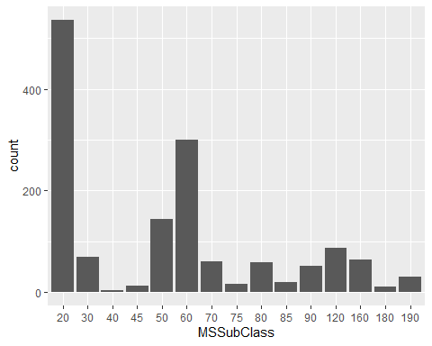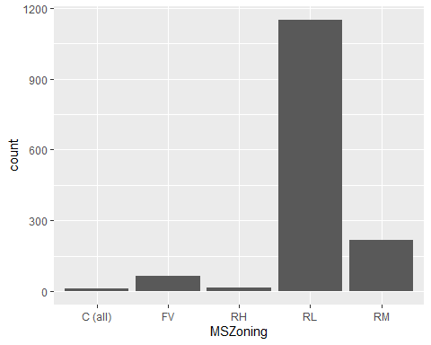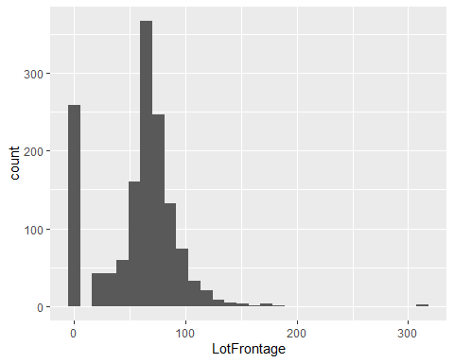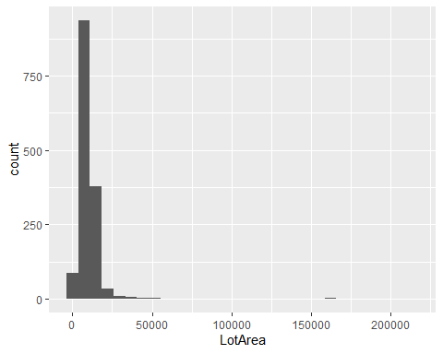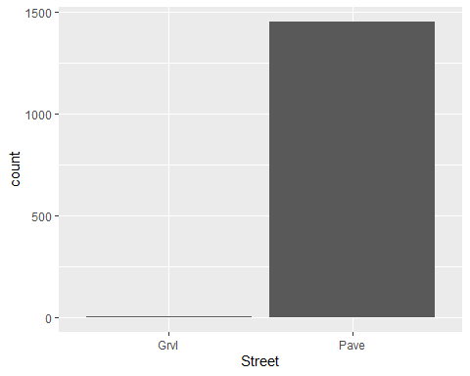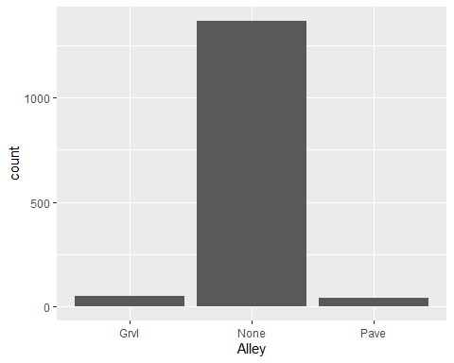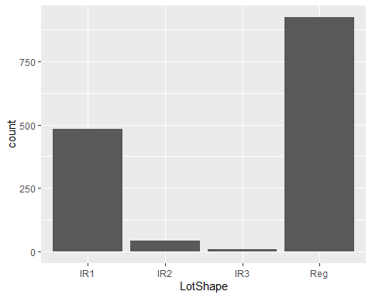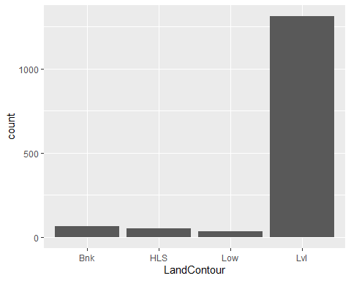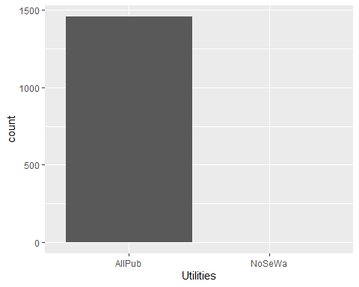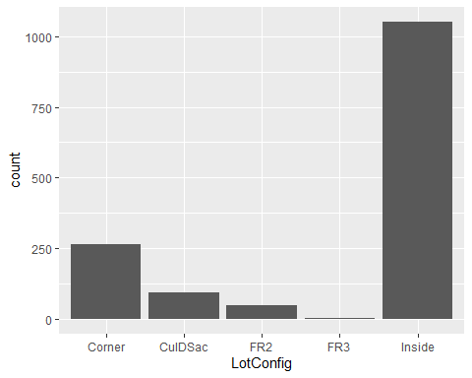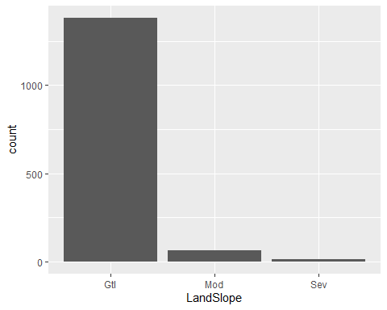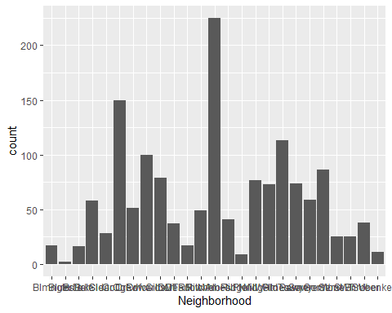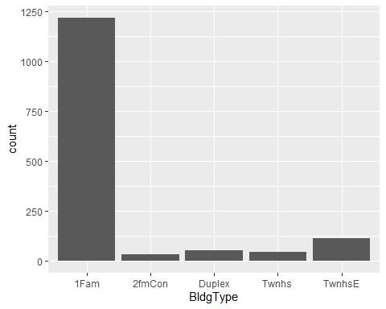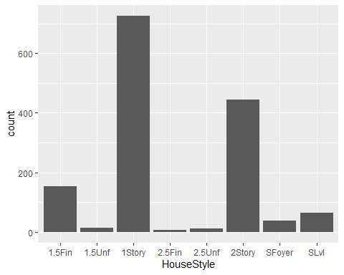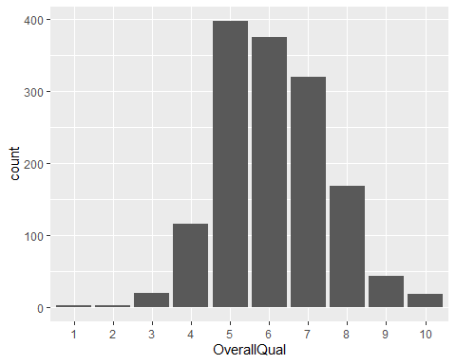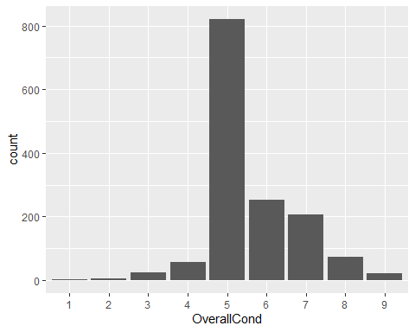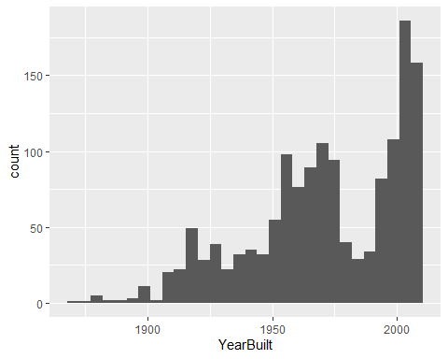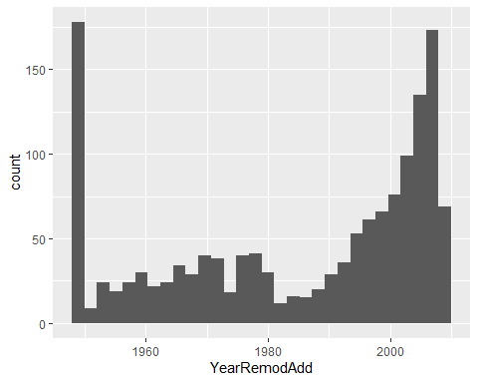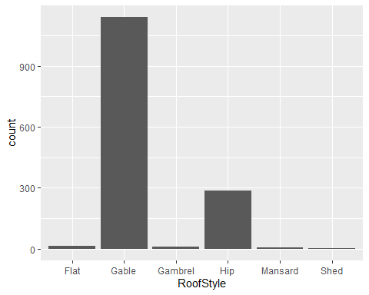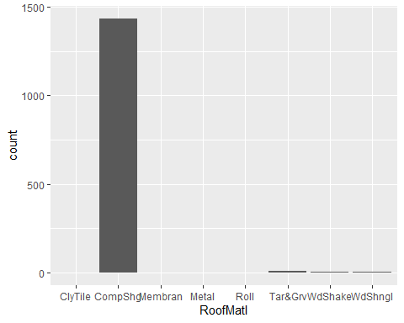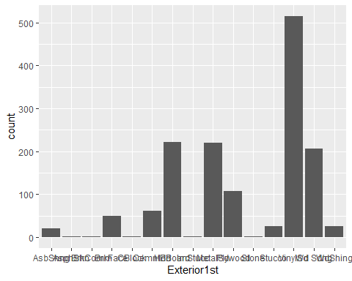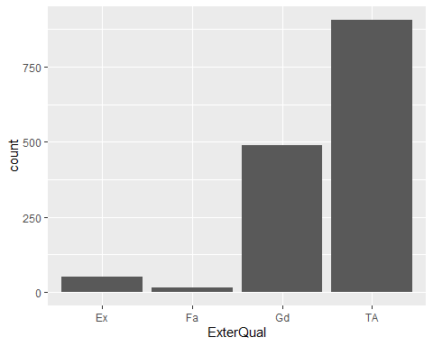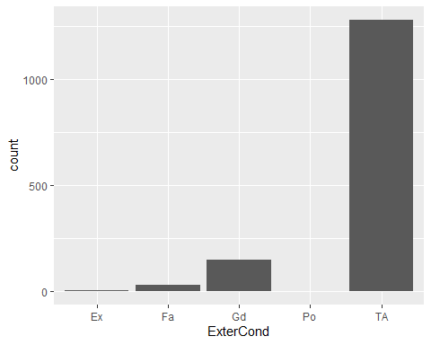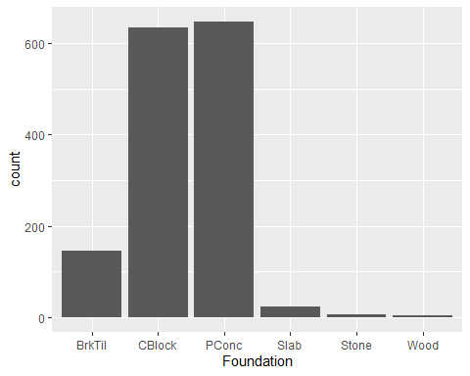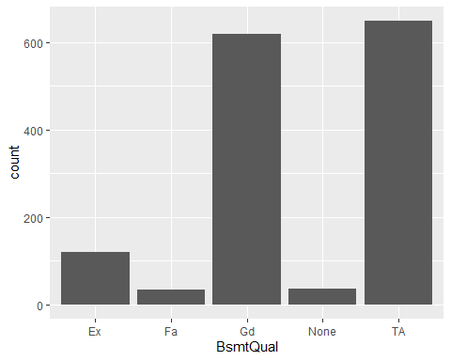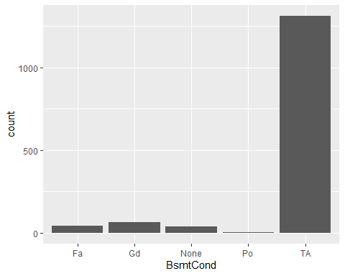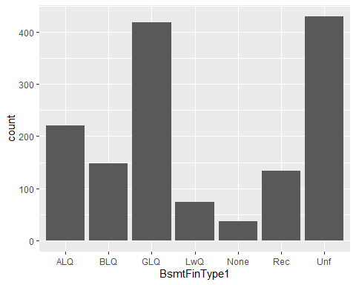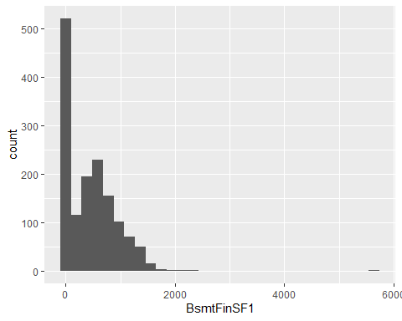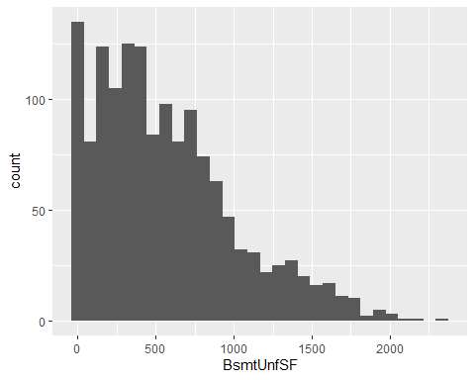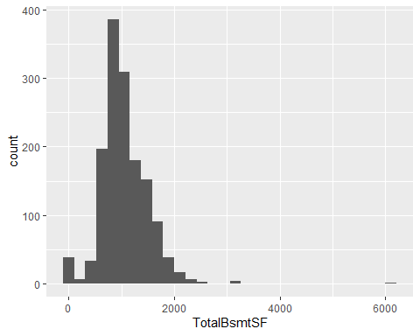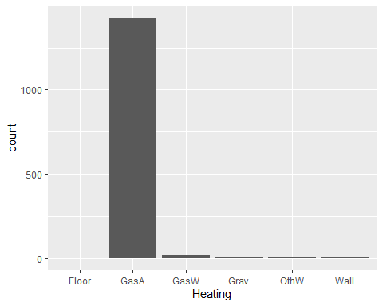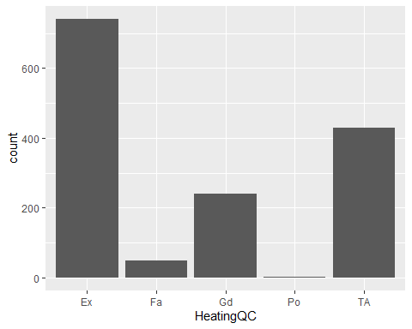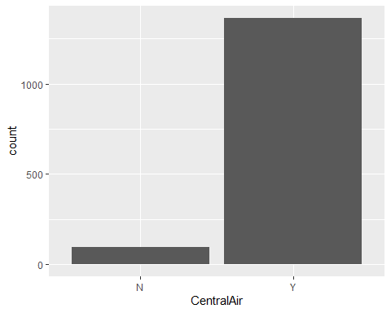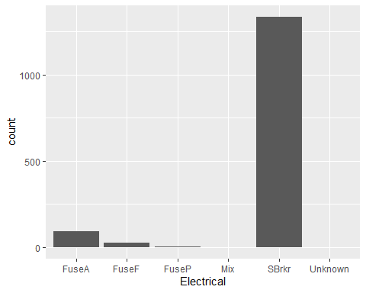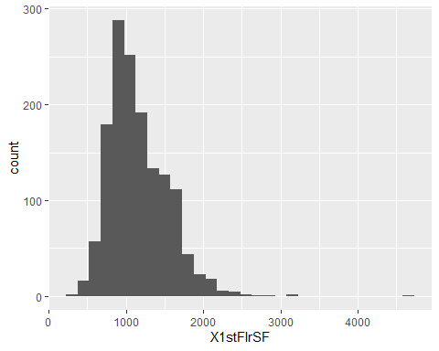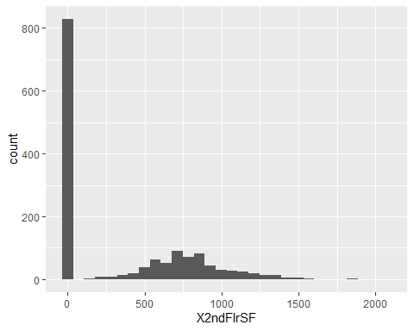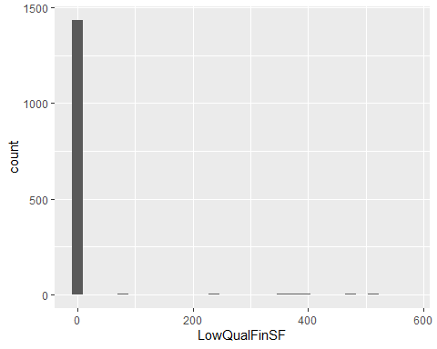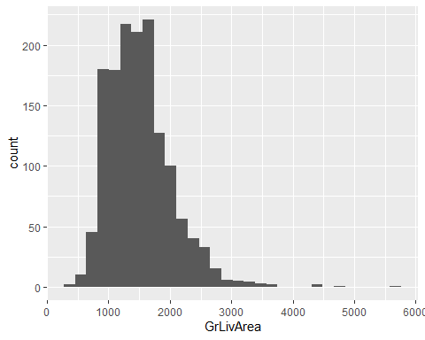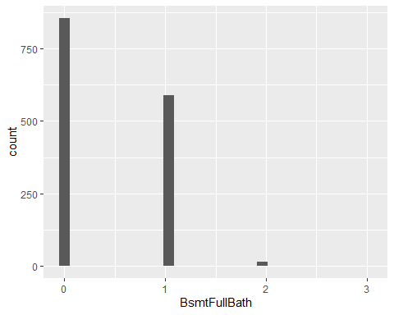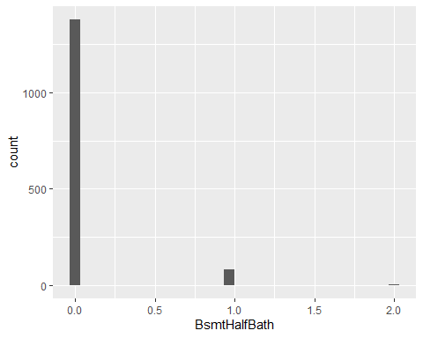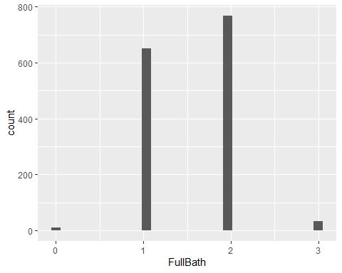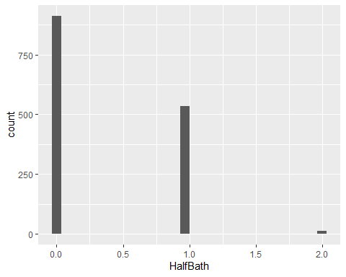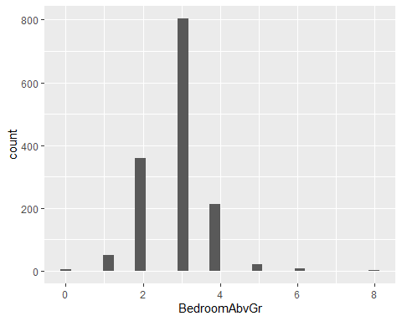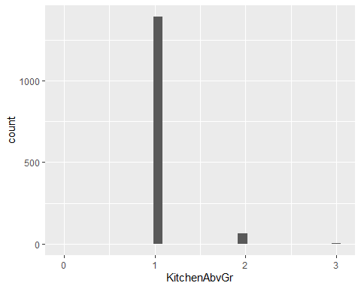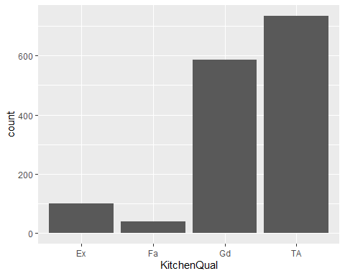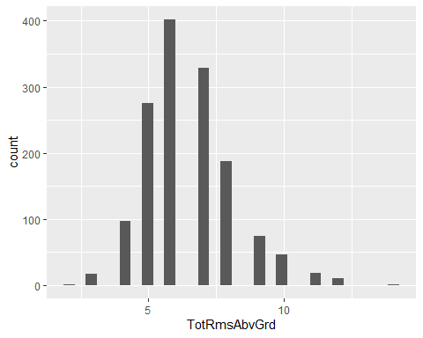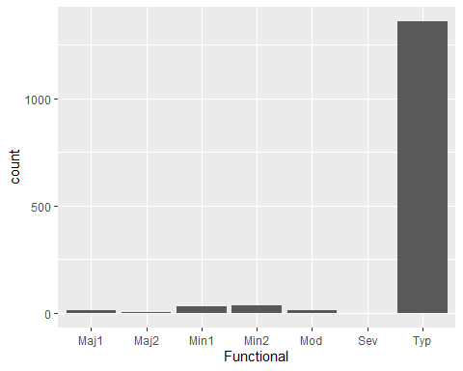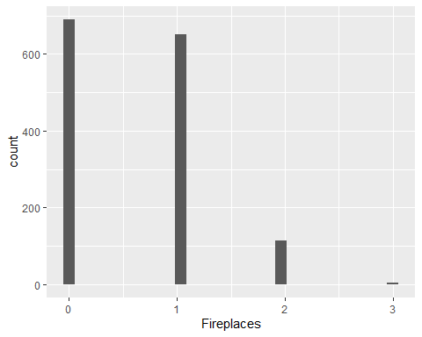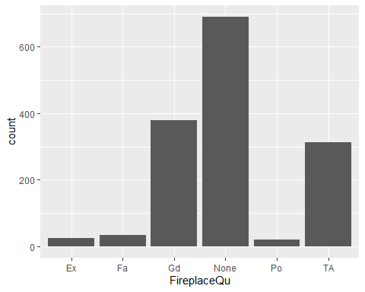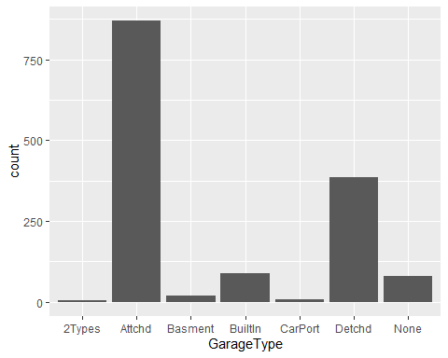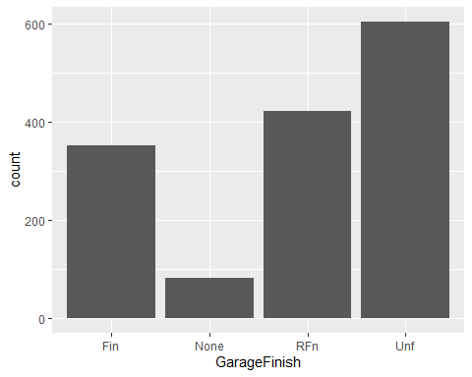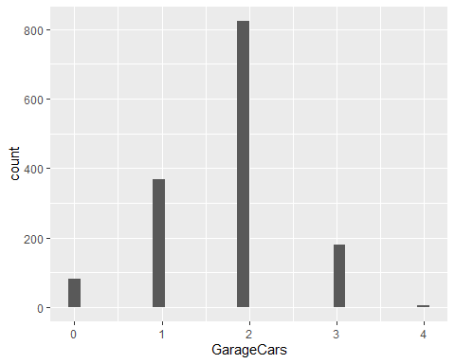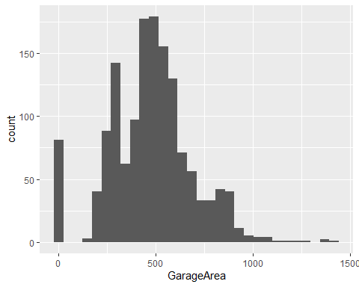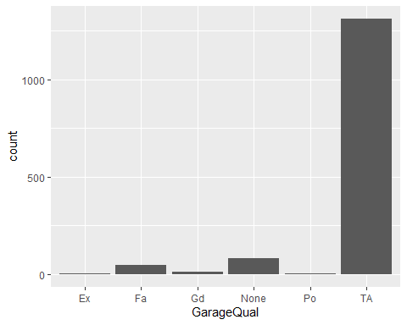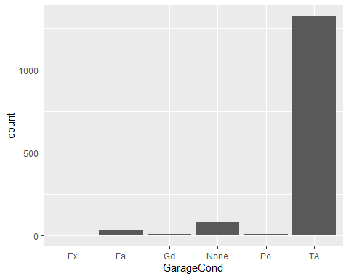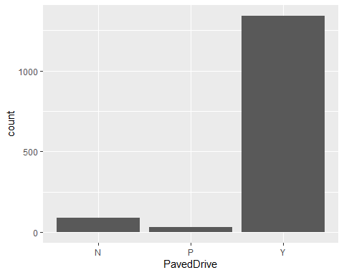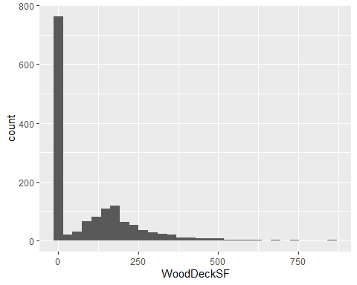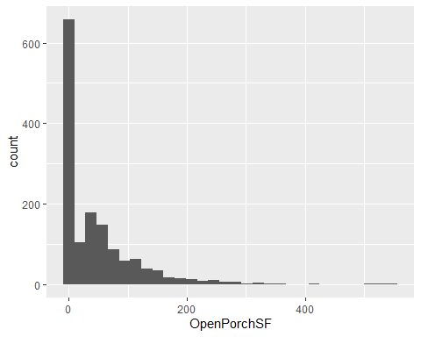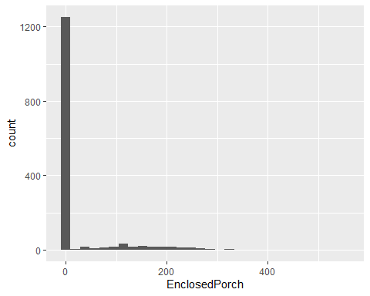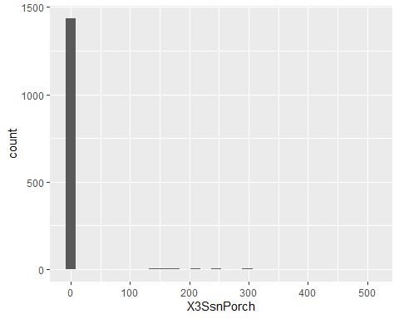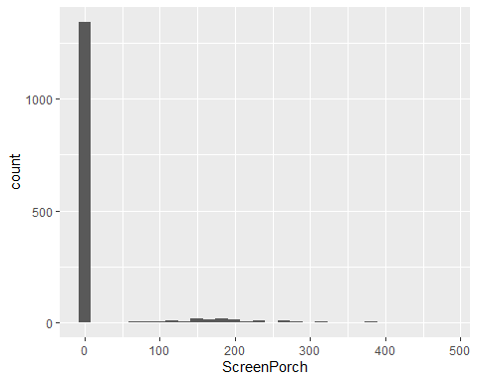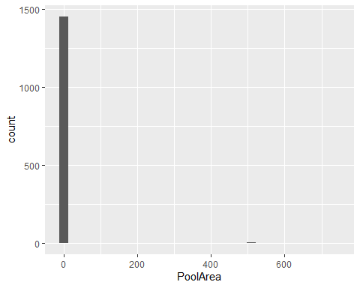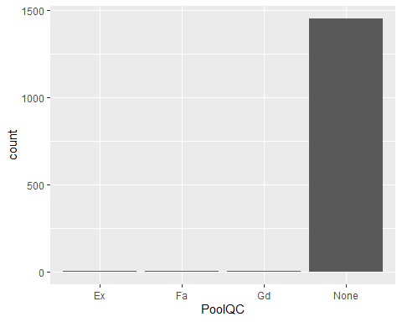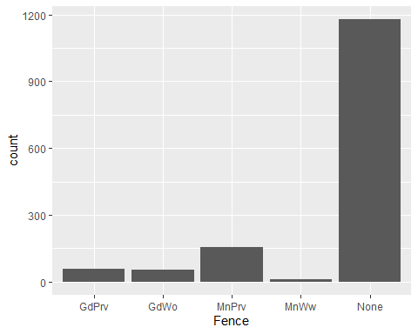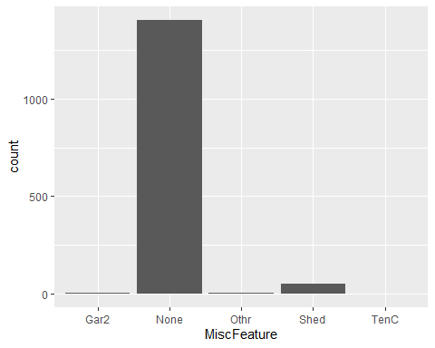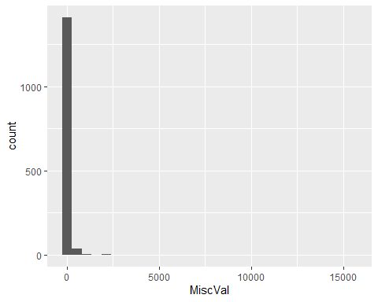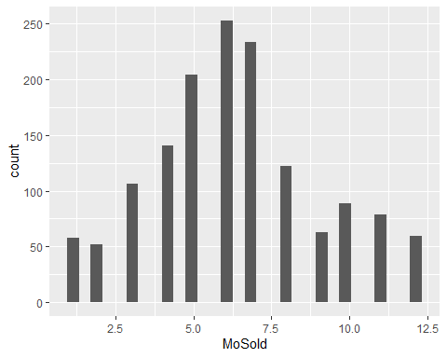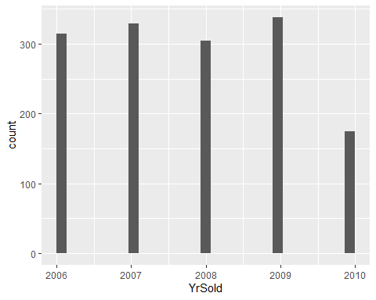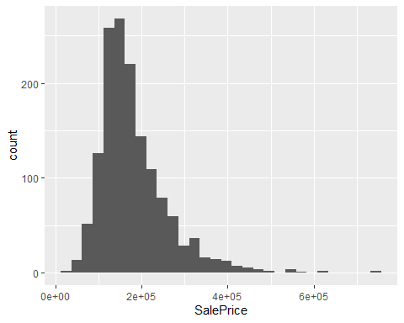

# Primary Method - Random Forests

mean(dat$SalePrice)

## [1] 180921.2

median(dat$SalePrice)

## [1] 163000

sd(dat$SalePrice)

## [1] 79442.5

set.seed(1234567890)  
  
n <- nrow(dat)  
  
tv.split <- sample(rep(0:1, c(round(n*.3),n-2*round(n*.15))),n)  
  
dat.train <- dat[tv.split==1,]  
  
dat.valid <- dat[tv.split==0,]  
  
housing.randomForest <- randomForest(formula = SalePrice ~ ., data = dat)  
  
housing.randomForest

##   
## Call:  
## randomForest(formula = SalePrice ~ ., data = dat)   
## Type of random forest: regression  
## Number of trees: 500  
## No. of variables tried at each split: 22  
##   
## Mean of squared residuals: 749248979  
## % Var explained: 88.12

tibble(`Out of Bag Error` = sqrt(housing.randomForest$mse),  
 ntrees = 1:housing.randomForest$ntree) %>%  
 gather(Grouping, RMSE, -ntrees) %>%  
 ggplot(aes(ntrees, RMSE)) +  
 geom_line() +  
 scale_y_continuous(labels = scales::dollar) +  
 xlab("Number of trees") + ggtitle("OOB RMSE, Basic Implementation")

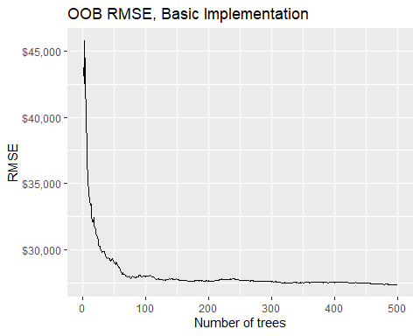

variable.Importance.Basic <- data.frame(housing.randomForest$importance) %>%  
 arrange(desc(IncNodePurity)) %>%  
 top_n(10)

## Selecting by IncNodePurity

(ggplot(data = variable.Importance.Basic,  
 aes(x = reorder(row.names(variable.Importance.Basic), IncNodePurity), y = IncNodePurity))  
 + geom_col() + coord_flip() + labs(title="Top 10 Important Variables, Basic Implementation",  
 x = "Predictor Variable", y = "Node Purity Increase"))

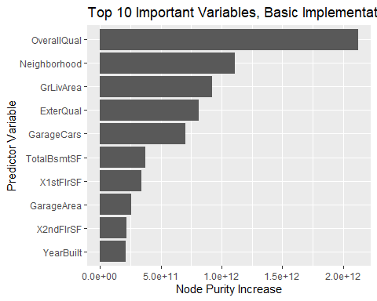

minErrorTreesBasic <- which.min(housing.randomForest$mse)  
  
minErrorTreesBasic

## [1] 491

minErrorValueBasic <- sqrt(housing.randomForest$mse[which.min(housing.randomForest$mse)])  
  
minErrorValueBasic

## [1] 27352.79

meanErrorValueBasic <- sqrt(mean(housing.randomForest$mse))  
  
meanErrorValueBasic

## [1] 28188.17

x.valid <- dat.valid[setdiff(names(dat.valid), "SalePrice")]  
  
y.valid <- dat.valid$SalePrice  
  
mean(y.valid)

## [1] 183505.8

median(y.valid)

## [1] 165250

sd(y.valid)

## [1] 81437.67

randomforest.trained <- randomForest(formula = SalePrice ~ ., data = dat.train)  
  
randomforest.trained

##   
## Call:  
## randomForest(formula = SalePrice ~ ., data = dat.train)   
## Type of random forest: regression  
## Number of trees: 500  
## No. of variables tried at each split: 22  
##   
## Mean of squared residuals: 964919761  
## % Var explained: 84.36

find.RMSPE <- function(true, predicted, df) {  
 return(sqrt(sum((predicted - true)^2)/nrow(df)))  
}  
  
predictions.valid <- predict(randomforest.trained, dat.valid)  
  
tibble(`Out of Bag Error` = sqrt(randomforest.trained$mse),  
 ntrees = 1:randomforest.trained$ntree) %>%  
 gather(Grouping, RMSE, -ntrees) %>%  
 ggplot(aes(ntrees, RMSE)) +  
 geom_line() +  
 scale_y_continuous(labels = scales::dollar) +  
 xlab("Number of trees") + ggtitle("OOB RMSE, Manual Validation")

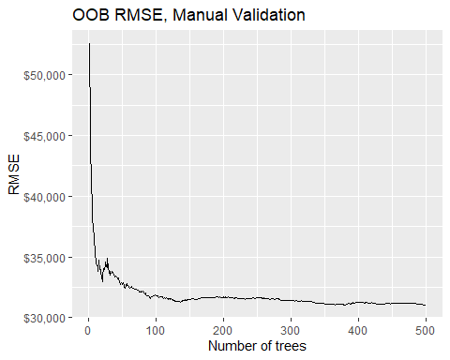

variable.Importance.trained <- data.frame(randomforest.trained$importance) %>%  
 arrange(desc(IncNodePurity)) %>%  
 top_n(10)

## Selecting by IncNodePurity

(ggplot(data = variable.Importance.trained,  
 aes(x = reorder(row.names(variable.Importance.trained), IncNodePurity), y = IncNodePurity))  
 + geom_col() + coord_flip() + labs(title="Top 10 Important Variables, Manual Validation",  
 x = "Predictor Variable", y = "Node Purity Increase"))

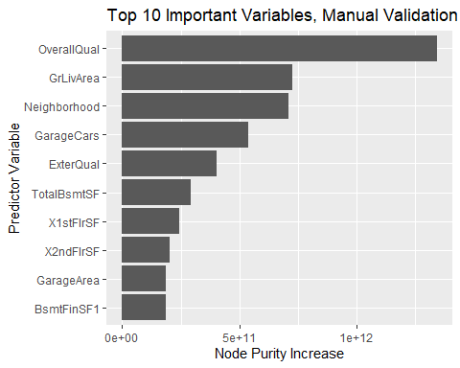

minErrorTreesTrained <- which.min(randomforest.trained$mse)  
  
minErrorTreesTrained

## [1] 497

minErrorValueTrained <- sqrt(randomforest.trained$mse[which.min(randomforest.trained$mse)])  
  
minErrorValueTrained

## [1] 31038.16

meanErrorValueTrained <- sqrt(mean(randomforest.trained$mse))  
  
meanErrorValueTrained

## [1] 31868.77

RMSPE <- find.RMSPE(dat.valid$SalePrice, predictions.valid, dat.valid)  
  
RMSPE

## [1] 25529.17

randomforest.validated <- randomForest(formula = SalePrice ~ ., data = dat.train,  
 xtest = x.valid, ytest = y.valid)  
  
randomforest.validated

##   
## Call:  
## randomForest(formula = SalePrice ~ ., data = dat.train, xtest = x.valid, ytest = y.valid)   
## Type of random forest: regression  
## Number of trees: 500  
## No. of variables tried at each split: 22  
##   
## Mean of squared residuals: 952389999  
## % Var explained: 84.56  
## Test set MSE: 660213523  
## % Var explained: 90.04

minErrorTreesOOB <- which.min(randomforest.validated$mse)  
  
minErrorTreesOOB

## [1] 436

minErrorValueOOB <- sqrt(randomforest.validated$mse[which.min(randomforest.validated$mse)])  
  
minErrorValueOOB

## [1] 30792.35

meanErrorValueTrained <- sqrt(mean(randomforest.validated$mse))  
  
meanErrorValueTrained

## [1] 32012.26

minErrorTreesValidation <- which.min(randomforest.validated$test$mse)  
  
minErrorTreesValidation

## [1] 466

minErrorValueValidation <- sqrt(randomforest.validated$test$mse[which.min(randomforest.validated$test$mse)])  
  
minErrorValueValidation

## [1] 25625.55

meanErrorValueValidation <- sqrt(mean(randomforest.validated$test$mse))  
  
meanErrorValueValidation

## [1] 26246.8

tibble(`Out of Bag Error` = sqrt(randomforest.validated$mse),  
 `Validation Error` = sqrt(randomforest.validated$test$mse),  
 ntrees = 1:randomforest.validated$ntree) %>%  
 gather(Grouping, RMSE, -ntrees) %>%  
 ggplot(aes(ntrees, RMSE, color = Grouping)) +  
 geom_line() +  
 scale_y_continuous(labels = scales::dollar) +  
 xlab("Number of trees") + ggtitle("OOB and Validation RMSE, Specified Validation Set")

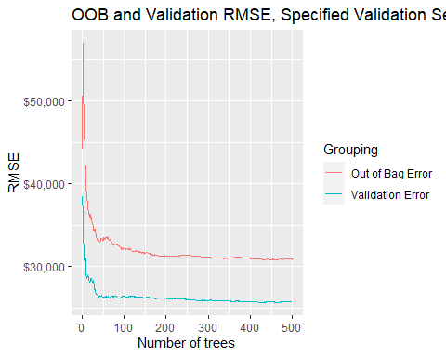

variable.Importance.validated <- data.frame(randomforest.validated$importance) %>%  
 arrange(desc(IncNodePurity)) %>%  
 top_n(10)

## Selecting by IncNodePurity

(ggplot(data = variable.Importance.validated,  
 aes(x = reorder(row.names(variable.Importance.validated), IncNodePurity), y = IncNodePurity))  
 + geom_col() + coord_flip() + labs(title="Top 10 Important Variables, Specified Validation Set",  
 x = "Predictor Variable", y = "Node Purity Increase"))

