

CUSTOMER RETENTION

Submitted by:

SIMRAN KUMARI

**ACKNOWLEDGMENT**

I would like to thank every one who helped me during the making of the projects.

The help was provided by:

1. Data Trained faculty

2. Shubham Yadav

References include

1. Scikit-learn.org

2. Kaggle.com

3. Github.com

4. Stack-Overflow

5. Learning.datatrained.com

**INTRODUCTION**

* Business Problem Framing

[E-retail factors for customer activation and retention: A case study from Indian e-commerce customers](https://www.researchgate.net/publication/346412647_E-retail_factors_for_customer_activation_and_retention_An_empirical_study_from_Indian_e-commerce_customers)

Customer satisfaction has emerged as one of the most important factors that guarantee the success of online store; it has been posited as a key stimulant of purchase, repurchase intentions and customer loyalty. A comprehensive review of the literature, theories and models have been carried out to propose the models for customer activation and customer retention. Five major factors that contributed to the success of an e-commerce store have been identified as: service quality, system quality, information quality, trust and net benefit. The research furthermore investigated the factors that influence the online customers repeat purchase intention. The combination of both utilitarian value and hedonistic values are needed to affect the repeat purchase intention (loyalty) positively. The data is collected from the Indian online shoppers. Results indicate the e-retail success factors, which are very much critical for customer satisfaction.

Be careful: There are two sheets (one is detailed) and second is encoded in the excel file. You may use any of them by extracting in separate excel sheet. The number of column(s) is more than 47. Read the column header carefully.

Note : Data Scientists have to apply their analytical skills to give findings and conclusions in detailed data analysis written in jupyter notebook . Only data analysis is required.

* Conceptual Background of the Domain Problem

E-Commerce implementation studies are always related to e-Commerce adoption. Adoption of e-Commerce within organization is growing by numbers continuously. However, as organizations grow over time, e-Commerce becomes more complex and challenging. This is mainly due to organizations insights of e-Commerce as part of their constrained costs rather than an opportunity for growth. Cost in general is not a main barrier for organizations to implement ecommerce, but, the relative advantage for the organizations is critical role in adoption decision. Moreover, organizations fail to identify the change in organization and management structure that may be required due to e-Commerce implementation as they do not usually incorporate any e-Commerce strategy that would permit them for effective ecommerce implementation. In enabling the success of the whole e-Commerce implementation, the process in implementation cannot be divided. Additionally, they suggest a more up-to-date and comprehensive representation of the implementation process. This representation would view the entire implementation as a holistic system, rather than breaking it into components. Therefore, there is a need for insights of ecommerce implementation studies for the organizations within business firms to understand the current research. In achieving this, we intended to do systematic review with evidence-based (i.e., from data of previous studies) for uncover the insight of e-Commerce implementation area.

**Analytical Problem Framing**

.

* Data Sources and their formats
* The data has column names with digits in it which should be removed for better data representation.
* There are 269 rows and 71 columns in the data.
* All the columns are of object datatype except for pincode column which is of int type.
* There are no null values is the dataset.
* All the columns are of categorical types. There are no identifier or constant columns
* Hardware and Software Requirements and Tools Used

Listing down the hardware and software requirements along with the tools, libraries and packages used. Describe all the software tools used along with a detailed description of tasks done with those tools.

**Model/s Development and Evaluation**

* Visualizations

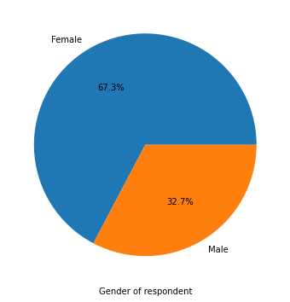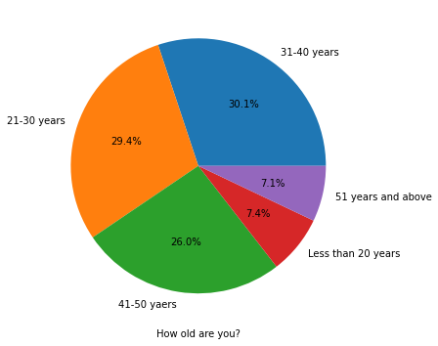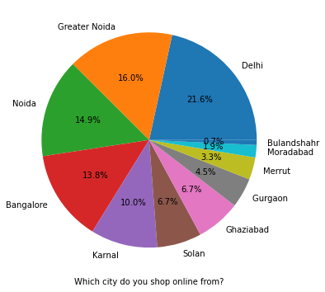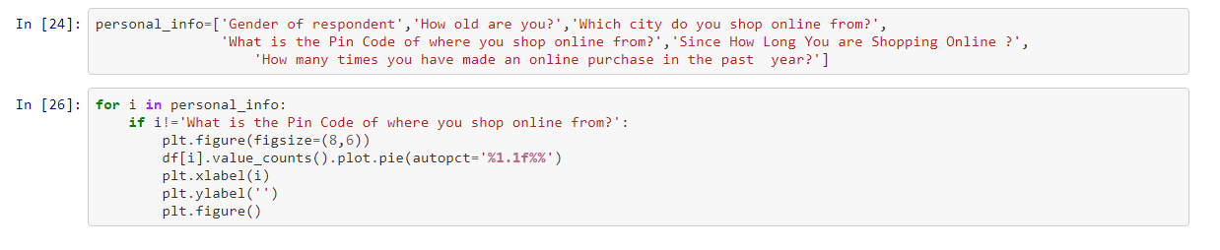

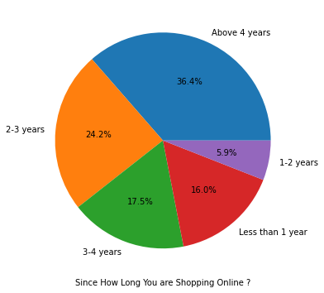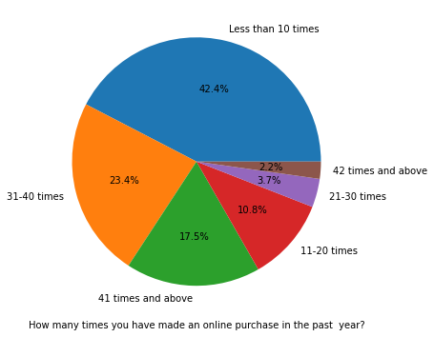

* There is double the number of women than men who have taken this survey.
* Most of the people are in their 30's followed by 20's, teenagers and senior citizen are the least in number.
* Most of the people belong from delhi, noida and banglore, ambiguity can also be seen as noida has two categories (noida and grater noida) which need to be handled.
* Most of the people shopping online have been shopping from a long time.
* Majority of people shop online 10 times a year, ambiguity can also be seen for range 42 times and above which needs to be handled

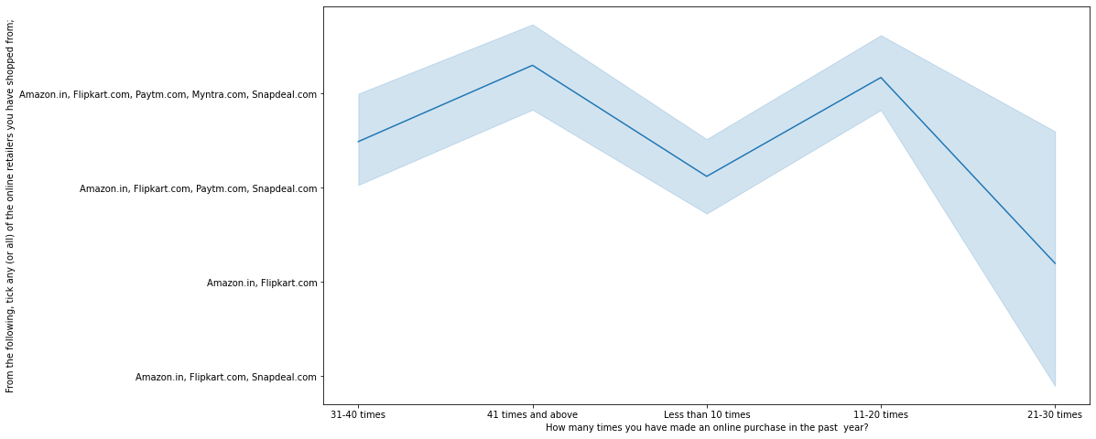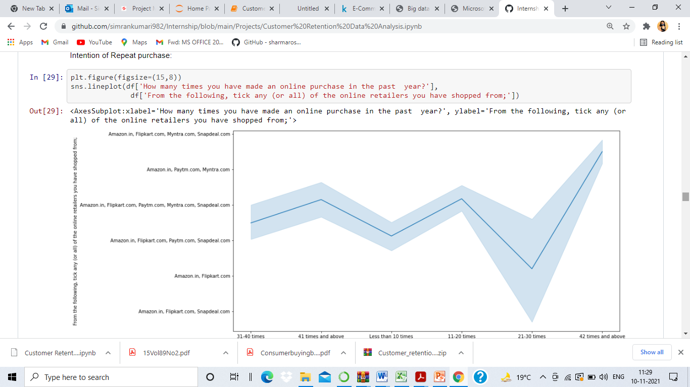

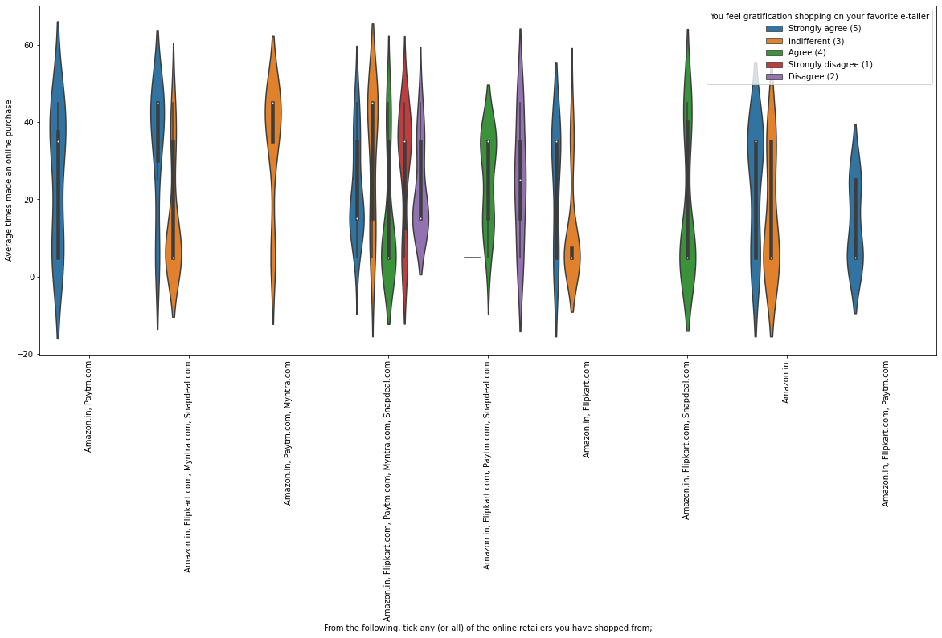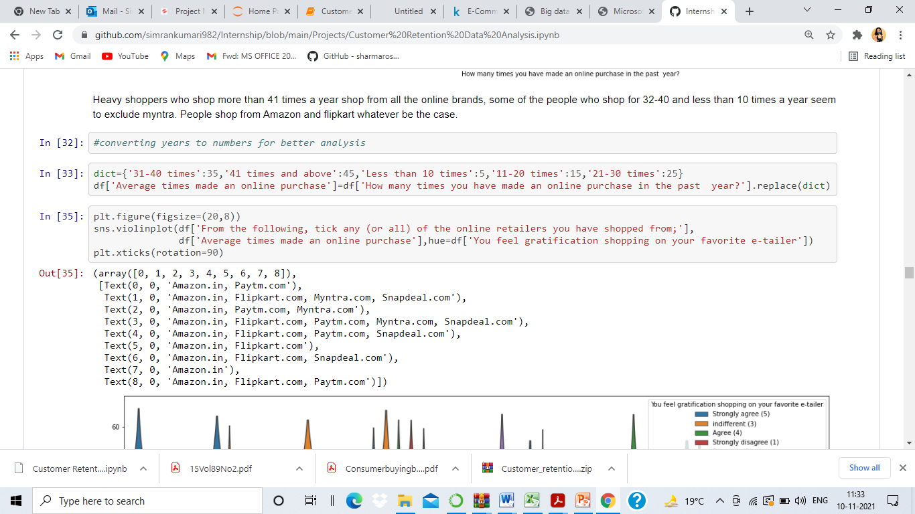Heavy shoppers who shop more than 41 times a year shop from all the online brands, some of the people who shop for 32-40 and less than 10 times a year seem to exclude Myntra. People shop from Amazon and Flipkart whatever be the case.

Almost all the people who have shopped from amazon, flipkart and paytm are satisfied. People who shop from a more number of online brands dosen’t seem to be satisfied.

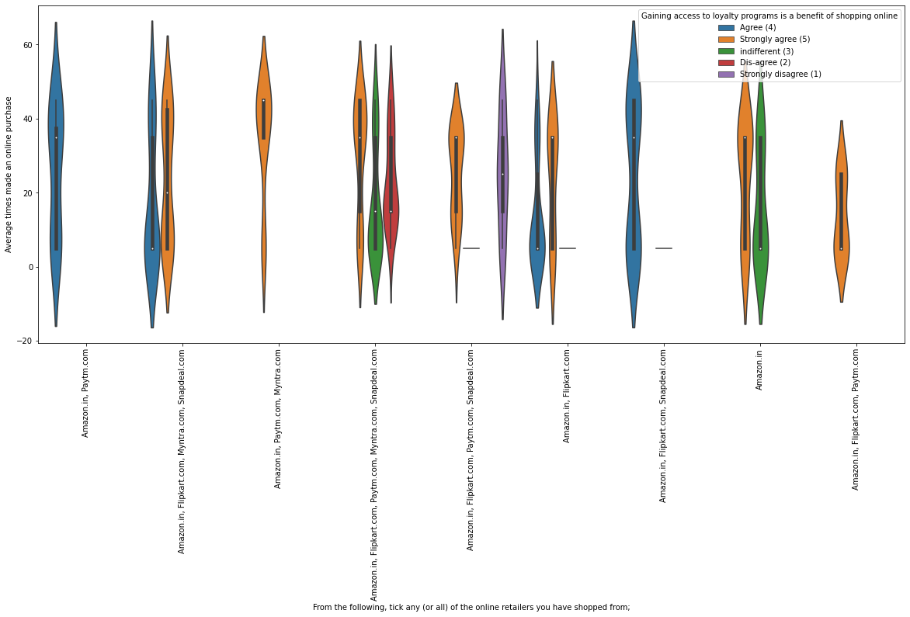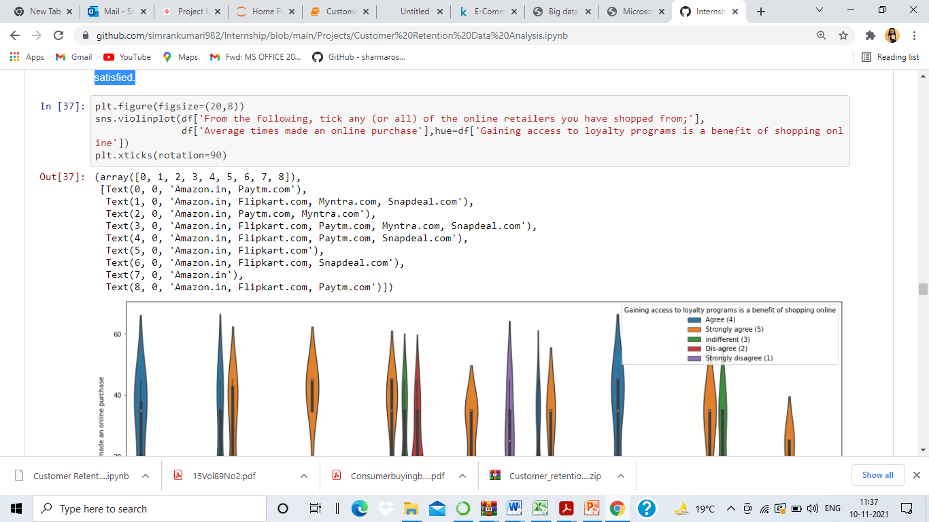

People shopping from amazon and paytm are getting benefits from the loyalty points, flipkart and sanpdeal also seem to give such benefits but people who shop from almost everywhere disagree with this statement too.

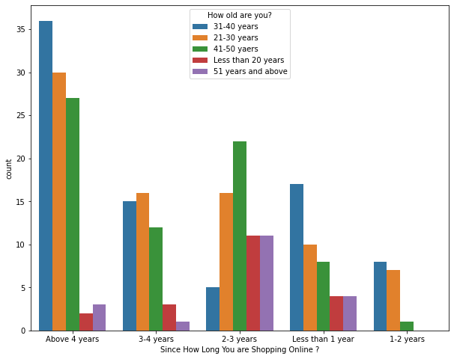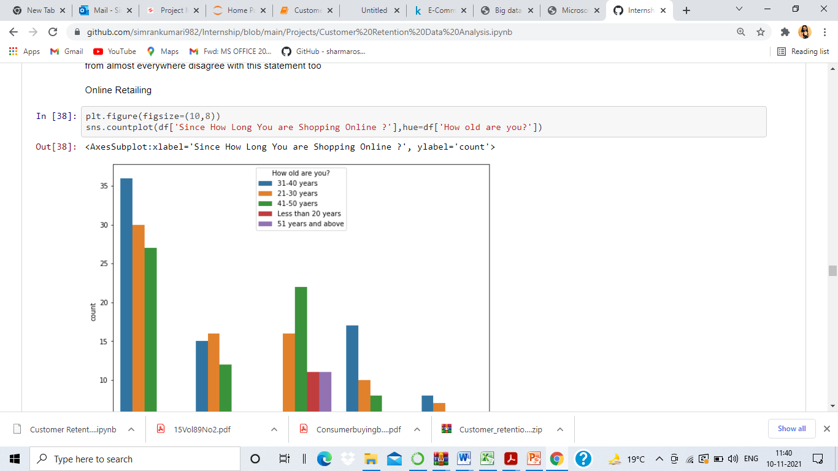

Highest number of people have been shopping online for above 4 years except for the age group below 20 years and above 50 years. People who are shopping online for 1-2 years does not include teenagers and elder people

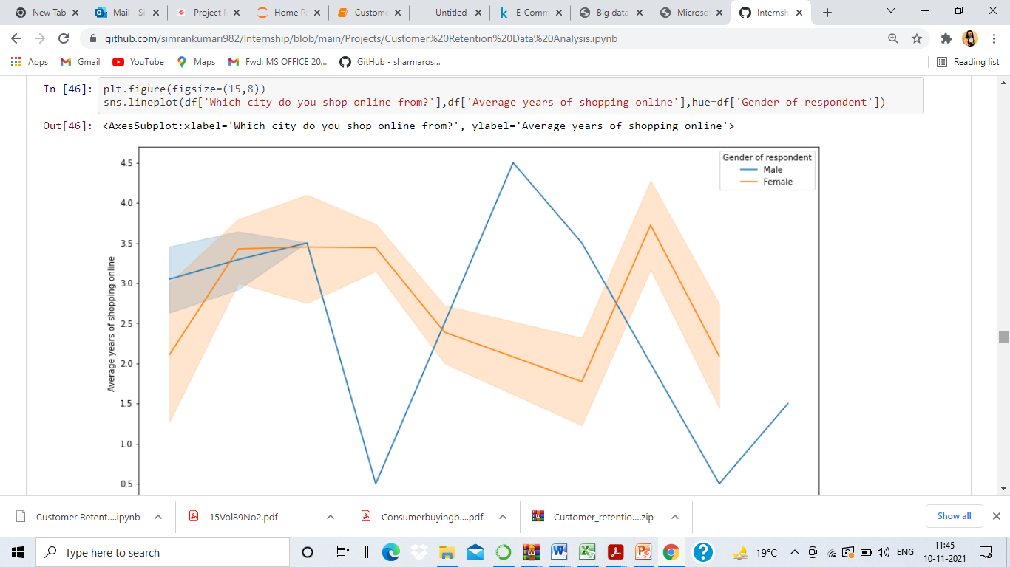

In lines, we can see that density of female customers is more than male. Men living in banglore and ghaziabad shop have shopped online for less than 1 year. Highest number of men shopping online belong from delhi and noida, while men from moradabad have been shopping online for the longest. Women from meerut and noida have shopped the longest

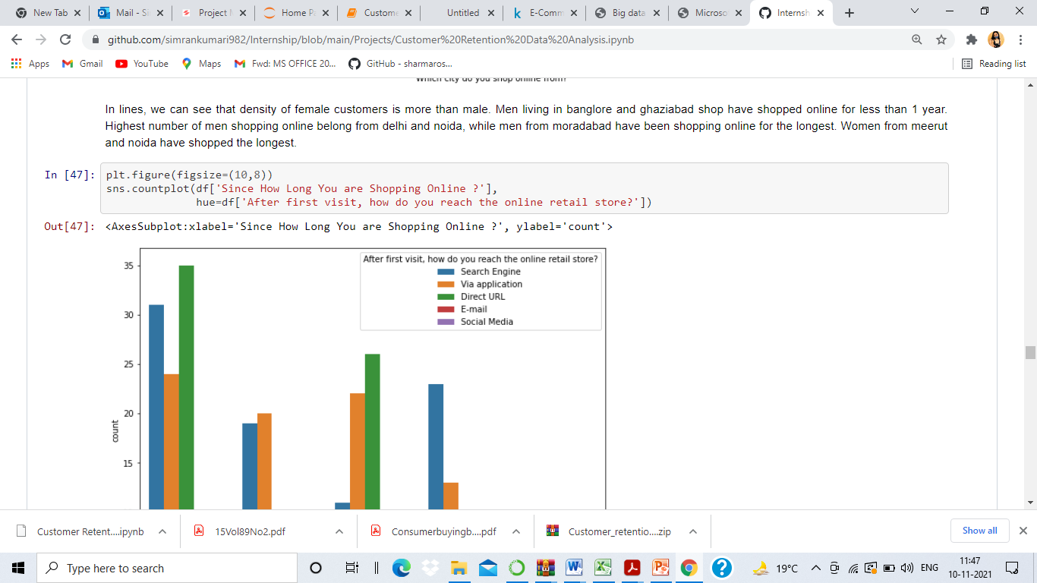

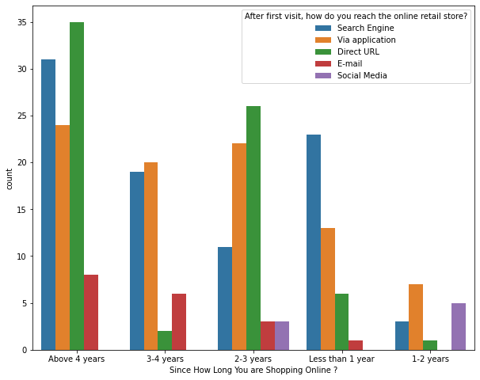

* Even though people who are shopping online for more than 3 years do not use the application rather use search engine and direct url's in large number which indicates that online brands should update all their platforms rather than just application.

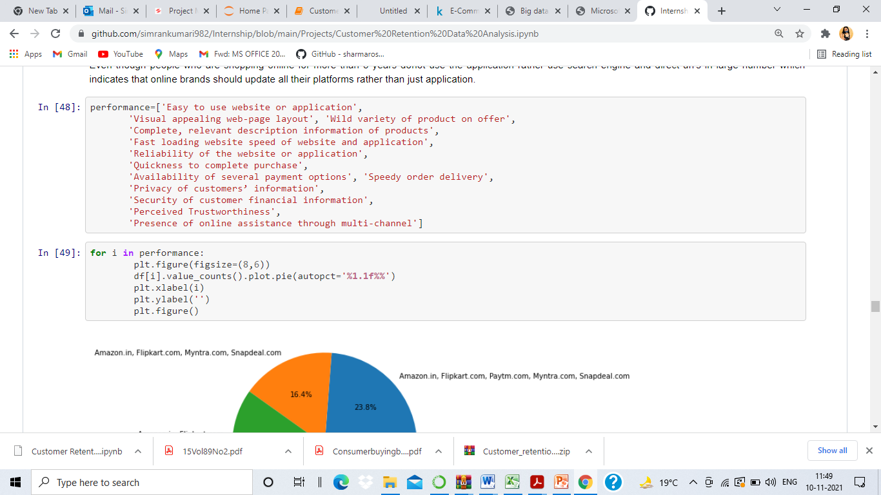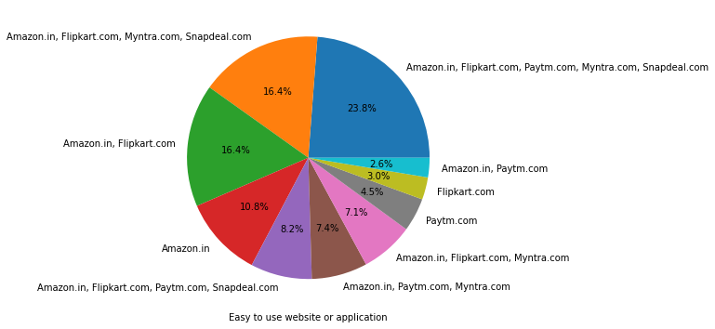

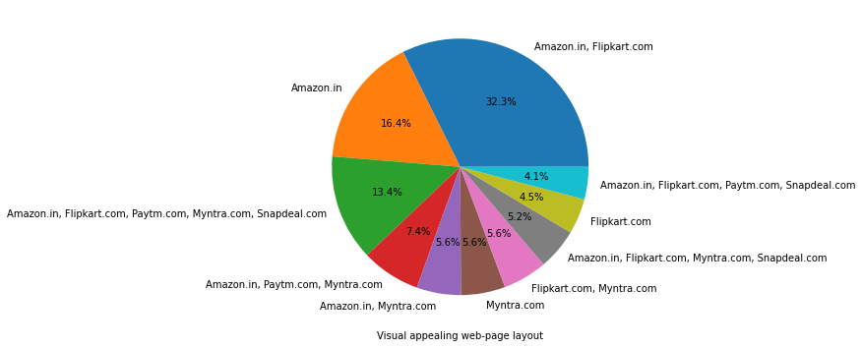

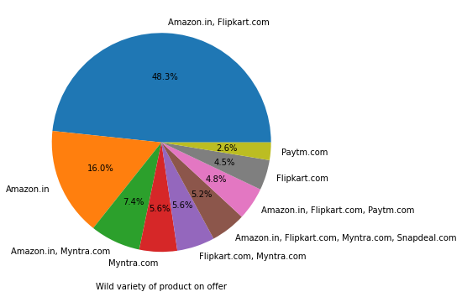

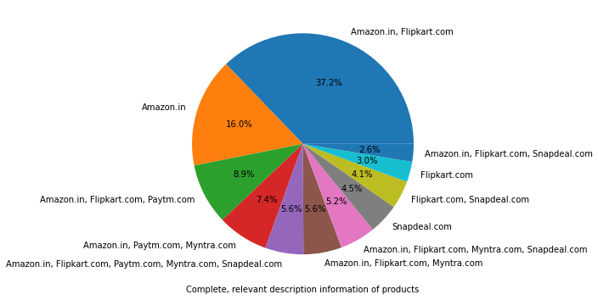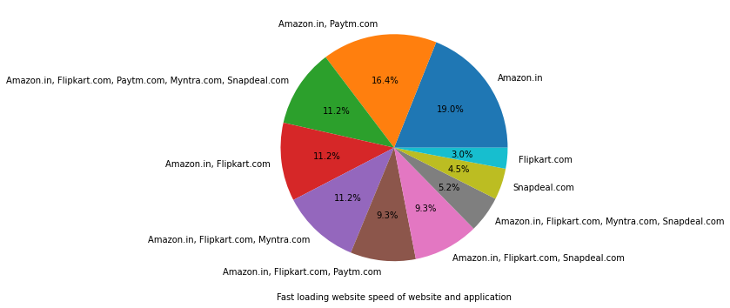

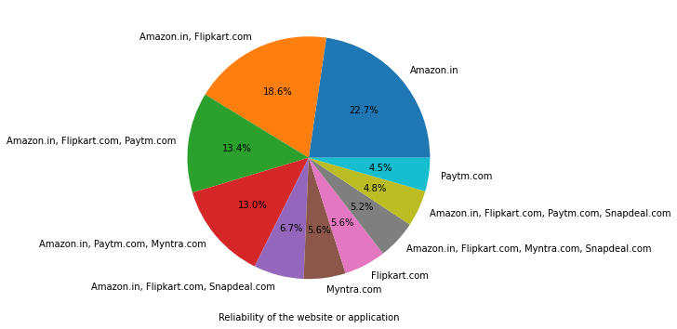

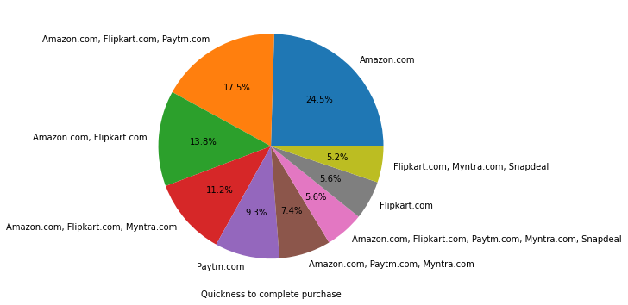

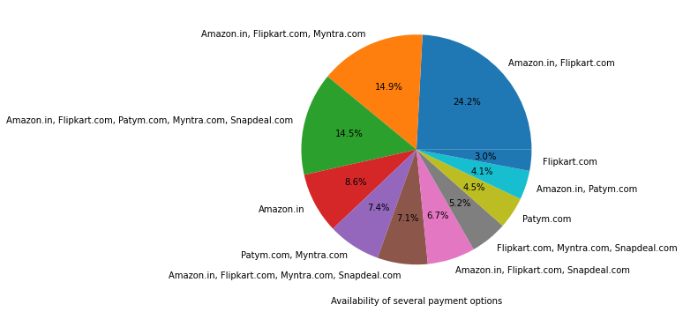

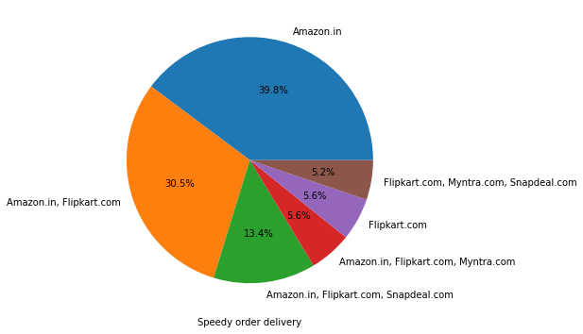

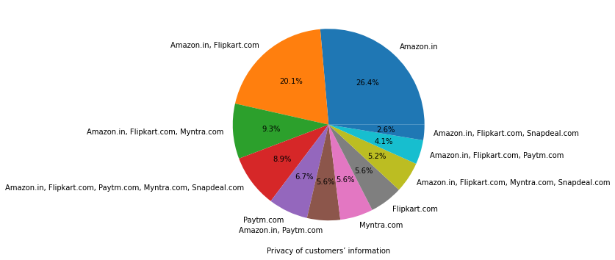

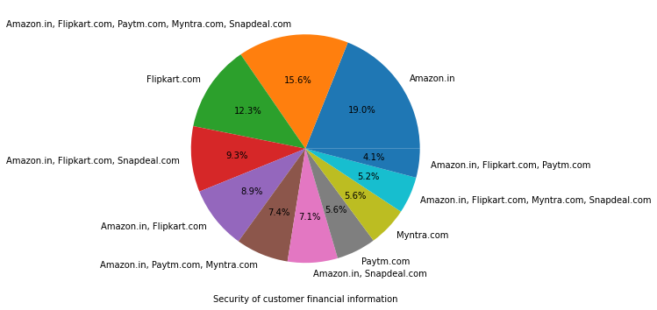

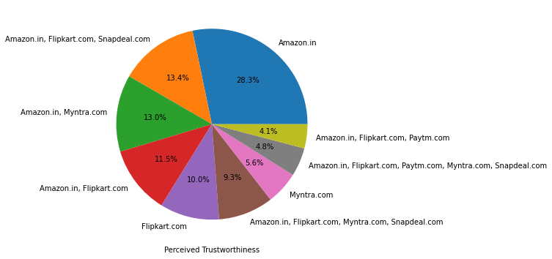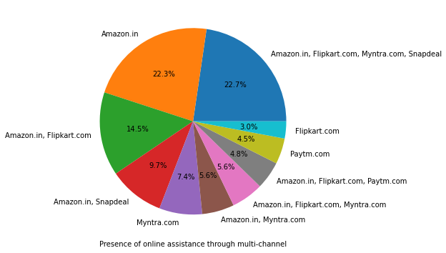

Amazon, Flipkart have been had the highest votes for having all the positive points and have maintained a very good brand image followed by paytm and the myntra

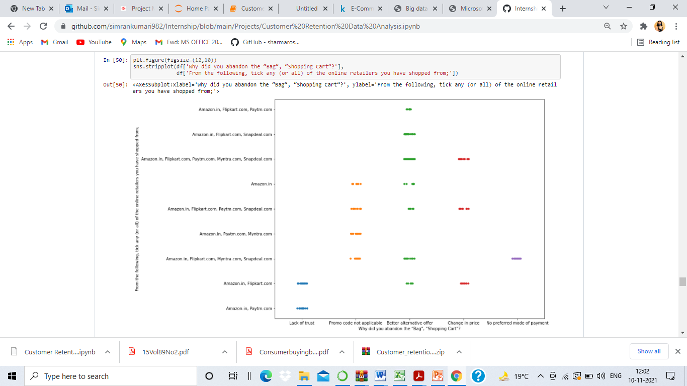

We can clearly see that most of the time people abandon the bag is beacuse they get a better alternative offer or promo code not applicable. There is also lack of trust seen in amazon, flipkart and paytm by some people.

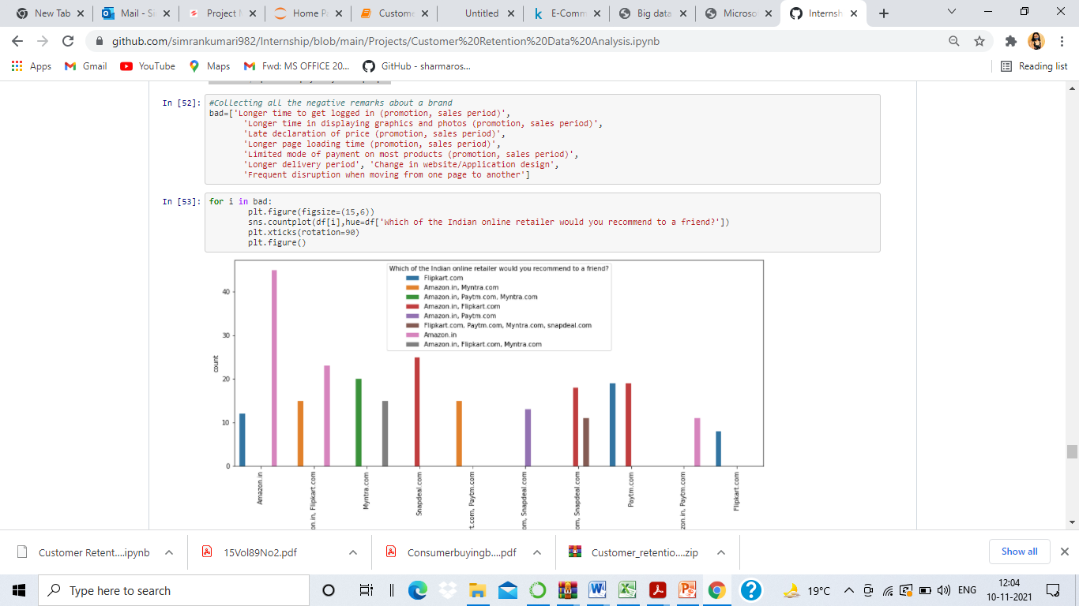

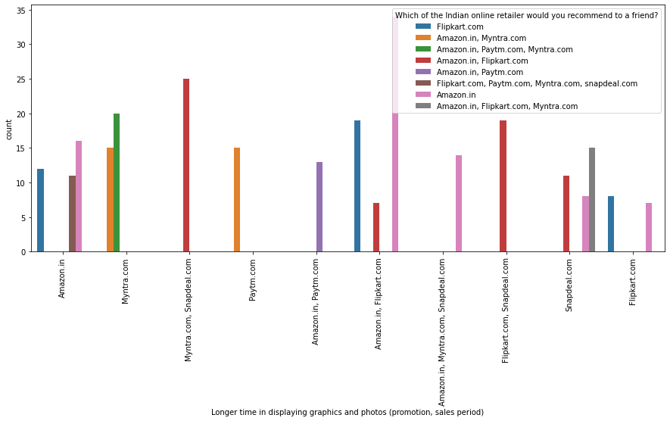

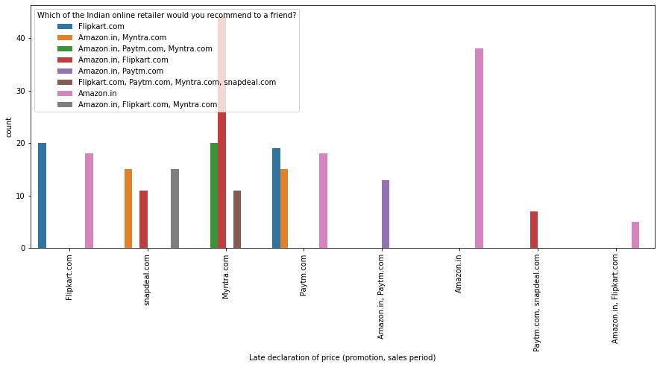

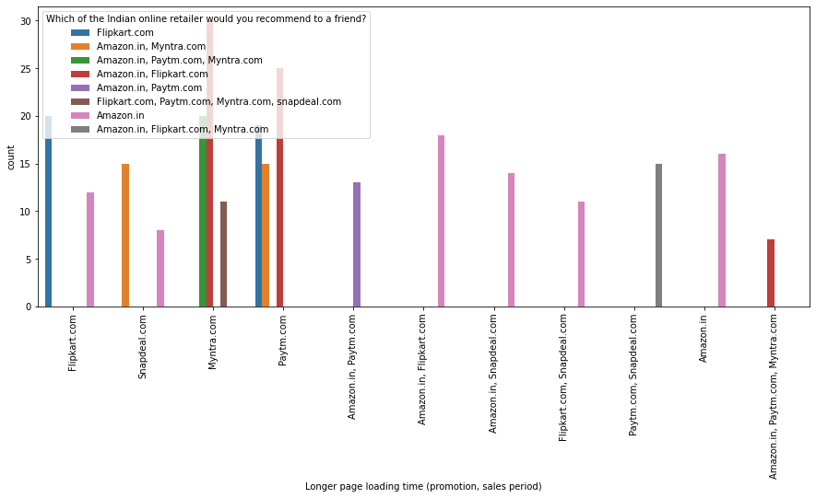

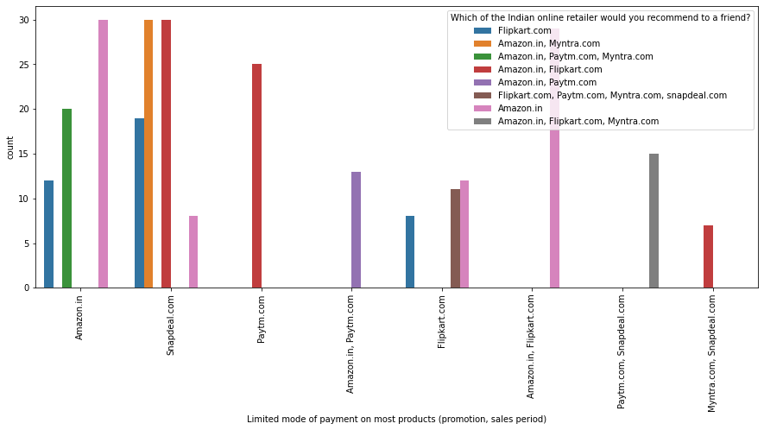

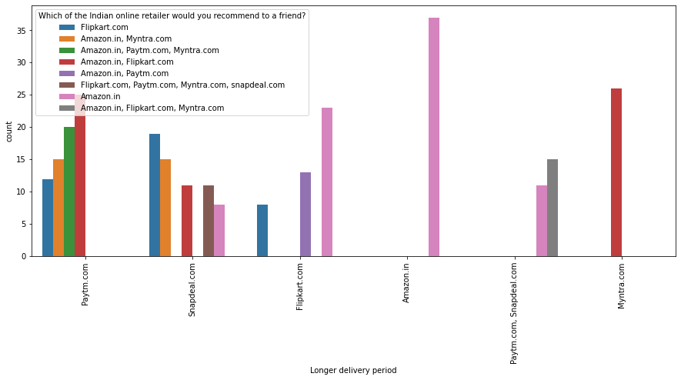

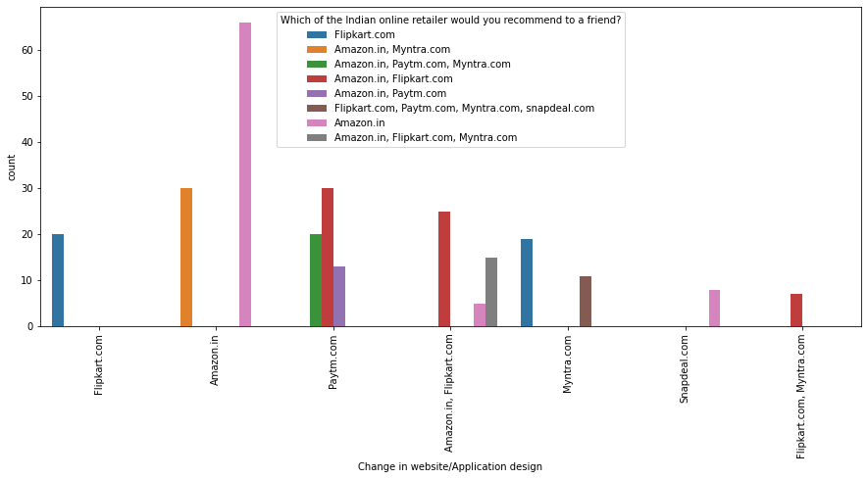

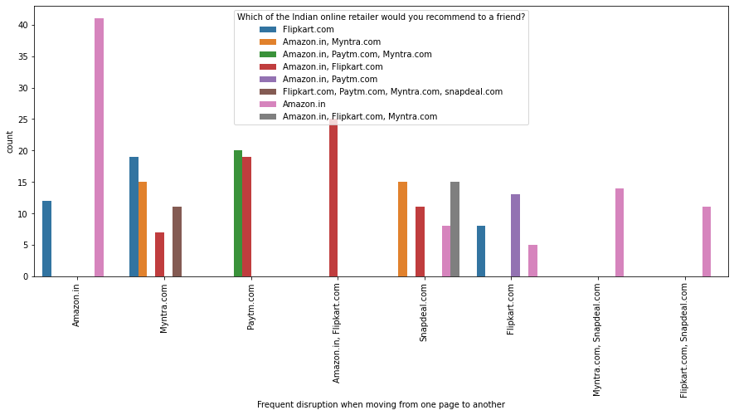

Customers seem to be more loyal to amazon, flipkart and paytm as even though many of them have given negative remarks about them still they would recommend these platforms to their friend

**CONCLUSION**

The results of this study suggest following outputs which might be useful for E-commerce websites to extend their business

The cost of the product, the reliability of the E-commerce company and the return policies all play an equally important role in deciding the buying behavior of online customers. The cost is an important factor as it was the basic criteria used by online retailers to attract customers. The reliability of the E-commerce company is also important, as it is even required in offline retail. It is important because customers are paying online, so they need to be sure of security of the online transaction. The return policies are important because in online retail customer does not get to feel the product. Thus, he wants to be sure that it will be possible to return the product if he does not like it in real. Whereas, the logistics factor, which included Cash on delivery option, One day delivery and the quality of packaging plays a secondary role in this process though these are Must-be-quality. This is so because these all does not interfere with the real product and people believe that this is the basic value that E-commerce websites provide.

All the websites were not equally preferred by online customers. Amazon was the most preferred followed by Flip kart. This can be explained easily by previous result that we got. These two companies are most trusted in the industry and hence, have a huge reliability. Also, the sellers listed on these websites are generally from Tier 1 cities as compared to Snapdeal and PayTM which have more sellers from tier 2 and 3 cities. Also, these websites have the most lenient return policies as compared to others and also the time required to process a return is low for these.