|  |  |  |
| --- | --- | --- |
| Index | Colour | Code |
| 1 | Red | A001 |
| 2 | Green | A002 |
| 3 | Blue | A003 |
| 4 | Black | A004 |

Table Name = dtColurs

|  |  |
| --- | --- |
| clrs | Code |
| Red | A001 |
| Green |  |
| Blue |  |
| Black | A004 |

Table Name = dtColurs2

Here we need dtColurs2 table , Code Columns to fill with missing values from the above dtColours table, So a vlookup needs to be performed.

UIPath file - Excel_VLookup.xaml will do the job,

Please add the following Inputs to the Parameters

In_DataTable1 = dtColurs2

In_LookupColumn = Colour

In_DataTable2 = dtColours

In_LookupColumn2 = “Code”

In_SourceColumn = “clrs”

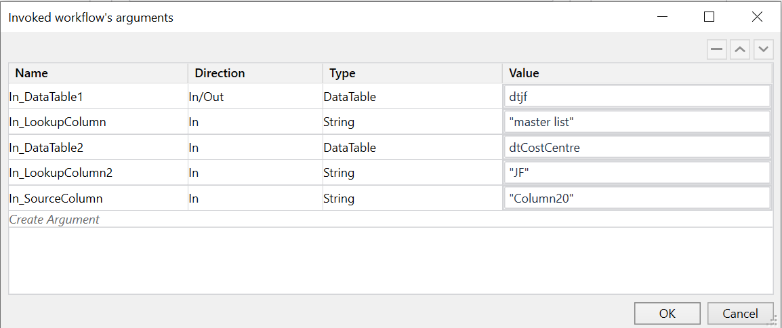

The output will be dtColurs2 which will be filled all the Blanks