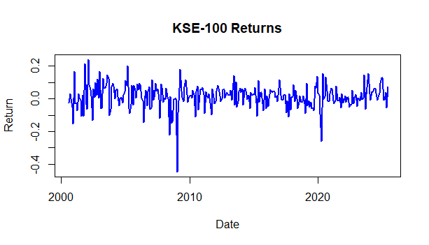

The KSE-100 returns plot clearly illustrates the time-varying nature of the market, with fluctuations around zero. This suggests that the returns exhibit volatility clustering, a common feature in financial markets, where periods of high volatility (large positive or negative returns) are followed by similarly large movements, and low volatility periods are followed by calm phases. This is indicative of a non-constant variance, implying that traditional models assuming constant volatility are insufficient. The plot also suggests that the returns may be stationary, as they fluctuate around zero without a discernible long-term trend. Given the volatility clustering observed, the next step is to check for autocorrelation in the returns to determine if an ARMA model is needed to model the mean of the returns. If autocorrelation is detected, we will explore ARMA for mean modeling and proceed with volatility modeling using GARCH for the time-varying variance.

Augmented Dickey-Fuller Test

data: na.omit(data$KSE_ret)
Dickey-Fuller = -5.7627, Lag order = 6, p-value = 0.01
alternative hypothesis: stationary

The Log returns are stationary.

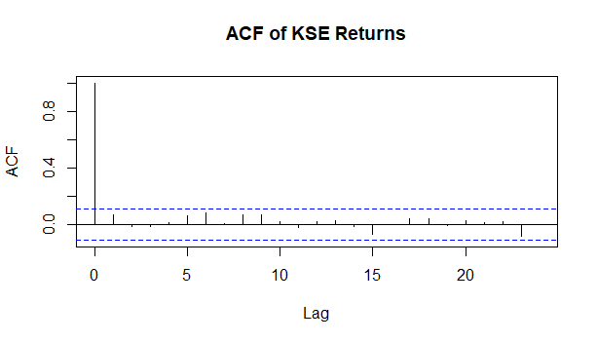

The ACF of KSE-100 Returns plot shows no significant autocorrelation beyond lag 0, as all the bars are well within the blue confidence bounds. This indicates that the returns are uncorrelated with their past values, suggesting that the mean process of the returns is effectively white noise. In simpler terms, past returns do not predict future returns, implying that an ARMA model for the mean is not necessary. While this indicates that we don’t need to model the mean using ARMA, it does not rule out the need for volatility modeling. Given the volatility clustering we observed earlier, we still need to account for time-varying volatility, which typically requires GARCH models. The next logical step is to examine the ACF of squared returns, which will help confirm whether volatility clustering is present. If significant autocorrelation in the squared returns is observed, this would justify fitting a GARCH model to model volatility.

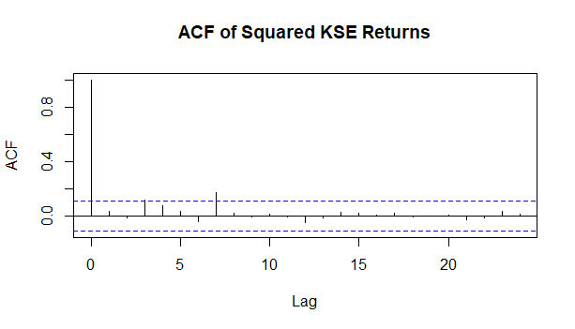

The ACF of Squared KSE Returns plot reveals some weak evidence of volatility clustering, as evidenced by a few significant spikes at lags 1 and 2. However, the autocorrelation quickly decays after these early lags, indicating that volatility does not exhibit long-term persistence. This suggests the presence of mild time-varying volatility, but it is not strong enough to justify complex GARCH models. While the evidence for volatility clustering is present, it is not robust enough to require high-order GARCH models. Based on this, a simple GARCH(1,1) model is appropriate, and we can fit it to capture the volatility dynamics. Furthermore, we should run other statistical tests to complement the plots, such as ARCH LM tests, to verify the presence of conditional heteroskedasticity formally. These tests will help ensure that our conclusions about volatility clustering are well-supported before proceeding with GARCH modeling.

Box-Ljung test

data: data$KSE_ret
X-squared = 8.3172, df = 12, p-value = 0.7599

The Box-Ljung test was performed to test for autocorrelation in the KSE-100 returns (KSE_ret). The null hypothesis of the test is that there is no autocorrelation up to a specified number of lags (in this case, 12). The alternative hypothesis is that there is significant autocorrelation in the returns. The test produced a p-value of 0.7599, which is much greater than the typical significance threshold of 0.05. Therefore, we fail to reject the null hypothesis, meaning there is no significant autocorrelation in the returns up to lag 12.
This result implies that the returns are independent and do not exhibit predictable patterns based on past returns. As a result, ARMA models for the mean of the returns are not necessary, as there is no serial dependence in the mean. Instead, we can focus on modeling volatility in the returns, which may still show time-varying behavior (volatility clustering). The next step will be to examine the ACF of squared returns to check for volatility clustering, which would justify the use of GARCH models to model the time-varying volatility.

ARCH LM-test; Null hypothesis: no ARCH effects

data: data$KSE_ret
Chi-squared = 16.551, df = 12, p-value = 0.1673

The ARCH LM test was conducted to assess the presence of time-varying volatility (ARCH effects: (conditional heteroskedasticity)) in the KSE-100 returns (KSE_ret). The test statistic (Chi-squared) was found to be 16.551, with 12 degrees of freedom. The corresponding p-value was 0.1673, which is greater than the typical significance threshold of 0.05. As a result, we fail to reject the null hypothesis (H₀), which states that there are no ARCH effects in the data. This implies that there is no evidence of time-varying volatility or volatility clustering in the returns, suggesting that the variance of returns is constant over time.
This finding indicates that GARCH models, which are designed to capture time-varying volatility, may not be necessary. Given that no significant ARCH effects are detected, we can focus on simpler models for volatility (such as rolling variance or EWMA) or reconsider other methods for capturing the dynamics of the data. However, we will need to further confirm this by looking at the ACF of squared returns to see if there’s still any volatility clustering, and possibly recheck the data for other potential patterns.

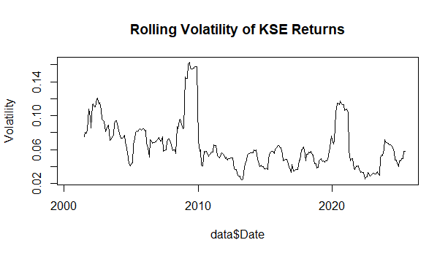

The rolling volatility plot of the KSE-100 returns shows intermittent volatility spikes, particularly around key financial events like market crises. While these spikes suggest moments of heightened uncertainty, the overall pattern does not show persistent volatility clustering, where high volatility periods are consistently followed by more high volatility. Instead, the volatility appears to ebb and flow, with calmer periods of lower volatility. This behavior, combined with the results from the ARCH LM test and ACF of squared returns, suggests that volatility is time-varying but not strongly persistent. Given this, GARCH models, which are designed to capture time-varying volatility, do not seem necessary for this dataset. Instead, simpler volatility models, such as EWMA (Exponentially Weighted Moving Average), or continued use of rolling variance, would be more appropriate for modeling volatility. These models can effectively capture the volatility dynamics without the complexity of GARCH.

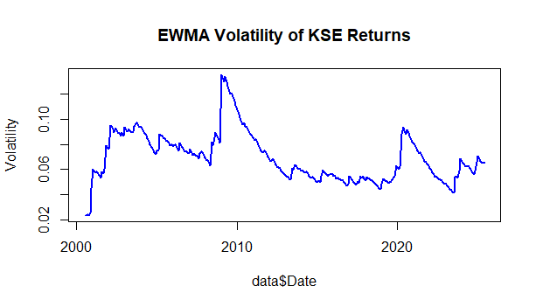

The EWMA volatility plot of KSE-100 returns reveals clear periods of heightened market volatility interspersed with calmer phases. Significant volatility spikes are evident, especially around key financial events such as the 2008 global financial crisis, as well as other periods of market uncertainty. The plot demonstrates the time-varying nature of volatility, where high volatility is often followed by more high volatility, and low volatility persists during stable market conditions. This confirms the presence of volatility clustering, where the market exhibits persistent risk during certain periods. Given the observable volatility patterns, simpler volatility models like EWMA provide a reasonable measure of market risk without the complexity of GARCH models.

