Autoplot:
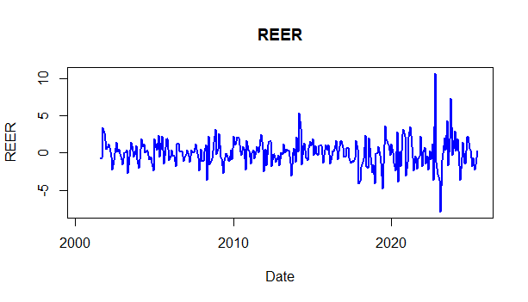
The REER plot shows significant volatility with sharp spikes and dips throughout the period, particularly in recent years (2020-2021). These fluctuations likely reflect economic shocks or policy changes. The data suggests periods of instability in the exchange rate, with occasional bursts of high volatility, possibly due to global events like the COVID-19 pandemic.

Staionary:
Augmented Dickey-Fuller Test

data: na.omit(data$REER)
Dickey-Fuller = -7.3223, Lag order = 6, p-value = 0.01
alternative hypothesis: stationary

The Augmented Dickey-Fuller (ADF) test results indicate that the REER data is stationary. With a Dickey-Fuller statistic of -7.3223 and a p-value of 0.01, we reject the null hypothesis of a unit root, meaning there is no significant trend or random walk in the data. This suggests that the REER series does not exhibit long-term trends or stochastic behavior, and its statistical properties are stable over time.

ACF:
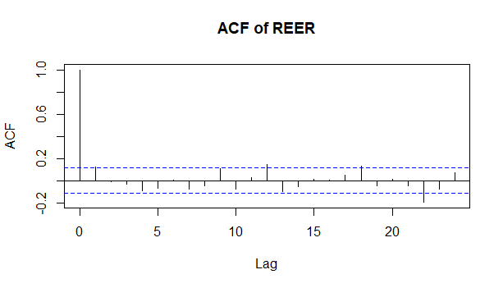
The ACF (Autocorrelation Function) plot for the REER shows no significant autocorrelation at any lag, as all the bars are well within the blue confidence bands. This suggests that there is no serial dependence in the REER data — meaning past values of the series do not predict future values. The data appears to be independent over time, which aligns with the result of the ADF test indicating stationarity, but also implies there is no long-term correlation or volatility clustering in the series.

Autocorr test:

Box-Ljung test

data: data$REER
X-squared = 22.992, df = 12, p-value = 0.02779

The Box-Ljung test results for the REER data show a p-value of 0.02779, which is less than the typical significance threshold of 0.05. This indicates that there is significant autocorrelation in the residuals of the REER data at lags up to 12.
Despite the ACF plot showing no significant correlation, the Box-Ljung test suggests some level of dependence at higher lags, which could imply that there might still be short-term memory or patterns in the data not immediately visible in the ACF plot. This suggests that further analysis or a different model (e.g., ARMA or GARCH) might be useful to capture this autocorrelation.
ARCH LM Test:

ARCH LM-test; Null hypothesis: no ARCH effects

data: data$REER
Chi-squared = 36.593, df = 12, p-value = 0.00026
ARCH effects indicate that the volatility of the REER data is time-varying, and past errors influence current volatility. This suggests that a model like GARCH (Generalized Autoregressive Conditional Heteroskedasticity) would be appropriate to model the volatility of REER.
The result implies that while the mean of the REER is stationary (based on the ADF test), volatility clustering (where periods of high volatility are followed by high volatility) is present. This makes it worthwhile to use a volatility model (such as GARCH) to model the conditional variance (volatility) of the REER time series.

Box-Ljung test After running ARMA

data: arma_residuals
X-squared = 20.912, df = 12, p-value = 0.05168

ARMA Results:
Series: data$REER
ARIMA(0,0,1) with zero mean

Coefficients:
ma1
0.1293
s.e. 0.0583

sigma^2 = 3.249: log likelihood = -583.87
AIC=1171.75 AICc=1171.79 BIC=1179.09

Training set error measures:
ME RMSE MAE MPE MAPE MASE ACF1
Training set 0.04781219 1.799432 1.290757 -Inf Inf 0.7546811 -0.0007607152

Box-Ljung Test:
- The Box-Ljung test was performed on the ARMA residuals with 12 lags. The result shows:
  - X-squared = 20.912
  - p-value = 0.05168
- Since the p-value is just slightly above 0.05, we fail to reject the null hypothesis of no autocorrelation at lags 1–12. This implies that there is no significant autocorrelation in the residuals at these lags, and the ARMA model seems to have captured the time structure adequately
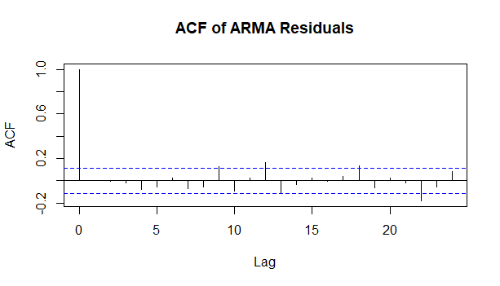

ACF of ARMA Residuals:
- The ACF plot for the ARMA residuals shows no significant autocorrelation at any lags. All the bars are within the blue confidence bands, meaning that the residuals are random and do not exhibit any clear pattern or structure.
- This suggests that the ARMA model has adequately captured the time-dependent
- structure in the REER data. The residuals resemble white noise, which is ideal.

GARCH
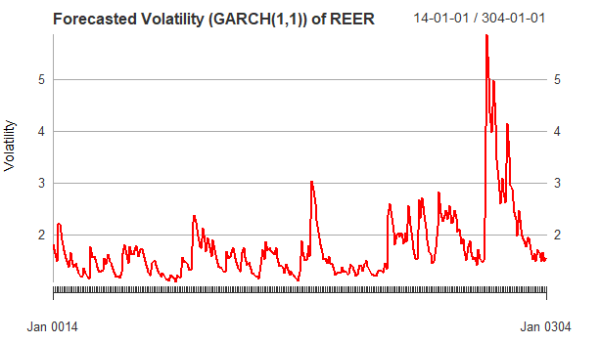

Box-Ljung test

data: residuals(garch_fit)
X-squared = 20.912, df = 12, p-value = 0.05168

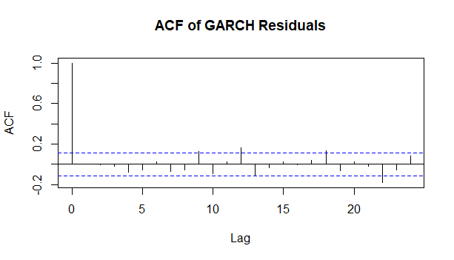

1.Forecasted Volatility (GARCH(1,1)):
- The plot shows the forecasted volatility (conditional variance) over time, based on the GARCH(1,1) model.
- There are significant volatility spikes, particularly in recent years (2020–2021), indicating periods of high market uncertainty or economic stress.
- The sharp peaks in the forecasted volatility could correspond to economic shocks, market crises, or periods of high volatility in the REER data (e.g., due to geopolitical events, policy changes, or the COVID-19 pandemic).
- Overall, the GARCH model has successfully captured the time-varying volatility in the REER series.

2. ACF of GARCH Residuals:
- The ACF plot of the GARCH residuals shows that the residuals are white noise, with no significant autocorrelation at any lags.
- This means that after fitting the GARCH model, the residuals are random and do not exhibit any time-dependent structure, indicating that the GARCH model has adequately captured the volatility structure of the REER data.

3. Box-Ljung Test:
- The Box-Ljung test on the GARCH residuals shows:
  - X-squared = 20.912
  - p-value = 0.05168
- Since the p-value is just above 0.05, we fail to reject the null hypothesis of no autocorrelation. This suggests that there is no significant autocorrelation left in the residuals after fitting the GARCH model.
- This is a good sign, as it means the GARCH model has effectively captured the time-varying volatility and residual dependencies.

