

# BATCH - 2019-2020

**ASSIGNMENT ON ECOLOGICAL**

**PYRAMIDS AND ENERGY FLOW**

***NAME – SHABNAM NEGI***

***I.D.NO. – 19071***

***B.Sc. FORESTRY (2ndsem.)***

***COURSE NAME – FOREST ECOLOGY***

***AND BIODIVERSITY***

***SUBMITTED TO – Dr. R.S. BALI***

***Dr. B.S. BUTOLA***

**CONTENTS**

1. *ECOLOGICAL PYRAMID*
2. *TYPES*
3. *PYRAMID OF NUMBER*
4. *PYRAMID OF BIOMASS*
5. *PYRAMID OF ENERGY*
6. *ECOLOGICAL PYRAMID EXAMPLES*
7. *ENRGY FLOW IN ECOSYSTEM*

***ECOLOGICAL PYRAMID***

*.An ecological pyramid is a graphical representation of the relationship between different organisms in an ecosystem .Each of the bars that make up the pyramid represents a different trophic level and their order which is based on who eats whom ,and represents the flow of energy . energy moves up the pyramid ,starting with the primary producers followed by primary consumers and then secondary consumers.*

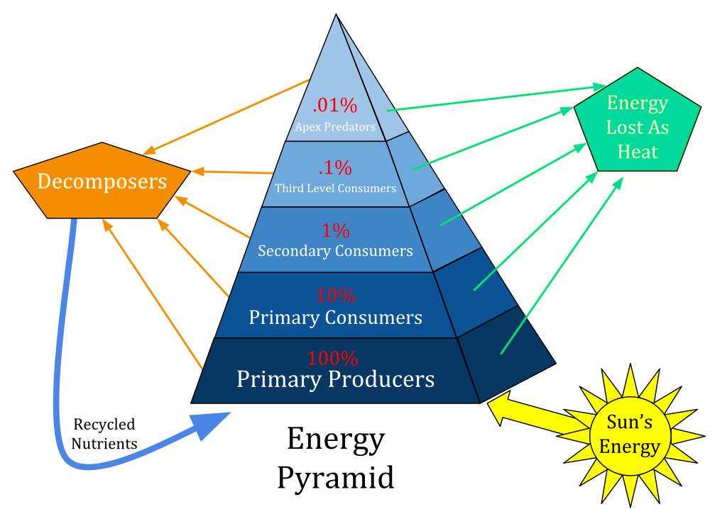

**Types**

*In many ecological pyramids, the producer form the base and the successive trophic levels make up the apex. The ecological pyramids may be of following three kinds.*

***Pyramid of energy***

*A pyramid of energy or pyramid of productivity shows the production or turnover of biomass at each trophic level. Instead of showing a single snapshot in time, productivity pyramids show the flow of energy through the food chain. Typical units are grams per square meter per year or calories per square meter per year. As with the others, this graph shows producers at the bottom and higher trophic levels on top.*

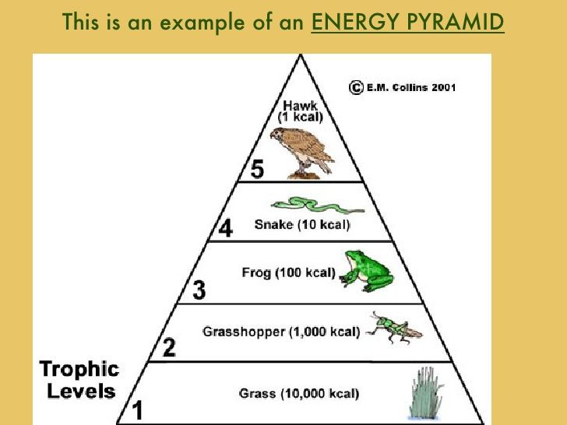

*Ecological pyramids begin with*[*producers*](https://en.wikipedia.org/wiki/Autotroph)*on the bottom and proceed through the various trophic levels. The highest level is the top of the*[*food chain*](https://en.wikipedia.org/wiki/Food_chain)*.*

***Pyramid of number***

***i***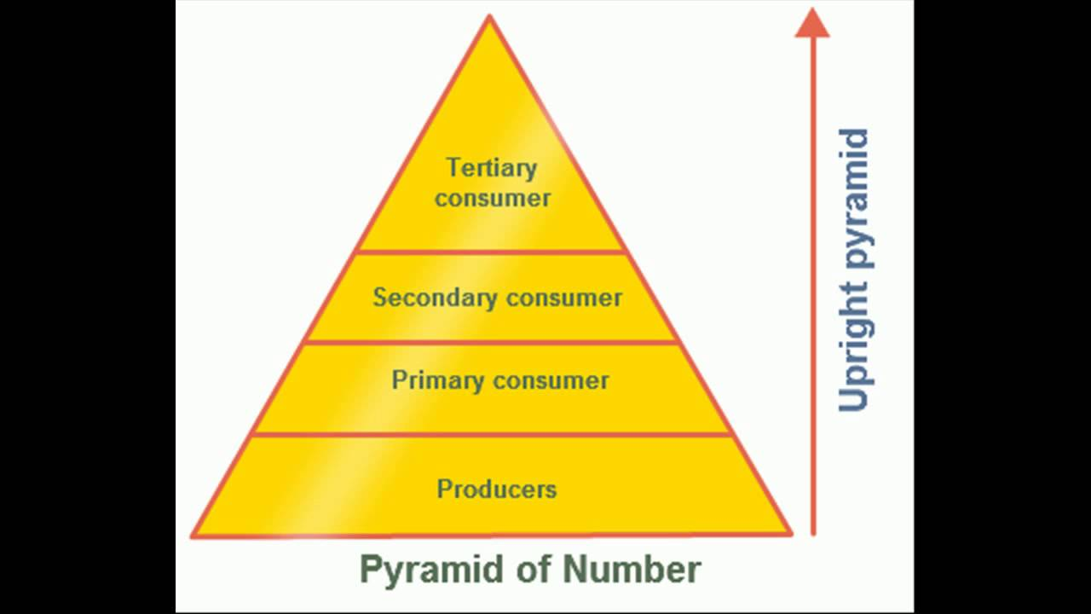

*In this type ecological pyramid ,the number of organisms in each tropic level is considered as a level in the pyramid. The pyramid of numbers is usually upright except for some situations like that of detritus food chain, where many organisms feed on one dead plant or animal.*

***Pyramid of biomass***

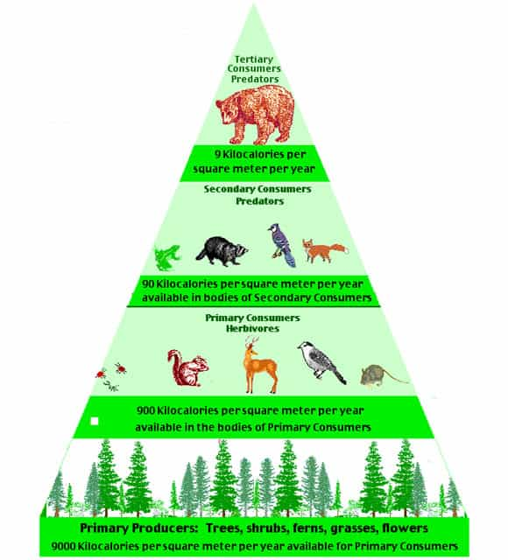

*In this particular type of ecological pyramid, each level takes into account the amount of biomass produced by each tropic level. The pyramid of biomass is*

*Also upright except for that observed in oceans where large number of zooplanktons depend on a relatively smaller number of phytoplanktons.*

***Energy flow in an ecosystem***

*The chemical energy of food is the main source of energy required by all living organisms. This energy is transmitted to different trophic levels along the food chain. This energy flow is based on two different laws of thermodynamics:*



*First law of thermodynamics, that states that energy can neither be created nor destroyed, it can only change from one form to another.*

*Second law of thermodynamics, that states that as energy is transferred more and more of it is wasted.*

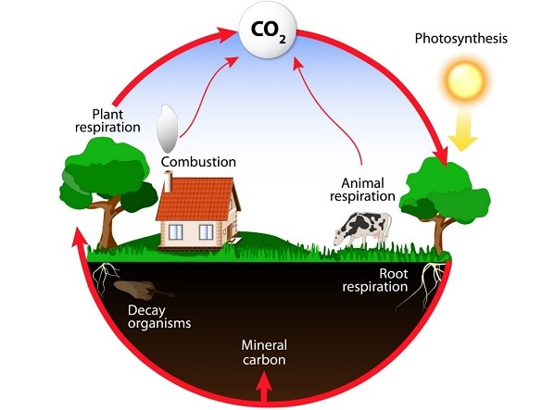

*References*

*⚫ ncert biology book class 12*

*⚫ www.tutorialspoint.com*

*⚫ www.wikipedia.org*

*⚫ www.biologyonline.com*