OVER THE WIRE

BANDIT

The Bandit wargame is aimed at absolute beginners. It will teach the basics needed to be able to play other wargames.

LEVEL 0

*#CHALLENGE*

The goal of this level is for you to log into the game using SSH. The host to which you need to connect is **bandit.labs.overthewire.org**, on port 2220. The username is **bandit0** and the password is **bandit0**. Once logged in, go to the [Level 1](https://overthewire.org/wargames/bandit/bandit1.html) page to find out how to beat Level 1.

*#SOLUTION*

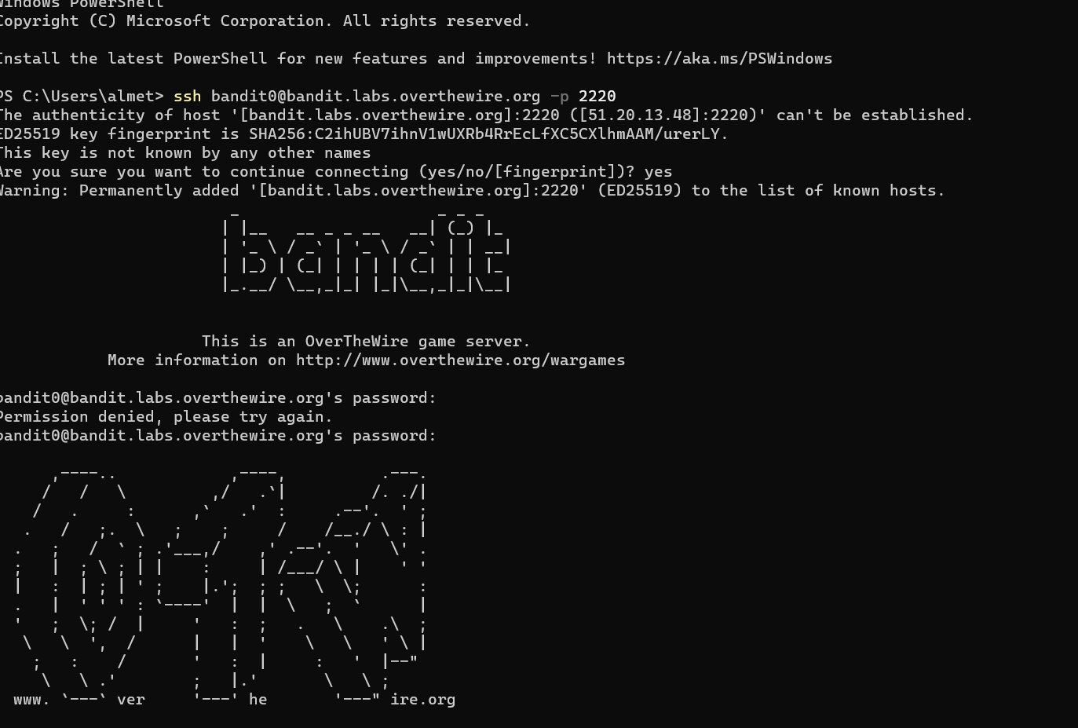

* ssh <username>@<remote> here username is bandit0.
* If you want to specify a port, add -p 0000, (replace 0000 with the desired port number). Here port is 2220.
* You will be asked for your [password](https://www.wikihow.com/Create-a-Password-You-Can-Remember) once the connection is established. You will not see the cursor move or any characters input when you type your password.

*#FLAG*

bandit0

*#REFERENCE:*

<https://www.wikihow.com/Use-SSH>

LEVEL 0 🡪 LEVEL 1

*#CHALLENGE*

The password for the next level is stored in a file called **readme** located in the home directory. Use this password to log into bandit1 using SSH. Whenever you find a password for a level, use SSH (on port 2220) to log into that level and continue the game.

*#SOLUTION*

Here two commands are used :

1. ls : This SSH command is used to list all files and directories.
2. cat : On getting the file name we use this command to display the content of a file.

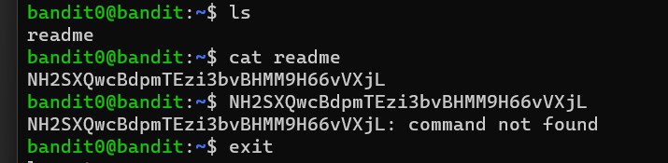

*#FLAG*

NH2SXQwcBdpmTEzi3bvBHMM9H66vVXjL

*#REFERENCE:*

<https://www.hostinger.com/tutorials/ssh/basic-ssh-commands#6_cat_Command>

LEVEL 1 🡪 LEVEL 2

*#CHALLENGE*

The password for the next level is stored in a file called **-** located in the home directory.

*#SOLUTION*

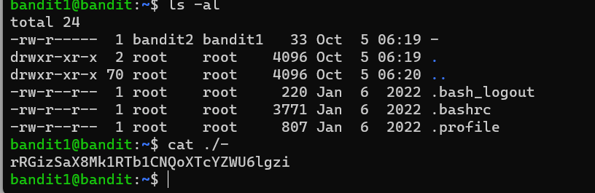

When working with filenames, a leading dot is the prefix of a "hidden" file, a file that an [ls](https://tldp.org/LDP/abs/html/basic.html#LSREF) will not normally show. Hence, we use **ls -al** command to show hidden files. On locating the ‘-‘file we display its contents by using **cat** command.

*#FLAG*

rRGizSaX8Mk1RTb1CNQoXTcYZWU6lgzi

*#REFERENCE:*

<https://www.hostinger.com/tutorials/ssh/basic-ssh-commands#6_cat_Command>

LEVEL 2 🡪 LEVEL 3

*#CHALLENGE*

The password for the next level is stored in a file called **spaces in this filename** located in the home directory.

*#SOLUTION*

1. First we list all files including hidden files using **‘ls-al’** command.
2. Next it doesn’t understand ‘**cat spaces in this filename** ‘as a single hence we use **‘\’** followed by a space .

*#FLAG*

aBZ0W5EmUfAf7kHTQeOwd8bauFJ2lAiG

*#REFERENCE:*

<https://linuxhandbook.com/filename-spaces-linux/>

LEVEL 3🡪 LEVEL 4

*#CHALLENGE*

The password for the next level is stored in a hidden file in the **inhere** directory.

*#SOLUTION*

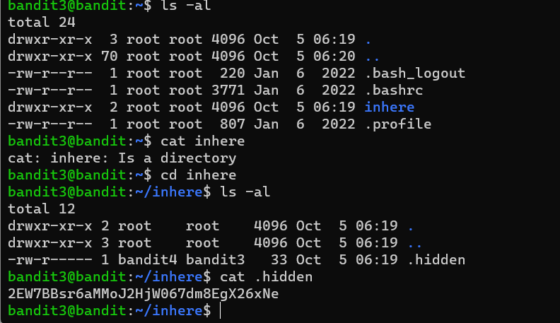

1. First, we use **‘ls-al’** command to list all files.
2. On using **cat** command, it displays a message that **inhere is a directory**.
3. So now we use **cd** command which is used to change between the directories.
4. On listing the files of inhere directory we get a hidden file.
5. On listing the contents of the hidden file, we get the password.

*#FLAG*

2EW7BBsr6aMMoJ2HjW067dm8EgX26xNe

*#REFERENCE:*

<https://www.hostinger.com/tutorials/ssh/basic-ssh-commands#6_cat_Command>

LEVEL 4🡪 LEVEL 5

*#CHALLENGE*

The password for the next level is stored in the only human-readable file in the **inhere** directory. Tip: if your terminal is messed up, try the “reset” command.

*#SOLUTION*

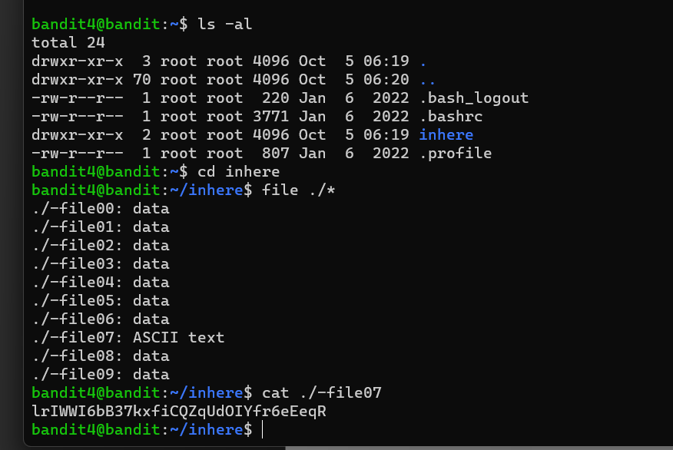

1. First, we use **‘ls-al’** command to list all files.
2. On using **cat** command, it displays a message that **inhere is a directory**. So now we use **cd** command which is used to change between the directories.
3. Now we use ‘**file ./*’** which lists all the type of files in the inhere directory .
4. After this we can see that ‘/-file07’ contains ASCII text which is human readable.

*#FLAG*

lrIWWI6bB37kxfiCQZqUdOIYfr6eEeqR

*#REFERENCE:*

https://man7.org/linux/man-pages/man1/file.1.html

LEVEL 5🡪 LEVEL 6

*#CHALLENGE*

The password for the next level is stored in a file somewhere under the **inhere** directory and has all of the following properties:

* human-readable
* 1033 bytes in size
* not executable

*#SOLUTION*

1. First, we use **‘ls-al’** command to list all files.
2. On using **cat** command, it displays a message that **inhere is a directory**. So now we use **cd** command which is used to change between the directories.
3. Now using ‘**find**’ followed :

**size +N/-N :** Search for files of ‘N’ blocks; ‘N’ followed by **‘c’** can be used to measure the size in characters; ‘+N’ means size > ‘N’ blocks and ‘-N’ means size < ‘N’ blocks.

**Followed by ‘! executable ‘ command and then ‘grep’ command is used to search specific phrase in file.**

*#FLAG*

**P4L4vucdmLnm8I7Vl7jG1ApGSfjYKqJU**

*#REFERENCE:*

<https://www.hostinger.com/tutorials/ssh/basic-ssh-commands#6_cat_Command>

LEVEL 6🡪 LEVEL 7

*#CHALLENGE*

The password for the next level is stored **somewhere on the server** and has all of the following properties:

* owned by user bandit7
* owned by group bandit6
* 33 bytes in size

*#SOLUTION*

1. Here we use the command ‘**find / -type f -user username -group groupname -size size given’** here username is : bandit7 , groupname is : bandit6 and size is 33 bytes . bytes is represented by ‘**c’** .
2. On getting a list of files we look for password file and then use **‘cat’**  command to display the contents of this file which gives us the password .

*#FLAG*

z7WtoNQU2XfjmMtWA8u5rN4vzqu4v99S

*#REFERENCE:*

<https://www.cyberciti.biz/faq/how-do-i-find-all-the-files-owned-by-a-particular-user-or-group/>

LEVEL 7🡪 LEVEL 8

*#CHALLENGE*

The password for the next level is stored in the file **data.txt** next to the word **millionth.**

*#SOLUTION*

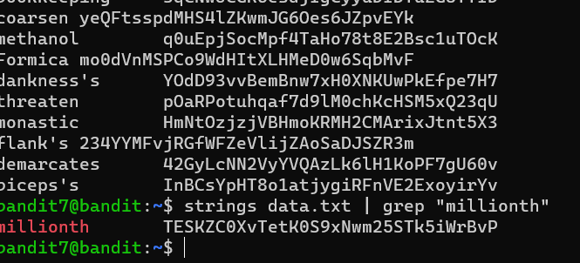

1. **First we list the files of the directory using ‘ls -al’**
2. **On finding data.txt we find the contents of the file using ‘cat’.**
3. **Now we use ‘grep’ command which helps to search specific phrases in the file / directory.**

*#FLAG*

**TESKZC0XvTetK0S9xNwm25STk5iWrBvP**

*#REFERENCE:*

<https://www.hostinger.com/tutorials/ssh/basic-ssh-commands#6_cat_Command>

LEVEL 8🡪 LEVEL 9

*#CHALLENGE*

The password for the next level is stored in the file **data.txt** and is the only line of text that occurs only once.

*#SOLUTION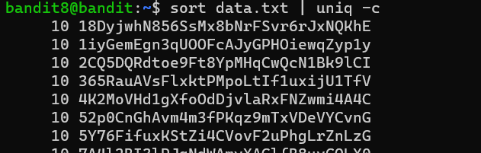*

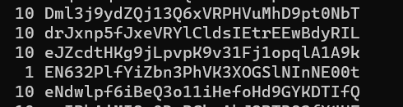

1. **First we list the files of the directory using ‘ls -al’.**
2. **On finding data.txt we list the files in it using ‘cat ‘ command .**
3. **Now we sort the files by using ‘sort’ command then we use ‘|’ to combine both statements it after which we use uniq command . uniq** can’t detect the duplicate lines unless they are adjacent to each other. The content in the file must be therefore sorted before using **uniq.** Now to get the count od lines we use **‘-c’ .**

*#FLAG*

EN632PlfYiZbn3PhVK3XOGSlNInNE00t

*#REFERENCE:*

<https://www.geeksforgeeks.org/uniq-command-in-linux-with-examples/>

LEVEL 9🡪 LEVEL 10

*#CHALLENGE*

The password for the next level is stored in the file **data.txt** in one of the few human-readable strings, preceded by several ‘=’ characters.

*#SOLUTION*

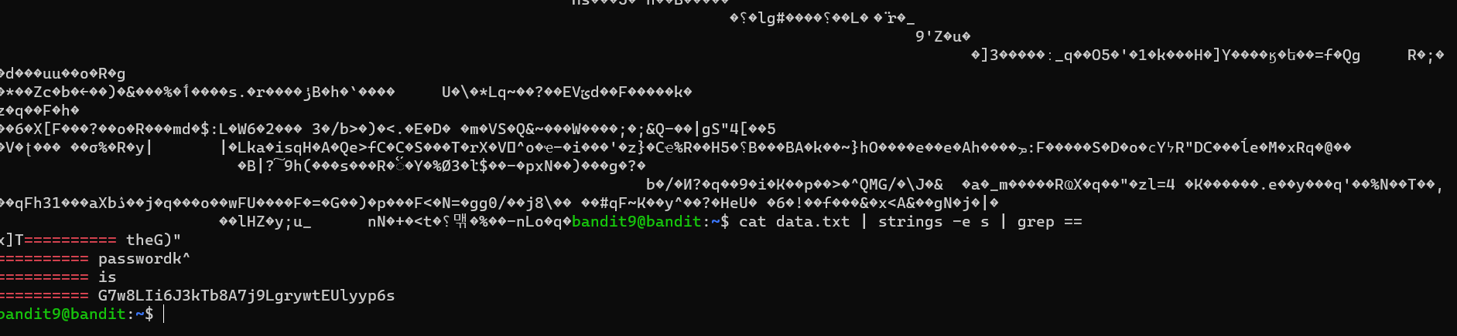

1. **First we list the files of the directory using ‘ls -al’.**
2. **On finding data.txt we list the files in it using ‘cat ‘command .**
3. The strings command provides four types of encoding options. **strings -e s file_name.** **s:** 7-bit byte (used for ASCII, ISO 8859).
4. Now we use ‘**grep’** command to get strings preceded by ‘=’.

*#FLAG*

G7w8LIi6J3kTb8A7j9LgrywtEUlyyp6s

*#REFERENCE:*

<https://www.javatpoint.com/linux-strings-command>

LEVEL 10🡪 LEVEL 11

*#CHALLENGE*

The password for the next level is stored in the file **data.txt**, which contains base64 encoded data.

*#SOLUTION*

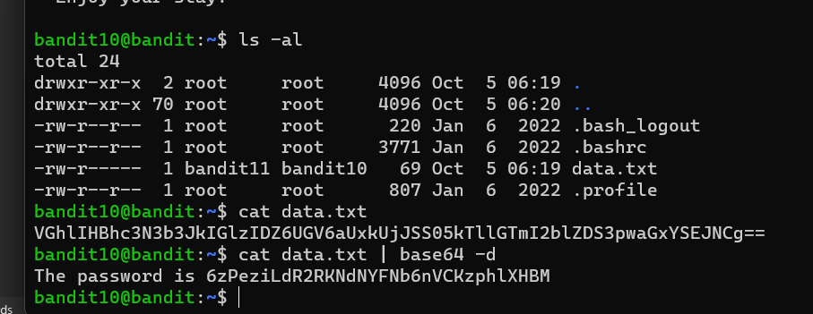

1. First we list all files of the directory using ‘**ls -al’**.
2. Now we use the ‘**ca**t’ command to display the contents of the data.txt file. But it is encoded in base64.
3. Hence to decode it we use **base64 -d** command which decodes the text to normal human readable text.

*#FLAG*

6zPeziLdR2RKNdNYFNb6nVCKzphlXHBM

*#REFERENCE:*

<https://www.serverlab.ca/tutorials/linux/administration-linux/how-to-base64-encode-and-decode-from-command-line/>