BANK DATABASE

CREATE DATABASE BANKDATABASE;

USE BANKDATABASE;

CREATE TABLES BY SPECIFYING PRIMARY AND FOREIGN KEYS

CREATE TABLE BRANCH(BRANCHNAME VARCHAR(20),BRANCHCITY VARCHAR(15),ASSETS DECIMAL(4),PRIMARY KEY(BRANCHNAME));

CREATE TABLE BANKACCOUNT(ACCNO INT,BRANCHNAME VARCHAR(20),BALANCE DECIMAL(4),PRIMARY KEY(ACCNO), FOREIGN KEY(BRANCHNAME) REFERENCES BRANCH (BRANCHNAME));

CREATE TABLE BANKCUSTOMER (CUSTOMERNAME VARCHAR (10),CUSTOMERSTREET VARCHAR(15),PRIMARY KEY(CUSTOMERNAME));

ALTER TABLE BANKCUSTOMER ADD CUSTOMERCITY VARCHAR (20);

CREATE TABLE DEPOSITER(CUSTOMERNAME VARCHAR(10),ACCNO INT,PRIMARY KEY(CUSTOMERNAME,ACCNO) ,FOREIGN KEY (CUSTOMERNAME) REFERENCES BANKCUSTOMER (CUSTOMERNAME),

FOREIGN KEY (ACCNO) REFERENCES BANKACCOUNT (ACCNO));

CREATE TABLE LOAN(LOANNUMBER INT,BRANCHNAME VARCHAR(20),AMOUNT DECIMAL(4),PRIMARY KEY(LOANNUMBER), FOREIGN KEY (BRANCHNAME) REFERENCES BRANCH(BRANCHNAME));

ALTER TABLE BRANCH MODIFY COLUMN ASSETS DECIMAL (10,2);

ALTER TABLE LOAN MODIFY COLUMN AMOUNT DECIMAL (10,2);

ALTER TABLE BANKACCOUNT MODIFY COLUMN BALANCE DECIMAL (10,2);

INSERT ATLEAST 5 TUPLES IN THE RELATION

INSERT INTO BRANCH VALUES ("SBI-CHAMARAJPET","BANGALORE",50000),("SBI-RESIDENCY ROAD","BANGALORE",100000),("SBI-SHIVAJI ROAD","MUMBAI",20000), ("SBI-PARLIAMENT ROAD","DELHI",40000 ),("SBI-JANTARMANTAR","DELHI",20000);

UPDATE BRANCH SET ASSETS=60000 WHERE BRANCHNAME="SBI-PARLIAMENT ROAD";

UPDATE BRANCH SET ASSETS=200000 WHERE BRANCHNAME="SBI-SHIVAJI ROAD";

UPDATE BRANCH SET ASSETS=300000 WHERE BRANCHNAME="SBI-JANTARMANTAR";

SELECT * FROM BRANCH;

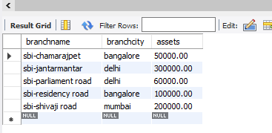

INSERT INTO BANKACCOUNT VALUES (12345,"SBI-CHAMARAJPET",30000),(67890,"SBI-RESIDENCY ROAD",45000),(54321,"SBI-SHIVAJI ROAD",10000), (18975,"SBI-SHIVAJI ROAD", 56000 ),(11345,"SBI-CHAMARAJPET",45000),(89700,"SBI-CHAMARAJPET",8000),(67845,"SBI-JANTARMANTAR",10000), (09321,"SBI-CHAMARAJPET", 56000 ),(56785,"SBI-RESIDENCY ROAD",30000),(45645,"SBI-PARLIAMENT ROAD",35000),(16545,"SBI-JANTARMANTAR",80000), (18976,"SBI-CHAMARAJPET",28000 );

SELECT * FROM BANKACCOUNT;

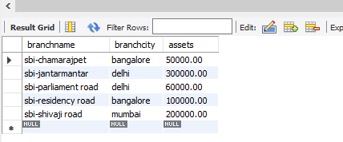

INSERT INTO BANKCUSTOMER VALUES ("ANUJ","TEMPLE ROAD","BANGALORE"),("ANURAG","SOUTH CIRCLE","BANGALORE"),("RISHI","GANDHI ROAD","MUMBAI"), ("VEER","SHAHJAHAN ROAD","DELHI");

INSERT INTO BANKCUSTOMER VALUES("ANSHUMAN","NEHRU ROAD","DELHI");

SELECT * FROM BANKCUSTOMER;

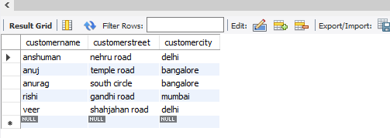

INSERT INTO DEPOSITER VALUES("ANUJ",12345),("ANURAG",67890),("RISHI",54321) ,("VEER",18975),("ANURAG",11345),("ANURAG",56785);

SELECT * FROM DEPOSITER;

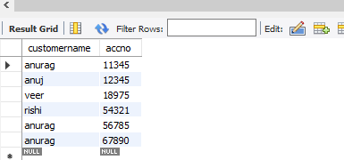

INSERT INTO LOAN VALUES (1,"SBI-CHAMARAJPET",20000 ),(2,"SBI-CHAMARAJPET",100000),(3,"SBI-RESIDENCY ROAD",45000),(4,"SBI-JANTARMANTAR",10000), (5,"SBI-PARLIAMENT ROAD",400000 ),(6,"SBI-SHIVAJI ROAD",56000);

SELECT * FROM LOAN;

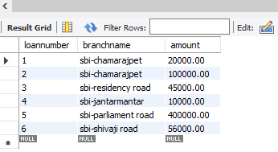

DISPLAY THE BRANCH NAME AND ASSETS FROM ALL BRANCHES IN LAKHS OF RUPEES AND RENAME THE ASSETS COLUMN TO 'ASSETS IN LAKHS'

SELECT BRANCHNAME , ASSETS AS ASSETS_IN_LAKHS FROM BRANCH;

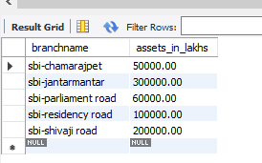

FIND ALL THE CUSTOMERS WHO HAVE AT LEAST TWO ACCOUNTS AT THE SAME BRANCH

SELECT D.CUSTOMERNAME,COUNT (*) AS NUMBER_OF_CUSTOMERS FROM DEPOSITER D , BANKACCOUNT BA WHERE D.ACCNO=BA.ACCNO GROUP BY (D.CUSTOMERNAME) HAVING NUMBER_OF_CUSTOMERS>=2;

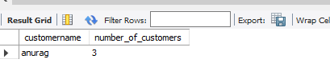

CREATE A VIEW WHICH GIVES EACH BRANCH THE SUM OF THE AMOUNT OF ALL THE LOANS AT THE BRANCH

CREATE VIEW LOANVIEW (BRANCH , TOTAL_LOAN_AMOUNT) AS SELECT BRANCHNAME ,SUM(AMOUNT ) FROM LOAN GROUP BY BRANCHNAME;

SELECT * FROM LOANVIEW;

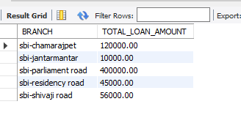

FIND ALL THE CUSTOMERS WHO HAVE AN ACCOUNT AT ALL THE BRANCHES LOCATED IN A SPECIFIC CITY

SELECT DISTINCT D.CUSTOMERNAME FROM DEPOSITER D, BANKACCOUNT BA WHERE D.ACCNO = BA.ACCNO AND BA.BRANCHNAME IN (SELECT BR.BRANCHNAME FROM BRANCH BR WHERE BR.BRANCHCITY="MUMBAI") ;

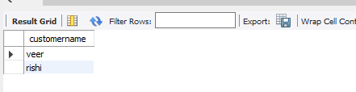

FIND ALL CUSTOMERS WHO HAVE A LOAN AT THE BANK BUT DO NOT HAVE AN ACCOUNT

SELECT BC.CUSTOMERNAME FROM BANKCUSTOMER BC WHERE BC.CUSTOMERNAME NOT IN ( SELECT DISTINCT D.CUSTOMERNAME FROM DEPOSITER D);

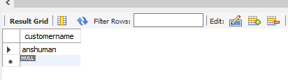

FIND ALL CUSTOMERS WHO HAVE BOTH AN ACCOUNT AND A LOAN AT THE BANGALORE BRANCH

SELECT BA.ACCNO FROM BANKACCOUNT BA WHERE BA.ACCNO IN ( SELECT D.ACCNO FROM DEPOSITER D);

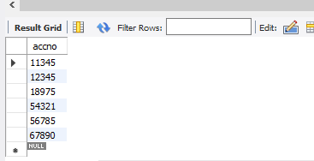

FIND THE NAMES OF ALL BRANCHES THAT HAVE GREATER ASSETS THAN ALL BRANCHES LOCATED IN BANGALORE

SELECT BRANCHNAME FROM BRANCH WHERE ASSETS > ALL(SELECT BR.ASSETS FROM BRANCH BR WHERE BR.BRANCHCITY="BANGALORE");

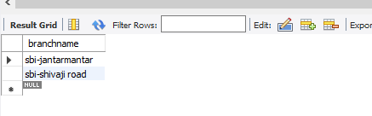

UPDATE THE BALANCE OF ALL ACCOUNTS BY 5%

UPDATE BANKACCOUNT SET BALANCE=BALANCE+(0.05*BALANCE) ;

SELECT * FROM BANKACCOUNT;

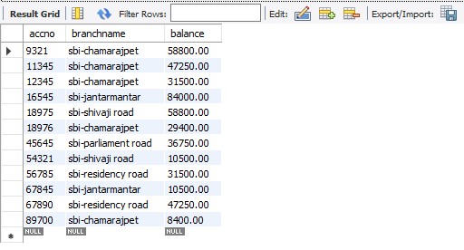

DEMONSTRATE HOW YOU DELETE ALL ACCOUNT TUPLES AT EVERY BRANCH LOCATED IN A SPECIFIC CITY

DELETE FROM BANKACCOUNT BA WHERE BA.BRANCHNAME IN (SELECT BR.BRANCHNAME FROM BRANCH BR WHERE BR.BRANCHCITY="MUMBAI");