CREATE DATABASE EMPLOYEE_DATABASE;

USE EMPLOYEE_DATABASE;

CREATE TABLES BY PROPERLY SPECIFYING THE PRIMARY KEYS AND THE FOREIGN KEYS.

CREATE TABLE DEPT (DEPTNO INT PRIMARY KEY,DNAME VARCHAR(30),DLOC VARCHAR(30));

CREATE TABLE EMPLOYEE (EMPNO INT, ENAME VARCHAR(20), MGRNO INT, HIREDATE DATE,SALARY DECIMAL(10,2), DEPTNO INT, PRIMARY KEY(EMPNO), FOREIGN KEY (DEPTNO) REFERENCES DEPT (DEPTNO));

ALTER TABLE EMPLOYEE ADD FOREIGN KEY (MGRNO) REFERENCES EMPLOYEE (EMPNO);

CREATE TABLE PROJECT (PNO INT PRIMARY KEY,PLOC VARCHAR(20),PNAME VARCHAR(30));

CREATE TABLE INCENTIVES(EMPNO INT,INCENTIVEDATE DATE,INCENTIVEAMT DECIMAL(10,2),PRIMARY KEY(EMPNO,INCENTIVEDATE), FOREIGN KEY(EMPNO) REFERENCES EMPLOYEE(EMPNO));

CREATE TABLE ASSIGNEDTO(EMPNO INT,PNO INT,JOBROLE VARCHAR(30), PRIMARY KEY(EMPNO,PNO),FOREIGN KEY (EMPNO) REFERENCES EMPLOYEE(EMPNO), FOREIGN KEY (PNO) REFERENCES PROJECT(PNO));

ENTER GREATER THAN FIVE TUPLES FOR EACH TABLE.

INSERT INTO DEPT VALUES (1,"COMPUTER ENGINEERING","BANGALORE"),(2,"ELECTRONICS ENGINEERING","KOLKATA"),(3,"ARTIFICIAL INTELLIGENCE","BANGALORE"),(4,"MACHINE LEARNING","MUMBAI"),(5,"MECHANICAL ENGINEERING","DELHI"),(6,"INFORMATION SCIENCE","DELHI");

SELECT * FROM DEPT;

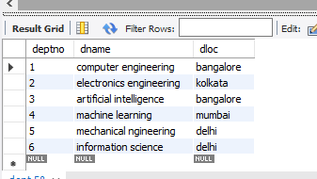

INSERT INTO EMPLOYEE VALUES(1001,"RAGHAV",NULL,"2024-05-25",80000,1),(1002,"RAGHU",NULL,"2024-05-13",70000,2),(101,"RAM",1001,"2023-05-25",40000,1),

(1003,"RADHA",NULL,"2023-04-25",70000,3),(102,"RISHI",1003,"2025-05-25",40000,3),(1004,"TANVI",NULL,"2023-06-25",70000,4),(1005,"TANU",NULL,"2024-05-25",80000,5),

(1006,"ARMAAN",NULL,"2025-11-02",60000,6),(103,"RENU",1003,"2025-05-25",30000,3),(104,"RADHIKA",1006,"2021-05-03",40000,6),(105,"ANUJ",1003,"2023-05-25",40000,1),

(106,"SHIVANI", 1004,"2024-06-25", 40000,3),(107,"VANI",1005,"2025-05-25",40000,6);

UPDATE EMPLOYEE SET SALARY=95000 WHERE EMPNO=1003;

UPDATE EMPLOYEE SET SALARY=55000 WHERE EMPNO=102;

UPDATE EMPLOYEE SET SALARY=65000 WHERE EMPNO=1004;

UPDATE EMPLOYEE SET SALARY=85000 WHERE EMPNO=1005;

UPDATE EMPLOYEE SET SALARY=25000 WHERE EMPNO=104;

UPDATE EMPLOYEE SET SALARY=45000 WHERE EMPNO=105;

UPDATE EMPLOYEE SET SALARY=35000 WHERE EMPNO=106;

UPDATE EMPLOYEE SET SALARY=15000 WHERE EMPNO=107;

SELECT * FROM EMPLOYEE;

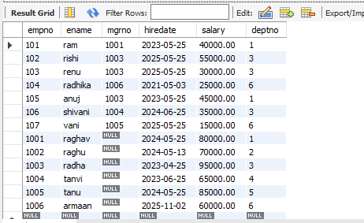

INSERT INTO PROJECT VALUES (10,"BANGALORE","WEB APPLICATION"),(20,"KOLKATA","TRANSFORMER"),(30,"MUMBAI","ENGINE MANUFACTURE"),(40,"DELHI","ROBOTICS"),

(50,"BANGALORE","AI CHATBOT"),(60,"MUMBAI","EMBEDDED SYSTEMS");

SELECT * FROM PROJECT;

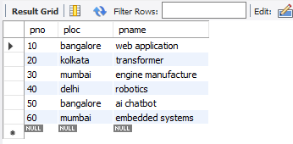

INSERT INTO INCENTIVES VALUES(1001,"2024-09-15",15000),(103,"2025-12-25",20000),(104,"2022-06-03",10000),(1006,"2026-01-01",35000),(107,"2025-12-03",10000);

SELECT * FROM INCENTIVES;

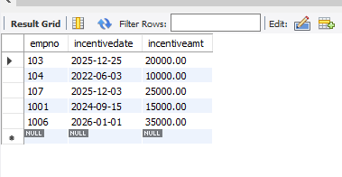

INSERT INTO ASSIGNEDTO VALUES(1001,10,"MANAGER"),(1002,20,"MANAGER"),(1003,30,"MANAGER"),(1004,40,"MANAGER"),(1005,50,"MANAGER"),(1006,60,"MANAGER"),(101,10,"ASSITANT"),(102,10,"DEVELOPER"),(103,20,"ASSISTANT"),(104,40,"DESIGNER"),(105,50,"ASSISTANT"),(106,50,"DESIGNER");

SELECT * FROM ASSIGNEDTO;

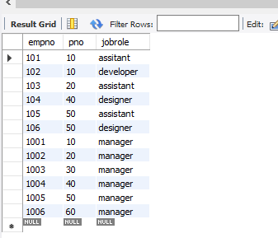

RETRIEVE THE EMPLOYEE NUMBERS OF ALL EMPLOYEES WHO WORK ON PROJECT LOCATED IN KOLKATA OR MUMBAI

SELECT A.EMPNO FROM ASSIGNEDTO A WHERE A.PNO IN (SELECT P.PNO FROM PROJECT P WHERE PLOC="KOLKATA" OR PLOC="MUMBAI");

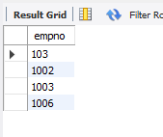

GET EMPLOYEE ID’S OF THOSE EMPLOYEES WHO DIDN’T RECEIVE INCENTIVES

SELECT E.EMPNO FROM EMPLOYEE E WHERE E.EMPNO NOT IN (SELECT I.EMPNO FROM INCENTIVES I);

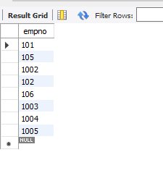

WRITE A SQL QUERY TO FIND THE EMPLOYEEES NAME, NUMBER, DEPT, JOBROLE, DEPARTMENT LOCATION AND PROJECT LOCATION WHO ARE WORKING FOR A PROJCT LOCATION SAME AS HIS/HER DEPARTMENT LOCATION

SELECT DISTINCT A.EMPNO, E.ENAME, E.DEPTNO, A.JOBROLE, D.DLOC ,P.PLOC FROM EMPLOYEE E,ASSIGNEDTO A,PROJECT P,DEPT D WHERE A.EMPNO=E.EMPNO AND A.PNO=P.PNO AND P.PLOC=D.DLOC;

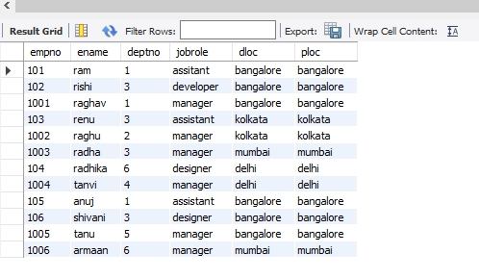

LIST THE NAME OF MANAGERS WITH THE MAXIMUM EMPLOYEES

SELECT E.MGRNO, COUNT (E.ENAME) AS NUMBEROFEMP FROM EMPLOYEE E , ASSIGNEDTO A WHERE E.MGRNO=A.EMPNO GROUP BY (E.MGRNO);

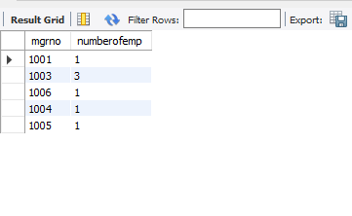

UPDATE INCENTIVES SET INCENTIVEAMT=25000 WHERE EMPNO=107;

FIND THE EMPLOYEE WHO GOT SECOND HIGHEST INCENTIVE IN THE YEAR 2025

SELECT I.EMPNO FROM INCENTIVES I WHERE 1 =(SELECT COUNT(INC.INCENTIVEAMT) FROM INCENTIVES INC WHERE INC.INCENTIVEAMT >I.INCENTIVEAMT AND (I.INCENTIVEDATE LIKE "2025%") );

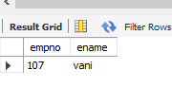

DISPLAY THOSE NAMES WHO ARE WORKING IN THE SAME DEPARTMENT WHERE HIS MANAGER IS WORKING

SELECT M.EMPNO , M.ENAME , M.DEPTNO , M.MGRNO FROM EMPLOYEE E ,EMPLOYEE M,DEPT D WHERE E.EMPNO =M.MGRNO AND M.DEPTNO=D.DEPTNO AND M.DEPTNO=E.DEPTNO;

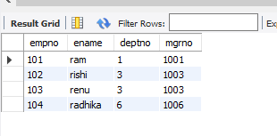

DISPLAY THOSE MANAGER NAME WHOSE SALARY IS MORE THAN THE AVERAGE SALARY OF HIS EMPLOYEE

SELECT A.EMPNO, E.ENAME, E.SALARY FROM ASSIGNEDTO A ,EMPLOYEE E WHERE A.EMPNO=E.EMPNO AND A.JOBROLE="MANAGER" AND E.SALARY> (SELECT AVG(EMP.SALARY) FROM EMPLOYEE EMP ,EMPLOYEE EM WHERE A.EMPNO=EM.MGRNO );

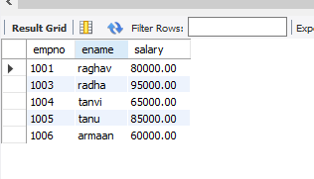

FIND THE NAME OF SECOND TOP LEVEL MANAGER OF EACH DEPARTMENT

SELECT E.ENAME,E.SALARY FROM EMPLOYEE E, ASSIGNEDTO A WHERE A.EMPNO=E.EMPNO AND 1=(SELECT COUNT(*) FROM EMPLOYEE EM WHERE EM.MGRNO IS NULL AND EM.SALARY>E.SALARY);

