SUPPLIER DATABASE
CREATE TABLES BY PROPERLY SPECIFYING THE PRIMARY KEYS AND THE FOREIGN KEYS.
CREATE DATABASE SUPPLIER_DATABASE;
USE SUPPLIER_DATABASE;
CREATE TABLE SUPPLIER (SID INT, SNAME VARCHAR (20),CITY VARCHAR(20), PRIMARY KEY(SID));
CREATE TABLE PARTS (PID INT, PNAME VARCHAR (20),COLOR VARCHAR(10),PRIMARY KEY(PID));
CREATE TABLE CATALOG(SID INT,PID INT,COST DECIMAL(10,2),PRIMARY KEY(SID,PID),FOREIGN KEY (SID) REFERENCES SUPPLIER(SID),FOREIGN KEY (PID) REFERENCES PARTS(PID));
INSERT APPROPRIATE RECORDS IN EACH TABLE.
INSERT INTO SUPPLIER VALUES(1,"RISHI","BANGALORE") ,(2,"ANURAG","KOLKATA") ,(3,"RAGHAV" ,"AYODHYA") ,(4,"TANU","MUMBAI"),(5,"ANUJ","AHMEDABAD");
SELECT * FROM SUPPLIER;
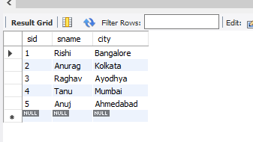
INSERT INTO PARTS VALUES (10,"NUTS","BLACK") ,(20,"SCREW","YELLOW"), (30,"SCREW","RED"), (40, "HAMMER", "BROWN"), (50,"NUTS","RED");
INSERT INTO PARTS VALUES (60,"BOLTS","BLACK");
SELECT * FROM PARTS;
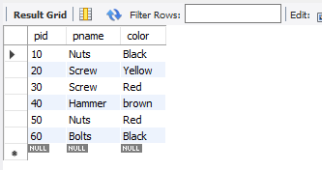
INSERT INTO CATALOG VALUES (1,10,1000) ,(1,20,5000), (1,30,2000), (1,40,4000), (1,50,10000), (2,10, 3000),(3,50,4400),(4,20,1100),(5,10,8000);
INSERT INTO CATALOG VALUES (1, 60, 4500);
INSERT INTO CATALOG VALUES (2, 20 ,6000);
SELECT * FROM CATALOG;
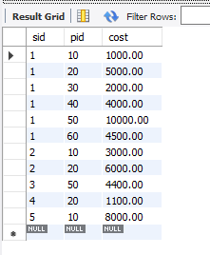
FIND THE PNAMES OF PARTS FOR WHICH THERE IS SOME SUPPLIER.
SELECT P.PNAME FROM PARTS P WHERE P.PID IN (SELECT C.PID FROM CATALOG C);
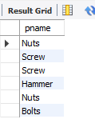
FIND THE SNAMES OF SUPPLIERS WHO SUPPLY EVERY PART.
SELECT C.SID , COUNT(*) FROM CATALOG C GROUP BY (C.SID) HAVING COUNT(*)=(SELECT COUNT(*) FROM PARTS);
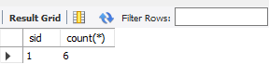
FIND THE SNAMES OF SUPPLIERS WHO SUPPLY EVERY RED PART.
SELECT S.SNAME FROM SUPPLIER S ,PARTS P,CATALOG C WHERE S.SID=C.SID AND P.PID=C.PID AND P.COLOR="RED" GROUP BY (S.SNAME) HAVING COUNT (*) =(SELECT COUNT(*) FROM PARTS PA WHERE PA.COLOR="RED");
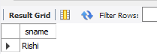
FIND THE PNAMES OF PARTS SUPPLIED BY RISHI AND BY NO ONE ELSE.
SELECT P.PNAME, P.PID FROM PARTS P , CATALOG C , SUPPLIER S WHERE P.PID=C.PID AND S.SID=C.SID AND S.SNAME="RISHI" AND P.PID NOT IN (SELECT CA.PID FROM CATALOG CA ,SUPPLIER SU WHERE CA.SID=SU.SID AND SU.SNAME <> "RISHI");
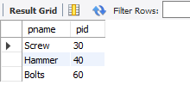
FIND THE SIDS OF SUPPLIERS WHO CHARGE MORE FOR SOME PART THAN THE AVERAGE COST OF THAT PART (AVERAGED OVER ALL THE SUPPLIERS WHO SUPPLY THAT PART).
SELECT DISTINCT C.SID FROM CATALOG C WHERE C.COST > (SELECT AVG (CA.COST) FROM CATALOG CA GROUP BY(C.PID));
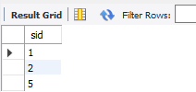
FOR EACH PART, FIND THE SNAME OF THE SUPPLIER WHO CHARGES THE MOST FOR THAT PART.
SELECT DISTINCT S.SID,S.SNAME,P.PID FROM SUPPLIER S,PARTS P ,CATALOG C WHERE C.PID=P.PID AND S.SID=C.SID AND C.COST =SOME (SELECT MAX(CA.COST) FROM CATALOG CA GROUP BY (CA.PID));
