MORE QUERIES ON EMPLOYEE DATABASE
USE EMPLOYEE_DATABASE;
INSERT INTO INCENTIVES VALUES (103,"2024-06-08",10000), (107,"2024-09-08",25000);
UPDATE INCENTIVES SET INCENTIVEAMT=12000 WHERE EMPNO=107;
INSERT INTO EMPLOYEE VALUES (108,"VEER",1001,"2025-07-11",60000,2);
UPDATE EMPLOYEE SET SALARY=68000 WHERE EMPNO=108;
INSERT INTO DEPT VALUES(7,"AEROSPACE ENGINEERING","BANGALORE");
INSERT INTO ASSIGNEDTO VALUES (101,20,"DESIGNER");
LIST EMPLOYEES WITH THEIR DEPARTMENT NAME & LOCATION
SELECT E.ENAME, D.DNAME,D.DLOC FROM EMPLOYEE E,DEPT D WHERE E.DEPTNO=D.DEPTNO;
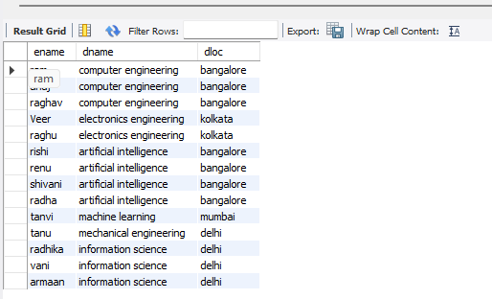
EMPLOYEES WHO ARE NOT ASSIGNED TO ANY PROJECT ,PROJECT-WISE HEADCOUNT
SELECT E.EMPNO ,E.ENAME FROM EMPLOYEE E WHERE E.EMPNO NOT IN (SELECT A.EMPNO FROM ASSIGNEDTO A);
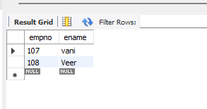
SELECT A.PNO, COUNT (*) AS PROJECT_WISE_HEAD_COUNT FROM ASSIGNEDTO A GROUP BY A.PNO;
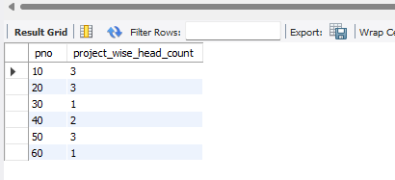
DEPARTMENT-WISE AVERAGE & MAX SALARY
SELECT E DEPTNO ,MAX (E.SALARY) AS MAXIMUM_SALARY,AVG(E.SALARY) AS AVERAGE_SALARY FROM EMPLOYEE E GROUP BY(E.DEPTNO);
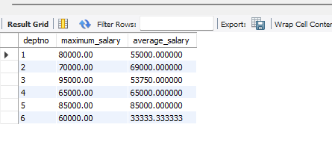
TOTAL INCENTIVES EARNED BY EACH EMPLOYEE
SELECT I.EMPNO,SUM(I.INCENTIVEAMT) AS TOTAL_INCENTIVE FROM INCENTIVES I GROUP BY(I.EMPNO);
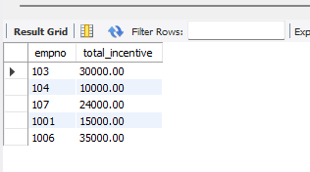
EMPLOYEES WORKING ON A GIVEN PROJECT
SELECT E.EMPNO,E.ENAME FROM EMPLOYEE E, PROJECT P, ASSIGNEDTO A WHERE E.EMPNO=A.EMPNO AND A.PNO=P.PNO AND P.PNAME="WEB APPLICATION";
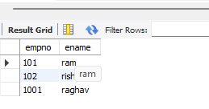
DEPARTMENTS WITH NO EMPLOYEES
SELECT D.DEPTNO FROM DEPT D WHERE D.DEPTNO NOT IN (SELECT DISTINCT E.DEPTNO FROM EMPLOYEE E);
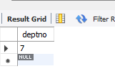
MANAGERS AND THEIR DIRECT REPORT COUNTS (MGR_NO REFERENCES EMPNO)
SELECT M.MGRNO , COUNT(M.MGRNO)AS REPORT_COUNT FROM EMPLOYEE E,EMPLOYEE M WHERE E.EMPNO =M.MGRNO GROUP BY(M.MGRNO);
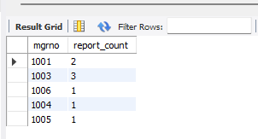
EMPLOYEES ASSIGNED TO MORE THAN ONE PROJECT
SELECT A.EMPNO,E.ENAME, COUNT(*) AS NO_OF_PROJECTS FROM EMPLOYEE E, ASSIGNEDTO A WHERE E.EMPNO=A.EMPNO GROUP BY (A.EMPNO) HAVING COUNT(*)>1;
