Maharashtra State Board of Technical Education

Government Polytechnic, Solapur

HOLIDAY RESORT WEBSITE

Program Name: Computer Course Name: Web page
Technology designing.
Program Code: 0015 Course Code: 312004

Maharashtra State Board of Technical Education

Government Polytechnic Solapur

CERTIFICATE

This is to certify following students of Diploma in Computer
Technology that they have satisfactorily completed the term work in subject
Webpage Designing for the academic year 2025- 2026 as prescribed in the
curriculum.

Roll  No. | Name | Enrollment No. | Exam Seat No.

Place: Solapur Date:

Subject Teacher Head of the Department Principal

ACKNOWLEDGEMENT

I would like to express my sincere gratitude to everyone who supported me in completing my project on “Holiday Resort Website Display Resort Information.” This project helped me understand the basics of website development using HTML and how to present information in a clear and attractive way.
I am thankful to my teacher for guiding me throughout the project and providing valuable suggestions whenever needed. Their support helped me improve my work and complete it successfully.
I would also like to thank my friends and family for encouraging me and helping me during the project. Their support kept me motivated.
Lastly, I thank all the resources and online materials that helped me learn and understand the concepts required to build this website.
This project gave me an opportunity to enhance my practical skills in creating responsive web pages, designing layouts, adding images, and presenting information in a structured way. I learned how to combine aesthetic design with functionality to create a website that effectively showcases resort information, facilities, and amenities for visitors.
I also acknowledge the use of online resources, tutorials, and reference websites that helped me understand web development concepts and implement them effectively in my project.
Finally, I would like to thank my family for their patience, support, and encouragement throughout the project work. Without their constant moral support, completing this project would have been much more difficult.
I hope this project will serve as a useful learning experience and a foundation for my future work in web development and design

INDEX

Sr.No | Topic | Page No.
1 | Cover page
2 | Certificate page
3 | Acknowledgments
4 | Introduction
5 | Objective
6 | Tools & Technology  used
7 | Project Descriptions
8 | Code Implementation
9 | Output Screenshots
10 | Challenges Faced
11 | Conclusion
12
13

INTRODUCTION

The Holiday Resort Website is designed to provide complete information about a resort in a simple and attractive way. In today’s digital world, most people search online before booking a vacation. This website helps users easily find details about the resort such as rooms, facilities, pricing, location, and contact information.

This project is developed using basic HTML to create a user-friendly interface. The main aim is to display resort information clearly so that visitors can understand the services offered without any confusion. It also helps improve basic web development skills and understanding of how websites are structured.

OBJECTIVES

To create a simple and attractive website for a holiday resort.
To display important resort information like rooms, services, and pricing.
To make the website easy to use and understand for users.
To learn and apply basic HTML concepts in real projects.
To improve skills in designing and organizing web content.

TOOLS & TECHNOLOGIES USED

HTML (HyperText Markup Language)
Used to create the structure of the website and display content like text, images, and headings.
CSS (Cascading Style Sheets) (optional if used)
Used to design and style the website, such as colors, layouts, fonts, and spacing.
Web Browser (Chrome / Edge / Firefox)
Used to run and view the website.
Code Editor (VS Code / Notepad++)
Used to write and edit the HTML and CSS code.
Images
Used to make the website attractive by showing resort rooms, views, and facilities.

PROJECT DESCRIPTION

The “Holiday Resort Website Display Resort Information” project is a basic website developed to present details about a holiday resort. The website includes different sections such as home, about the resort, rooms, facilities, gallery, and contact information.
The homepage gives a brief introduction to the resort along with attractive images. Other sections provide detailed information about room types, pricing, amenities like swimming pool, food services, and recreational activities. A gallery section displays images of the resort to attract visitors.

<html>
<head>
<title>Moshin Patel Resort</title>
<meta name="viewport" content="width=device-width, initial-scale=1">

<style>
body{margin:0;
font-family:Arial;
background:#f0f8ff}

nav{background:#0077b6;
color:white;
padding:15px;text-align:center}

nav a{color:white;
margin:10px;
text-decoration:none;
font-weight:bold}

.hero{
height:450px;
background:url("https://images.unsplash.com/photo-1507525428034-b723cf961d3e");
background-size:cover;
background-position:center;
color:white;
text-align:center;
padding-top:140px;
}

.btn{background:gold;
padding:12px 25px;
border:none}

section{padding:40px;
text-align:center}
h2{color:#0077b6}

.rooms{display:flex;
flex-wrap:wrap;
justify-content:center}

.room{
width:250px;margin:15px;
background:white;
border-radius:10px;
box-shadow:0 0 10px gray;
overflow:hidden
}
.room img{width:100%;
:150px}
.gallery img{width:200px;
margin:10px;
border-radius:10px}

.slideshow{max-width:700px;
margin:auto}
.slide{width:100%;
height:300px;
display:none;
border-radius:10px;
object-fit:cover}

input,textarea{width:70%;
padding:10px;
margin:10px}
button{padding:10px}

@media(max-width:600px){
.room{width:90%}
.gallery img{width:90%}
}
</style>
</head>

<body>

<nav>
<h2><Moshin Patel Resort</h2>
<a href="#home">Home</a>
<a href="#about">About</a>
<a href="#rooms">Rooms</a>
<a href="#contact">Contact</a>
</nav>

<div class="hero" id="home">
<h1>Azure Paradise Resort</h1>
<p>Escape Into Luxury • Experience the Ocean</p>
<button class="btn">Book Now</button>
</div>

<section>
<h2>Enjoy Every Moment</h2>

<div class="slideshow">
<img class="slide" src="https://images.unsplash.com/photo-1507525428034-b723cf961d3e">
<img class="slide" src="https://images.unsplash.com/photo-1596464716127-f2a82984de30">
<img class="slide" src="https://images.unsplash.com/photo-1559339352-11d035aa65de">
<img class="slide" src="https://images.unsplash.com/photo-1501117716987-c8e1ecb210b5">
</div>

<p>🏖 Beach Fun | 👶 Kids Playing | 🍽 Family Dining | 🏊 Pool Enjoyment</p>
</section>

<section id="about">
<h2>About Resort</h2>
<p>
Moshin Patel Resort offers a perfect holiday experience with beautiful beach views,
luxury comfort, and fun activities for families. Enjoy relaxation, delicious dining,
and unforgettable moments in a peaceful environment.
</p>
</section>

<section id="rooms">
<h2>Rooms</h2>

<div class="rooms">

<div class="room">
<img src="https://images.unsplash.com/photo-1566665797739-1674de7a421a">
<h3>Deluxe Room</h3>
<p>₹5000 / night</p>
</div>

<div class="room">
<img src="https://images.unsplash.com/photo-1582719478250-c89cae4dc85b">
<h3>Suite Room</h3>
<p>₹8000 / night</p>
</div>

<div class="room">
<img src="https://images.unsplash.com/photo-1618773928121-c32242e63f39">
<h3>Luxury Villa</h3>
<p>₹12000 / night</p>
</div>

</div>
</section>

<section>
<h2>Facilities</h2>

<div style="display:flex;justify-content:center;flex-wrap:wrap;gap:15px;">

<div style="width:180px;background:white;border-radius:10px;box-shadow:0 0 8px gray;overflow:hidden;">
<img src="https://images.unsplash.com/photo-1572331165267-854da2b10ccc" style="width:100%;height:120px;object-fit:cover;">
<h4 style="margin:10px;">🏊 Pool</h4>
</div>

<div style="width:180px;background:white;border-radius:10px;box-shadow:0 0 8px gray;overflow:hidden;">
<img src="https://images.unsplash.com/photo-1414235077428-338989a2e8c0" style="width:100%;height:120px;object-fit:cover;">
<h4 style="margin:10px;">🍽 Restaurant</h4>
</div>

<div style="width:180px;background:white;border-radius:10px;box-shadow:0 0 8px gray;overflow:hidden;">
<img src="https://images.unsplash.com/photo-1503454537195-1dcabb73ffb9" style="width:100%;height:120px;object-fit:cover;">
<h4 style="margin:10px;">👶 Kids Area</h4>
</div>

<div style="width:180px;background:white;border-radius:10px;box-shadow:0 0 8px gray;overflow:hidden;">
<img src="https://images.unsplash.com/photo-1507525428034-b723cf961d3e" style="width:100%;height:120px;object-fit:cover;">
<h4 style="margin:10px;">🏖 Beach</h4>
</div>

</div>
</section>
<section>
<h2>Gallery</h2>
<div class="gallery">
<img src="https://images.unsplash.com/photo-1507525428034-b723cf961d3e">
<img src="https://images.unsplash.com/photo-1596464716127-f2a82984de30">
<img src="https://images.unsplash.com/photo-1559339352-11d035aa65de">
<img src="https://images.unsplash.com/photo-1501117716987-c8e1ecb210b5">
</div>
</section>

<section id="contact">
<h2>Contact</h2>

<form onsubmit="return checkForm()">
<input type="text" id="name" placeholder="Name"><br>
<input type="email" id="email" placeholder="Email"><br>
<textarea id="msg" placeholder="Message"></textarea><br>
<button>Send</button>
</form>

</section>

<script>
function checkForm(){
var n=document.getElementById("name").value;
var e=document.getElementById("email").value;
var m=document.getElementById("msg").value;

if(n==""||e==""||m==""){
alert("Fill all fields");
return false;
}
alert("Message Sent");
return true;
}

let i=0;
show();

function show(){
let s=document.getElementsByClassName("slide");
for(let j=0;j<s.length;j++){
s[j].style.display="none";
}
i++;
if(i>s.length){i=1;}
s[i-1].style.display="block";
setTimeout(show,2000);
}
</script>

</body>
</html>

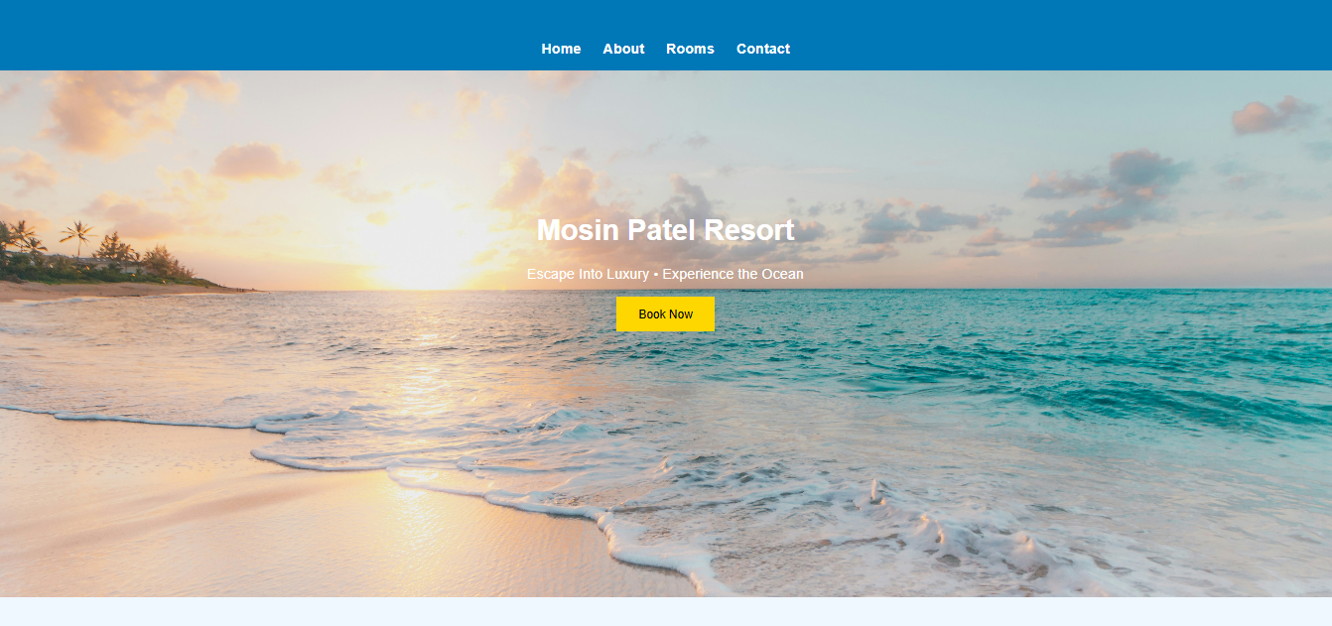

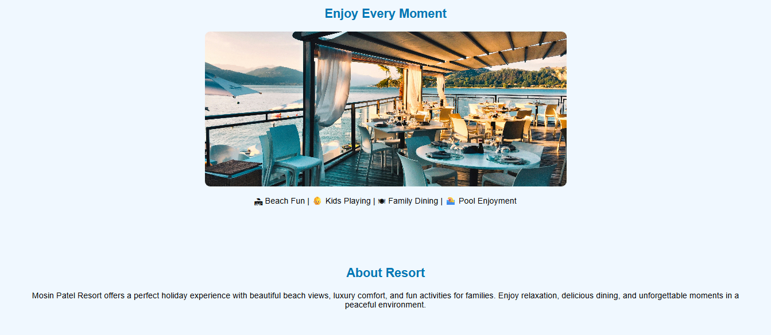

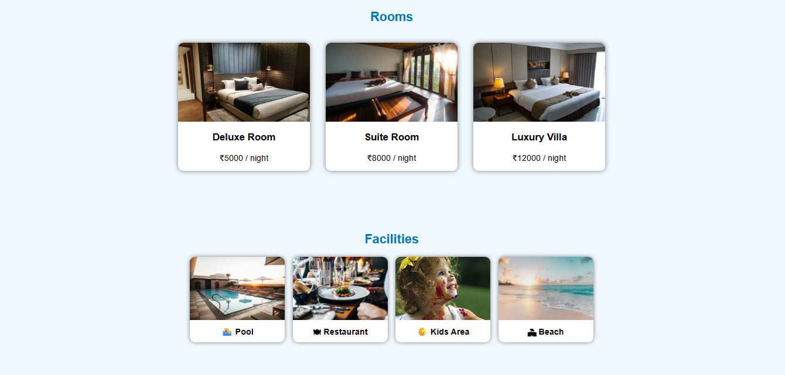

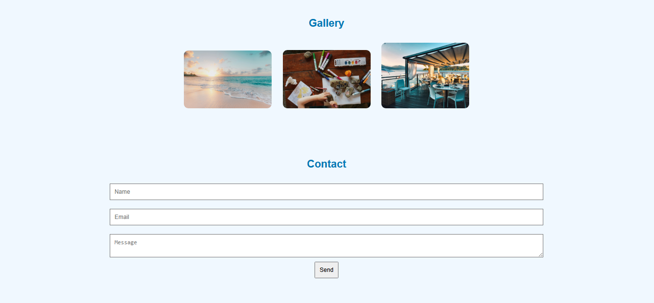
CHALLENGES FACED

Designing the Layout
It was challenging to decide how to arrange different sections like homepage, rooms, and contact details in a proper structure.
Understanding HTML Tags
Initially, it was difficult to understand and use different HTML tags correctly.
Adding Images Properly
Managing image size, alignment, and placement on the webpage was a bit confusing.
Making the Website Attractive
Creating a visually appealing design using basic HTML (and CSS if used) required practice.
Navigation Between Sections
Linking different parts of the website smoothly was a challenge.
Debugging Errors
Small mistakes in code sometimes caused errors, which took time to find and fix.
Time Management
Completing the project within the given time while learning new concepts was also a challenge.

CONCLUSION

The “Holiday Resort Website Display Resort Information” project was successfully completed using basic HTML (and CSS if applied). This project helped in understanding how to create a simple and user-friendly website to display important information about a resort.
Through this project, I learned how to structure a webpage, add images, and organize content in a clear and attractive way. It also improved my knowledge of web development and problem-solving skills while handling errors.
Overall, this project was a good learning experience and provided practical knowledge about designing websites. The website created can be further improved by adding advanced features like online booking and better styling in the future.

REFERENCES

- W3Schools Website
https://www.w3schools.com/⁠�
(Used for learning HTML and basic web development concepts)
- MDN Web Docs
https://developer.mozilla.org/⁠�
(Used for understanding HTML tags and their usage)
- YouTube Tutorials
(Various videos used for learning website design and HTML basics)
- Google Search
(Used for finding images and additional information about resort websites)
- Sample Resort Websites
(Referred to for design ideas and layout structure)

