Contents as per syllabus:

- Bipolar junction Transistor (BJT)
  - Introduction to BJT
  - Need to Study BJT
  - Constructional Details of BJT
  - Working Principle of BJT
  - Operating regions of BJT
  - Types of BJT
  - Configurations of BJT
1.7.1 Common Base Configuration
1.7.2 Common Emitter Configuration
1.7.3 Common Collector Configuration
  - Advantages & Disadvantages of BJT
  - Applications of BJT
  - BJT as a Switch

- Bipolar Junction Transistor (BJT)
  - Introduction to Transistors
- The basic of electronic system nowadays is semiconductor device.
- A transistor is a 3 terminal electronic device made of semiconductor material.
- A bipolar junction transistor is a three-terminal semiconductor device that consists of two p-n junctions which are able to amplify or magnify a signal.
- It is a current controlled device. The three terminals of the BJT are the base, the collector, and the emitter.
- A signal of a small amplitude applied to the base is available in the amplified form at the collector of the transistor.
- This is the amplification provided by the BJT. Note that it does require an external source of DC power supply to carry out the amplification process.
- Transistors have many uses, including amplification, switching, voltage regulation, and the modulation of signals

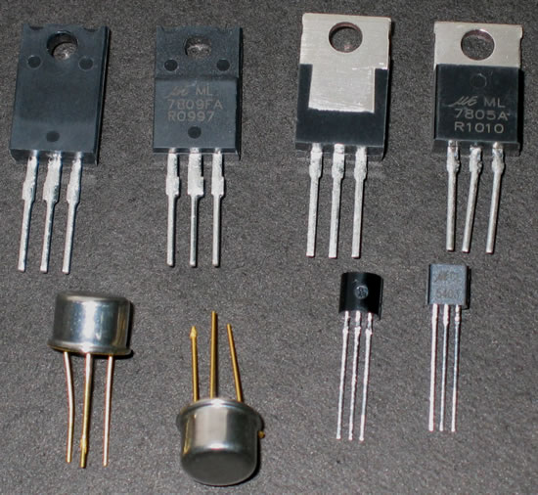

Fig. 1.1.1. Transistors

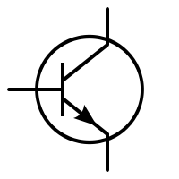

Fig. 1.1.2. Symbol of BJT
  - Need to Study BJT
The main basic function of a BJT is to amplify current. This allows BJTs to be used as amplifiers or switches to produce wide applicability in electronic equipment including mobile phones, industrial control, television, and radio transmitters.

  - Constructional Details of BJT
A transistor is basically a Si or Ge crystal containing three separate regions.

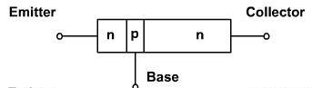

Fig. 1.3.1. Construction of BJT
- The bipolar junction transistor (BJT) is constructed with three doped semiconductor regions separated by two p-n junctions
- Regions are called emitter, base and collector
- The depletion layers do not have the same width, because different regions have different doping levels.
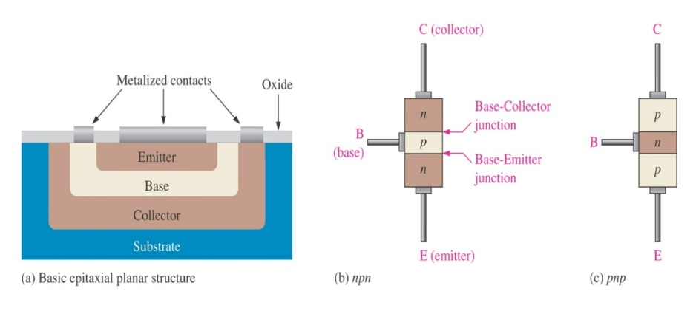
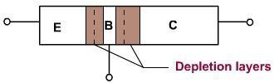

- 3-layer semiconductor device consisting:
2 n- and 1 p-type layers of material npn transistor
- 2p- and 1 n-type layers of material pnp transistor
- The term bipolar reflects the fact that holes and electrons participate in the injection process into the oppositely polarized material
- A single p-n junction has two different types of bias:
  - Forward bias
  - Reverse bias
Thus, a two-p-n-junction device has four types of bias.
- BJT consists of three terminals:
Collector: C
Base: B
Emitter: E
- Base is located at the middle and thinner from the level of collector and emitter
- The emitter and collector terminals are made of the same type of semiconductor
material, while the base of the other type of material

  - Working Principle of BJT:
- The basic operation will be described using the pnp transistor. The operation of the pnp transistor is exactly the same if the roles played by the electron and hole are

interchanged.
- One p-n junction of a transistor is reverse-biased, whereas the other is forward-biased.
- Both biasing potentials have been applied to a pnp transistor and resulting majority and minority carrier flows indicated.
- Majority carriers (+) will diffuse across the forward-biased p-n junction into the n-type material.
- A very small number of carriers (+) will through n-type material to the base terminal. Resulting IB is typically in order of microamperes.
- The large number of majority carriers will diffuse across the reverse-biased junction into the p-type material connected to the collector terminal.
- Majority carriers can cross the reverse-biased junction because the injected majority carriers will appear as minority carriers in the n-type material.

- Applying KCL to the transistor:
- I_{E} = I_{C} + I_{B}
- It comprises of two components – the majority and minority carriers
I_{C} = I_{Cmajority} + I_{COminority}
I_{CO} – I_{C} current with emitter terminal open and is called leakage current.
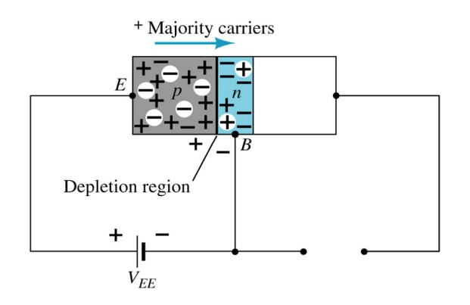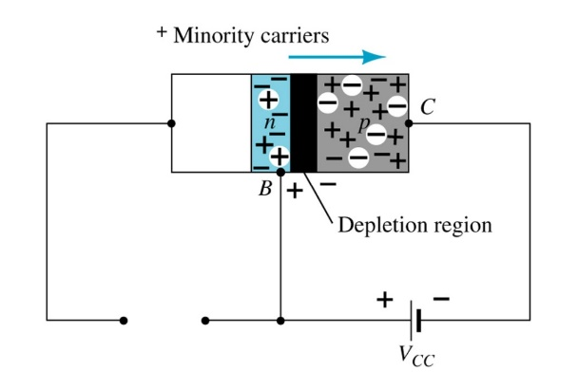
Reverse-biased junction
of a pnp transistor
Forward-biased junction
of a pnp transistor

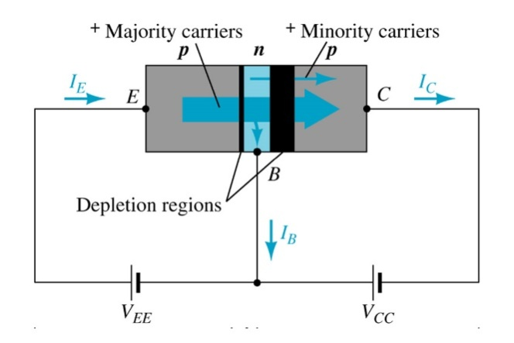
Fig. 1.4.1. Working Principle of BJT

  - Operating regions of BJT

- BJT will operates in one of following three regions:
Cutoff region (for digital circuit)
Saturation region (for digital circuit)
Linear (active) region (to be an amplifier)
- In order to operate transistor in one of these regions, we have to supply dc voltage to the npn or pnp transistor. Based on the polarity of the applied dc voltage, the transistor operates in any one of these regions. Applying dc voltage to the transistor is nothing but the biasing of transistor.

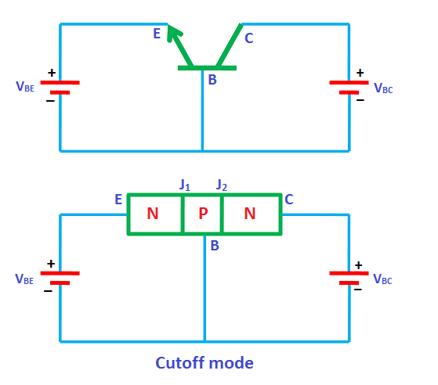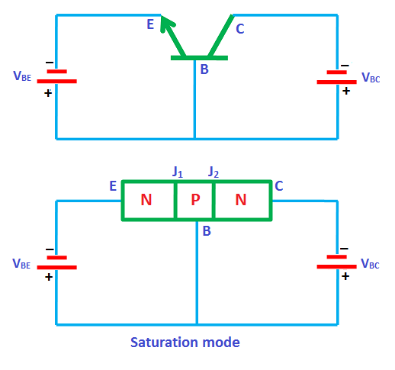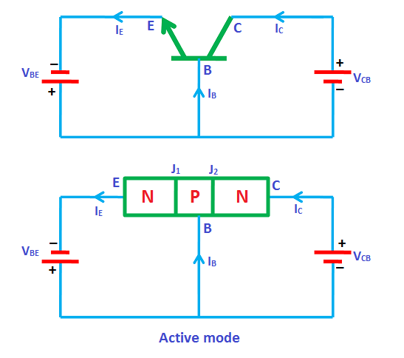
Fig. 1.5.1 Operating Principle of BJT

- Cutoff mode
- In the cutoff mode, both the junctions of the transistor (emitter to base and collector to base are reverse biased.
- In other words, if we assume two p-n junctions as two p-n junction diodes, both the diodes are reverse biased in cutoff mode.
- We know that in reverse bias condition, no current flows through the device. Hence, no current flows through the transistor.
- Therefore, the transistor is in off state and acts like an open switch. The cutoff mode of the transistor is used in switching operation for switch OFF application.

- Saturation mode
In the saturation mode, both the junctions of the transistor (emitter to base and collector to base) are forward biased. In other words, if we assume two p-n junctions as two p-n junction diodes, both the diodes are forward biased in saturation mode. We know that in forward bias condition, current flows through the device. Hence, electric current flows through the transistor.

In saturation mode, free electrons (charge carriers) flows from emitter to base as well as

from collector to base. As a result, a huge current will flow to the base of transistor.
Therefore, the transistor in saturation mode will be in on state and acts like a closed switch.
The saturation mode of the transistor is used in switching operation for switch ON application.
From the above discussion, we can say that by operating the transistor in saturation and cutoff region, we can use the transistor as an ON/OFF switch.

- Active mode
In the active mode, one junction (emitter to base) is forward biased and another junction (collector to base) is reverse biased. In other words, if we assume two p-n junctions as two p-n junction diodes, one diode will be forward biased and another diode will be reverse biased. The active mode of operation is used for the amplification of current.

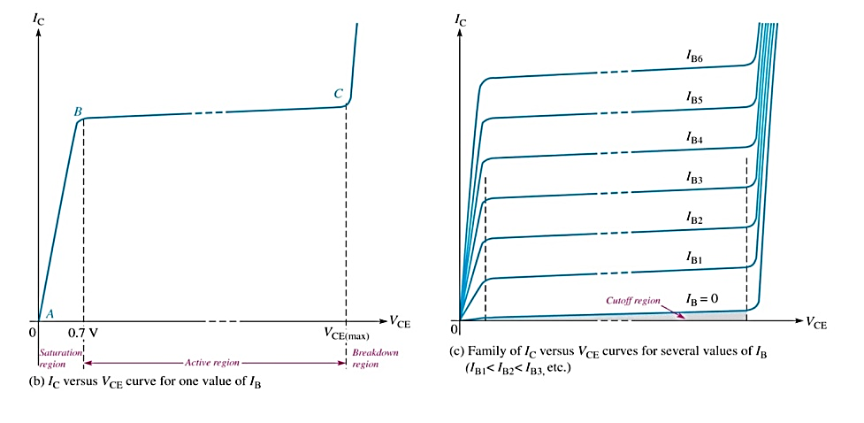
Fig. 1.5.1. V/I Characteristics of BJT

  - Types of BJTs
∗NPN
* PNP
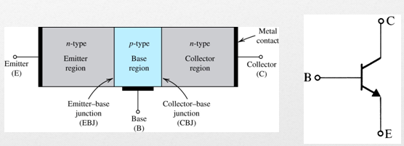
Fig. 1.6.1. Simplified architecture and symbol of npn transistor

- Conduction through electrons.

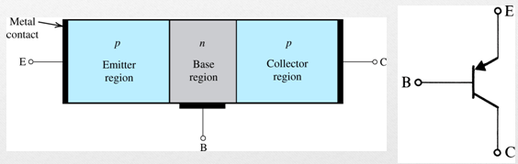
Fig. 1.6.2. Simplified structure and symbol of pnp transistor
- Conduction through holes.

  - Configurations in BJT

    - Common base Configuration
- Common-base terminology is derived from the fact that the:
- base is common to both input and output of the configuration.
- base is usually the terminal closest to or at ground potential.
- All current directions will refer to conventional (hole) flow and the arrows in all electronic symbols have a direction defined by this convention.

- Note that the applied biasing (voltage sources) is such as to establish current in the direction indicated for each branch.
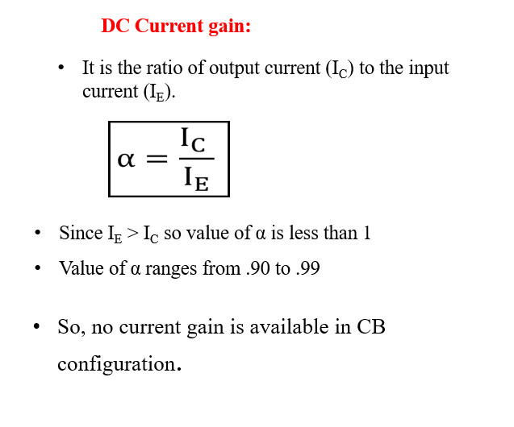
- To describe the behavior of common-base amplifiers requires two set of characteristics:
Input or driving point characteristics.
Output or collector characteristics
- The output characteristics has 3 basic regions:
- Active region –defined by the biasing arrangements
- Cutoff region – region where the collector current is 0A
- Saturation region- region of the characteristics to the left of V_{CB} = 0V
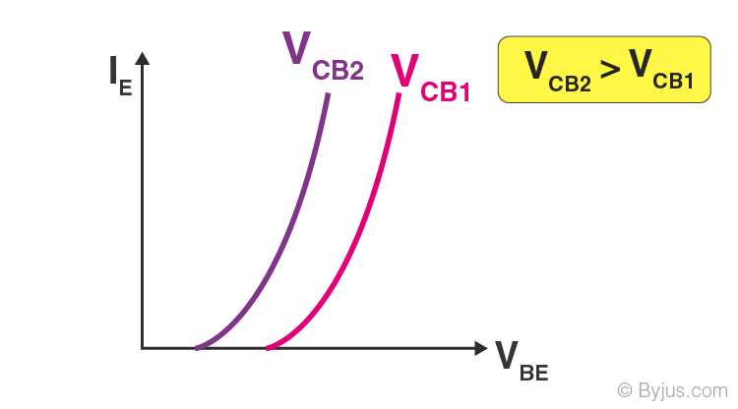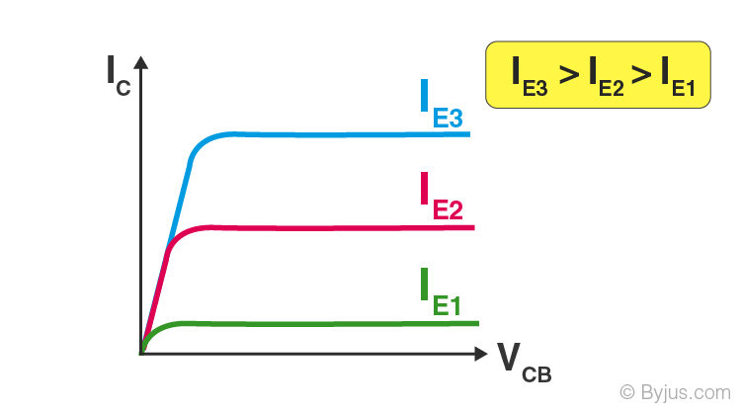
Input characteristics Output characteristics

Fig. 1.7.1 V/I CHARACTERISTICS

    - Common emitter Configuration
- It is called common-emitter configuration since:
- - Emitter is common or reference to both input and output terminals.
- - Emitter is usually the terminal closest to or at ground potential.
- Almost amplifier design is using connection of CE due to the high gain for current and voltage.

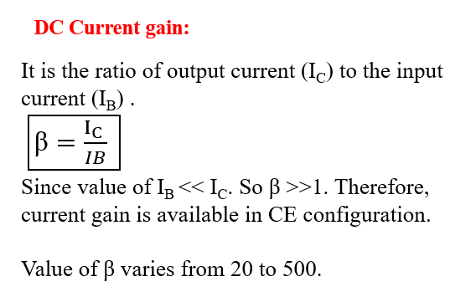
- Two set of characteristics are necessary to describe the behavior for CE input (base terminal) and output (collector terminal) parameters.
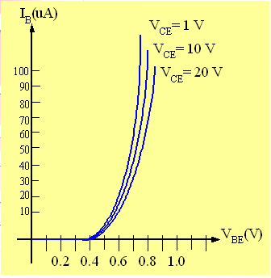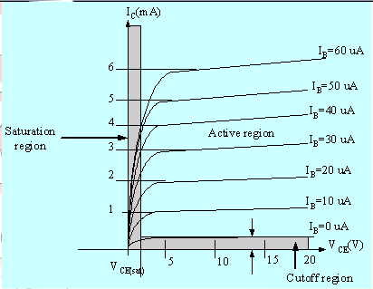
Input characteristics Output characteristics
Fig. 1.7.2 V/I CHARACTERISTICS

1.7.3 Common collector Configuration
- Also called emitter-follower (EF).
- It is called common-emitter configuration since both the
- Signal source and the load share the collector terminal as a common connection point.
- The output voltage is obtained at emitter terminal.
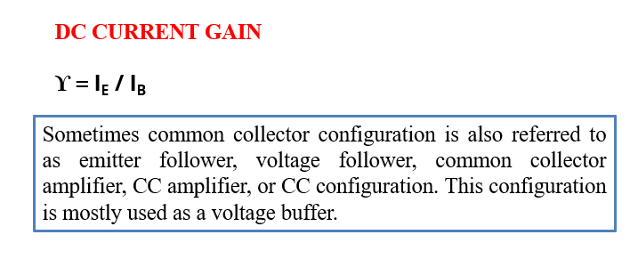
- The input characteristic of common-collector configuration is similar with common-emitter configuration.
- Common-collector circuit configuration is provided with the load resistor connected from emitter to ground.
- It is used primarily for impedance-matching purpose since it has high input impedance and low output impedance.

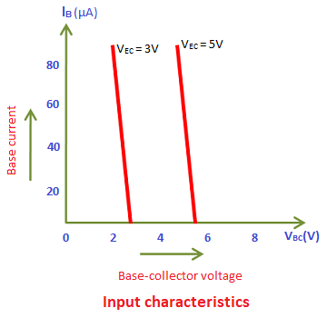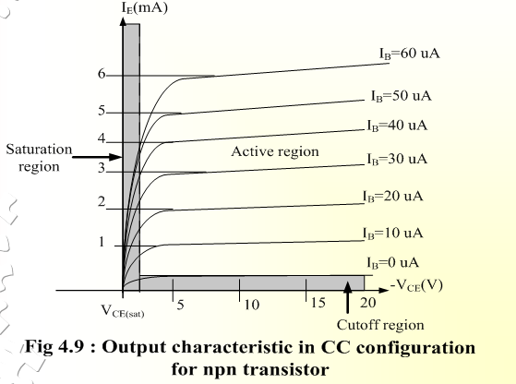

Fig. 1.7.1 V/I CHARACTERISTICS

  - Advantages & Disadvantages of BJT
Advantages:
There are some advantages of BJT (bipolar junction transistor) which are given below:

- The BJT has a large gain bandwidth.
- It shows better performance at high frequency.
- It has a better voltage gain.
- It can be operated in low or high-power applications.
- It has high current density.
- There is a low forward voltage drop.
Disadvantages:
- It affects by radiation.
- It generates more noise.
- It has less thermal stability.
- Base control of BJT is very complex.
- Switching frequency is low & high complex control.
- The switching time of BJT is low as compared with voltage & current with high alternating frequency.

  - Applications of BJTs
- The bipolar junction transistor (BJT) is used in logic circuits.
- The BJT is used as an oscillator.
- It is used as an amplifier.
- It is used as a multivibrator.
- For wave shaping it is used in clipping circuits.
- Used as a detector or demodulator.
- It is also used as modulator.
- Used in timer and time delay circuits.
- It is used in electronics switch.
- It is used in switching circuits.

1.10 The BJT as a Switch
As mentioned in the previous lecture, the first major application for a BJT is a switching application. When used as an electronic switch, a BJT is normally operated alternately in cutoff and saturation. Many digital circuits use the BJT as a switch, where 0 V means logic 0 (cutoff = open circuit) and +5 V means logic 1 (saturation = short circuit).
From the above discussion, we can say that the transistor works as an ON/OFF switch in saturation and cutoff modes whereas it works as an amplifier of current in active mode.

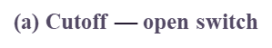
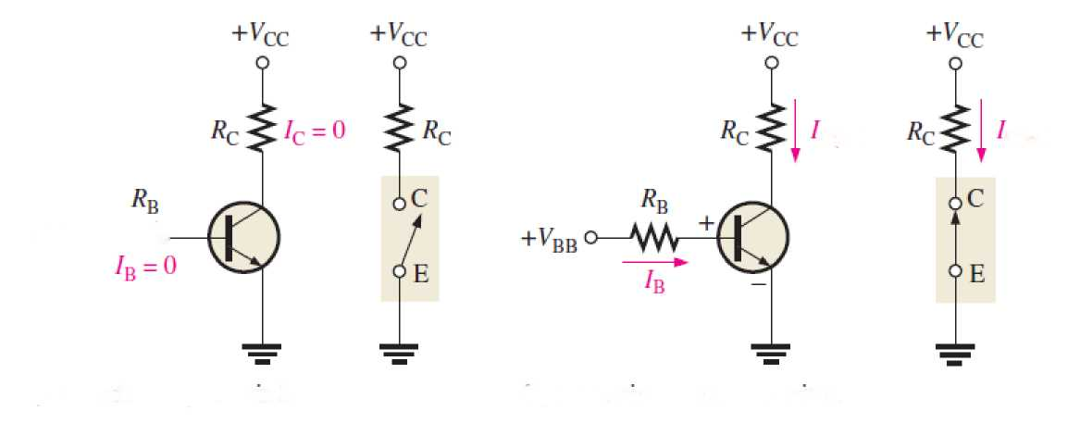
Fig. 1.10.1 BJT AS A SWITCH

Contents:

2 Field Effect Transistor (FET)
  - Introduction to FET
  - Differences between BJT and FET
  - Advantages of FET
  - Need to study FET
  - JFET
2.5.1 N-channel JFET
2.5.2 P-channel JFET
  - . JFET characteristic curve
  - Operation of N-channel JFET
  - Transfer characteristics
  - MOSFET
  - Types of MOSFET
2.10.1 Basic MOSFET structure and symbol
2.10.2 Enhancement mode MOSFET
2.10.3 Depletion mode MOSFET
2.11. Working of MOSFET
2.12. I-V characteristics.
2.13. CMOS: Construction.
2.14. CMOS: Working Principle and Characteristics.
2.15. CMOS: NOT, NAND & NOR implementation using CMOS.

- Field Effect Transistors (FET)
  - Introduction to Field Effect Transistors
- Field-effect transistor (FET) is important devices such as BJTs.
- Also used as amplifier and logic switches.
- Types of FET: JFET (Junction field effect transistor)
MOSFET (Metal-oxide-semiconductor field-effect transistor)

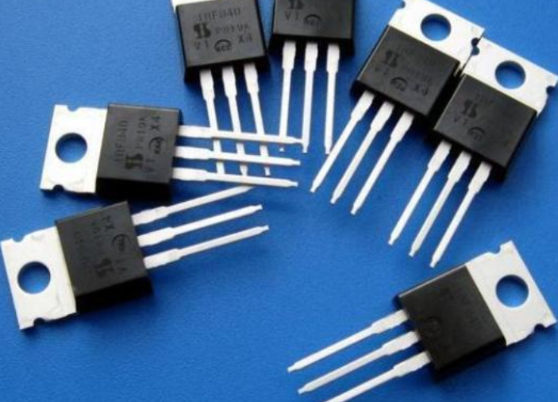
Fig. 1 Field Effect Transistors

  - Difference between BJT and FET
BJT | FET
It is bipolar device i.e. operation depends on majority and minority carriers both. | It is unipolar device i.e. operation depends on majority carriers only.
Current controlled device i.e. output is controlled by current. | Voltage controlled device i.e. output is controlled by voltage.
Input resistance is very low. | Input resistance is very high.
Temperature dependent due to minority carriers. | Temperature independent due to absence of minority carriers.
Power consumption is high. | Power consumption is low.
More noisy. | Less noisy.
Cost is low. | Cost is high.
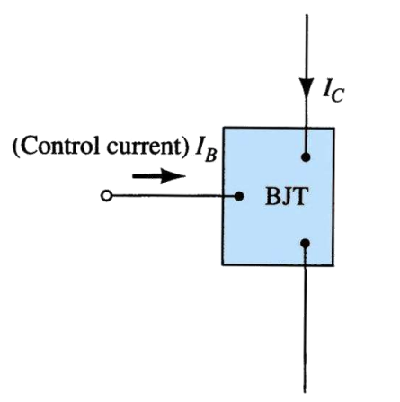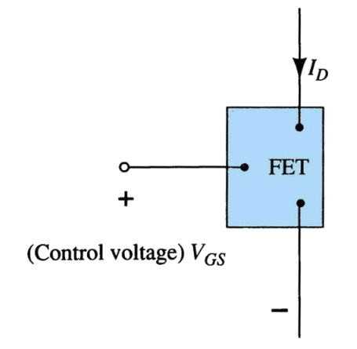
- BJT (b) FET
Fig. 2 Schematic Representation of BJT and FET
- BJT is a bipolar device.
- FET is a unipolar device.

  - Advantages of FET over BJT
- High input impedance (Linear AC amplifier system)
- Temperature stable than BJT
- Smaller than BJT
- Can be fabricated with fewer processing
- BJT is bipolar – conduction both hole and electron
- FET is unipolar – uses only one type of current carrier
- Less noise compare to BJT
- Usually use as logic switch

  - Need to study Field Effect Transistor
- A field-effect transistor (FET) is a type of transistor commonly used for weak-signal amplification (for example, for amplifying wireless signals).
- The device can amplify analog or digital signals.
- It can also switch DC or function as an oscillator.

  - Junction Field Effect Transistor (JFET)
- There are 2 types of JFET : n-channel JFET
P-channel JFET
- It is a Three Terminal device: Drain – D
Gate -G
Source – S
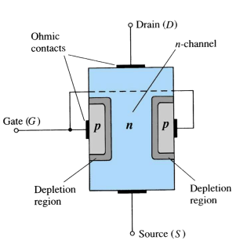
Fig. 3. JFET
    - N-Channel JFET
- Major structure is n-type material (channel) between embedded p-type material to form 2 p-n junction.
- In the normal operation of an n-channel device, the Drain (D) is positive with respect to the Source (S). Current flows into the Drain (D), through the channel, and out of the Source (S).
- Because the resistance of the channel depends on the gate-to-source voltage (VGS), the drain current (ID) is controlled by that voltage.
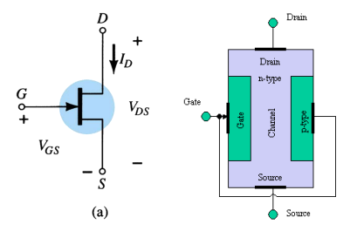
Fig. 4. N-Channel JFET
    - P-Channel JFET
- Major structure is p-type material (channel) between embedded n-type material to form 2 p-n junction.
- Current flow: from Source (S) to Drain (D).
- Holes injected to Source (S) through p-type channel and flowed to Drain (D).
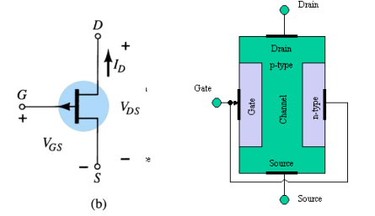
Fig. 5. P-Channel JFET
  - JFET Characteristic curve
- To start, suppose VGS=0.
- Then, when VDS is increased, ID increases.
- Therefore, ID is proportional to VDS for small values of VDS.
- For larger value of VDS, as VDS increases, the depletion layer become wider, causing the resistance of channel increases.
- After the pinch-off voltage (Vp ) is reached, the ID becomes nearly constant (called as ID maximum, IDSS-Drain to Source current with Gate Shorted).
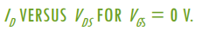
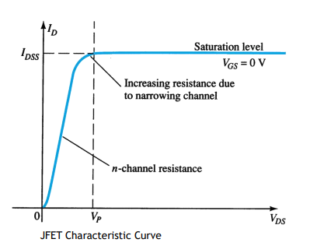
Fig. 6. I_{D} versus V_{DS} curve for V_{GS}=0 V
- The channel becomes narrower as V_{DS} is increased.
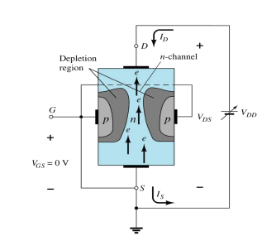
Fig. 7. Channel for large V_{DS}.
- When pinch-off is reached the two depletion regions coincide.

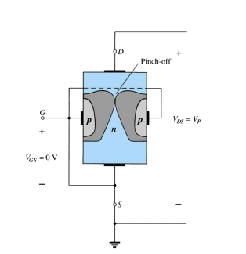
Fig. 8. Channel for pinch-off condition.
- For negative values of VGS, the gate-to-channel junction is reverse biased even with VDS=0.
- Thus, the initial channel resistance is higher (in which the initial slope of the curves is smaller for values of VGS closer to the pinch-off voltage (VP ).
- The resistance value is under the control of VGS.
- If VGS is less than pinch-off voltage, the resistance becomes an open-circuit ;therefore the device is in cutoff (VGS=VGS(off) ).

- The region where ID constant – The saturation/pinchoff region.

- The region where ID depends on VDS is called the linear/triode/ohmic region.

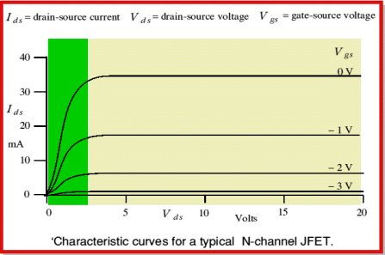
Fig. 9: Characteristics for N-channel JFET.
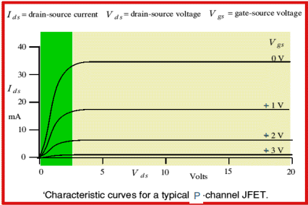
Fig. 10: Characteristics for P-channel JFET.
  - Operation of N-channel JFET
- JFET is biased with two voltage sources: VDD
VGG
- VDD generate voltage bias between Drain (D) and Source (S) – VDS.
- VDD causes drain current, ID flows from Drain (D) to Source (S).
- VGG generate voltage bias between Gate (G) and Source (S) with negative polarity source is connected to the Gate Junction (G) – reverse-biases the gate; therefore gate current, IG = 0.

- VGG is to produce depletion region in N channel so that it can control the amount of drain current, ID that flows through the channel.
  - Transfer Characteristics
- The input-output transfer characteristic of the JFET is not as straight forward as it is for the BJT.
- In BJT:
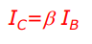
- In JFET, the relationship between VGS (input voltage) and ID (output current) is used to define the transfer characteristics. It is called as Shockley’s Equation:
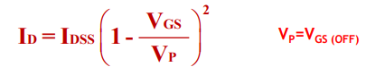
- The relationship is more complicated (and not linear) .As a result, FET’s are often referred to a square law devices.
- Obtaining transfer characteristic curve axis point from Shockley:
When VGS = 0 V, ID = IDSS
When VGS = VGS(off) or Vp , ID = 0 mA
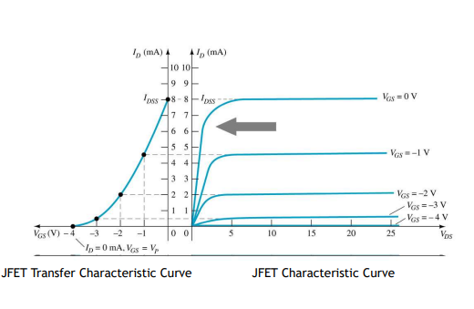
Fig. 11: Transfer characteristics.
  - MOSFET
- MOSFET is a voltage controlled field effect transistor that differs from a JFET in that it has a “Metal Oxide” Gate electrode which is electrically insulated from the main semiconductor n-channel or p-channel by a very thin layer of insulating material usually silicon dioxide, commonly known as glass.

- This ultra thin insulated metal gate electrode can be thought of as one plate of a capacitor.
- The isolation of the controlling Gate makes the input resistance of the MOSFET extremely high way up in the Mega-ohms (MΩ) region thereby making it almost infinite.
- As the Gate terminal is isolated from the main current carrying channel “NO current flows into the gate” and just like the JFET, the MOSFET also acts like a voltage controlled resistor were the current flowing through the main channel between the Drain and Source is proportional to the input voltage.
- Also like the JFET, the MOSFETs very high input resistance can easily accumulate large amounts of static charge resulting in the MOSFET becoming easily damaged unless carefully handled or protected.
- Characteristics of MOSFET : 1. Bilaterally Symmetric device
2. Unipolar device
3. High Input Impedance
4. Voltage Controlled
5. Self Isolated
- MOS transistor performs very well as a switch; it introduces very few parasitic effects, simple integration density, simple manufacturing process which make it possible to produce large and complex circuits in an economical way.
- MOSFETs are three terminal devices with a Gate, Drain and Source and both P-channel (PMOS) and N-channel (NMOS) MOSFETs are available.
- n-Channel MOS : Majority carriers are electrons.
- p-Channel MOS : Majority carriers are holes.
    - Types Of MOSFET
- The MOSFET’s are available in two basic forms:
1. Depletion Type – The transistor requires the Gate-Source voltage, ( VGS ) to switch the device “OFF”. The depletion mode MOSFET is equivalent to a “Normally Closed” switch.
2. Enhancement Type – the transistor requires a Gate-Source voltage, ( VGS ) to switch the device “ON”. The enhancement mode MOSFET is equivalent to a “Normally Open” switch.
- The symbols and basic construction for both configurations of MOSFETs are shown below:
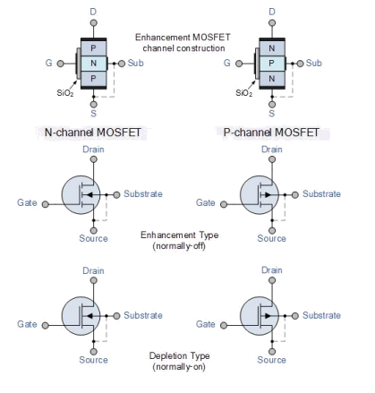
Fig 12: Construction and symbols of MOS transistors.
- The four MOSFET symbols above show an additional terminal called the Substrate and it is not normally used as either an input or an output connection but instead it is used for grounding the substrate.
- It connects to the main semiconductive channel through a diode junction to the body or metal tab of the MOSFET. Usually in discrete type MOSFETs, this substrate lead is connected internally to the source terminal.
- As in enhancement types, it can be omitted from the symbol for clarification. The line between the drain and source connections represents the semiconductive channel.
- If this is a solid unbroken line then this represents a “Depletion” (normally-ON) type MOSFET as drain current can flow with zero gate potential.
- If the channel line is shown dotted or broken it is an “Enhancement” (normally-OFF) type MOSFET as zero drain current flows with zero gate potential. The direction of the arrow indicates whether the conductive channel is a p-type or an n-type semiconductor device.

  - Basic MOSFET structure and symbol
- The construction of the Metal Oxide Semiconductor FET is very different to that of the Junction FET.
- Both the Depletion and Enhancement type MOSFETs use an electrical field produced by a gate voltage to alter the flow of charge carriers, electrons for n-channel or holes for P-channel, through the semiconductive drain-source channel.
- The gate electrode is placed on top of a very thin insulating layer and there are a pair of small n-type regions just under the drain and source electrodes.
- Figure 13 below represents the basic MOSFET structure.
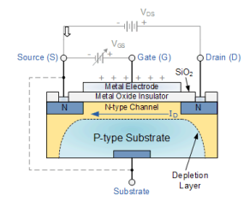
Fig.13: Basic MOSFET structure.
- The gate of a junction field effect transistor, JFET must be biased in such a way as to reverse-bias the pn-junction.
- With a insulated gate MOSFET device no such limitations apply so it is possible to bias the gate of a MOSFET in either polarity, positive (+ve) or negative (-ve).
- This makes the MOSFET device especially valuable as electronic switches or to make logic gates because with no bias they are normally non-conducting and this high gate input resistance means that very little or no control current is needed as MOSFETs are voltage controlled devices.
- Both the p-channel and the n-channel MOSFETs are available in two basic forms, the Enhancement type and the Depletion type.
    - Enhancement Mode MOSFET
- The more common Enhancement-mode MOSFET or eMOSFET, is the reverse of the depletion-mode type.

- Here the conducting channel is lightly doped or even undoped making it non-conductive.
- This results in the device being normally “OFF” (non-conducting) when the gate bias voltage, VGS is equal to zero.
- The circuit symbol shown above for an enhancement MOS transistor uses a broken channel line to signify a normally open non-conducting channel.
- For the n-channel enhancement MOS transistor a drain current will only flow when a gate voltage (VGS) is applied to the gate terminal greater than the threshold voltage (VTH) level in which conductance takes place making it a transconductance device.
- The application of a positive (+ve) gate voltage to n-type E-MOSFET attracts more electrons towards the oxide layer around the gate thereby increasing or enhancing (hence its name) the thickness of the channel allowing more current to flow.
- This is why this kind of transistor is called an enhancement mode device as the application of a gate voltage enhances the channel.
- Increasing this positive gate voltage will cause the channel resistance to decrease further causing an increase in the drain current, ID through the channel.
- In other words, for an n-channel enhancement mode MOSFET: +VGS turns the transistor “ON”, while a zero or -VGS turns the transistor “OFF”.
- Then, the enhancement-mode MOSFET is equivalent to a “normally-open” switch. The reverse is true for the p-channel enhancement MOS transistor.
- When VGS = 0 the device is “OFF” and the channel is open. The application of a negative (-ve) gate voltage to the p-type E-MOSFET enhances the channels conductivity turning it “ON”.
- Then for an p-channel enhancement mode MOSFET: +VGS turns the transistor “OFF”, while -VGS turns the transistor “ON.
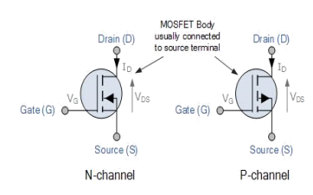
Fig 14: Symbols of e-MOSFET transistors.

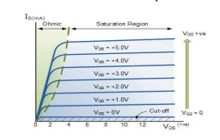
Fig 15: Drain characteristics of e-MOSFET.
    - Depletion mode MOSFET
- The Depletion-mode MOSFET, which is less common than the enhancement mode types is normally switched “ON” (conducting) without the application of a gate bias voltage.
- That is the channel conducts when VGS = 0 making it a “normally-closed” device. The circuit symbol shown above for a depletion MOS transistor uses a solid channel line to signify a normally closed conductive channel.
- For the n-channel depletion MOS transistor, a negative gate-source voltage, -VGS will deplete (hence its name) the conductive channel of its free electrons switching the transistor “OFF”. Likewise for p-channel depletion MOS transistor a positive gate source voltage, +VGS will deplete the channel of its free holes turning it “OFF”.
- In other words, for an n-channel depletion mode MOSFET: +VGS means more electrons and more current. While a -VGS means less electrons and less current. The opposite is also true for the p-channel types. Then the depletion mode MOSFET is equivalent to a “normally-closed” switch.
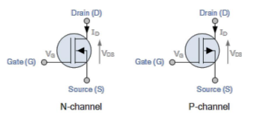
Fig 16: Symbols for depletion MOSFET.

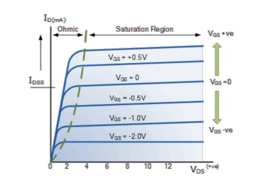
Fig 17: Drain characteristics for depletion MOSFET.
  - Working of MOSFET
- MOSFET consists of a MOS capacitor with two p-n junctions placed closed to the channel region and this region is controlled by gate voltage. To make both the p-n junction reverse biased, substrate potential is kept lower than the other three terminals potential.
- If the gate voltage will be increased beyond the threshold voltage (V_{GS}>V_{TO}), inversion layer will be established on the surface and n – type channel will be formed between the source and drain. This n – type channel will carry the drain current according to the V_{DS} value.
- For different value of V_{DS}, MOSFET can be operated in different regions as explained below.

Linear Region
- At V_{DS} = 0, thermal equilibrium exists in the inverted channel region and drain current I_{D} = 0. Now if small drain voltage, V_{DS} > 0 is applied, a drain current proportional to the V_{DS} will start to flow from source to drain through the channel.
- The channel gives a continuous path for the flow of current from source to drain. This mode of operation is called linear region. The cross-sectional view of an n-channel MOSFET, operating in linear region, is shown in the figure given below.
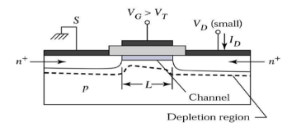
Fig 18: Linear region

At the Edge of Saturation Region
Now if the V_{DS} is increased, charges in the channel and channel depth decrease at the end of drain. For V_{DS} = V_{DSAT}, the charges in the channel is reduces to zero, which is called pinch – off point. The cross-sectional view of n-channel MOSFET operating at the edge of saturation region is shown in the figure given below.
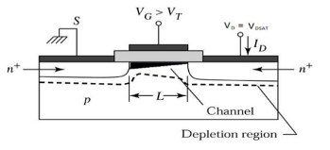
Fig 19: At edge saturation region.

Saturation Region
- For V_{DS}>V_{DSAT}, a depleted surface forms near to drain, and by increasing the drain voltage this depleted region extends to source.
(b)This mode of operation is called Saturation region. The electrons coming from the source to
the channel end, enter in the drain – depletion region and are accelerated towards the drain in
high electric field.
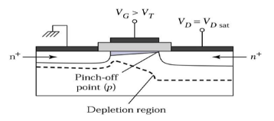
Fig 20: Saturation region.

  - I-V Characteristics
- P-type enhancement MOSFET
- The transfer characteristics of p-type enhancement MOSFETs from which it is evident that IDS remains zero (cutoff state) until VGS becomes equal to -VT . This is because, only then the channel will be formed to connect the drain terminal of the device with its source terminal.
- After this, the IDS is seen to increase in reverse direction (meaning an increase in I SD, signifying an increase in the device current which will flow from source to drain) with the decrease in the value of VDS.
- This means that the device is functioning in its ohmic region wherein the current through the device increases with an increase in the applied voltage (which will be VSD).

- However, as VDS becomes equal to –VP, the device enters into saturation during which a saturated amount of current (IDSS) flows through the device, as decided by the value of VGS .
- Further it is to be noted that the value of saturation current flowing through the device is seen to increase as the VGS becomes more and more negative i.e. saturation current for VGS3 is greater than that for VGS2 and that in the case of VGS4 is much greater than both of them as VGS3 is more negative than VGS2 while VGS4 is much more negative when compared to either of them.
- In addition, from the locus of the pinch-off voltage it is also clear that as VGS becomes more and more negative, even the negativity of VP also increases.
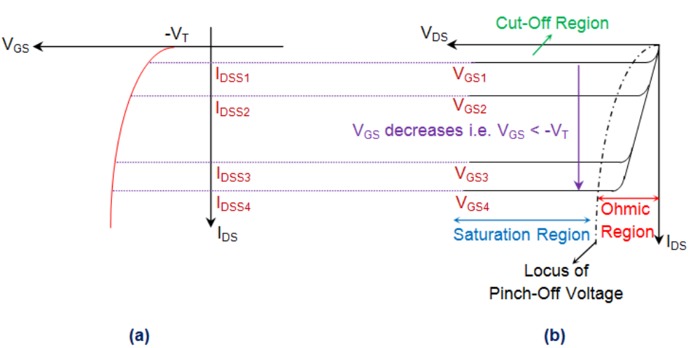
Fig 21: p-channel enhancement type MOSFET: (a) Transfer (b) Output characteristic
- N-channel enhancement MOSFET
- Its working is similar to that of p-channel enhancement MOSFET but only operationally and constructionally there are different from each other.
- The Characteristics is shown in figure 22 below.
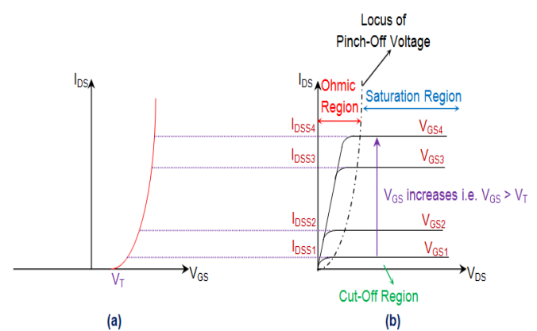
Fig 22: n-channel enhancement MOSFET: (a) Transfer (b) Output characteristic
- N-channel depletion type MOSFET
- The characteristics regions are shown below:

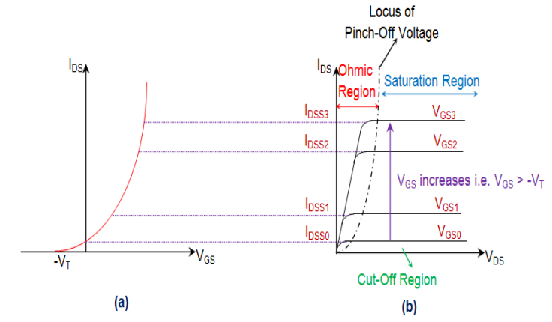
Fig 23: n-channel depletion MOSFET: (a) Transfer (b) Output characteristic
- P-channel depeletion type MOSFET
- Construction wise p-channel DE-MOSFET is just reverse of the n channel depletion MOSFET.
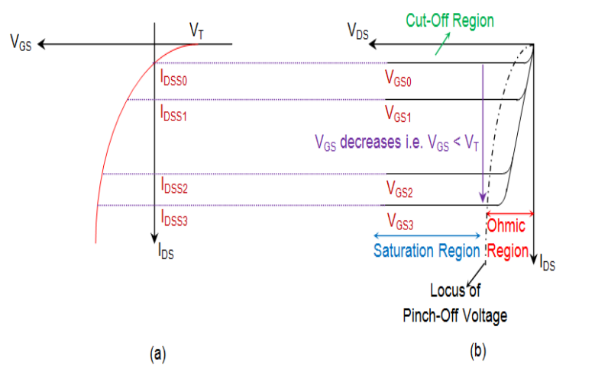
Fig 24: p-channel depletion MOSFET: (a) Transfer (b) Output characteristics.
Pinch off Voltage:
- In JFET, if V_{DS} is increased a condition comes when depletion layer just touches each other. This condition is called Pinch off condition.
- The value of V_{DS} which establish this condition is called Pinch off voltage (V_{P}). After pinch off current becomes constant (I_{DSS}).
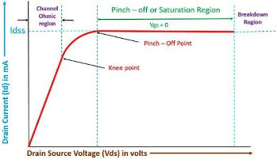

Voltage controlled resistance: JFET works as a variable resistance in ohmic region. The resistance of JFET is given by:

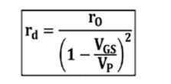

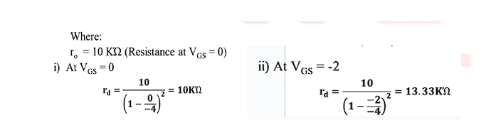

So JFET works as variable resistance or voltage-controlled resistance in ohmic region.

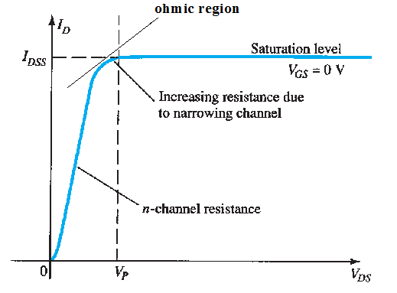

Differences between JFET and MOSFET

 | JFET | MOSFET
1. | It can only operate in the depletion mode. | It operates in both depletion mode and enhancement mode.
2. | It has high input impedance on the order of 1010 ohms, therefore they are more sensitive towards input voltage signals. | It offers even higher input impedance than the JFETs, therefore they are more resistive.
3. | It is relatively cheaper than MOSFETs | It’s too expensive.
4. | These are ideal for low noise applications. | These are mainly used for high noise applications.
5. | Manufacturing process of JFETs is simple. | Manufacturing process of MOSFETs is complex.

FET as a Voltage Variable Resistor (VVR)

- At low drain-to-source voltage (VDS), the FET operates in the ohmic region (also called linear region).In this region, the channel acts like a resistor, whose value can be controlled by the gate-to-source voltage (VGS).When VDS is small → channel current ID ∝ VDS.Resistance between drain and source (RDS) depends on VGS.Increasing |VGS| (for JFET, making gate more negative for n-channel) → channel width decreases → RDS increases.

FET Current Source
- FET constant current sources use JFETs and MOSFETs to deliver a load current which remains constant despite changes in load resistance or supply voltage An FET Current Source is a type of active circuit which uses a Field Effect Transistor to supply a constant amount of current to a circuit.
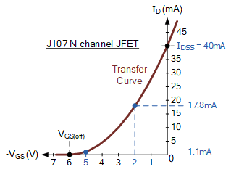

- CMOS CONSTRUCTION: -

The term CMOS stands for “Complementary Metal Oxide Semiconductor”. CMOS technology is one of the most popular technologies in the computer chip design industry and broadly used today to form integrated circuits in numerous and varied applications. Today’s computer memories, CPUs and cell phones make use of this technology due to several key advantages. This technology makes use of both P channel and N channel semiconductor devices. One of the most popular MOSFET technologies available today is the Complementary MOS or CMOS technology. This is the dominant semiconductor technology for microprocessors, microcontroller chips, memories like RAM, ROM, EEPROM and application specific integrated circuits (ASICs).

CMOS technology combines two types of transistors, NMOS and PMOS, in a complementary arrangement. This design significantly reduces power consumption because it only draws current when switching between logic states. Unlike older designs that rely on NMOS-only or bipolar junction transistors and consume power continuously, CMOS circuits remain idle (and consume little power) when not switching.
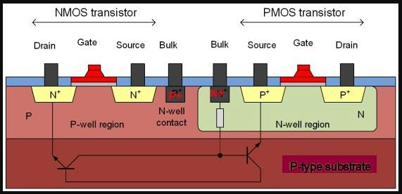

Fig. 2.13.1 CMOS Construction using NMOS & PMOS

NMOS
NMOS is built on a p-type substrate with n-type source and drain diffused on it. In NMOS, the majority carriers are electrons. When a high voltage is applied to the gate, the NMOS will conduct.

Similarly, when a low voltage is applied to the gate, NMOS will not conduct. NMOS are considered to be faster than PMOS, since the carriers in NMOS, which are electrons, travel twice as fast as the holes.

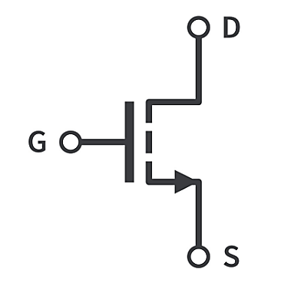

PMOS
P- channel MOSFET consists P-type Source and Drain diffused on an N-type substrate. Majority
carriers are holes. When a high voltage is applied to the gate, the PMOS will not conduct. When a low voltage is applied to the gate, the PMOS will conduct. The PMOS devices are more immune to noise than NMOS devices.

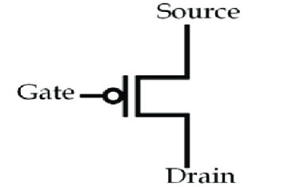

2.14. CMOS Working Principle & Characteristics
In CMOS technology, both N-type and P-type transistors are used to design logic functions. The same signal which turns ON a transistor of one type is used to turn OFF a transistor of the other type. This characteristic allows the design of logic devices using only simple switches, without the need for a pull- up resistor. In CMOS logic gates a collection of n-type MOSFETs is arranged in a pull-down network between the output and the low voltage power supply rail (Vss or quite often ground). Instead of the load resistor of NMOS logic gates, CMOS logic gates have a collection of p-type MOSFETs in a pull-up network between the output and the higher-voltage rail (often named Vdd). Thus, if both a p-type and n-type transistor have their gates connected to the same input, the p- type MOSFET will be ON when the n-type MOSFET is OFF, and vice-versa. The networks are arranged such that one is ON and the other OFF for any input pattern as shown in the figure below.

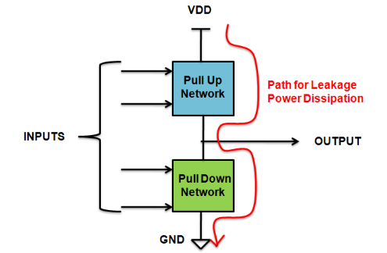
Fig. 2.14.2 CMOS Pull Up & Down Network

2.15. CMOS: NOT, NAND & NOR implementation using CMOS.

CMOS Inverter
A CMOS inverter is a basic building block in digital logic design. It consists of two types of transistors: one PMOS (positive-channel) and one NMOS (negative-channel). These transistors are arranged in a complementary configuration.
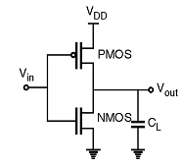
Fig. 2.15.1 CMOS Inverter

Fig. 2.13.2 CMOS Both the PMOS and NMOS transistors are controlled by the same input voltage, called Vin, which is connected to the gate terminal of each transistor. The drains of the two transistors are connected. This shared node produces the output voltage, called Vout. The source of the PMOS transistor connects directly to the positive power supply, denoted as Vdd. The source of the NMOS transistor connects to ground, or 0 volts.

• When Vin is High (Close to Vdd): The NMOS transistor conducts (turns on), creating a low-resistance path to ground. The PMOS transistor does not conduct (turns off), effectively disconnecting the output from Vdd. As a result, the output voltage is pulled down to ground. Vout becomes 0 volts, representing logic level 0.

• When Vin is Low (Close to 0V): The NMOS transistor turns off and no longer conducts. The PMOS transistor turns on, creating a path from Vdd to the output. The output is pulled up to Vdd. Vout becomes equal to Vdd, representing logic level 1. This switching behaviour causes the CMOS inverter to output the logical opposite (inversion) of the input voltage.

INPUT | LOGIC INPUT | OUTPUT | LOGIC OUTPUT
0 v | 0 | Vdd | 1
Vdd | 1 | 0 v | 0

CMOS NAND Gate

The below figure shows a 2-input Complementary MOS NAND gate. It consists of two series NMOS transistors between Y and Ground and two parallel PMOS transistors between Y and VDD.If either input A or B is logic 0, at least one of the NMOS transistors will be OFF, breaking the path from Y to Ground. But at least one of the pMOS transistors will be ON, creating a path from Y to VDD. Hence, the output Y will be high. If both inputs are high, both of the nMOS transistors will be ON and both of the pMOS transistors will be OFF. Hence, the output will be logic low. The truth table of NANDlogic gate is given in below table.If either input A or B is logic 0, at least one of the NMOS transistors will be OFF, breaking the path from Y to Ground. But at least one of the pMOS transistors will be ON, creating a path from Y to VDD. Hence, the output Y will be high. If both inputs are high, both of the nMOS transistors will be ON and both of the pMOS transistors will be OFF. Hence, the output will be logic low.
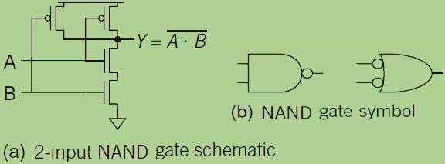

Fig. 2.15.2 CMOS NAND

CMOS NOR Gate

A 2-input NOR gate shown in the figure below. The NMOS transistors are in parallel to pull the output low when either input is high. The PMOS transistors are in series to pull the output high when both inputs are low, as given in below table. The output is never left floating.

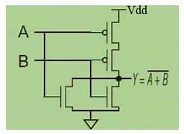
Fig. 2.15.3 CMOS NOR

CMOS Applications

Complementary MOS processes were widely implemented and have fundamentally replaced NMOS and bipolar processes for nearly all digital logic applications. The CMOS technology has been used for the following digital IC designs.
- Computer memories, CPUs
- Microprocessor designs
- Flash memory chip designing
- Used to design application-specific integrated circuits (ASICs)

