Introduction to Amazon EC2
Amazon EC2 (Elastic Compute Cloud) is AWS’s core service for renting virtual servers on-demand, giving you scalable computing power without investing in physical hardware. It lets you launch, configure, and manage virtual machines (instances) with flexible pricing
and capacity that can grow or shrink as your workload changes.
Objectives
By the end of this lab, you should be able to do the following:
- Launch a web server with termination protection enabled.
- Monitor Your EC2 instance.
- Modify the security group that your web server is using to allow HTTP access.
- Resize your Amazon EC2 instance to scale.
- Test termination protection.
- Terminate your EC2 instance.

1: You are on the EC2 Dashboard for the Mumbai region. You clicked the orange "Launch instance" button to start the setup.

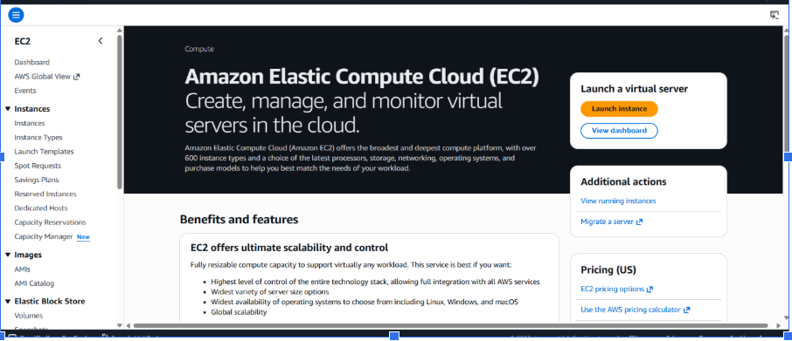
2: In the Name and tags section, you named the instance "simran-test-01". Under Application and OS Images, you selected Amazon Linux as the operating system.
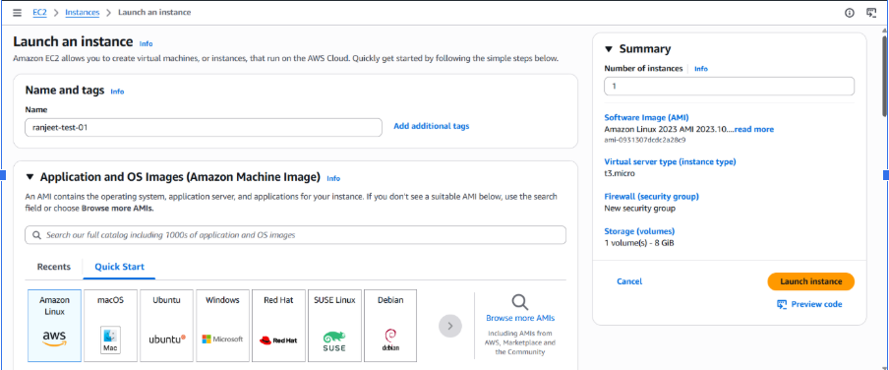
3: This shows the specific AMI details (Amazon Linux 2023). It confirms the image is "Free tier eligible" and uses a 64-bit architecture
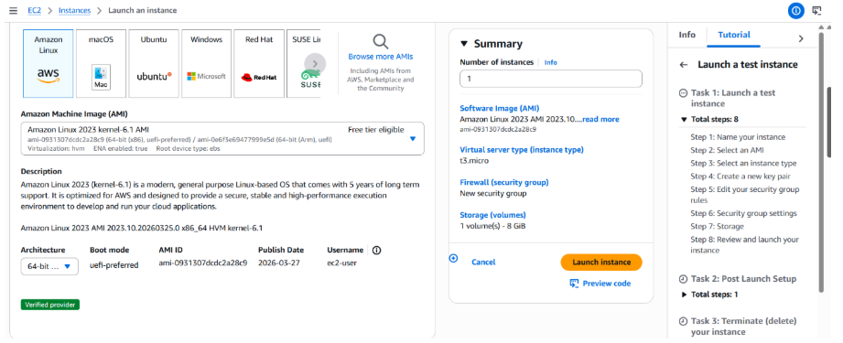
4: Under Instance type, you chose t3.micro (2 vCPUs, 1 GiB Memory), which is also Free tier eligible. The Key pair section is visible but not yet filled.
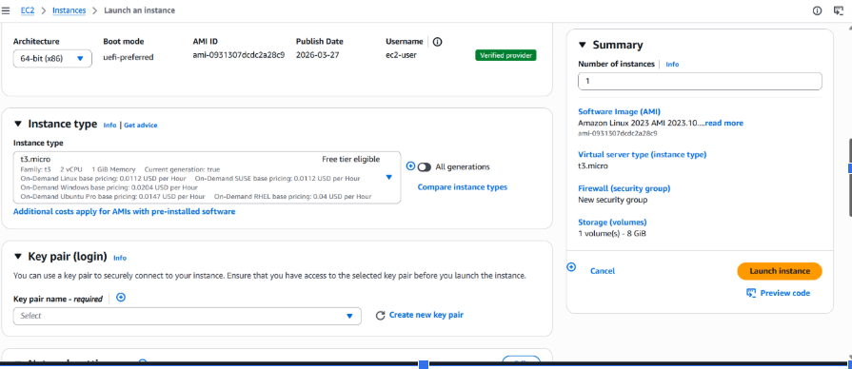
5: In Network settings, you opted to "Create security group." You enabled rules to allow SSH and HTTPS traffic from anywhere (0.0.0.0/0).
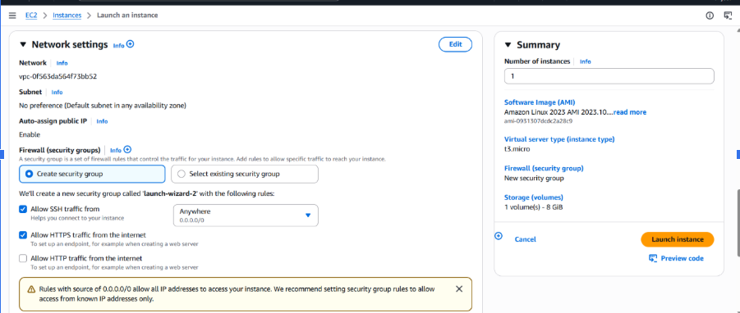
6: In the Configure storage section, you set the Root volume to 8 GiB using the gp3 (General Purpose SSD) volume type.
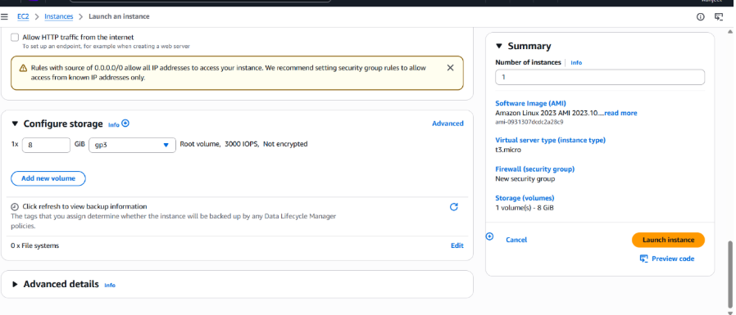
7: A warning popup appeared because no key pair was selected. You chose to "Proceed without a key pair," meaning you won't be able to log in via SSH unless you've configured another method.
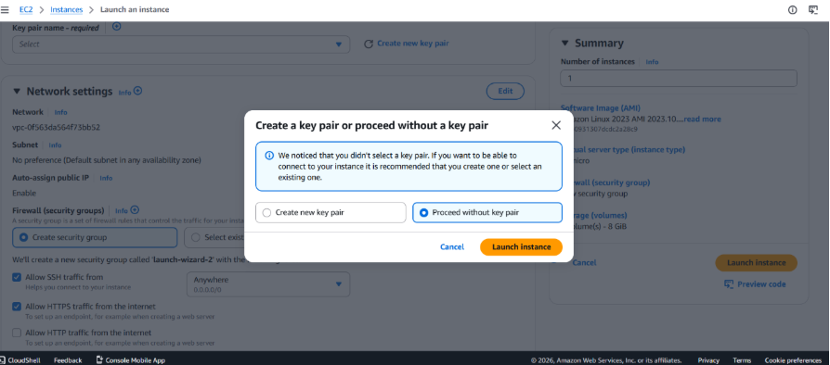
8: Success! The instance (ID: i-0598f1c97e476214a) has been successfully initiated. The screen shows next steps like "Connect to instance" or "Create billing alerts."
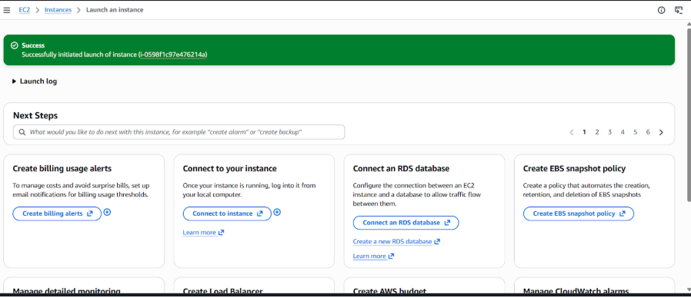
9: This displays the Launch Log, confirming that all background tasks (initializing requests, creating security groups, and launch initiation) have Succeeded.
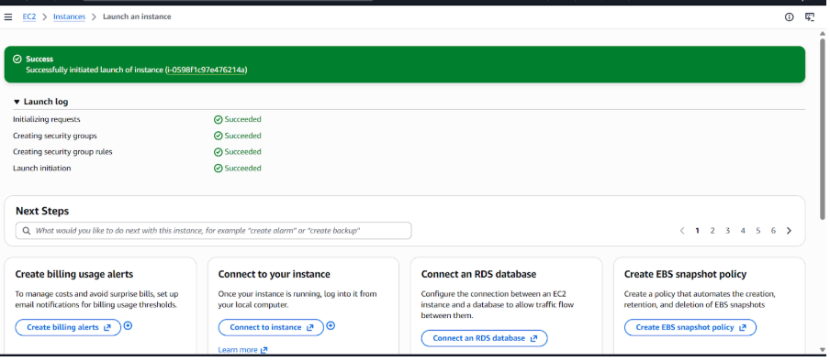
10: You are back at the Instances Dashboard. It shows one instance has been "Terminated" (deleted) and your new instance (ranjeet-test-01) is officially Running with all checks passed.
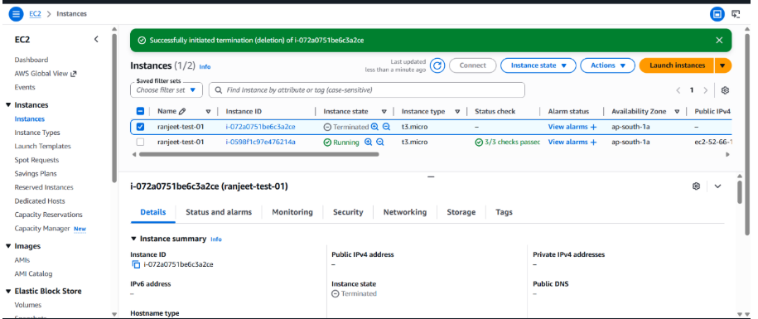
11: You clicked "Connect." Under the EC2 Instance Connect tab, you have selected to connect using a Public IP (52.66.187.124).
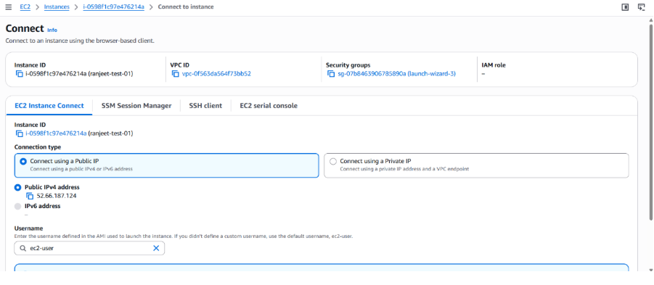
12: The default username "ec2-user" is automatically filled. You are ready to click the orange "Connect" button at the bottom right.
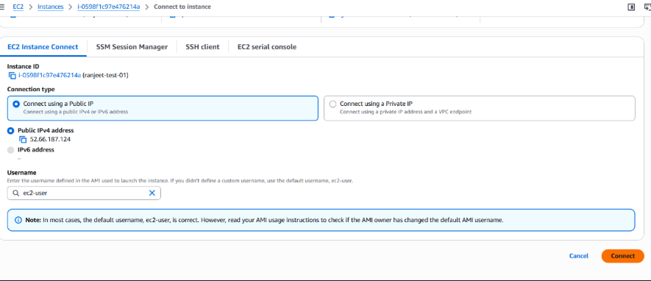
13: Inside the terminal, I ran the command pwd (print working directory), which confirmed you are currently in the /home/ec2-user folder.
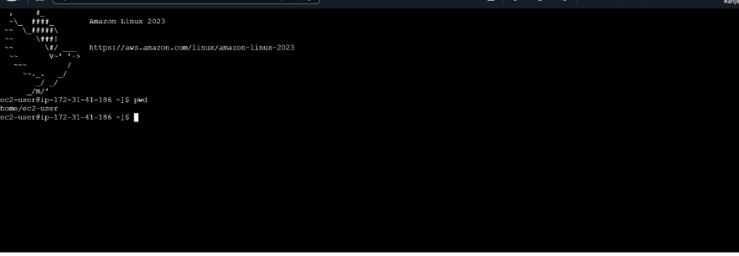
AWS Services
• Amazon Elastic Compute Cloud
Intended Audience
• Architects
• Infrastructure Engineers

