Implementation of Event-Driven Messaging using Amazon SNS
(Simple Notification Service)
Objective:
Using the Amazon SNS service, a Pub/Sub (Publish/Subscribe) model was created. In this, a topic was created, an email endpoint was subscribed, and the message was successfully published and its delivery was verified.

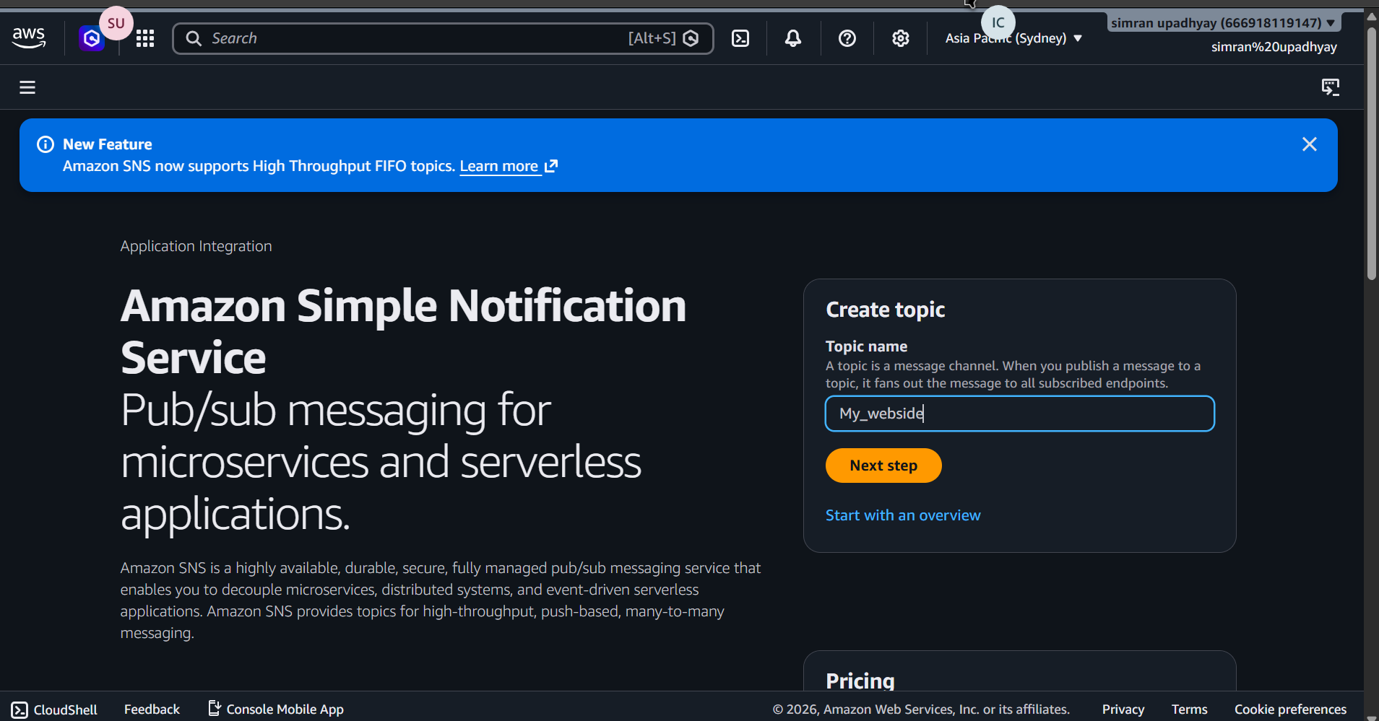
Step 2: Topic Successfully Created
The system confirms the creation of the topic with a green success banner. The details for the topic TestMessage are displayed, showing its unique Amazon Resource Name (ARN). At this stage, there are zero subscriptions.
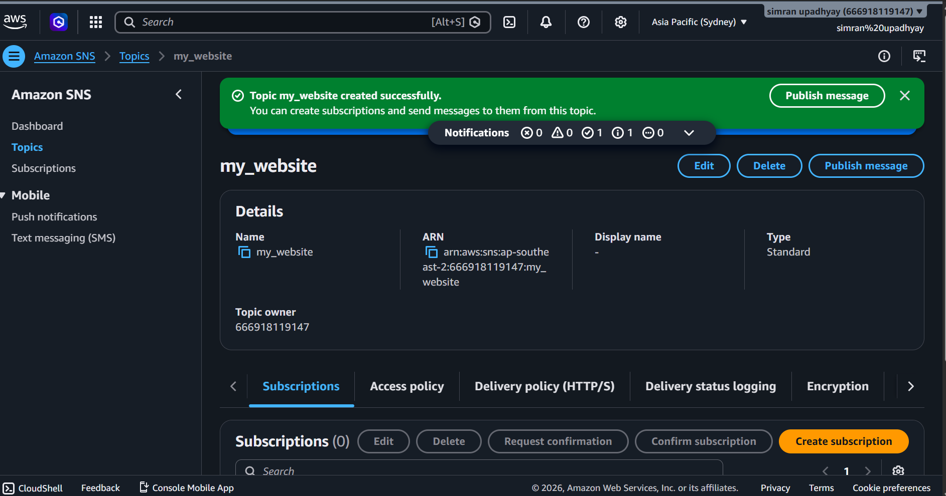
Step 3: Configuring a Subscription
The user clicks "Create subscription." Here, the Topic ARN is automatically populated. The user selects Email as the protocol and enters the endpoint addres:upadhyaysimran538@gmail.com 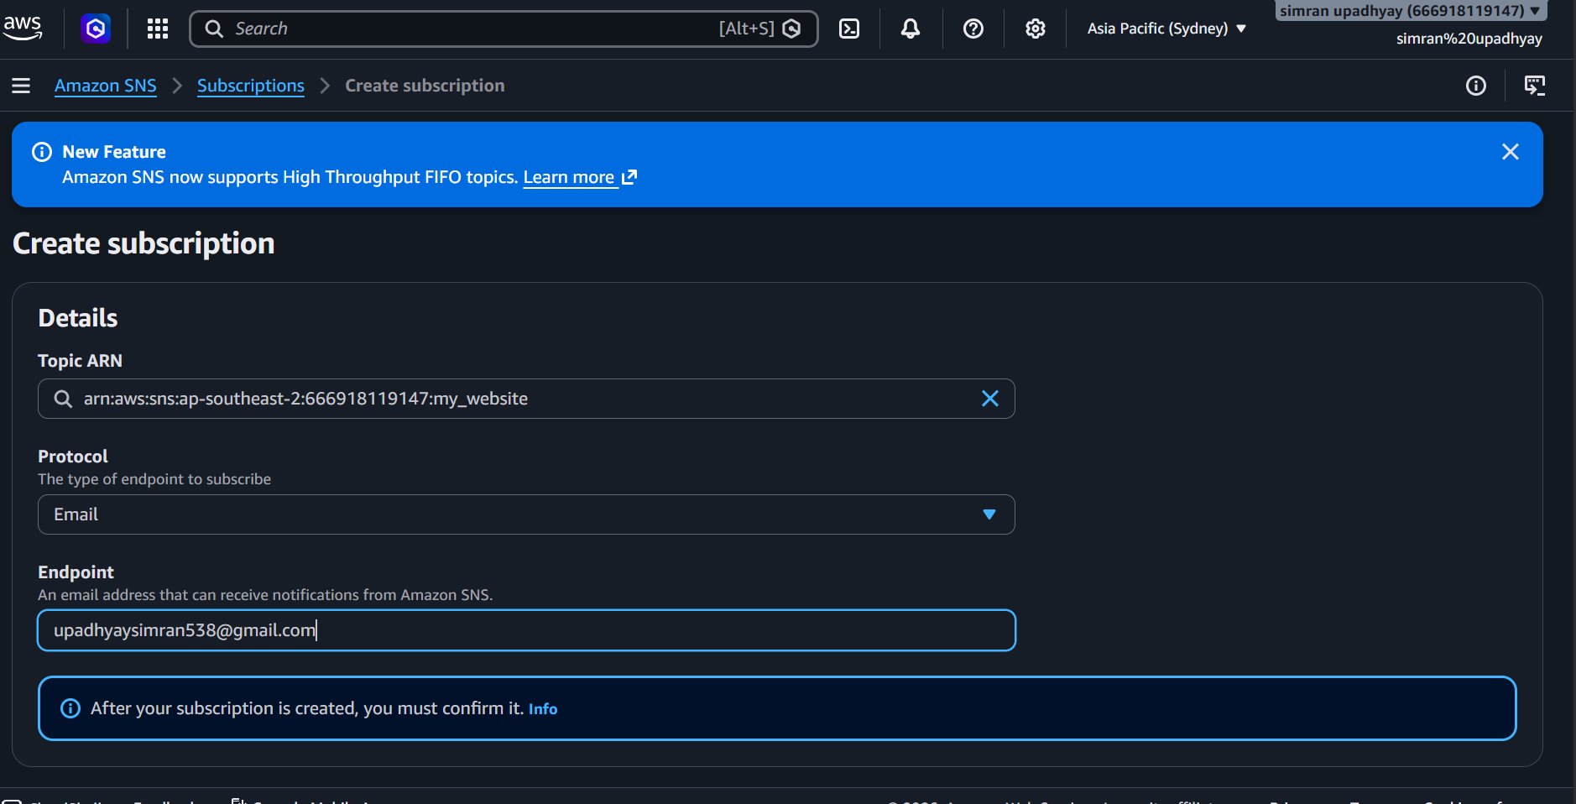
Step 4: Subscription Pending Confirmation
A second success banner appears stating the subscription was created. However, the status is listed as Pending confirmation. This is a security measure to ensure the owner of the email address actually wants to receive these notifications.
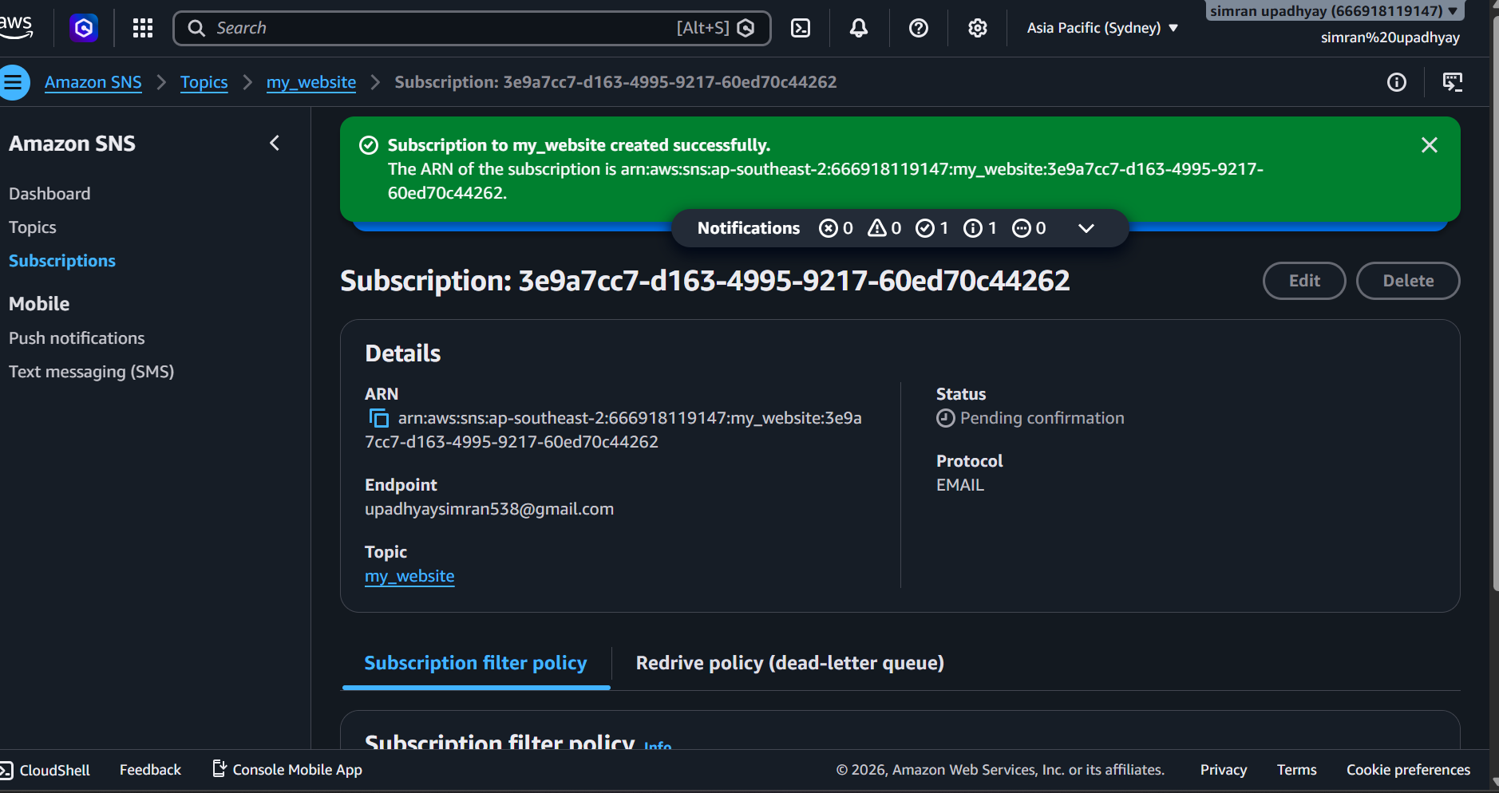

Step 5: Drafting the Message
The user opens the Publish message to topic page for the "myself" topic.
- Subject: The user enters the word Test.
- Settings: Other options like Message group ID and TTL (Time to Live) are left at their default settings.

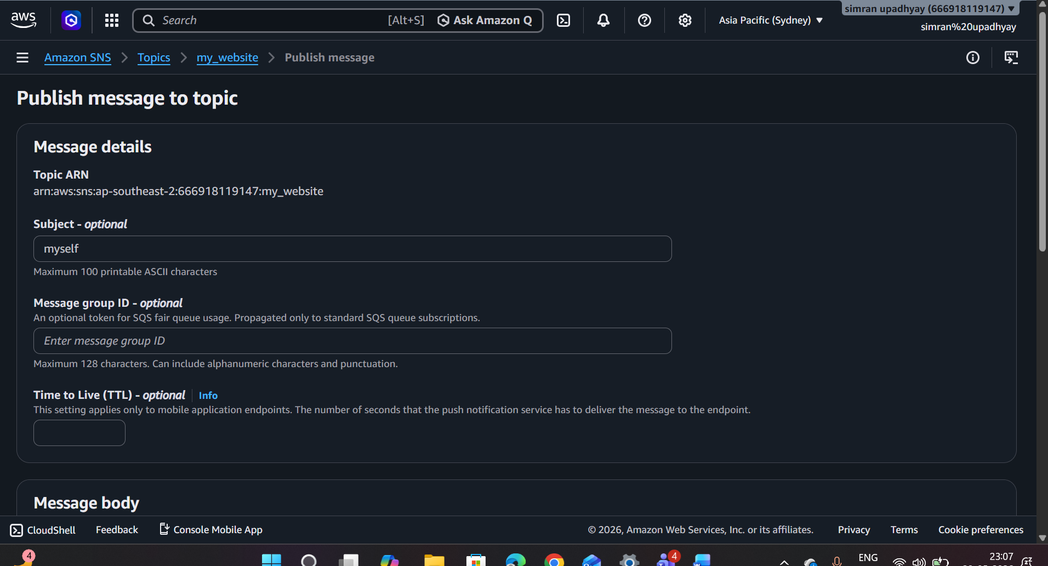
Step 6: Entering the Message Body
In the Message body section, the user selects "Identical payload for all delivery protocols." In the text box, the user types: I am Simran.

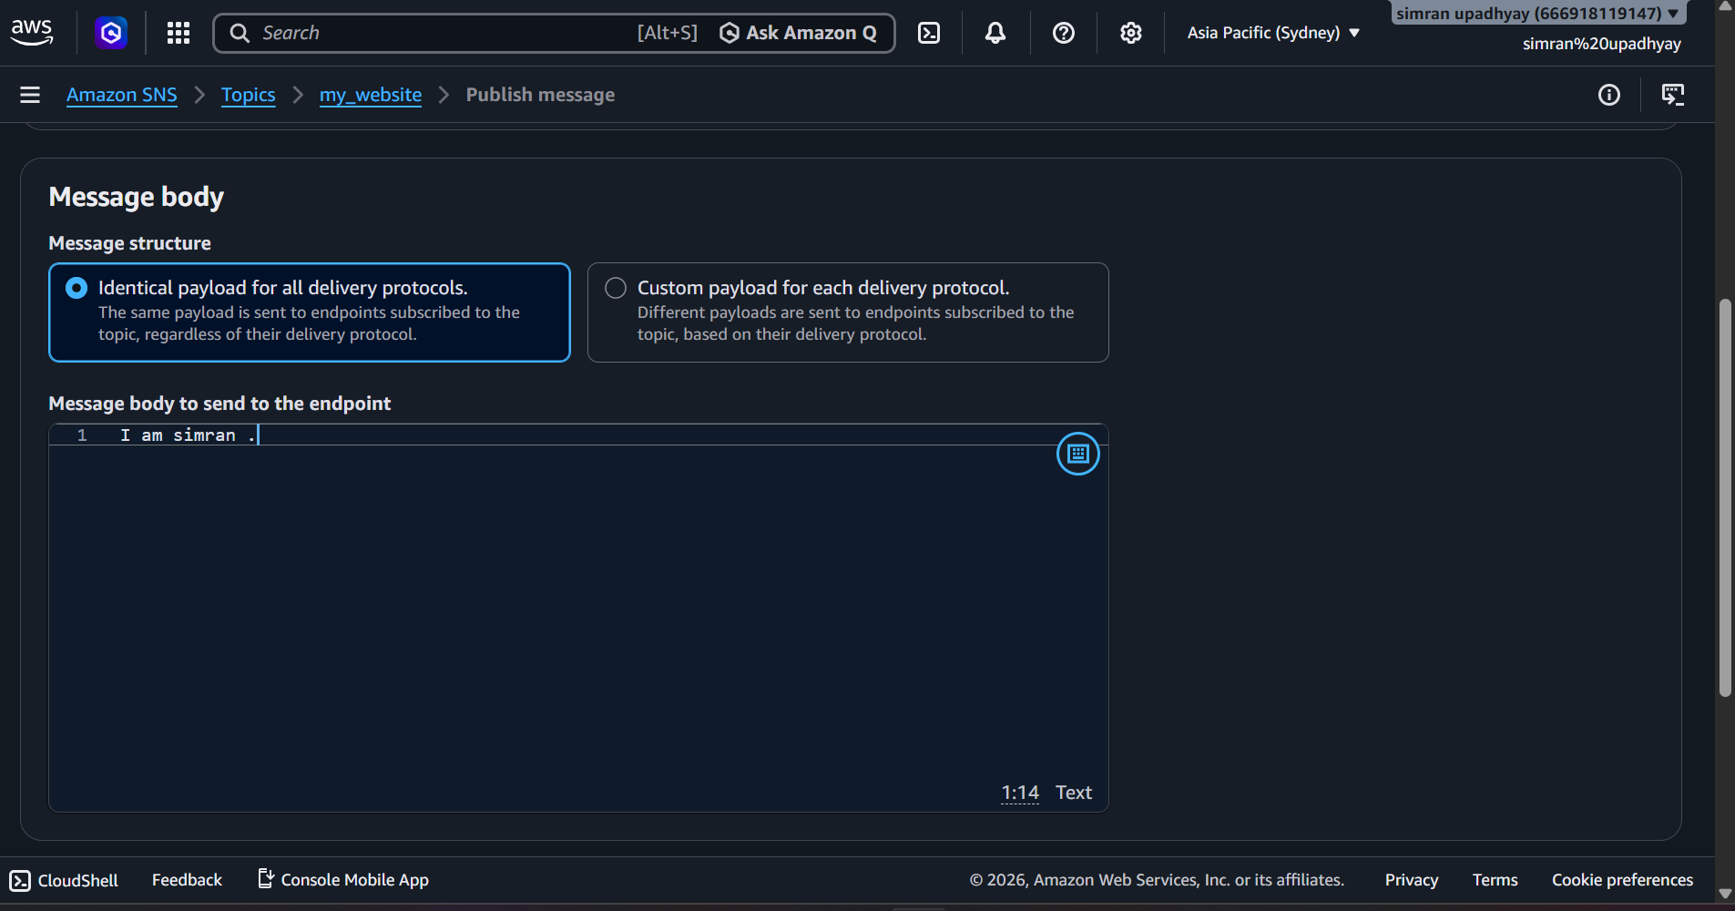
Step 7: Successful Message Publication
After clicking publish, a green banner confirms: "Message published to topic myself successfully." The console displays a unique Message ID and Request ID as proof of the transaction.

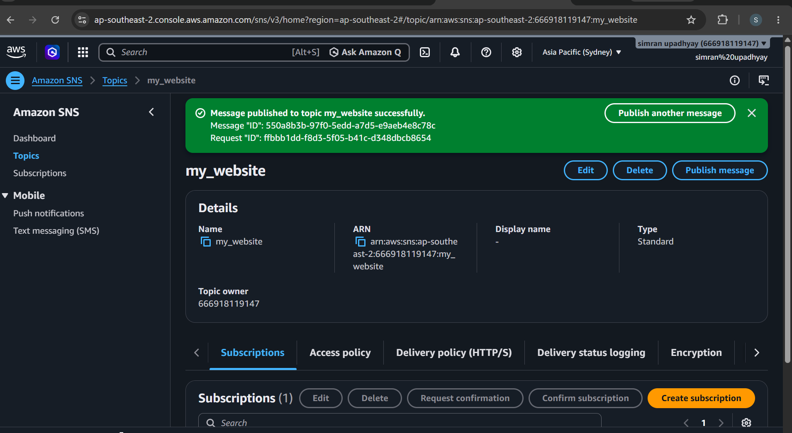
Step 8: Verifying Delivery (Email Received)
The user checks their Gmail inbox. A new email has arrived from AWS with the subject "myself" The body correctly contains the text myself from AWS SNS. This confirms the pub/sub flow is working.
