**GURU NANAK DEV ENGINEERING COLLEGE, LUDHIANA**

**DEPATMENT OF INFORMATION TECHNOLOGY**



5th SEMESTER ,2018 BATCH

Advanced web Technology

ASSIGNMENT

SUBMITTED BY:

SIMRATH KAUR

URN – 1805561

D3IT/B1

1. Go to your Git repository which you created in the previous tutorial assignment.

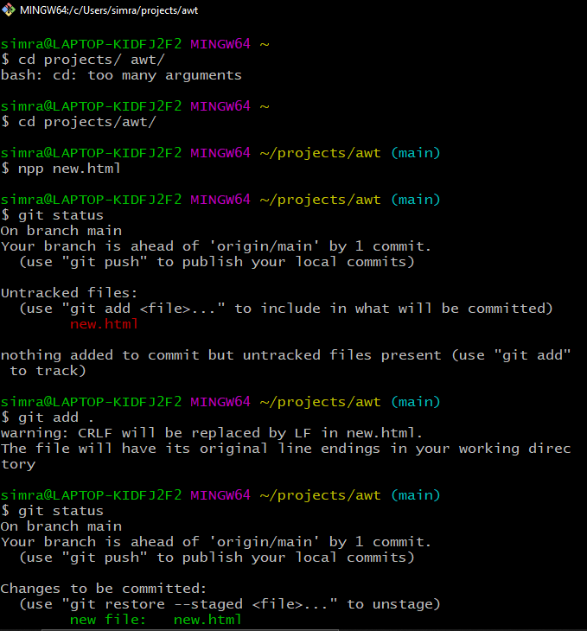

1. Do some modifications in your text file.

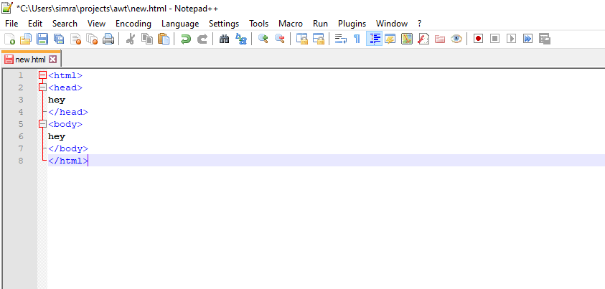

1. Commit the changes

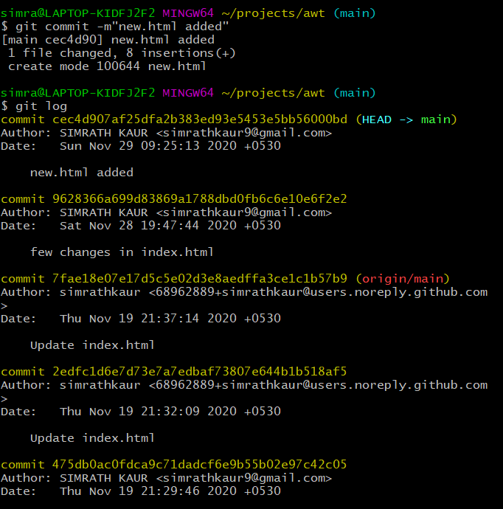

1. Remove the file

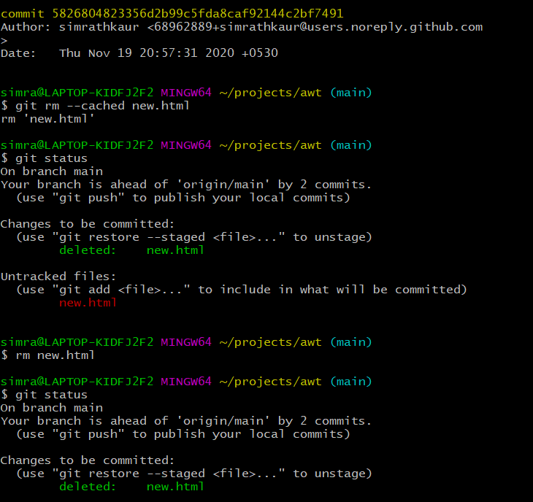

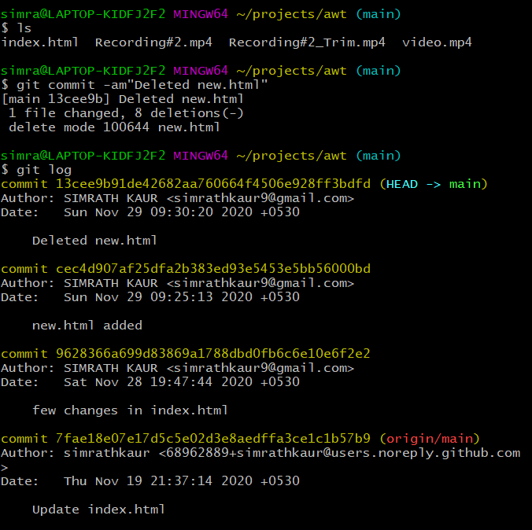

1. Restore the removed file

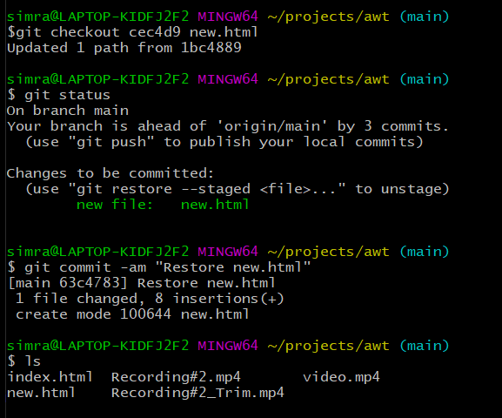

1. Make few changes in the file and discard them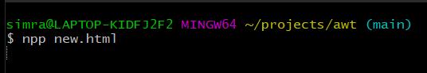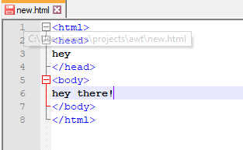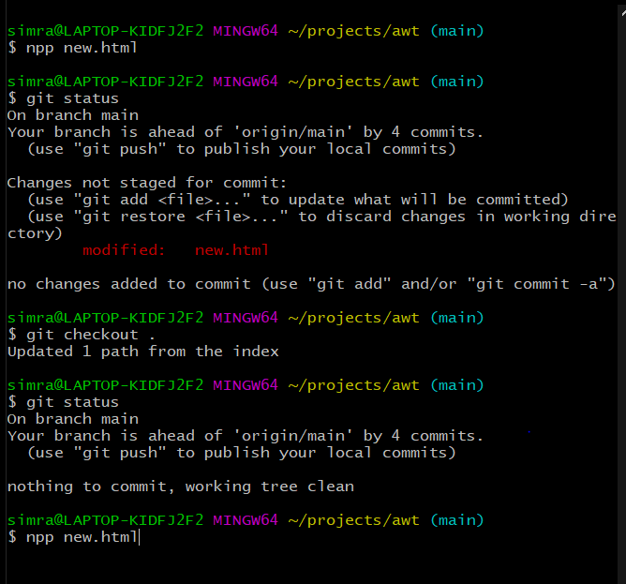

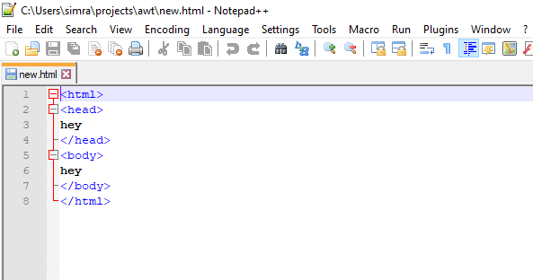

1. Reverting to an earlier version

