**GURU NANAK DEV ENGINEERING COLLEGE, LUDHIANA**

**DEPATMENT OF INFORMATION TECHNOLOGY**



5th SEMESTER ,2018 BATCH

Advanced web Technology

ASSIGNMENT

SUBMITTED BY:

SIMRATH KAUR

URN – 1805561

D3IT/B1

Let’s first do few changes in new.html and index.html

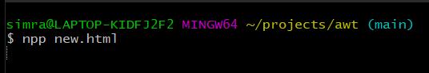

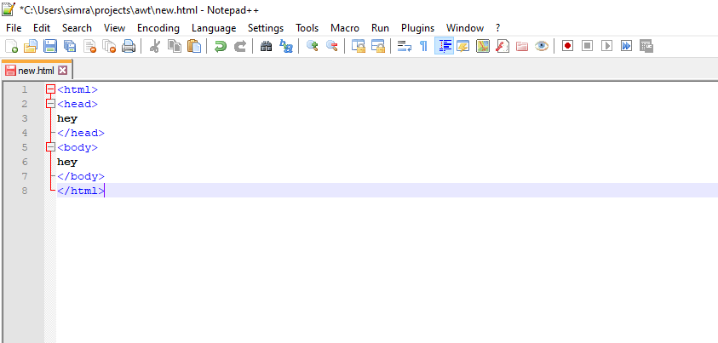

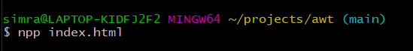

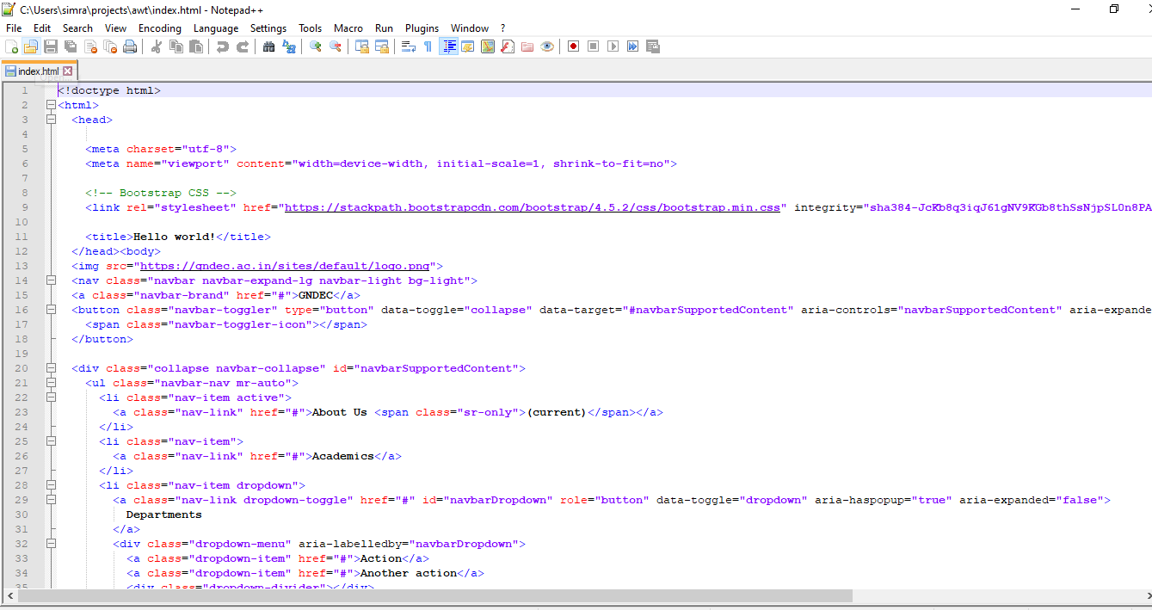

Let’s check status

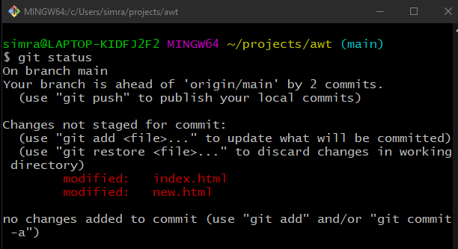

1. Now let’s compare the changes using git diff

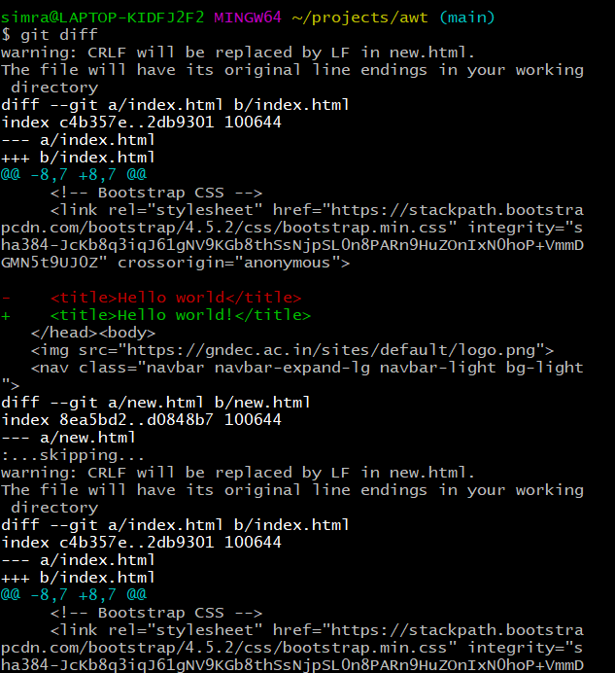

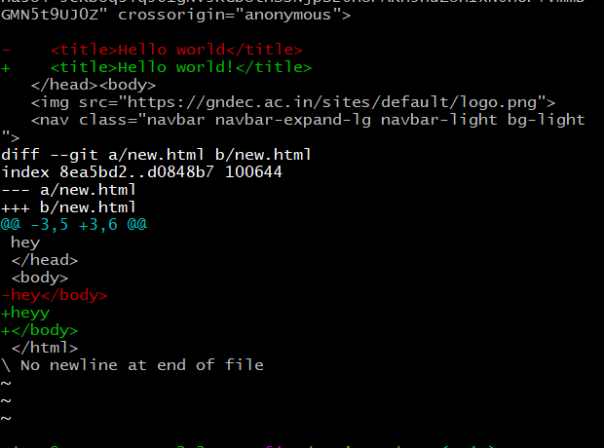

1. Git show

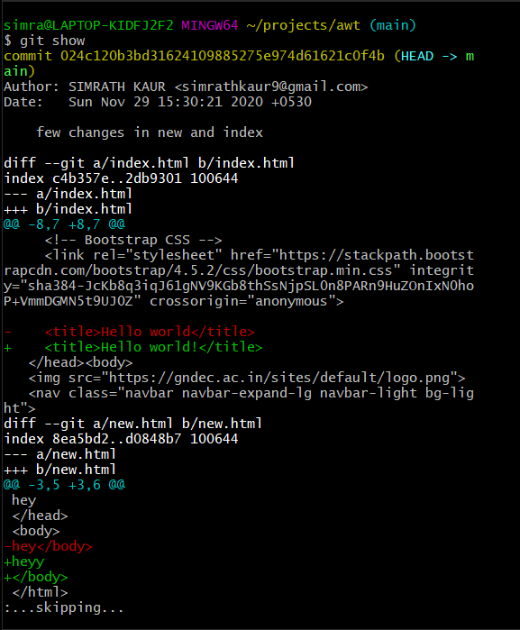

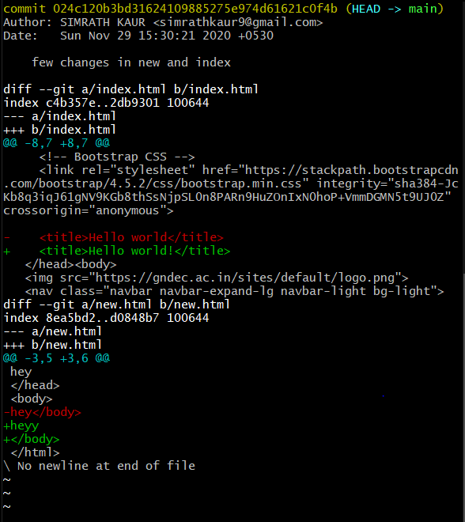

1. Git blame

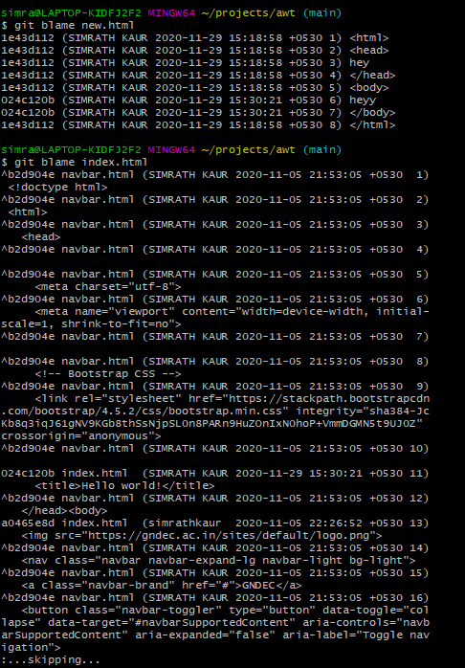

1. Git help

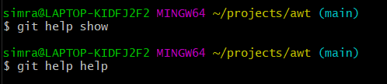

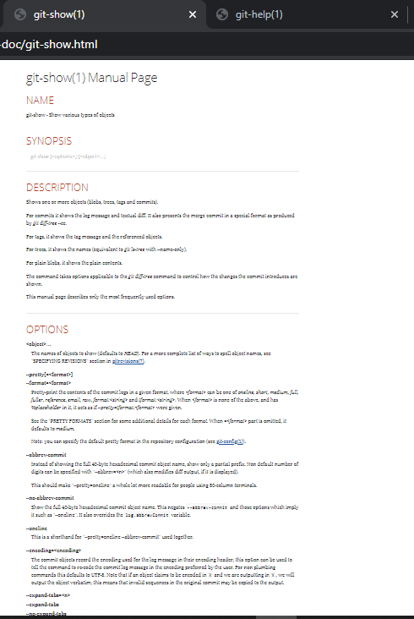

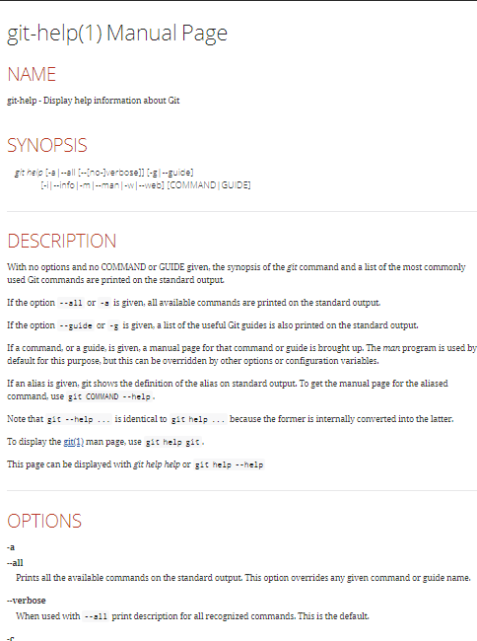

1. Git reflog

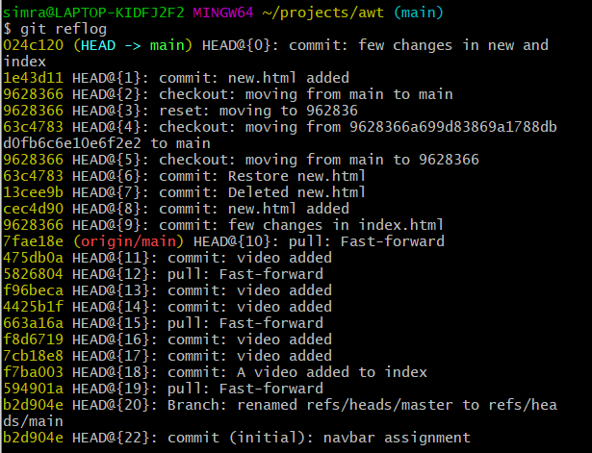

1. Git diff HEAD tilde HEAD

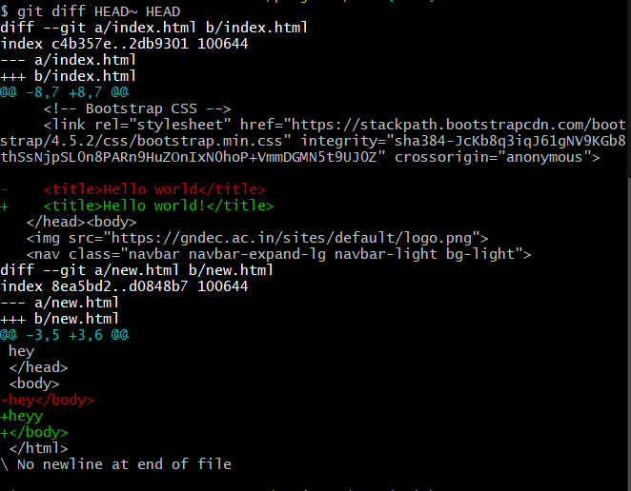

1. Git show HEAD

