**GURU NANAK DEV ENGINEERING COLLEGE, LUDHIANA**

**DEPATMENT OF INFORMATION TECHNOLOGY**



5th SEMESTER ,2018 BATCH

Advanced web Technology

ASSIGNMENT

SUBMITTED BY:

SIMRATH KAUR

URN – 1805561

D3IT/B1

1. **Create a lightweight tag and an annotated tag**

Lightweight – v1.1

Annotated tag – v1.2

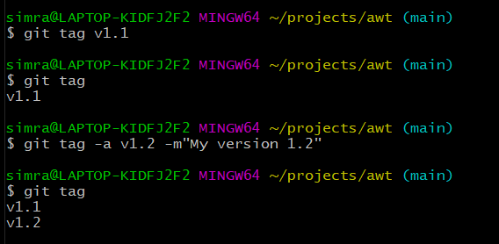

1. **Understand the difference between both the tags**

**Lightweight tag:**

Using show on v1.1:

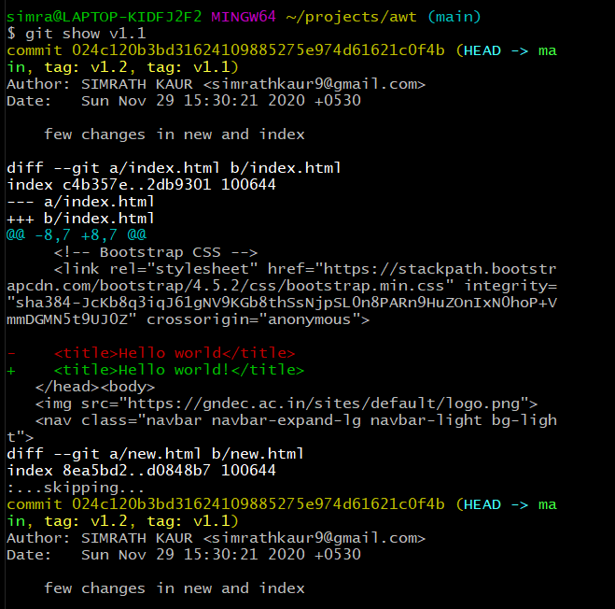

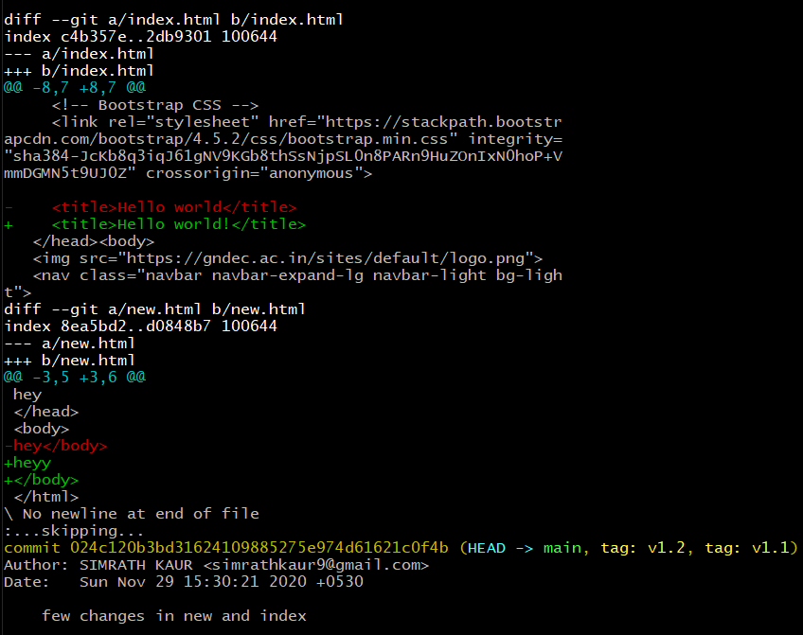

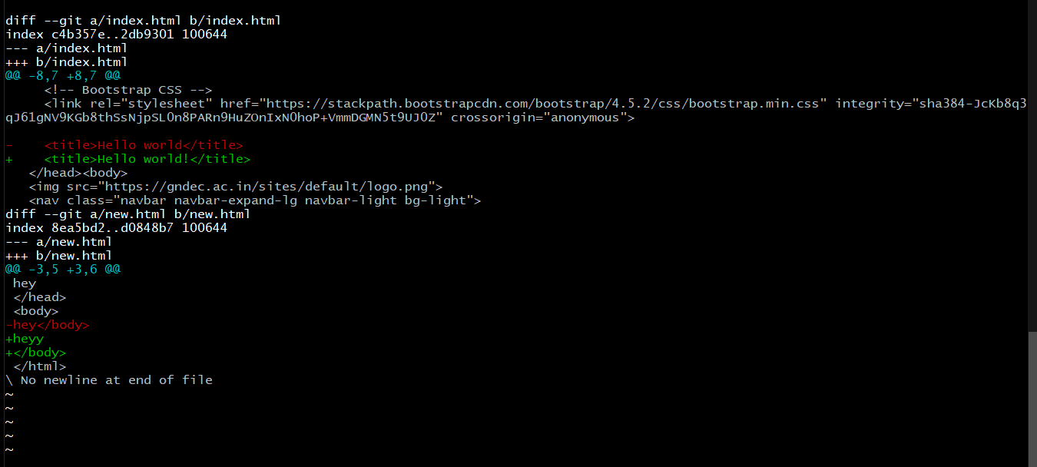

**Annotated tag :**

Using show on v1.2 :

