**GURU NANAK DEV ENGINEERING COLLEGE, LUDHIANA**

**DEPATMENT OF INFORMATION TECHNOLOGY**



5th SEMESTER ,2018 BATCH

Advanced web Technology

ASSIGNMENT

SUBMITTED BY:

SIMRATH KAUR

URN – 1805561

D3IT/B1

1. Create a branch named chapter-two

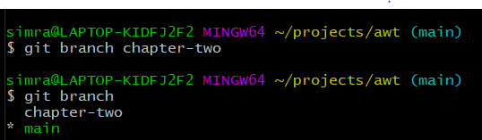

1. into the chapter-two branch



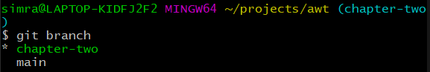

1. Do some commits

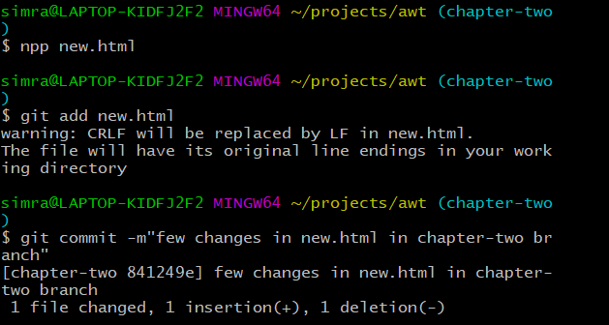

1. Checking log in chapter-two

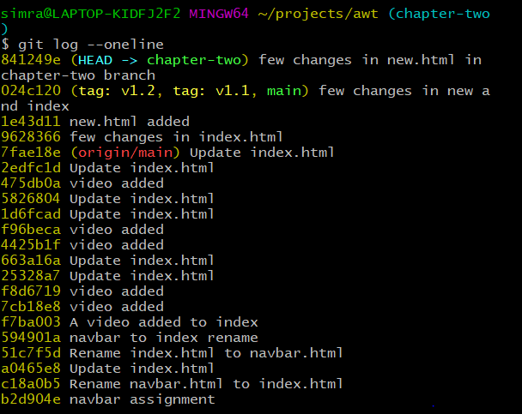

1. Switch back to master branch

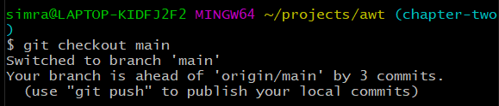

1. Check the Git log

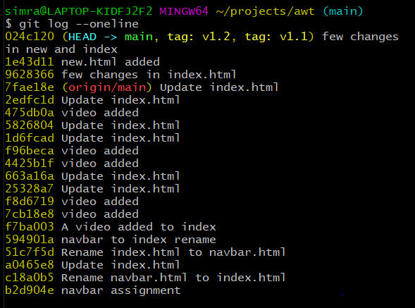

We Understood that, in the master branch, we can't see the commits of the branch chapter-two