**GURU NANAK DEV ENGINEERING COLLEGE, LUDHIANA**

**DEPATMENT OF INFORMATION TECHNOLOGY**



5th SEMESTER ,2018 BATCH

Advanced web Technology

ASSIGNMENT

SUBMITTED BY:

SIMRATH KAUR

URN – 1805561

D3IT/B1

1. Check the commits of the branch chapter-two which we created in the previous assignment

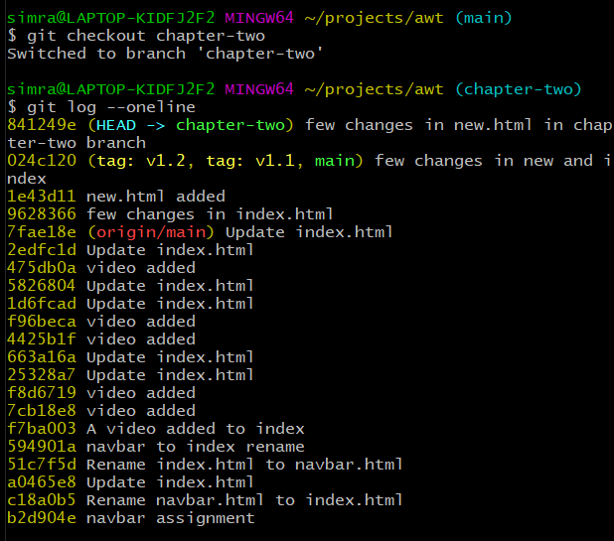

1. Merge it with the master branch

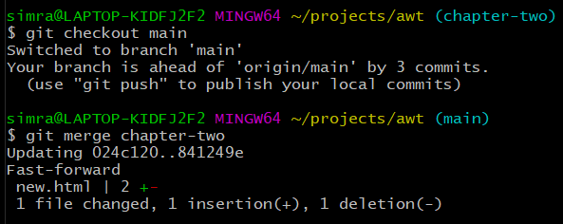

Let’s check the log in main now

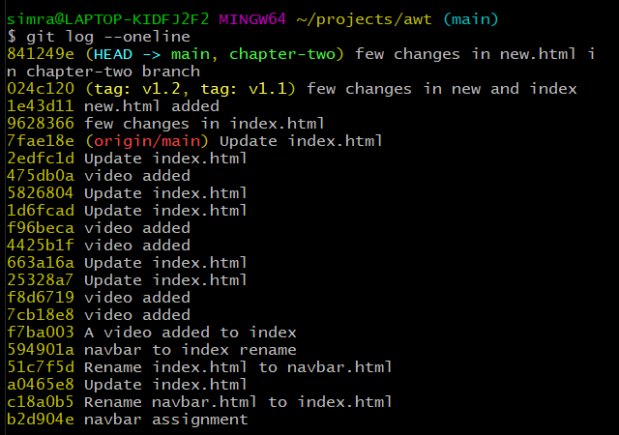

1. Delete the chapter-two branch

