**GURU NANAK DEV ENGINEERING COLLEGE, LUDHIANA**

**DEPATMENT OF INFORMATION TECHNOLOGY**



5th SEMESTER ,2018 BATCH

Advanced web Technology

ASSIGNMENT

SUBMITTED BY:

SIMRATH KAUR

URN – 1805561

D3IT/B1

1. Create three stashes in your repository

First stash:

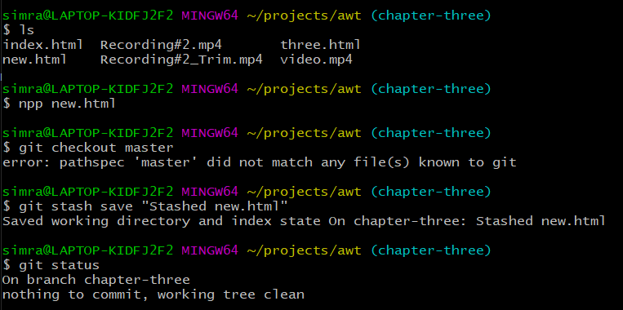

Second Stash:

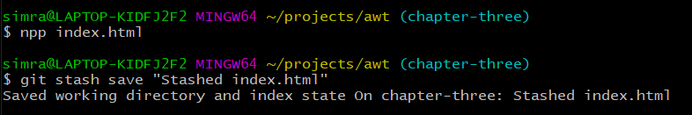

Third stash:

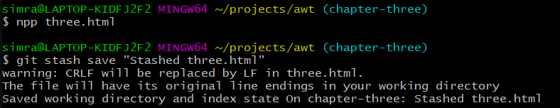

The list of stashes:

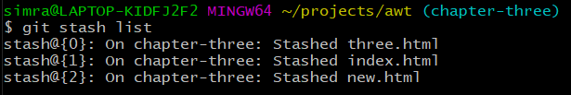

1. Explore the command git stash show

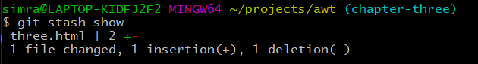

1. Understand the difference between the commands git stash show and git stash show stash@{1}



This command shows the details of latest stash

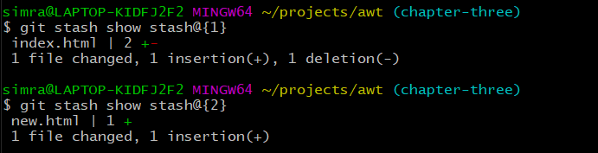

This command shows the detail of given stash number.

1. Apply the latest stash (Use â€“ git stash pop)

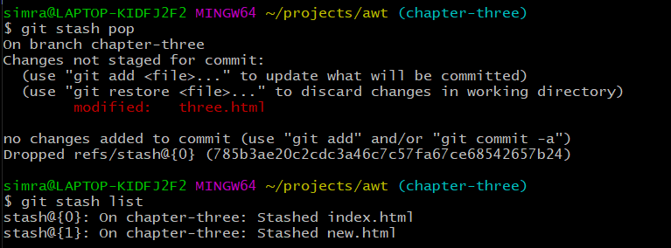

1. Delete all the stashes from the repository. (Hint â€“ git stash clear)

