**Chatterbot**

ChatterBot is a Python library that makes it easy to generate automated responses to a user’s input. ChatterBot uses a selection of machine learning algorithms to produce different types of responses. This makes it easy for developers to create chat bots and automate conversations with users.

Example1

In this example with the help of chatterbot we can make calculations and also find the current time.

CODE-

from chatterbot import ChatBot

bot = ChatBot(

'Math & Time Bot',

logic_adapters=[

'chatterbot.logic.MathematicalEvaluation',

'chatterbot.logic.TimeLogicAdapter'

]

)

# Print an example of getting one math based response

response = bot.get_response('What is 4 + 9?')

print(response)

# Print an example of getting one time based response

response = bot.get_response('What time is it?')

print(response)

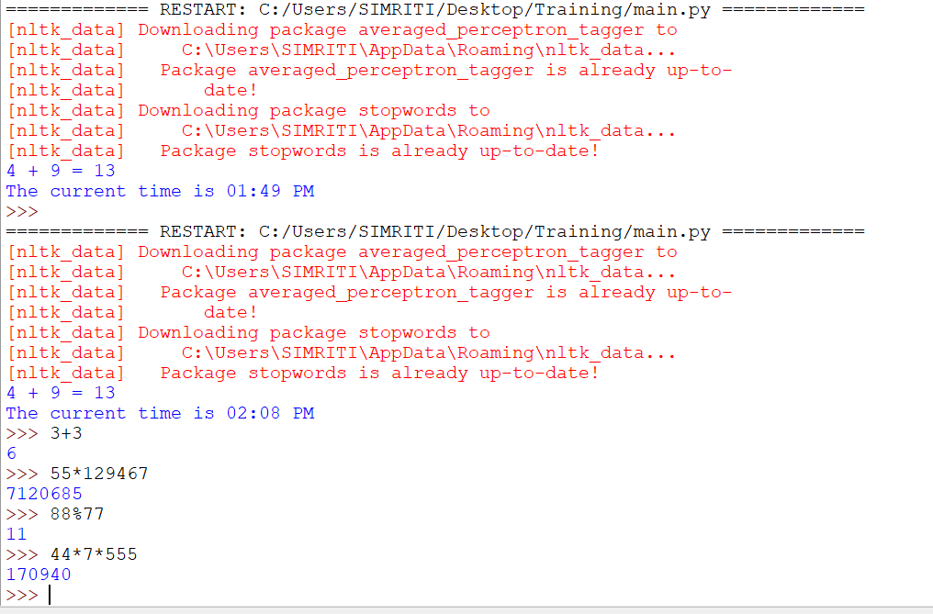

Example 2

CODE-

from nltk.chat.util import Chat, reflections

pairs = [

[

r"my name is (.*)",

["Hello %1, How are you today ?",]

],

[

r"what is your name ?",

["My name is Chatty and I'm a chatbot ?",]

],

[

r"how are you ?",

["I'm doing good\nHow about You ?",]

],

[

r"sorry (.*)",

["Its alright","Its OK, never mind",]

],

[

r"i'm (.*) doing good",

["Nice to hear that","Alright :)",]

],

[

r"hi|hey|hello",

["Hello", "Hey there",]

],

]

def chatty():

print("Hi, I'm Chatty and I chat alot ;")

chat = Chat(pairs, reflections)

chat.converse()

if __name__ == "__main__":

chatty()

