**ABSTRACT**

The aim of the project is to study how unity helps in developing various 2D and 3D games and how unity works on various platforms like android, iOS , Xbox etc.

The project shows how simply a 2D game can be developed in unity which is very important for gaming but is also now a standard in worldwide gaming industry.

The thesis will cover implementation and working of physics 2d like rigid body, box collider effects, real time graphics as well as audio effects. C script language is used for scripts and for implementing various effects in different scenes of the project.

Extreme Race is a 2d racing game where we have to protect our car from various enemy cars and reach the maximum score. The project is very interesting and knowledgeable.

**“Video Games foster the mindset that allows creativity to grow”**

**-Nolan Bushnell**

**Table Of Contents**

CERTIFICATE………………………………………………………………………...I

ACKNOWLEDGEMENT…………………………………………………………..II

ABSTRACT…………………………………………………………………………III

CHAPTER 1: INTRODUCTION

* 1. INTRODUCTION
  2. SCOPE
  3. OBJECTIVE
  4. TIMELINE
  5. STRUCTURE OF REPORT

CHAPTER 2: MATERIALS AND METHOD

2.1 UNITY GAME ENGINE

2.2 SCRIPTS

2.3 UNITY 2D USERINTERFACE

2.3 OTHER SOFTWARES USED

CHAPTER 3: STEPS TO MAKE GAME

CHAPTER 4: RESULT AND DISCUSSION

CHAPTER 5: CONCLUSION

CHAPTER 6: IMPLICATION FOR FUTURE RESEARCH

CHAPTER 7: REFERENCE

**Chapter 1- Introduction**

* 1. **Introduction**: The game is all about protection your own car from various enemy cars that can come from any random position and reach the maximum score to be the winner of the game. The scripts are written in C# using visual studio and audio is also added.

The track is made with the help inkscape. The sprits like cars are downloaded from the net.

* 1. **Scope:** The game is for single player. The game is quite simple for anyone but fun to play. The game can have more levels and some additional animations to make game more attractive. The game can also have a option in a menu so that the player can choose a car of his or he own choice. Some more features like adding the map and fuel bar on the top right corner.
  2. **Objective:** The main aim of developing the game is to learn and work on unity software and get similar with C#. The game is 2-d which is very basic and easy to make but initially it takes to get familiar with the software and its working. Now I can jump on developing 3-D games and add various effects and animations.
  3. **Timeline:**

|  |  |  |
| --- | --- | --- |
| S.No | Duration | Description |
| 1 | 15/05/2018 –  17/05/2018 | Downloaded unity and started searching on similar projects on various websites . Started the work and learn little bit of C#. |
| 2 | 18/05/2018-  25/05/2018 | Made the basic structure of my game. Added the track, cars.  Added the enemy car and provided them with the speed and audio. |
| 3 | 25/05/2018-  28/05/2018 | Worked on the userinterface added pause button, menu button, replay . Made the front page of the game |

* 1. **Structure of report:** The report consist of all the important aspects and methods with the help of the game is developed. We can structure and build the game only if we have the basic knowledge about the unity software and the C# script.We can many more additional features to our game to make it more attractive and entertaining.

.

**Chapter 2: Material and Methods**

**2.1 Unity Game Engine :**  Unity is game engine developed by Apple in June 2005.the unity is written in C++ (Runtime) and C# (Unity Scripting API)

The unity can be use to create both three dimensional and two dimensional environment. Many versions of game engine has been released since it is launched, the latest unity version is 2018.2 version released in July 2018.

The unity game engine supports various different platforms. Some of the platforms are iOS, Android, Mac, Linux, Xbox One, Android TV etc. The engine has support following API: video game consoles, macOS, webGL on the web etc.

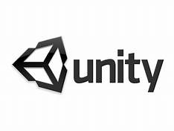

**2.2 Scripts**

Scripting plays a very vital role in all games. Even the most unembellished game needs script to control the player movements and take the input from him. Scripting is also used in implementing AI system for various objects in the game and to coordinate the player and the objects.

Since scripting is the essential part of the game it takes some time and endeavour to learn the language.

**Why c# is used as the main scripting language in unity game engine?**

Unity uses various scripting languages like javascript, C# and Boo. But all the gamers prefer C# around the word because of the following reasons

1. C# is implemented faster and have more additional features which provides it edge over other two scripting languages.
2. C# is more popular than other languages and is

native to .NET.

1. The most of assets on unity stored are developed

using C#.

**2.3 Unity 2-D UserInterface**

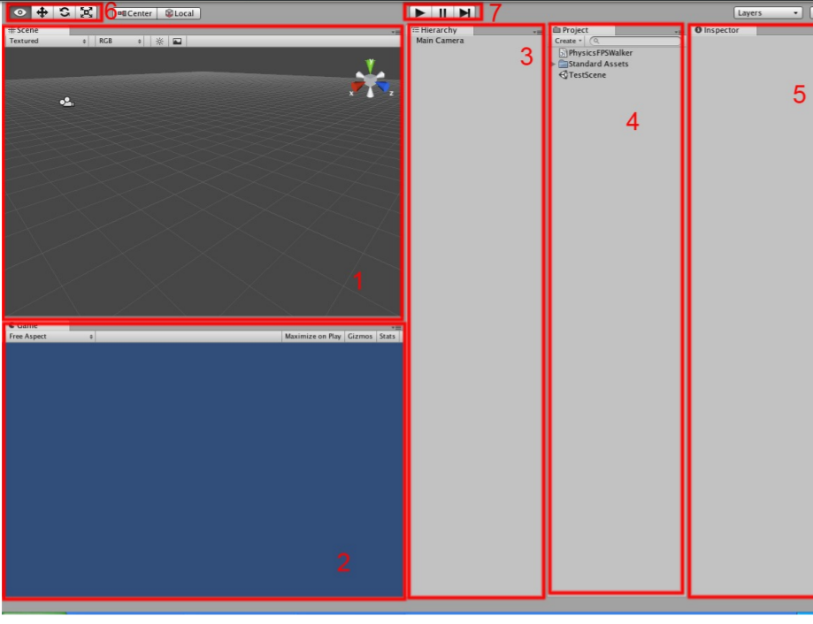

1. It is now as unity Scene View it is a place where we put all the assets. We can have two types of views for our scene they are orthographic view or perspective view.

The orthographic view is used in 3D gaming. A perspective camera in the scene view tells us about the depth of the things around us and we can estimate their distance whereas orthographic removes this sense of depth. Perspective view is commonly used in 3D gaming whereas

1. The **game view** shows how the game will look when we are creating different scenes using scene view.
2. **Hierarchy** is the list of all the objects being used in the current loaded scene.
3. **Project/asset view** contains list of all the assets being used in our games. It includes

scripts, prefabs, audio, graphical assets etc.

1. **Inspector** allow us change the setting of individual game object or add additional graphics.
2. These are graphical icons for moving scene and the content on the unity scene view
3. This allows us to play, pause and stop the game. This the easiest and quickest way to test your game if it is working properly or not.

.

**2.4 OTHER SOFTWARES USED**

**MICROSOFT VISUAL STUDIO**

Microsoft visual studio is an integrated development environment used to develop various web programs and web sites. It is also used to develop wed apps and mobile apps. Microsoft visual studio is written down in C++ and C#. Visual studio includes code editor, code refactoring, wed designer etc.

It aid 36 programming languages. Some built-in languages that visual studio includes is C++, HTML, css,

Java Script, Python etc.

The visual studio is really useful in writing various codes in its code friendly environment. Error detection is very easy in visual studio

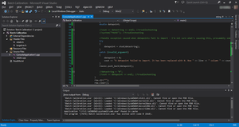

**INKSCAPE**

Inkscape is used to create and edit various graphics like charts, diagrams, logos etc.

I made my track with the help of inkscape the working on inkscape is very easy and contain many features like rectangle and square tool,3D box tool, spiral tool, stars and polygon tool etc.

I made the main menu cover with the help of inkscape

As we click on start the game loads the level and the game begins.

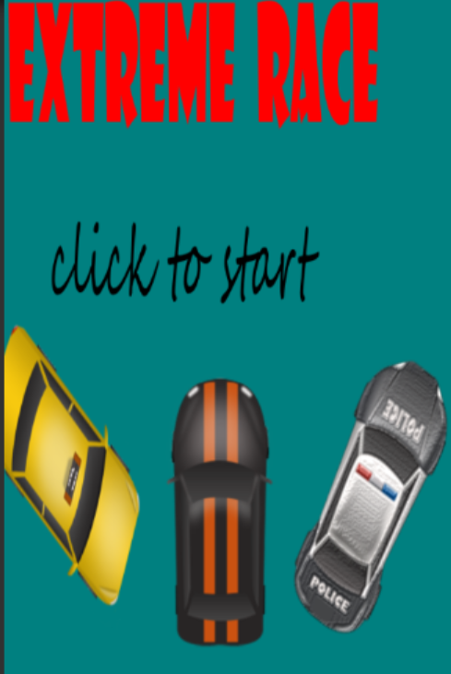

**Chapter 3: STEPS TO MAKE THE GAME**

1. Download unity game engine from the unity website.
2. When unity is downloaded ,open unity add new project and change the template to 2D
3. Now the unity user interface will open , layout it according to preference.
4. Since my project was about cars . I downloaded the required sprits for asset store and searched some more on google.
5. In asset view add all the folder that you may require for the game example sprits folder, script folder, prefabs folder etc
6. Now download inkscape and visual studio.
7. Inkscape helps is creating various graphics for our game whereas visual studio helps in writing the scripts.
8. Drag the sprites as required to the scene view or to the hierarchy.
9. Now place the track and the player car to the position where you can them to be according to the game view.
10. The basic of the game is done. Add the carcontroller script to the player car s the car can moves in horizontal direction on the both sides of the game.
11. Now add enemy cars to your game.

12 Now write the script for the collision of the cars. When the player car will collide with the enemy car the game will end.

1. Add carspawned script to so that the enemy cars can come from any random position.
2. Now using userinterface game object and button game object add play and menu button to the game.
3. Similarly add new scene for menu .Menu have ”click to start” button when loads the level and game starts.
4. Also add score to the score.

**Chapter 4: RESULT AND DISCUSSION**

Extreme race is the normal racing game when one player and different enemies.the game is developed with the help of unity game engine ,visual studio and inkscape.

When the help of userinterface i added menu play pause buttons to my game.I also added score to the left side corner of the game.

**MENU OF THE GAME**

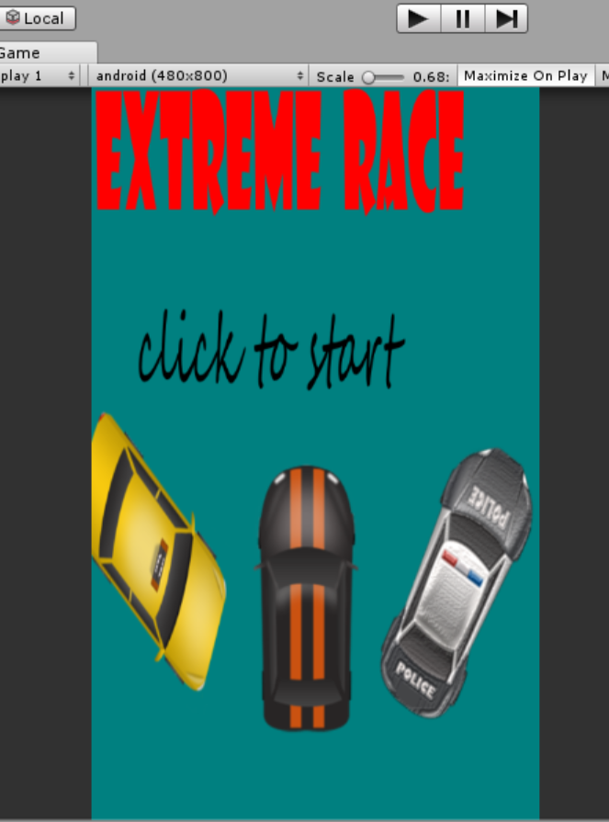

This the menu of the extreme game. Click on “ click to start” button to start the game. The menu is build with help of inkscape and sprites.

**MAIN GAME**

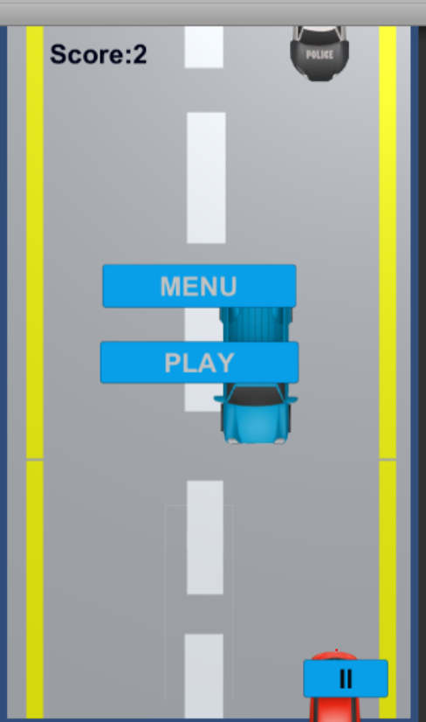

**PAUSE BUTTON** : The pause button build using user interface pause the game and we can click on the pause button to start tha game grom where we pausd the game.The pause button is present on the right hand corner.



**Score:** It calculates the score as we move on in our game. The score increases in every 1 sec .We have to win the game with maximum score without collision.



**MENU AND PLAY BUTTON:** menu and ply button are shown on the screen after the collision. We can restart the game using play button and return to the main menu using the play button



**SCRIPTS:**

*CARCONTROLLER SCRIPT*

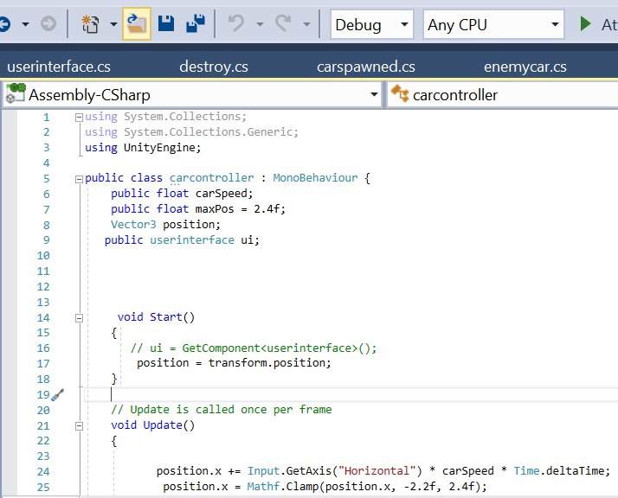

The carcontroller scripts helps in moving the car to left and right along x axises. Here maxpos tells about the maximum position till which the car can move along x axises and –x axises.

*TRACKMOVE*

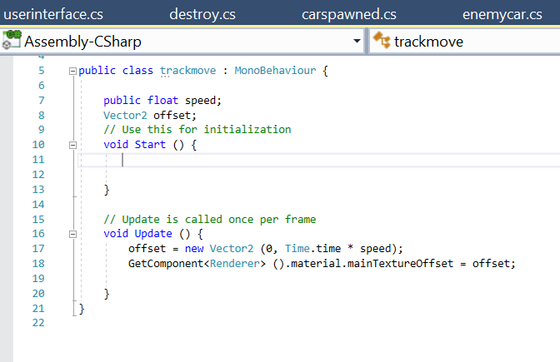

The script helps in making the illusion the track is moving.

*CARSPAWNED*

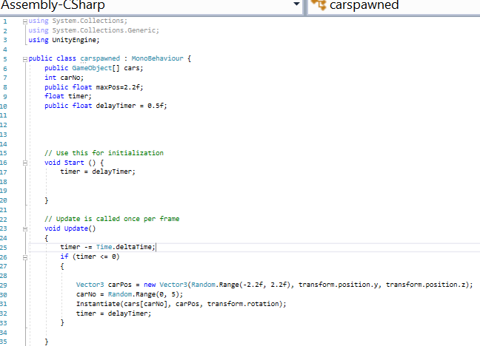

The car spawned script helps in adding various enemy car and to allocate random position and time to enter the track.

USERINTERFACE

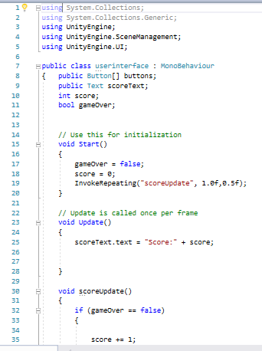 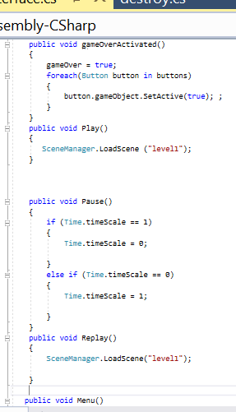

Userinterface script helps in developing and loading the level from the menu scene.It also helps in adding score and butons to the game.

**Chapter 5: CONCLUSION**

Working on the unity for my in-house project really changed my mindset regarding different games that I used to play everyday on my mobile or on my computer. It really takes great dedication and knowledge to work and build different game that not only looks good but also attract and appeal other person.

Unity is the best game engine I came across since it decreases the complexity of the game and helps the developer to have good coding environment. The drag and drop property and various graphical icons makes it very easy for developer to the place the sprite to the correct position and resize it accordingly.

The basic necessity of the unity is high level programming language C#.

So in all the unity is very easy to work on and build different 2D and 3D game. I really enjoyed making my first game ever.

**Chapter 6: IMPLICATION IN FUTURE RESEARCHES**

“One of the most difficult tasks men can perform, however much others may despise it, is the invention of good games.” 

― [**C.G. Jung**](https://www.goodreads.com/author/show/38285.C_G_Jung)

The project shows how simply a 2D game can be developed in unity which is very important for gaming but is also now a standard in worldwide gaming industry.

The thesis will cover implementation and working of physics 2d like rigid body, box collider effects, real time graphics as well as audio effects. C script language is used for scripts and for implementing various effects in different scenes of the project.

Extreme Race is a 2d racing game where we have to protect our car

from various enemy cars and reach the maximum score. The project is very interesting and knowledgeable .

I am really satisified with my performance in the game development as a beginner.I did a lot of research on youtube, google, coursera etc to come with the best and

the simpliest game. Overall research led me to the development a simple racing game” extreme run”. The game is based on the simple idea of protecting the car from enemies and reach the maximum score.

I can add more levels to the game and some additional animations to make game more attractive. I can also add a option in a menu so that the player can choose a car of his or he own choice. Some more options like featureslike adding the map and fuel left bars on the sides of the game.

.