**[](https://www.bing.com/images/search?view=detailV2&ccid=AHMHxkef&id=EF896880373D05C4A03E7F642D847D9C60F5816A&thid=OIP.AHMHxkef6GIlqa5kLe38LABGBT&q=amity+university+logo&simid=608022316784616726&selectedIndex=25)**

**In-house Report**

On

**THE SPACE RUN-2D GAME**

**AMITY UNIVERSITY, UTTAR PRADESH, NOIDA**

**Guided By: Submitted By:**

**Ms. Misha Kakkar Akshat Uttam**

**A2305216405**

**CERTIFICATE**

This is to certify that Mr. Akshat Uttam, student of B.Tech in Computer science has carried out the work presented in the project of the In-house Report entitled “The Space Run" as a part of Second year programme of Bachelor of Technology in Computer science from Amity University, Noida, Uttar Pradesh under my supervision.

Name of the faculty Guide: Ms. Misha Kakkar

Signature:

                                                             Amity University, Noida

Acknowledgment

I have taken efforts in this project. However, it would not have been possible without the kind support and help of many individuals and organizations. I would like to extend my sincere thanks to all of them.

I am highly indebted to Ms.Misha Kakkar for their guidance and constant supervision as well as for providing necessary information regarding the project & also for their support in completing the project.

I would like to express my special gratitude and thanks to industry persons for giving me such attention and time.

My thanks and appreciations also go to my colleague in developing the project and people who have willingly helped me out with their abilities.

Nobody has been more important to me in the pursuit of this project than the members of my family. I would like to thank my parents, whose love and guidance are with me in whatever I pursue. They are the ultimate role models.

Abstract

The main aim of this project was to make a 2d game using unity game engine and to examine how games are designed and to see how different mechanics work and how to use them in a unity game.

It shows how unity interface helps to make game environments, how scripts are used for logic, game interaction and other things. The report discusses the different tools and languages used to create the game. A series of trials were performed before making the final draft of the game.

A game prototype was created and enhanced over the time period by making certain changes in the tools and scripts and by adding different animations and prefabs that resulted in a unity 2d game.

The game developed is a 2d space game in which we have to protect our spaceship from enemy spaceships and alien planets and then leading to a great score. The game was developed using Microsoft visual studio and different strategies and methods were used to make the game.

When I completed the game, I found out that using unity is kind off easy and interactive. Unity is used in different game developments.

Table of contents

Certificate ……………………………………………………………..... .I

Acknowledgements……………………………………………………….II

Abstract………………………………………………………………..….III

1. Introduction
   1. The Space Run
2. Materials and Methods

2.1 Unity game engine

2.2 Microsoft visual studio

2.3 Scripting

1. Results and Discussions
2. Conclusions
3. Implications of future research
4. References

Introduction

**The Space Run**

The game I have created is basically about to protect your spaceship from enemy spaceship and alien planets. The game made is so developed that enemy generated are randomized and can come from any direction. The player who scores the highest by defending his spaceship from foreign attack wins the game only one player can play at a time. Various different sprites have been used like for spaceship, the space in the background and the alien planets coming towards us are all randomized. Scripts are used to control the movement of the spaceship and to make the enemy attack us. I have also added an option to count our score and also I have added a fun audio in the game that makes the game interesting and a bit funny too.

The development of this game helped me a lot to learn new things about unity about visual studio about everything. I am satisfied with the game I developed and look forward to develop and advance the game in near future. I have added two options in the menu section till now in the game that I will change afterwards. Later on I will add more options of sound adjustment and brightness level and may more things. For now the game I have created is a beginners game and is fun to play with normal difficulty level.

2. Materials and Methods

The game has been designed using unity game engine with the help of C# language and the drag and drop interface of unity. The programming has been done on the Microsoft visual studio.

Basic Software’s used in the making of the game are:

1. Unity game engine: Unity game engine is a cross platform for game development. It has a friendly user interface. It provides the user with drag and drop option that makes game development very easy and interesting.
2. Microsoft Visual Studio: it provides an integrated development environment known as IDE that is used to develop many websites, mobile applications and games.
3. C Script: it is a structured and object oriented programming language used here to make the scripts that help us to control and manage the gaming environment.
   1. **UNITY GAME ENGINE**

Itis a cross platform game engine developed by unity tech. it was launched at apples conference as an operating system exclusive game engine. Now it supports about 27 platforms the engine is used to create three dimensional and two dimensional games as well as simulations for laptops, pc’s, smart TV’s and mobile devices.

Unity gives users the ability to create game in both 2d and 3d and the engine provides primary scripts in C# as well as drag and drop functionality. Within 2d games, unity allows us to import different sprites and a developed 2d renderer. It allows us the specification of texture compressed and mipmaps and different resolution settings so as to support in different devices. Unity allows us to add different prefabs, maps, text, image etc.



My game is a 2d game developed using unity game engine while using different animations, prefabs, images, text, space background, spaceship prefabs, writing different scripts and maintaining different scenes for menu and different scene for the game. I used many sprite types, many sprite renderers and editing them to get the desired result out of those. 2d physics was applies to all the objects present in the game such as rigid body, collider 2d etc... I used C# to write all the scripts and develop a fully functional 2d game.

* 1. **MICROSOT VISUAL STUDIO**

Microsoft Visual Studio is an incorporated advancement condition (IDE) from Microsoft. It is utilized to create PC programs, and in addition sites, web applications, web administrations and versatile applications. Visual Studio utilizes Microsoft programming advancement stages, for example, Windows API, Windows Forms, Windows Presentation Foundation, Windows Store and Microsoft Silverlight. It can deliver both local code and oversaw code.

Visual studio has helped me in making my project. It gives a coding environment that is user friendly and is easy to learn. I have written many C sharp scripts in visual studio.



* 1. **Scripting**

Scripts are short computer programs that do steps that could be done at a time by a person. It automates the work to make it easier and reliable. There are different types of scripting done in computer world that contains JavaScript, C sharp etc. in this project; everything in scripting is done in C#.

C sharp:- it is a multi paradigm language i.e. it is object oriented, event driven and structured language.

C scripts:- it is a specific dialect of c programming language supported by test complete. It is base on Jscript. It was specially designed so the C# developers can easily port script routines to the self testing and to the connected applications.CS Script is basically a CLR (common language runtime) based script that has full support on mono behavior.

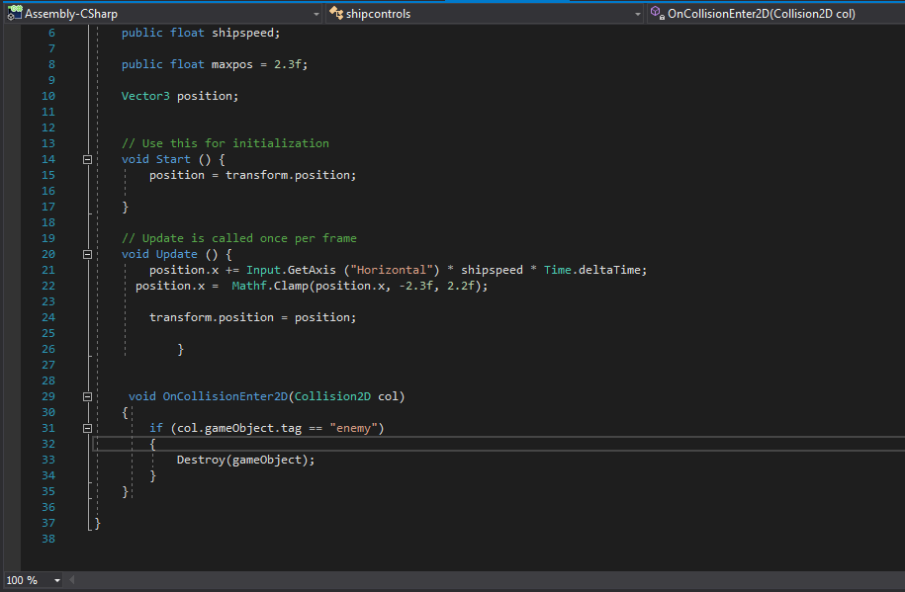

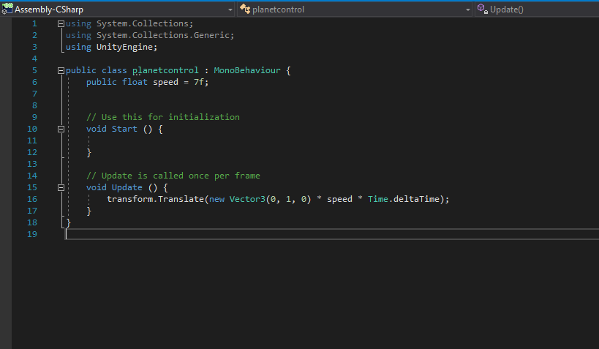

Results and Discussion

The end result of this in-house project is that I developed a 2d game using unity and visual studio and by developing scripts for different movements and controls in the game. I have also made this report on my game and explained about the different tools and methods used in making it possible. I made a 2d game in unity that was quite easy and worth my time. The course time for the work to be completed was merely twenty days which made it difficult to make the game in time. I had to invest a lot of time in the making of the game.

I am satisfied with my performance in the game development. As for a beginner I did what had to be done. I did a lot of hard work and study to get going the game. Game development through unity is easy to learn. I did a lot of study on how to use unity and its tools. Overall studies, research led me to the development of this game called the space run. After making this game I would like to continue game development in the future as this is quite interesting.

Full screen of unity game engine:

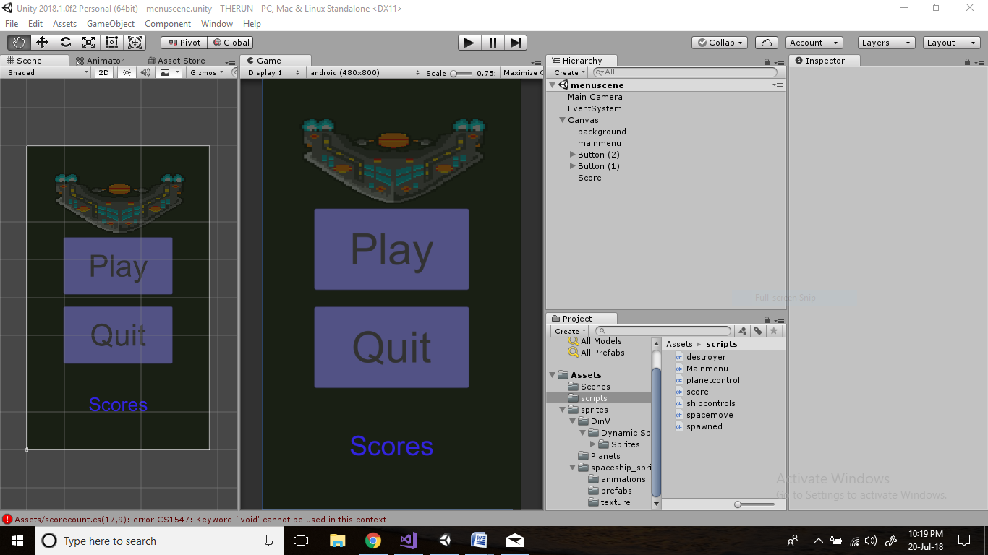

Game In Progress: defending our spaceship from enemies

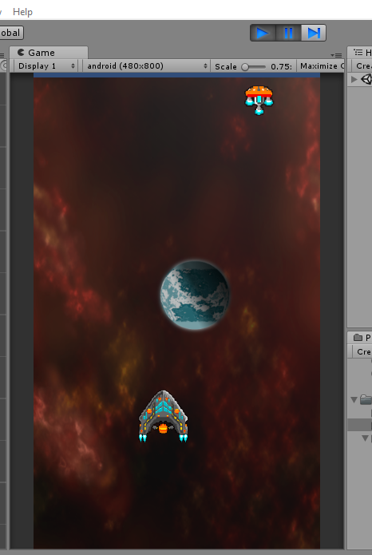

Menu of the game: menu has two options of play and quit.

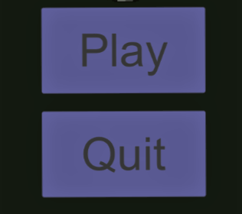

Score: it counts the score.



After you get struck by enemy: the spaceship vanishes

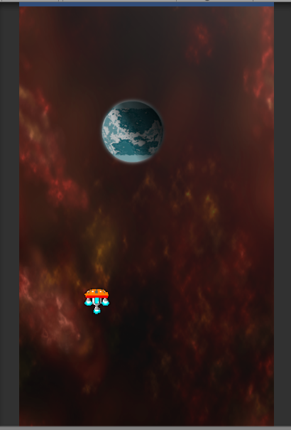

Scripts have been used to control the environment and the spaceship:

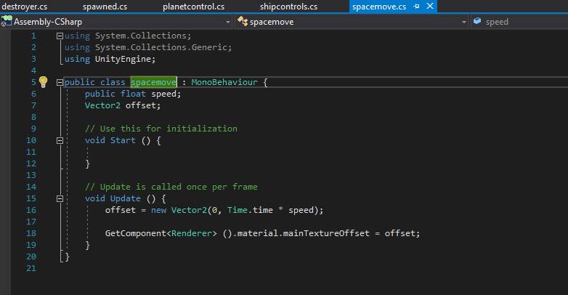

Spawned script: it helps to randomly create and send enemies.

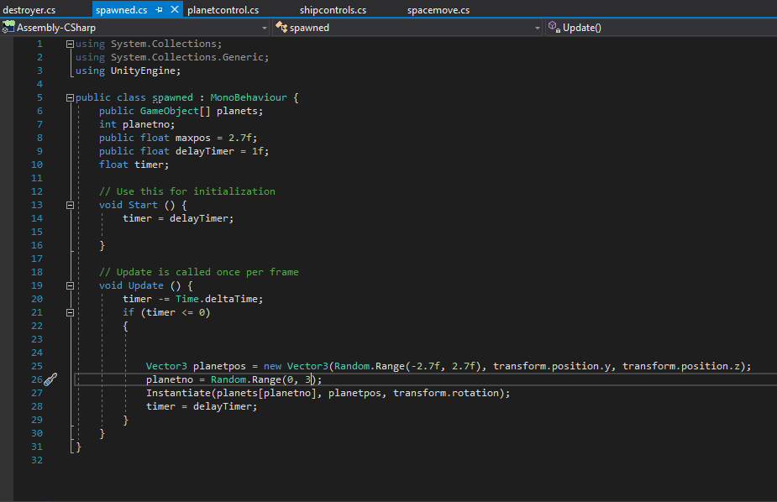

The destroyer script has helped to destroy our spaceship after we are hit by an enemy spaceship or by an alien planet.

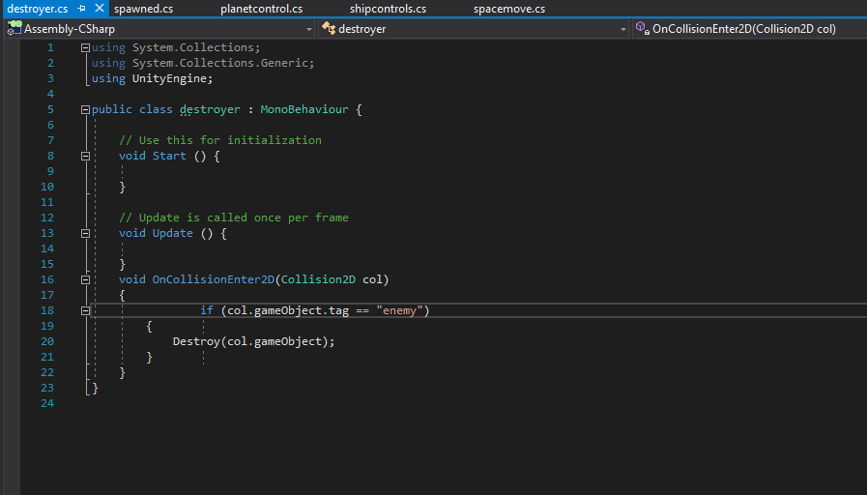

Conclusions

Aim of this project report was to define the programming and gaming tools used in the making of the game. I used unity game engine and Microsoft visual studio to do the same. Using unity was not much hard but took time for me to complete my objectives. On the starting of the report I had no idea about unity and how to use it. Neither did I know about the c sharp programming language but I learned these things and now my game is developed.

I came to learn a lot of new things along the making of the game and the report. Making this report helped me to know that game making is not an easy task. I really did enjoyed playing games but now after this I think that game making is also equally interesting and kind off adventurous as you get to know the various things you can do in the gaming development field. After making this report and after learning game development I would like to make more games in future using unity.

Implications for Future Research

Despite the fact that online gaming is one of the fastest growing entertainment industries, there is very little data on the development and acceptance of this. This study attempted to remedy many of the shortcomings. In my research I found out that the gaming level can be further increased by increasing the difficulty in the advanced games for professionals of gaming. For more like of a beginner level we can add a more basic level that can be played by more individuals.

I can further add more difficulty and levels and increase the scope of game development. I will develop and improve it further. I will learn more new techniques and programming and will make advancement in my game. The future of gaming is going to be great. Unity has provided me with a lot o options to improvise my game and make it more difficult and interesting. I haven’t yet added many things in my game which I can do later. I can increase the pace of the game with more enemies and can make my game better.

References

1. Riccitiello, John (October 23, 2014). "John Riccitiello sets out to identify the engine of growth for Unity Technologies (interview)". Venture Beat (Interview). Interviewed by Dean Takahashi*. Retrieved January 18, 2015*.
2. Lextrait, Vincent (January 2010). "The Programming Languages Beacon, v10.0". Archived from the original on 30 May 2012*. Retrieved 5 January2010*.
3. www.youtube.com/charger-games/build-a-2d-game.
4. www.unity2d.com/