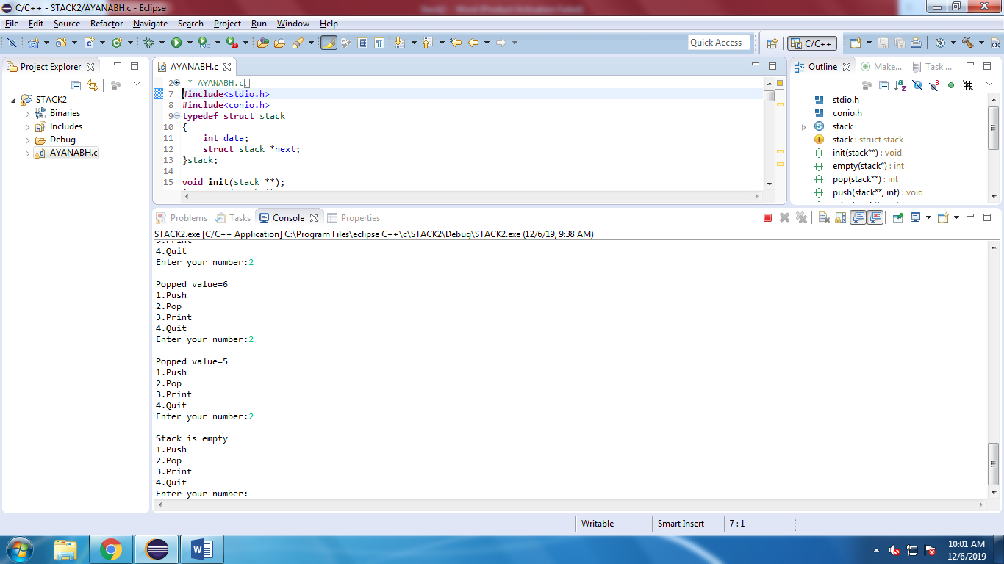

/*

* AYANABH.c

*

* Created on: Dec 6, 2019

* Author: Administrator

*/

#include<stdio.h>

#include<conio.h>

typedef struct stack

{

int data;

struct stack *next;

}stack;

void init(stack **);

int empty(stack *);

int pop(stack **);

void push(stack **, int);

void print(stack *p);

void main()

{

stack *TOP;

int x,op;

init(&TOP);

do

{

printf("\n1.Push\n2.Pop\n3.Print\n4.Quit");

printf("\nEnter your number:");

_flushall();

scanf("%d",&op);

switch(op)

{

case 1: printf("\n Enter a no.:");

_flushall();

scanf("%d",&x);

push(&TOP,x);

break;

case 2: if(!empty(TOP))

{

x=pop(&TOP);

printf("\nPopped value=%d",x);

}

else

printf("\nStack is empty");

break;

case 3: print(TOP);

break;

}

}while(op!=4);

}

void init(stack **T)

{

*T=NULL;

}

int empty(stack *TOP)

{

if(TOP==NULL)

return(1);

return(0);

}

void push(stack **T, int x)

{

stack *p;

p=(stack *)malloc(sizeof(stack));

p->data=x;

p->next=*T;

*T=p;

}

int pop(stack **T)

{

int x;

stack *p;

p=*T;

*T=p->next;

x=p->data;

free(p);

return(x);

}

void print(stack *p)

{

printf("\n");

while(p!=NULL)

{

printf("%d",p->data);

p=p->next;

}

}