Conservatoire Virtuel
Music School Management System
Project report – Object-oriented design, database and Java application
Group 2 – I2new
Authors: [names of the group members]
November 2026

Contents
1. Project description 3
1.1 Context and objectives 3
1.2 Functional scope 3
1.3 Business rules 3
1.4 Technical overview 3
2. UML design 5
2.1 Class diagram 5
2.2 Sequence diagram – scheduling a lesson 6
2.3 Activity diagram – exam registration 7
2.4 From UML to code 7
3. Design rationale 9
3.1 Layered architecture 9
3.2 Where the business rules live 9
3.3 Database design 9
3.4 Plain JDBC and transactions 10
3.5 Two user interfaces 10
3.6 Limitations and possible improvements 10
4. Screenshots of execution 11
4.1 Desktop interface 11
4.2 Console interface 15
5. Testing scenario 16
5.1 Initial data 16
5.2 Test cases 16
5.3 Evidence 18
5.4 Unit tests 22
6. Discussion of the object-oriented requirements 24
6.1 Abstract classes 24
6.2 Interfaces 24
6.3 Polymorphism 25
6.4 Copy constructors 25
6.5 Inheritance, composition, encapsulation, abstract versus concrete types 26
7. Conclusion 27
Appendix – running the application 27

1. Project description

1.1 Context and objectives
Conservatoire Virtuel is a private music school that needs one information system for its internal activities. The goal of the project is to design and implement that system following good software and database design practices, with a strong emphasis on object-oriented design.
The delivered application is a Java 25 program backed by a MySQL database. It offers two user interfaces built on the same business layer: a Swing desktop interface (default) and the console menu required by the specification (--console).

1.2 Functional scope
Area | What the system manages
Students | Identity, contact details, date of birth, level (Beginner / Intermediate / Advanced), preferred instruments, purchased packages, remaining hours and usage history.
Teachers | Identity, hourly rate, qualifications, instruments they can teach (specializations) and weekly availability.
Course packages and services | Packages of N hours with validity dates, unlimited packages, single paid lessons (teacher rate × duration), instrument rental and room rental. Every purchase is invoiced.
Scheduling | Individual and group lessons (teacher + students + room + instrument), room bookings and exam sessions, each with date, start time, duration and status (scheduled / completed / cancelled). Conflicts are prevented.
Exams | Name, instrument, date, duration and capacity; registration of students; results recorded later (pass/fail and optional score out of 100).
Payments and billing | Invoices with items, partial payments and outstanding balances; total spent by a student; summary per month and per student.

1.3 Business rules
- Package expiry – package hours expire at the package end date and cannot be used afterwards.
- Late cancellation – a lesson cancelled less than 24 hours before it starts counts as consumed. Cancelled earlier, its hours are given back and unpaid charges for it are removed.
- Exam capacity – registration closes when the maximum capacity is reached. A student cannot register twice for the same exam.
- Group lessons – a group lesson consumes its duration from each participant's package.
In addition, scheduling validates the teacher's specialization and availability, the room's opening hours and capacity, the instrument's availability, and the absence of overlap with other activities of the same teacher, room or students.

1.4 Technical overview
Item | Choice
Language | Java 25, built with Maven
Database | MySQL 8 (MariaDB compatible), accessed with plain JDBC through DAO classes
User interfaces | Swing desktop application (default) and text console menu (--console)
Tests | JUnit 5 – 13 unit tests on the business rules, no database needed
Size | 52 Java source files (about 5 200 lines), 23 database tables

The code is organised in layers, each in its own package of I2new.group2:
Package | Responsibility
model | Domain classes, the Billable and Schedulable interfaces and the enumerations. Business rules that belong to one object live here.
dao | Database access: one DAO per aggregate, the shared DatabaseConnection and the DatabaseInitializer that creates the schema and loads the demo data.
service | Use cases and rules that span several objects (scheduling, enrollment, exams, billing, reports). Used by both interfaces.
exception | InvalidSpecializationException and ScheduleConflictException, named in the sequence diagram.
ui | The Swing window (DesktopApp) and the console menus a–e.

2. UML design
Three diagrams describe the system. They are written in PlantUML and stored in the UML folder of the repository. The class diagram is the reference for the domain model and the database schema; the sequence and activity diagrams describe the two most important flows.

2.1 Class diagram
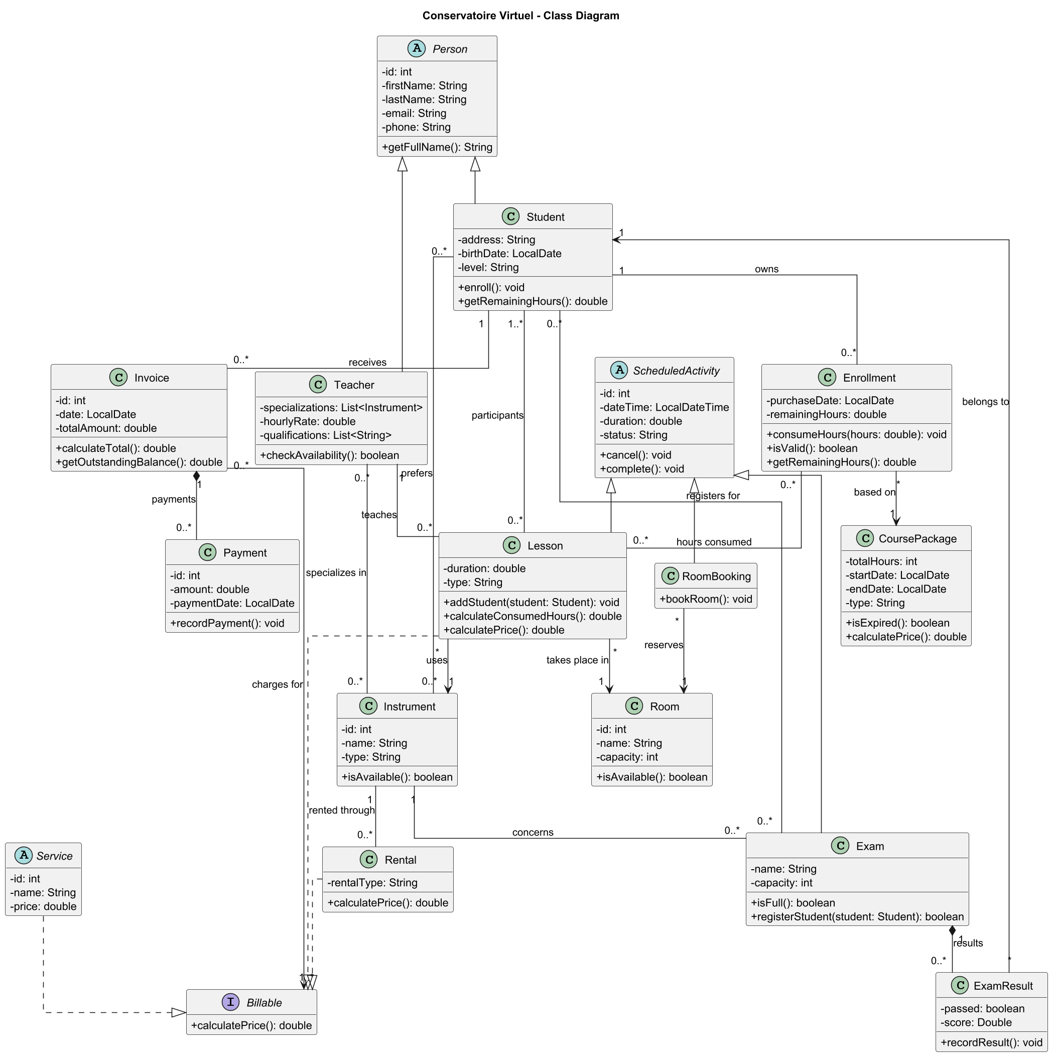
Figure 1 – Class diagram of the domain model (UML/basic class diagram.puml)
The diagram is organised around six groups of classes:
- People – the abstract class Person holds the identity shared by Student and Teacher.
- Services and packages – the abstract class Service and the Billable interface. CoursePackage and Rental are the services the school sells; Lesson is also billable when a student pays per lesson.
- Enrollment – an Enrollment is a package bought by a student, with its remaining hours. The many-to-many association with Lesson records which lesson consumed how many hours.
- Instruments and rooms – resources used by lessons. Teachers specialize in instruments; students prefer instruments; rentals concern an instrument.
- Scheduling – the abstract class ScheduledActivity generalizes Lesson, RoomBooking and Exam, which share date, duration, status, cancel() and complete().
- Exams and billing – an Exam owns its ExamResults (composition); an Invoice owns its Payments (composition) and charges for one or more Billable items.

2.2 Sequence diagram – scheduling a lesson
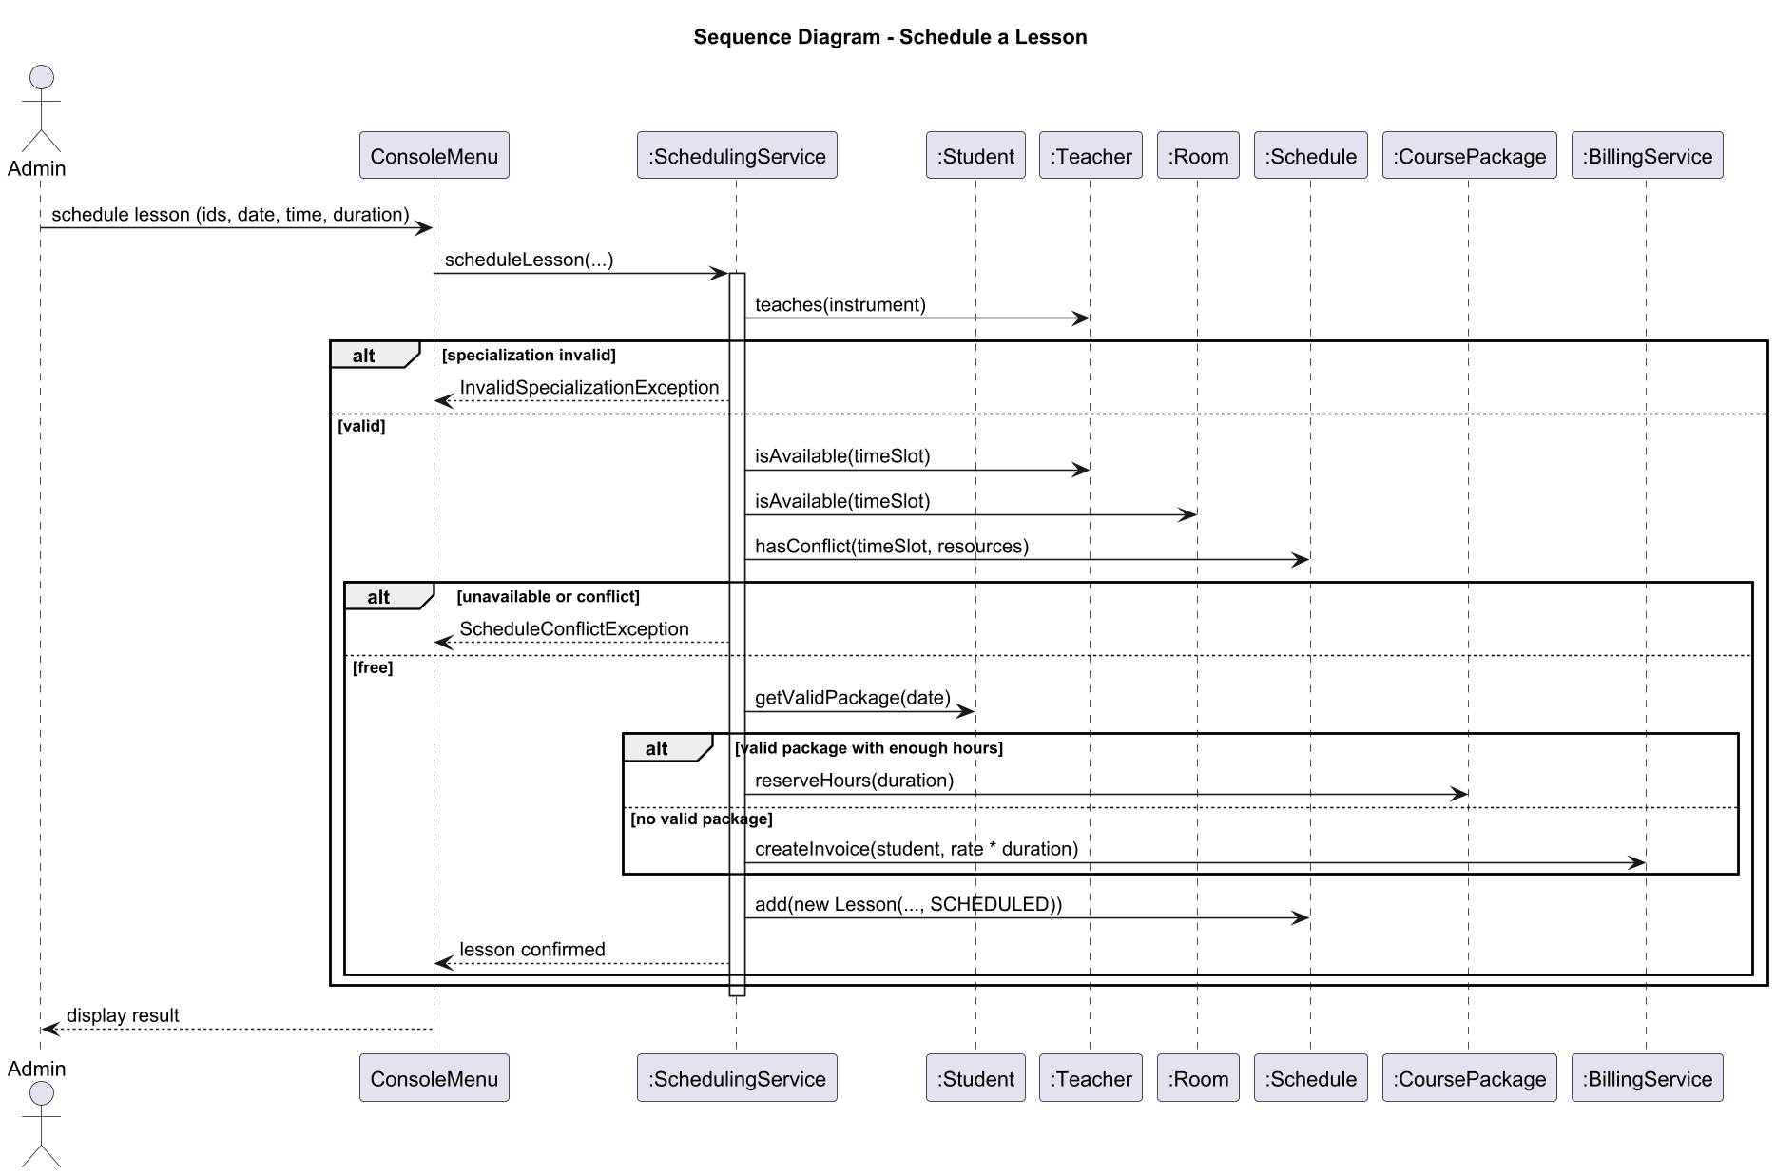
Figure 2 – Sequence diagram for scheduling a lesson (UML/SeqDiagram.puml)
The scheduling flow is implemented step by step in SchedulingService.scheduleLesson:
- The administrator enters the teacher, instrument, lesson type, students, room, start and duration in a menu or in the GUI form.
- Specialization check – teacher.teaches(instrument); if it fails, an InvalidSpecializationException is thrown and nothing is saved.
- Availability – teacher.isAvailable(...) checks the weekly availability, room.isAvailable(...) the opening hours, and the instrument must be in service.
- Conflicts – ActivityDao.findConflict(...) queries the database for a non-cancelled activity that overlaps the slot and uses the same teacher, room or one of the students. A conflict throws a ScheduleConflictException.
- Payment – for each student, student.getValidPackage(date, hours) looks for a valid package with enough hours (unlimited packages first). Hours are consumed from it; otherwise the lesson is added to a new invoice at the teacher's rate × duration.
- The lesson is saved with status SCHEDULED. Steps 5 and 6 run in one database transaction, so a failure leaves no partial lesson behind.

2.3 Activity diagram – exam registration
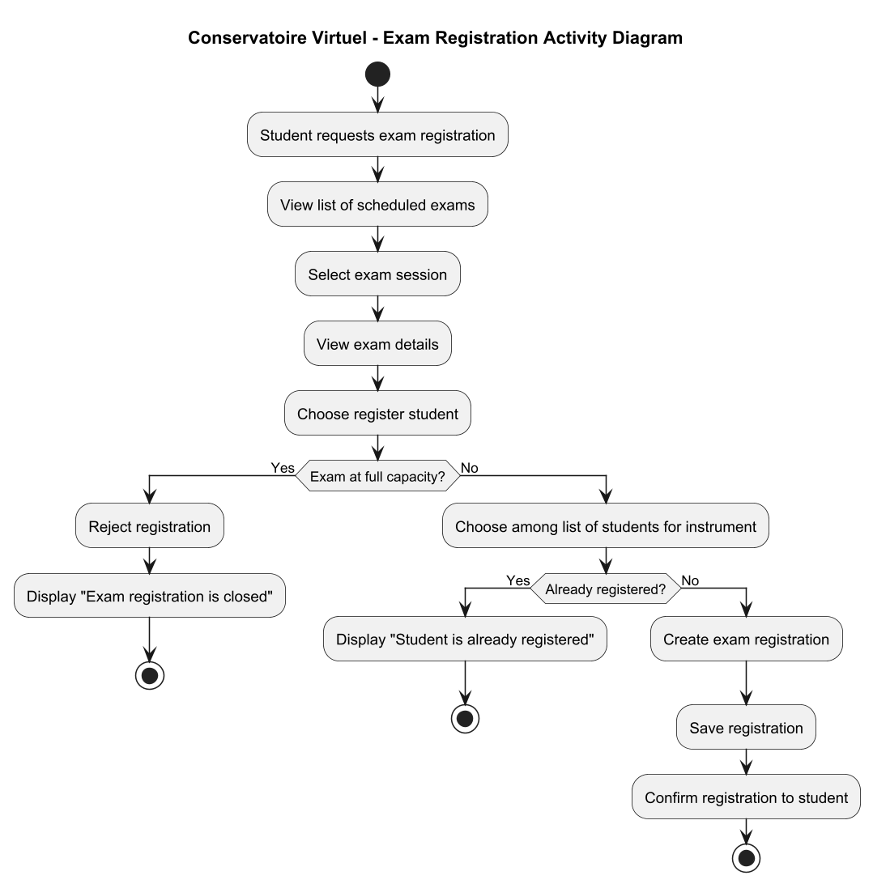
Figure 3 – Activity diagram for exam registration (UML/ExamRegistration.puml)
The registration flow is implemented in Exam.registerStudent and ExamService.registerStudent, in the order of the diagram:
- the administrator selects a scheduled exam and sees its details and remaining seats;
- if the exam is full, registration is rejected with the message "Exam registration is closed" (business rule 3);
- otherwise a student is chosen among the students who play the exam's instrument;
- if the student is already registered, the message "Student is already registered" is shown;
- otherwise the registration is created, saved and confirmed.

2.4 From UML to code
Classes, attributes and associations of the class diagram are mapped one-to-one to Java classes and database tables. The group agreed on a small number of deviations, each needed by the specification:
Deviation | Reason
Schedulable interface implemented by Teacher and Room | The specification requires at least two interfaces; the diagram has only Billable.
teacher_availability table and Teacher.Availability record | Gives checkAvailability() the weekly slots it needs to validate scheduling.
Enumerations instead of String fields | StudentLevel, ActivityStatus, PackageType, LessonType, RentalType: invalid values become impossible.
CoursePackage and Rental extend Service | The inheritance arrow was implied by the design but missing from the diagram.
Two exception classes | Named in the sequence diagram.
Instrument.available field | Backs the diagram's isAvailable() method (an instrument can be out of service).

3. Design rationale

3.1 Layered architecture
Separating model, data access, services and user interface keeps each concern in one place:
- the model classes can be tested without a database (all unit tests run in memory);
- SQL is confined to the DAO classes, so the business code never builds queries;
- the services contain the use cases once, and both the console and the Swing interface call them. Adding the GUI required no change to the business logic.

3.2 Where the business rules live
A rule is placed in the class that owns the data it needs:
Rule | Location | Why there
Package expiry | CoursePackage.isExpired(), Enrollment.isValid() / consumeHours() | Only the enrollment knows its package and remaining hours.
24 h cancellation | Lesson.cancel(LocalDateTime) (overrides ScheduledActivity) | Specific to lessons; room bookings and exams cancel without this rule.
Exam capacity and duplicates | Exam.registerStudent() | The exam owns its list of registered students.
Group lesson consumption | Lesson.calculateConsumedHours() + SchedulingService | The lesson knows the duration; the service applies it to each participant's enrollment.
Conflicts and availability | Teacher / Room (Schedulable) + ActivityDao.findConflict() | Intrinsic availability is checked by the objects, overlaps with the whole schedule by a database query.
Payments | Invoice.addPayment() | The invoice refuses a payment larger than its outstanding balance.

3.3 Database design
- One table per class and per many-to-many association of the class diagram (23 tables), for example lesson_participant, enrollment_lesson, exam_registration, teacher_instrument.
- Inheritance mapped as "joined" tables: service + course_package / rental, and scheduled_activity + lesson / room_booking / exam. Each subclass row shares the id of its base row, so polymorphic reads are a simple join.
- Integrity enforced by the database as well as by Java: foreign keys, unique e-mails, CHECK constraints (positive capacity and duration, valid score range, exactly one billable per invoice item, etc.).
- The usage history is the association table enrollment_lesson, so it cannot drift from the hours actually consumed.
- Demo data with relative dates (CURDATE() + INTERVAL n DAY): the scenario always contains an expired package, a lesson starting within 24 hours and an upcoming exam, whatever the day it is loaded.

3.4 Plain JDBC and transactions
Plain JDBC was preferred to an ORM so that the object model stays visible and is not hidden behind framework annotations, and so that each query can be explained in the report. A single shared connection is provided by the DatabaseConnection singleton. Its inTransaction(...) method commits on success and rolls back on any exception; a nested call simply joins the running transaction. Operations that write several tables (scheduling a lesson, cancelling one, selling a package, inserting a teacher) are therefore atomic.

3.5 Two user interfaces
The console follows the menu structure of the specification (a–e). Each menu is a subclass of the abstract Menu class, which implements the input loop and the error handling once (Template Method pattern).
The Swing interface shows one tab per area with sortable tables and dialog forms. All database work runs on one dedicated background thread so the window stays responsive and the shared connection is never used by two tasks at the same time. After every change, the tables are reloaded.

3.6 Limitations and possible improvements
- The GUI cannot yet create instruments, rooms, course packages or rentals; the console can.
- Specializations, availability and preferred instruments are entered when a person is created and cannot be edited afterwards.
- The GUI is in French while the console and the error messages are in English.
- A single database connection is enough for one user; a multi-user deployment would use a connection pool.

4. Screenshots of execution
The screenshots below were taken from the running application, connected to MySQL, after the testing scenario of section 5 was executed. They therefore show its results: new lessons #8 and #9, cancelled lessons #2 and #3, a full piano exam and a paid invoice.

4.1 Desktop interface
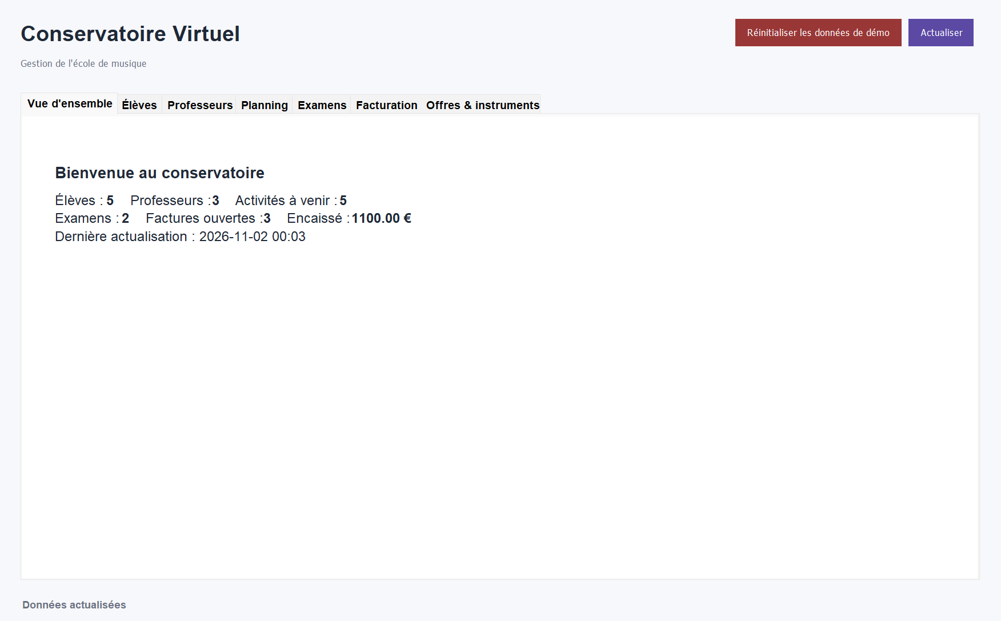
Figure 4 – Overview tab: key figures of the school
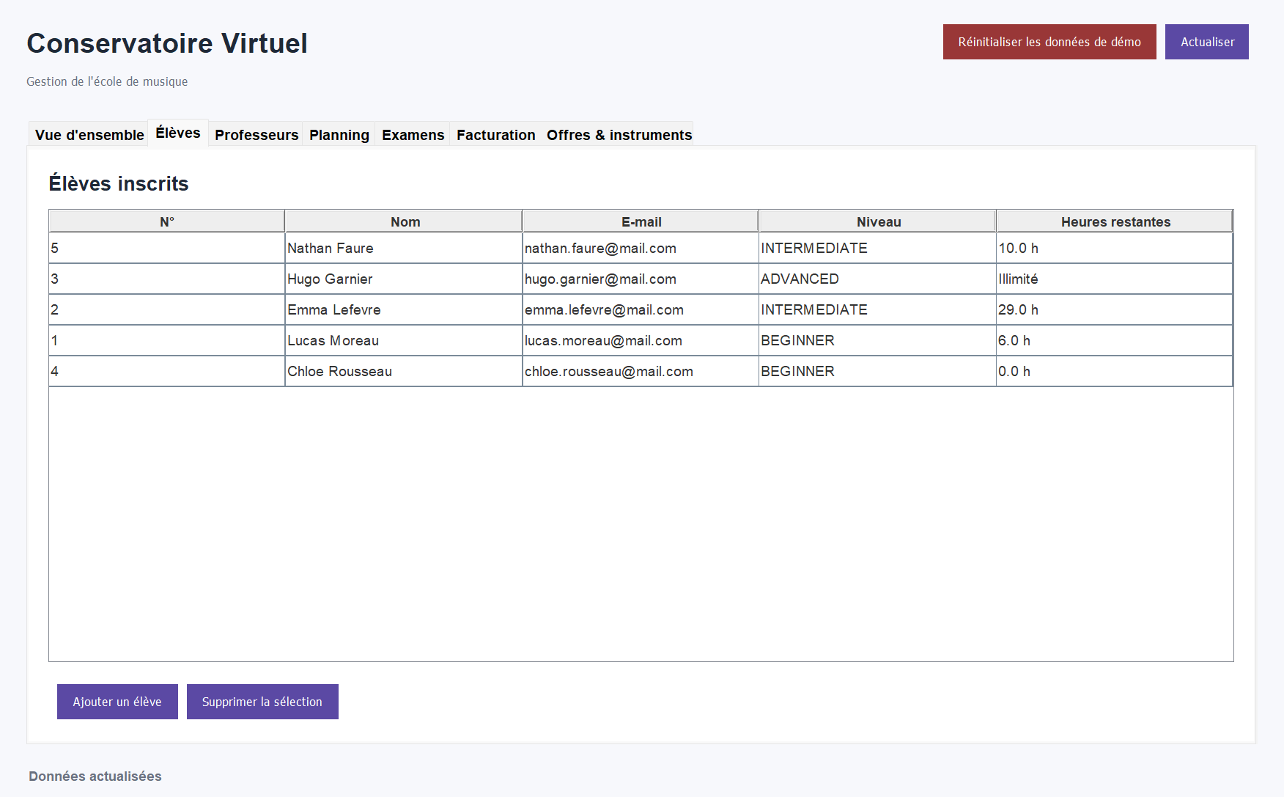
Figure 5 – Students tab: level and remaining hours (Hugo has an unlimited package, Chloe's package has expired)
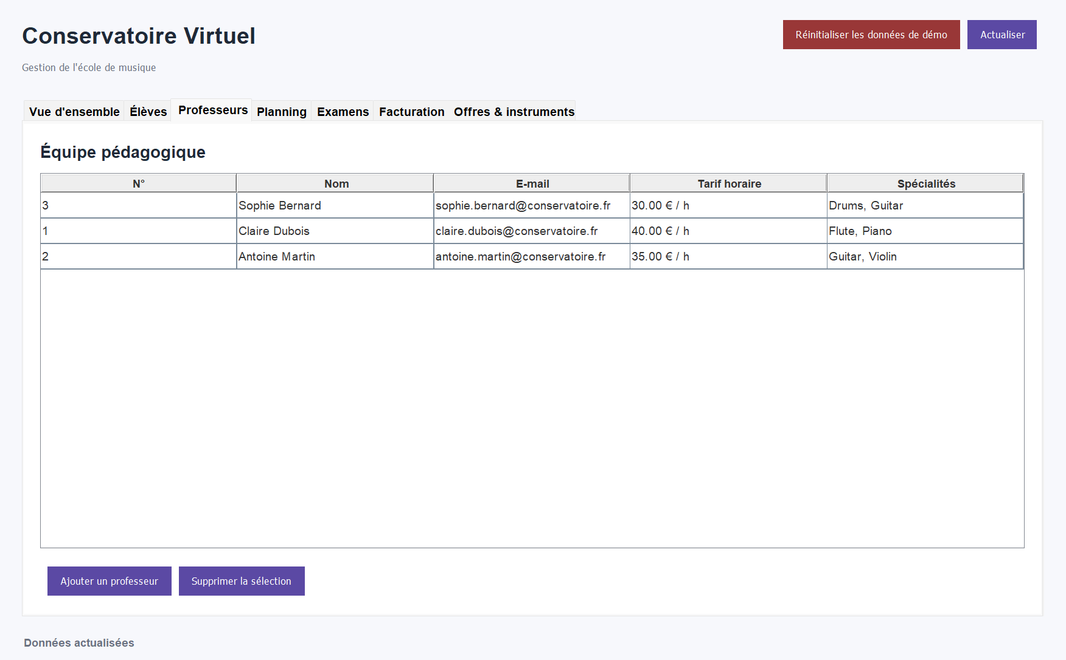
Figure 6 – Teachers tab: hourly rate and specializations
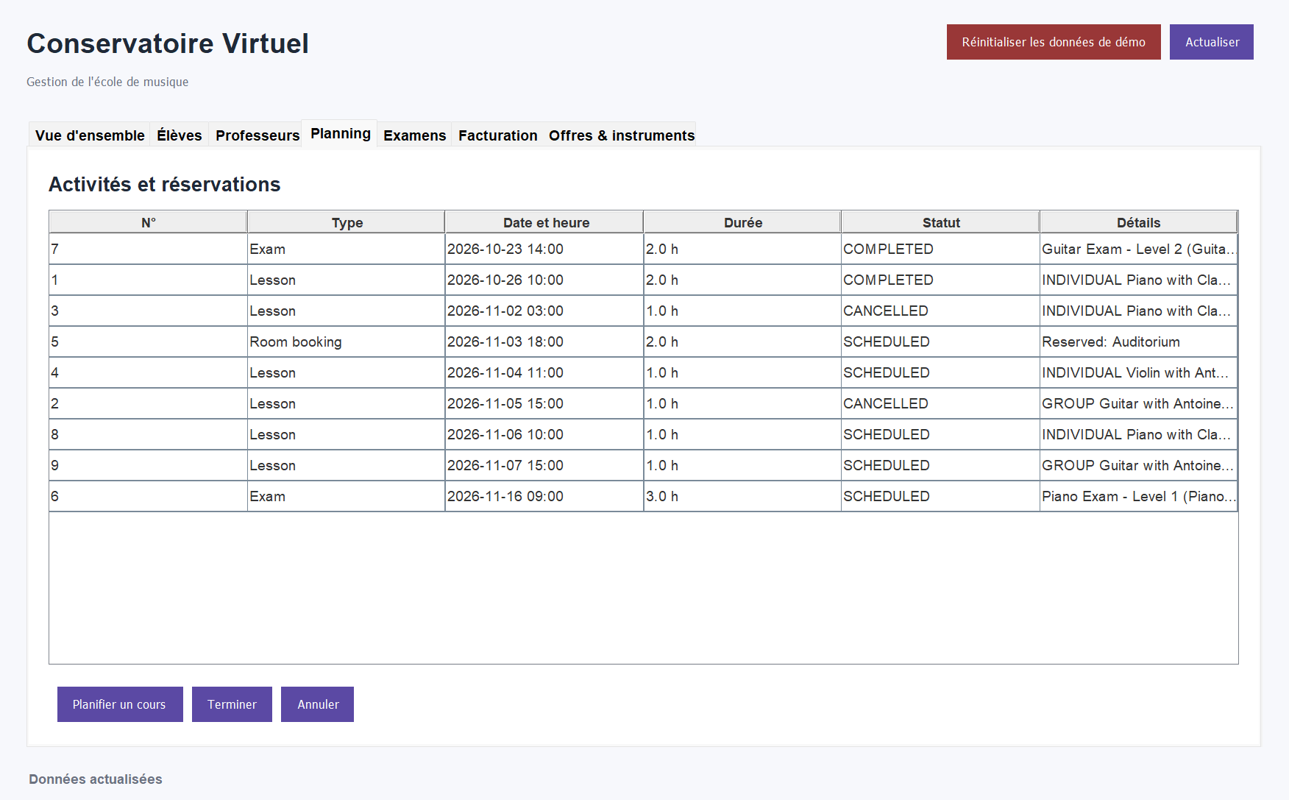
Figure 7 – Planning tab: lessons, room booking and exams in one polymorphic list, with their status
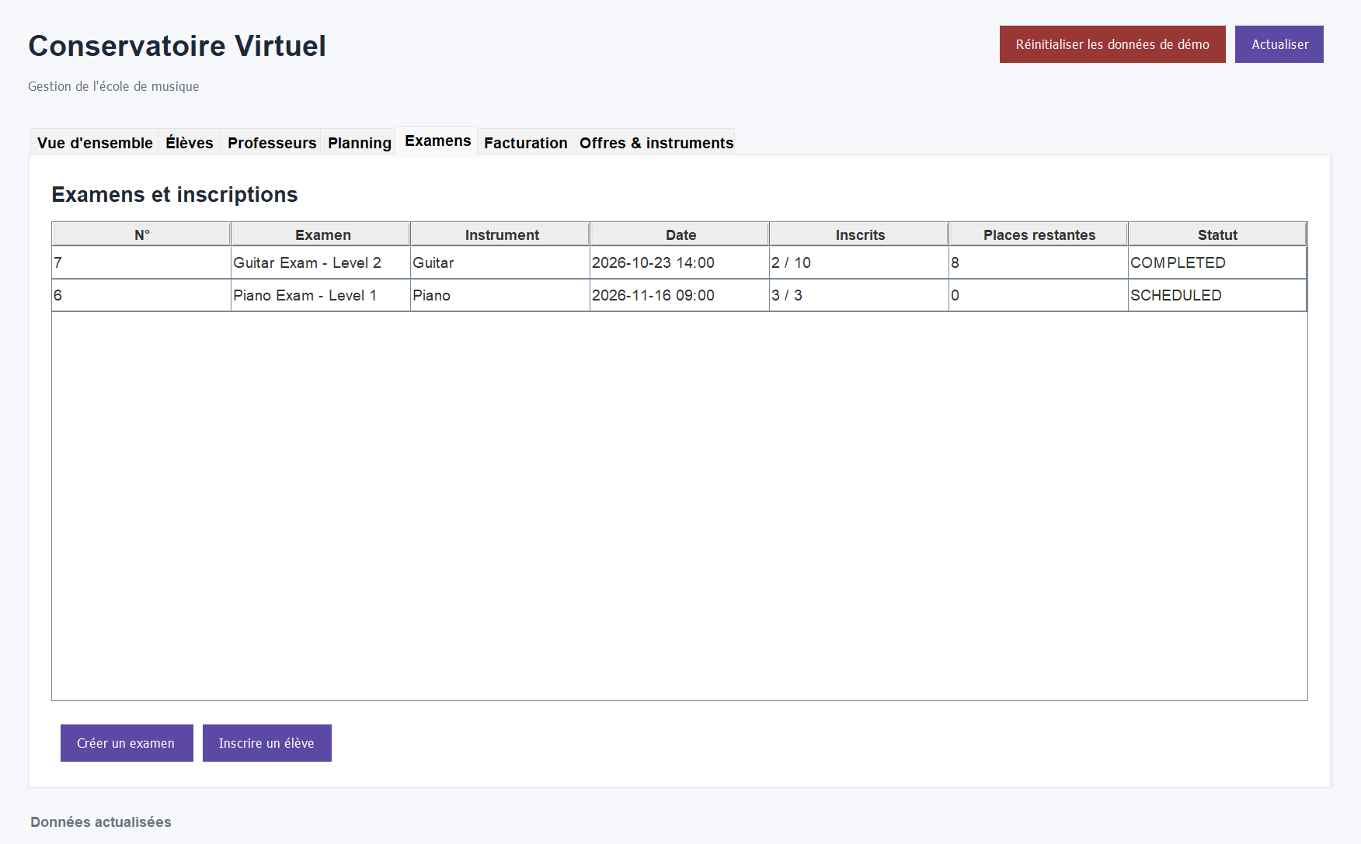
Figure 8 – Exams tab: the piano exam is full (3/3), so registration is closed
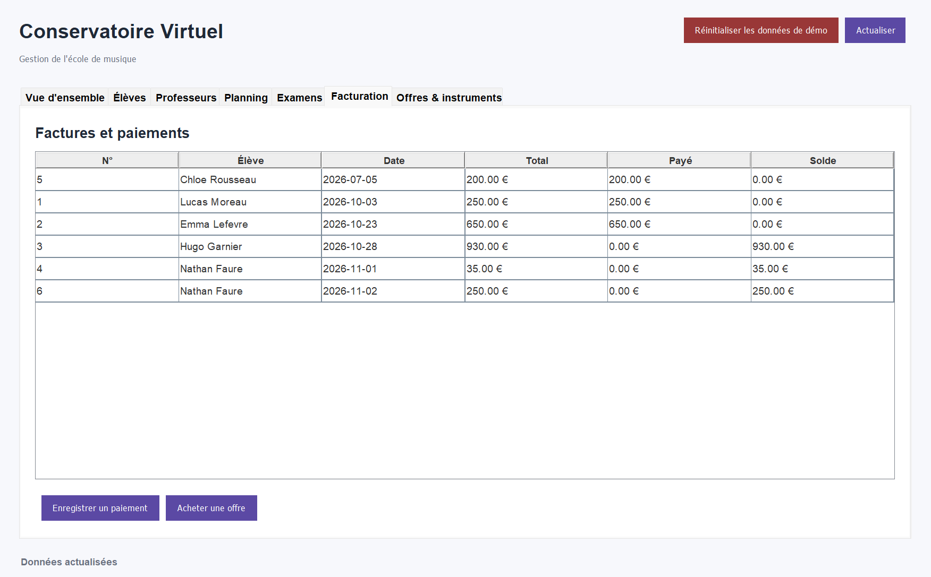
Figure 9 – Billing tab: totals, amounts paid and outstanding balances
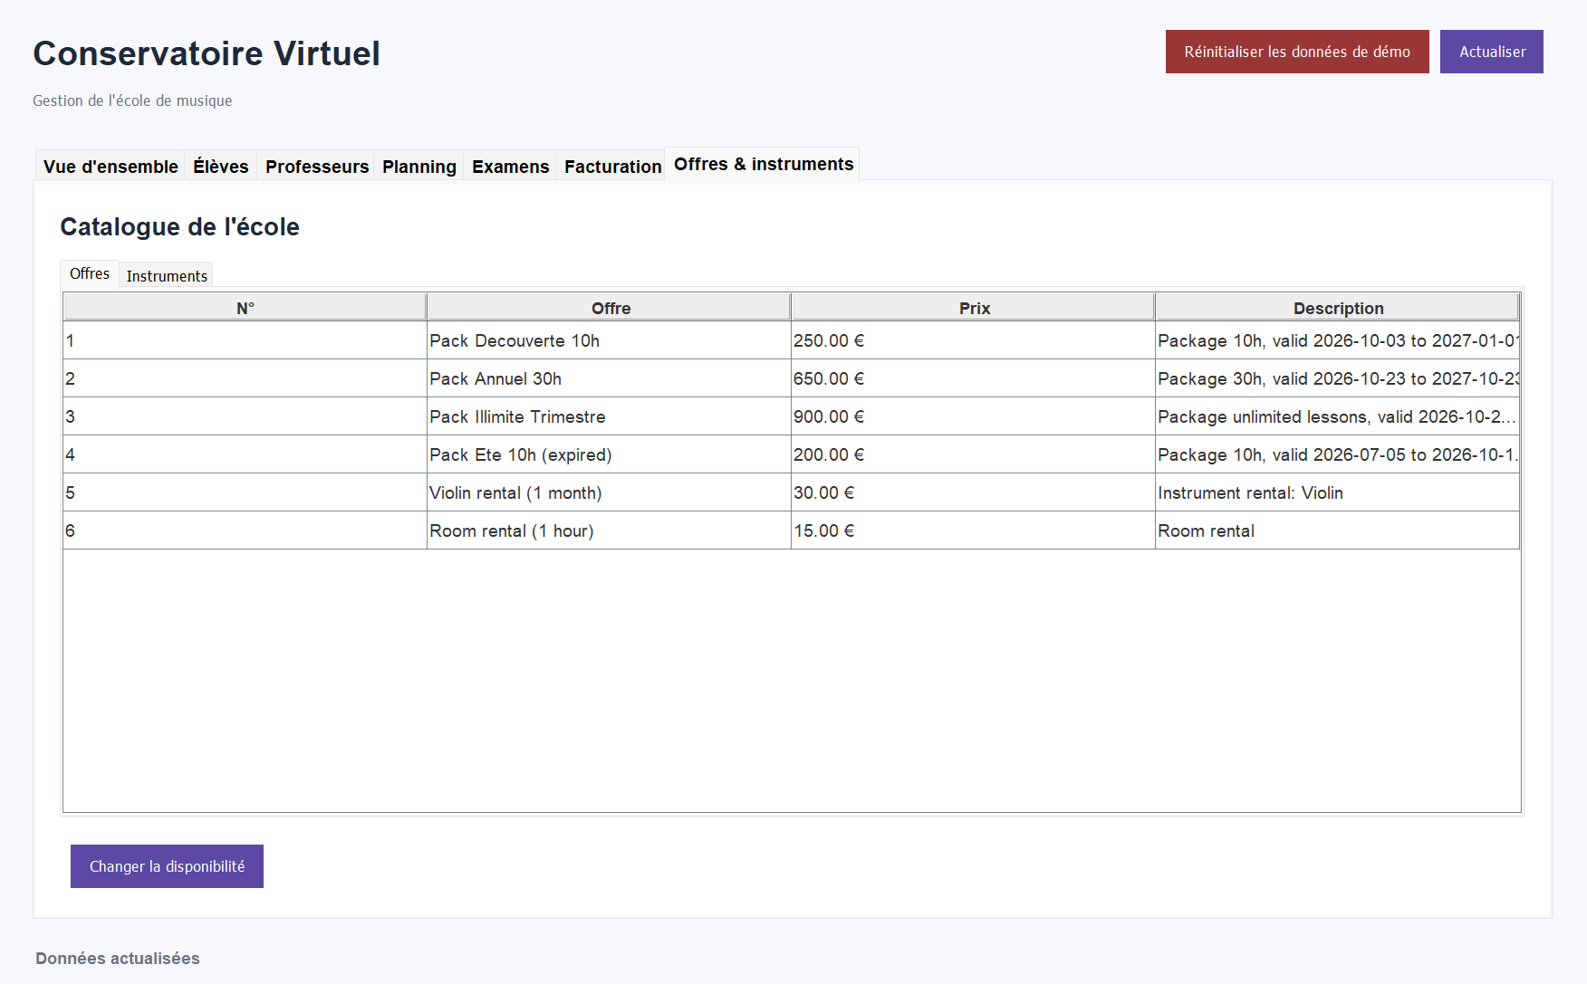
Figure 10 – Services tab: course packages and rentals, each described by its own class
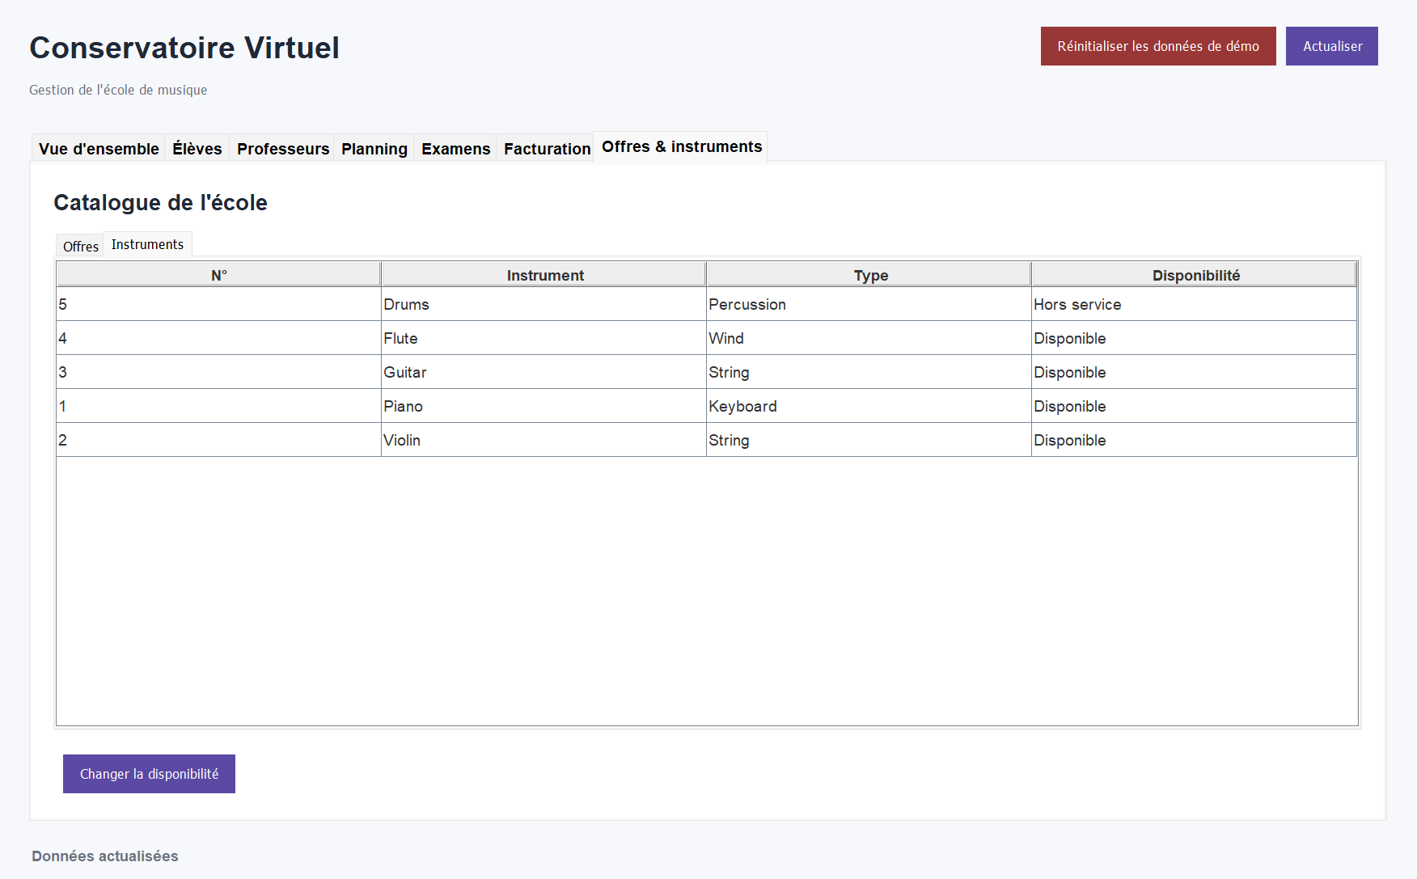
Figure 11 – Instruments tab: the drums are out of service and cannot be used for lessons

4.2 Console interface
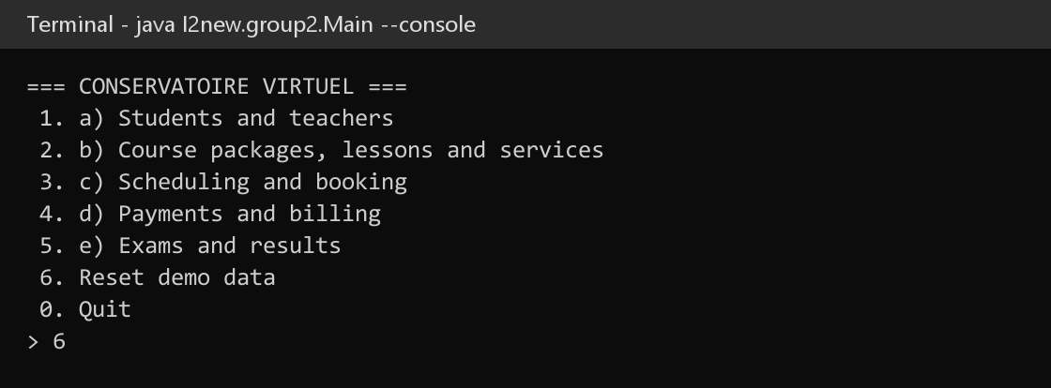
Figure 12 – Console main menu, started with --console
The other console screenshots are shown in section 5 as evidence for each test case.

5. Testing scenario

5.1 Initial data
The demo scenario (src/main/resources/data.sql) is loaded automatically on first run, and can be reloaded at any time with Reset demo data. It was designed so that every business rule can be demonstrated:
Data | Content and purpose
Students (5) | Lucas (10 h package), Emma (30 h package), Hugo (unlimited package), Chloe (expired package with 6 h left), Nathan (no package – pays per lesson).
Teachers (3) | Claire – piano and flute, every day 09:00–20:00; Antoine – violin and guitar, every day 08:00–22:00; Sophie – drums and guitar, weekday afternoons only.
Instruments (5) | Piano, violin, guitar, flute, drums. The drums are out of service.
Rooms (3) | Studio A (2 places), Salle Chopin (6), Auditorium (30).
Services (6) | Four packages (10 h, 30 h, unlimited, expired summer pack) and two rentals (violin, room).
Activities (7) | A completed lesson, a group lesson in 3 days, a lesson starting within 3 hours, a single paid lesson, an auditorium booking, a piano exam with 1 seat left and a past guitar exam with results.
Billing | 5 invoices with full, partial and no payments.

5.2 Test cases
The scenario below was executed on the console interface, against MySQL, starting from freshly reset data. Each line gives the expected result and the result actually observed.
# | Test | Input | Expected | Observed | Result
T1 | Expired package (rule 1) | List students | Chloe's 6 h are not counted | "remaining: 0.0h" for Chloe | Pass
T2 | Sell a package | Nathan buys the 10 h pack | Enrollment + invoice | Invoice #6, 250.00 €; Nathan has 10 h | Pass
T3 | Valid lesson | Claire, piano, Lucas, Studio A, 1 h | Lesson saved, 1 h consumed | Lesson #8 confirmed, Lucas 7 h → 6 h | Pass
T4 | Schedule conflict | Claire again, 30 min later | ScheduleConflictException | "Conflicts with #8" | Pass
T5 | Wrong specialization | Antoine teaching piano | InvalidSpecializationException | "Antoine Martin does not teach Piano" | Pass
T6 | Group lesson (rule 4) | Antoine, guitar, Emma + Hugo | 1 h from each participant | Lesson #9; Emma 29 h → 28 h; Hugo unlimited | Pass
T7 | Cancel ≥ 24 h (rule 2) | Cancel lesson #2 (in 3 days) | Hours refunded | "cancelled in time: … refunded" | Pass
T8 | Cancel < 24 h (rule 2) | Cancel lesson #3 (in < 3 h) | Hours stay consumed | "the hours count as consumed" | Pass
T9 | Duplicate registration | Lucas on the piano exam again | Refused | "Student is already registered" | Pass
T10 | Last seat | Emma on the piano exam | Registered, exam full | "Registration confirmed", 3/3 | Pass
T11 | Full exam (rule 3) | Register on the full exam | Refused | "Exam registration is closed" | Pass
T12 | Result too early | Result for the upcoming exam | Refused | "Results can be recorded once the exam has taken place" | Pass
T13 | Record a result | Hugo, guitar exam, pass, 61 | Result saved | "PASS (61.0/100)" | Pass
T14 | Partial → full payment | 350 € on invoice #2 | Invoice paid | Invoice #2 PAID, due 0.00 | Pass
T15 | Overpayment | 5 000 € on invoice #3 | Refused | "exceeds the outstanding balance of 930.00 EUR" | Pass
T16 | Reports | Total spent, monthly and per-student summaries | Consistent totals | Emma spent 650.00 €; summaries match the invoices | Pass

5.3 Evidence
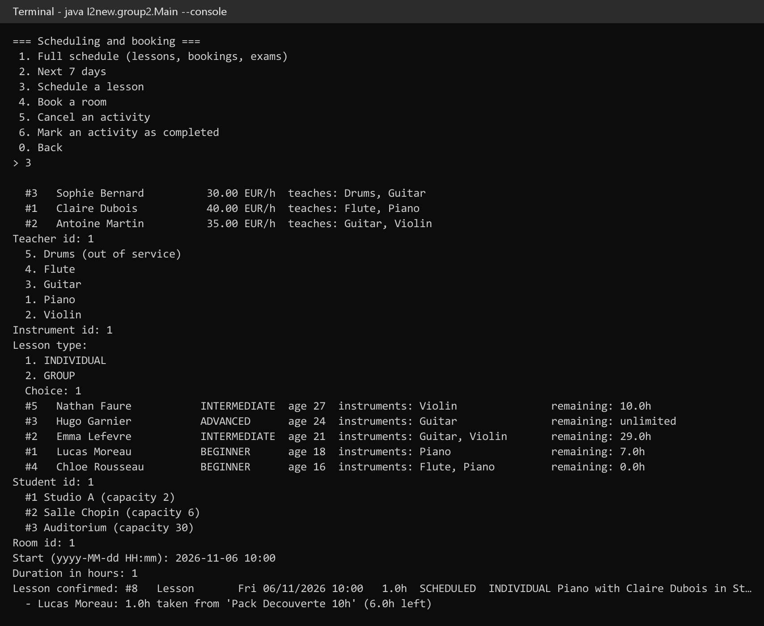
Figure 13 – T3 – a valid lesson is scheduled and one hour is taken from Lucas's package
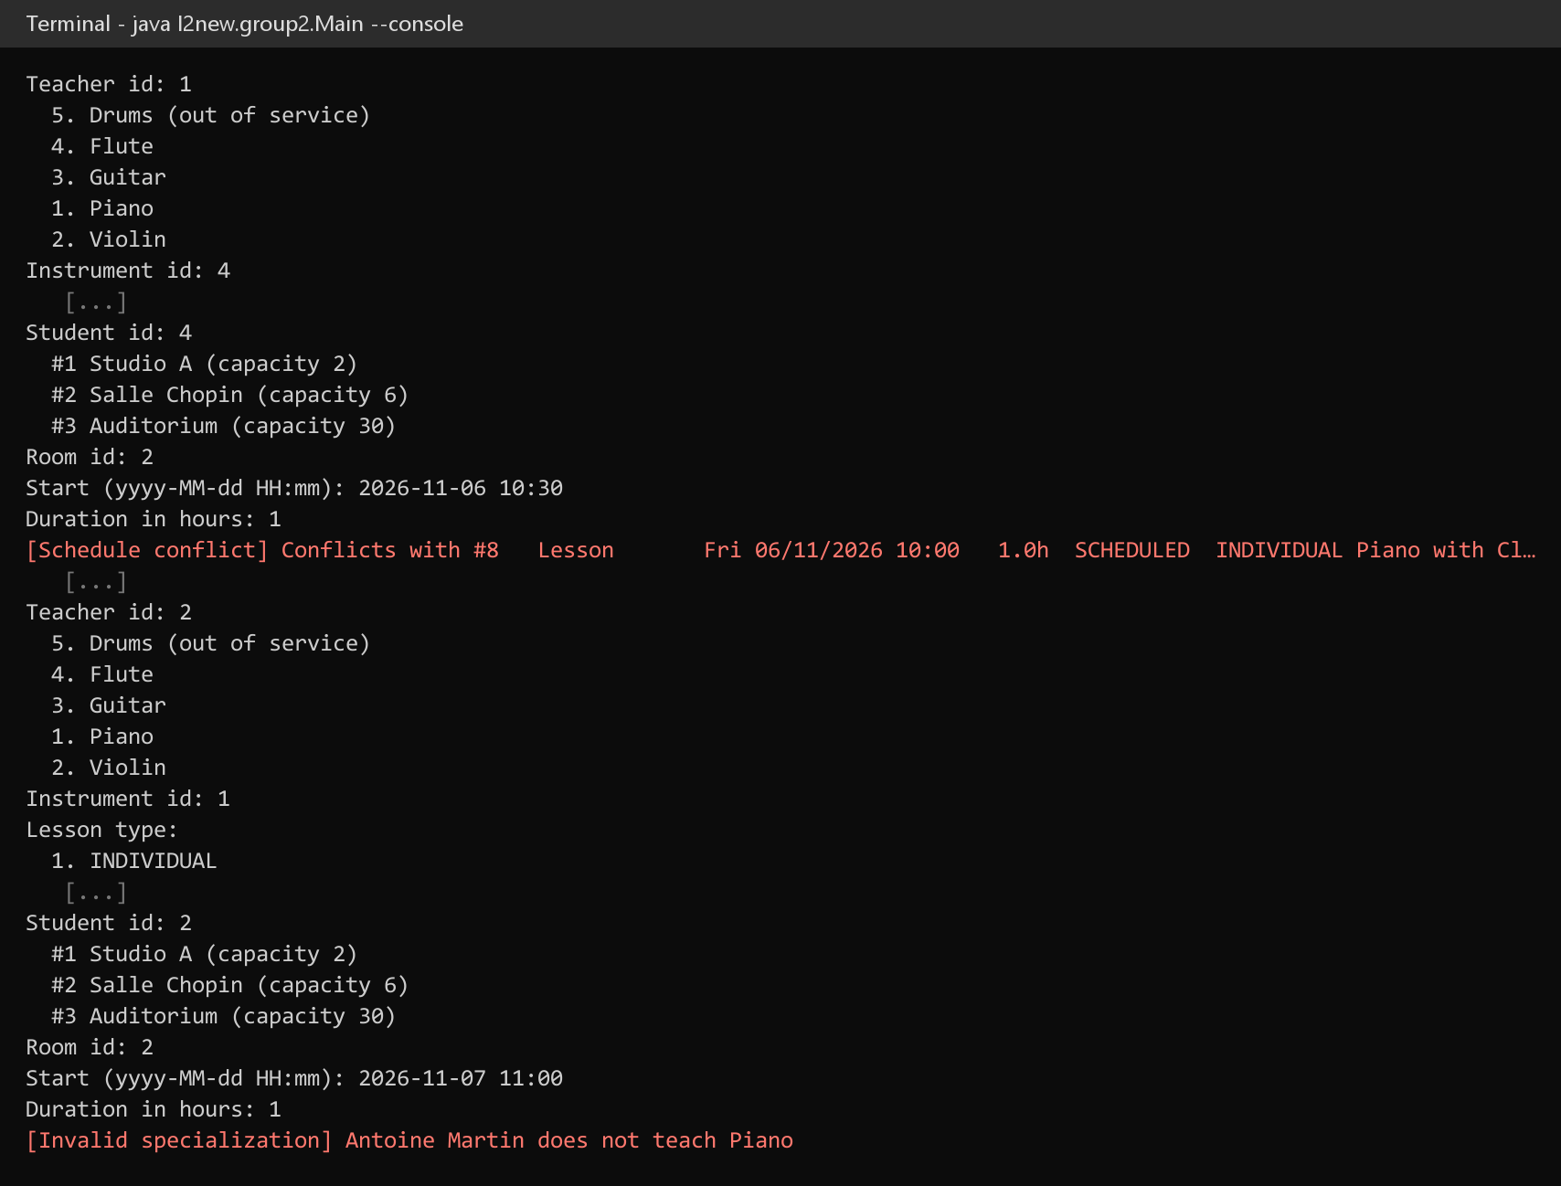
Figure 14 – T4 and T5 – the overlapping lesson and the wrong specialization are refused, nothing is saved
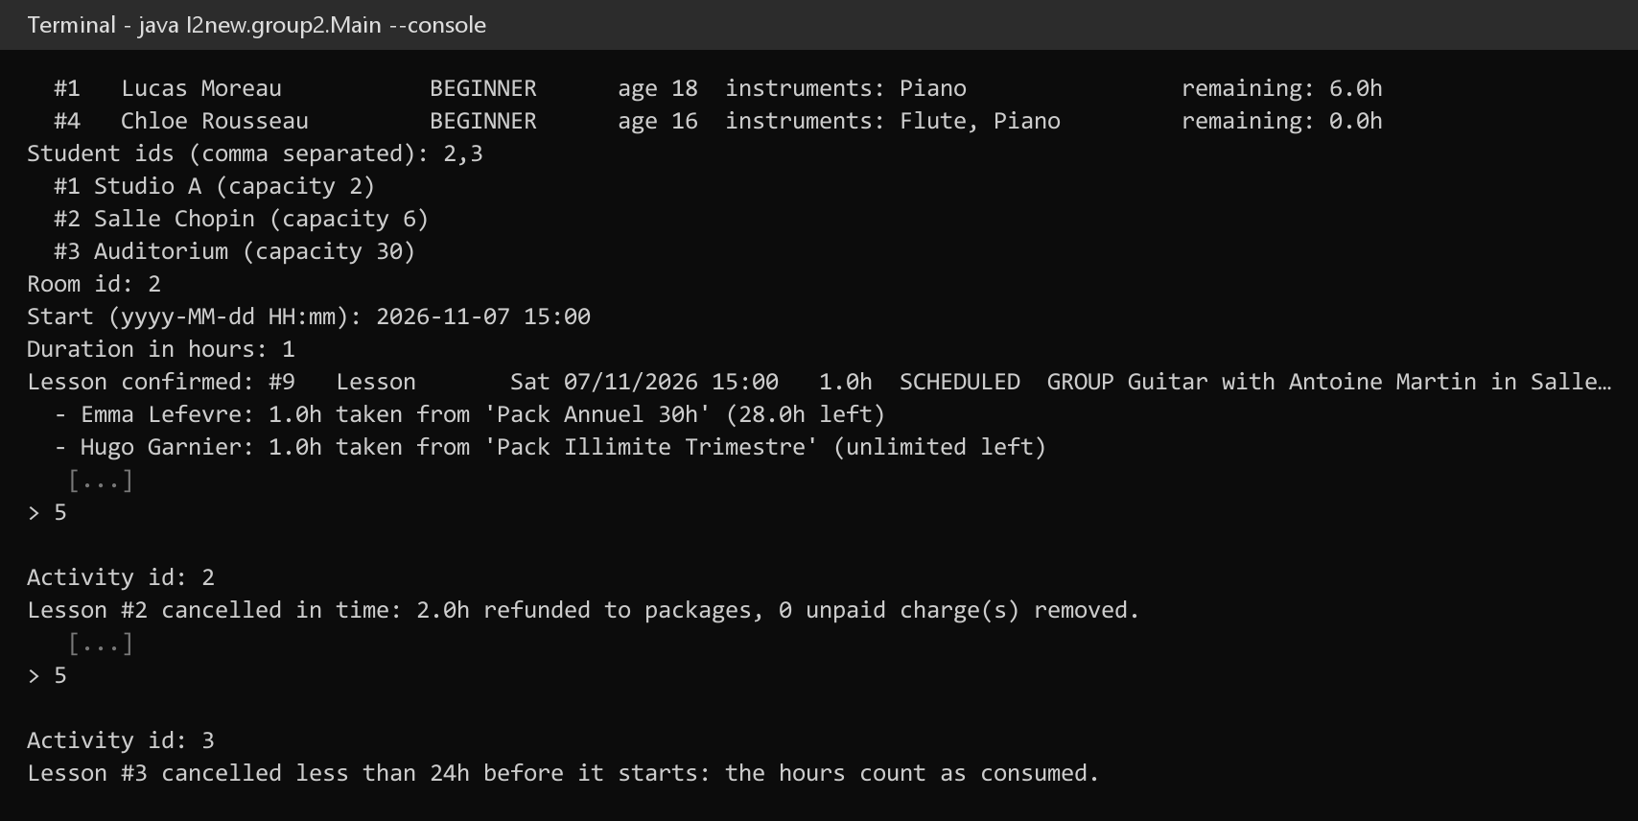
Figure 15 – T6 to T8 – group lesson, cancellation in time (refund) and late cancellation (consumed)
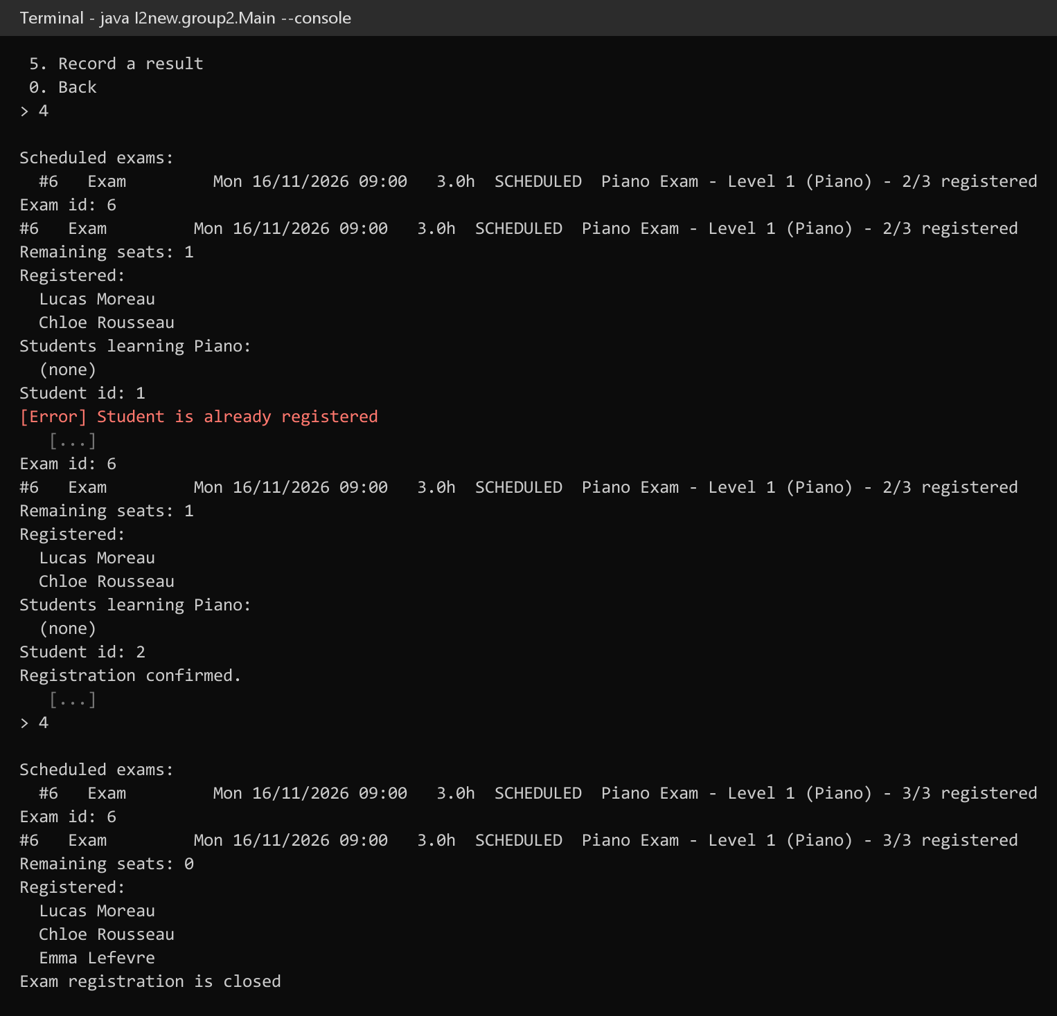
Figure 16 – T9 to T11 – duplicate registration refused, last seat taken, registration closed
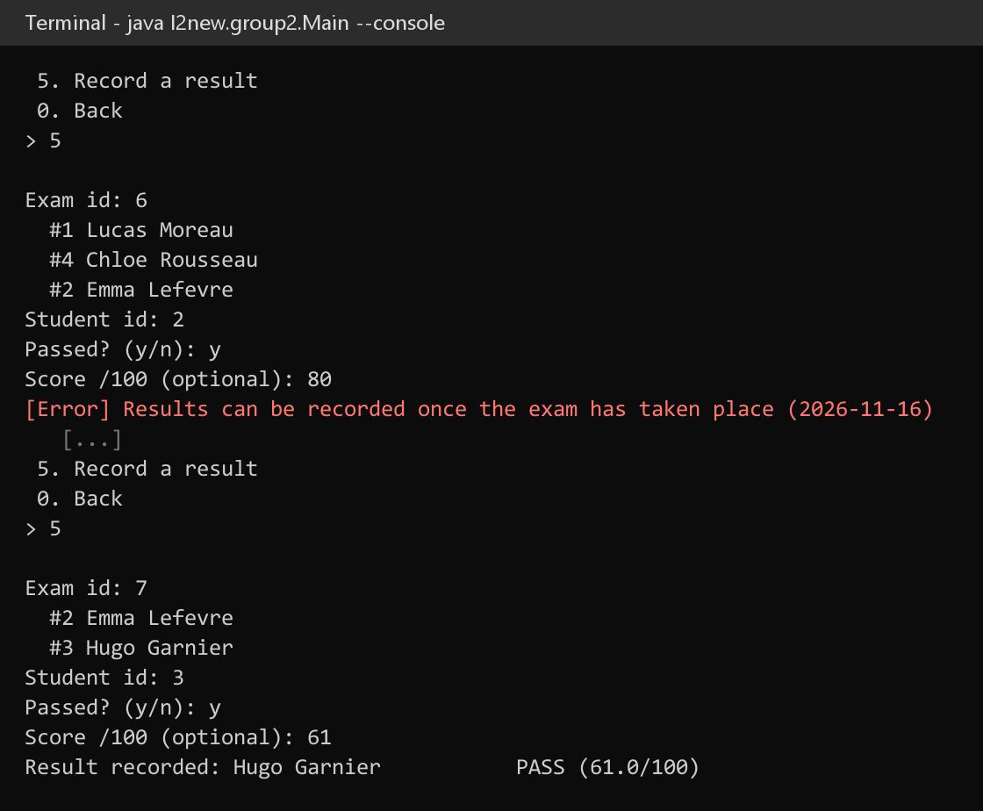
Figure 17 – T12 and T13 – results only after the exam has taken place
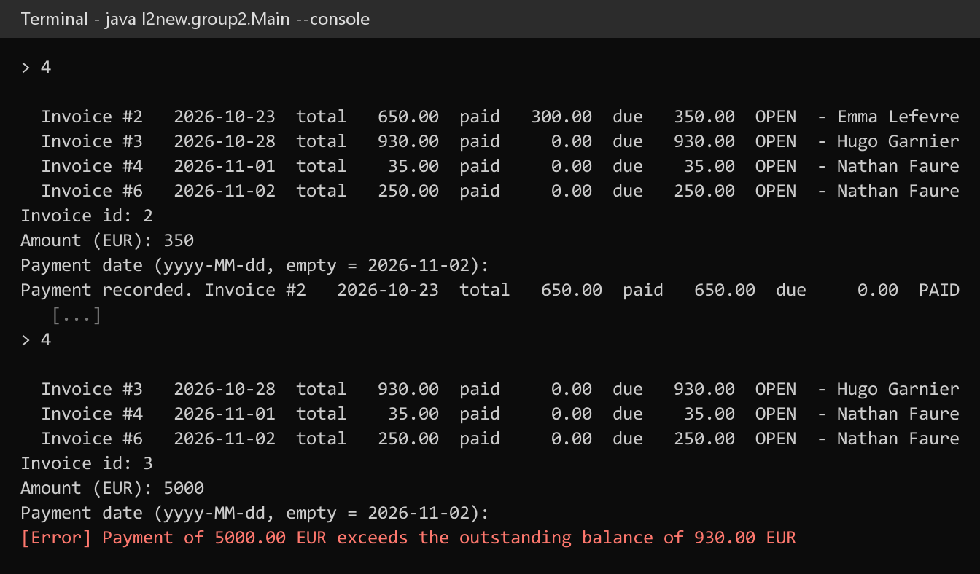
Figure 18 – T14 and T15 – a payment that settles the invoice and a refused overpayment
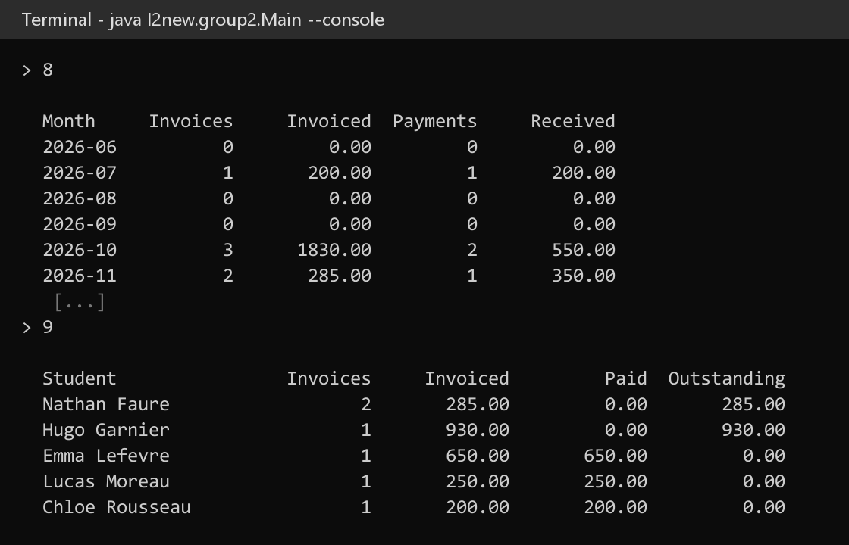
Figure 19 – T16 – summary of the last 6 months and summary per student

5.4 Unit tests
Thirteen JUnit 5 tests (BusinessRulesTest) check the business rules and the OOP behaviour directly on the model, without a database. They all pass (mvn test).
Test | What it checks
expiredPackageHoursCannotBeUsed | Rule 1: an expired package is invalid and refuses to consume hours.
consumingHoursOnValidPackage | Hours are consumed, and consuming more than what is left is refused.
lateCancellationIsDetected | Rule 2: cancelling 10 h before the start is a late cancellation.
earlyCancellationIsFree | Rule 2: cancelling 3 days before is free; a lesson cannot be cancelled twice.
examRegistrationClosesWhenFull | Rule 3: "Exam registration is closed" when capacity is reached.
duplicateExamRegistrationIsRefused | "Student is already registered".
examScoreMustBeBetween0And100 | Score validation; the score is optional.
groupLessonConsumesHoursFromEachParticipant | Rule 4, and room capacity limits the number of participants.
individualLessonHasOneStudent | An individual lesson refuses a second student.
teacherAvailabilityAndOverlap | Weekly availability and overlap detection (back-to-back lessons allowed).
invoiceTotalUsesPolymorphicBillables | Invoice total over a package, a rental and a lesson; overpayment refused.
polymorphicScheduleDescribesEachActivity | Dynamic dispatch of getActivityType() over a List<ScheduledActivity>.
copyConstructorsAreIndependent | Copies of Student, Teacher and Exam do not share state with the original.

6. Discussion of the object-oriented requirements

6.1 Abstract classes
Abstract class | Concrete subclasses | Shared state and behaviour | Abstract methods
Person | Student, Teacher | Id, names, e-mail, phone, validation, getFullName() | getRole(), describe()
Service | CoursePackage, Rental | Id, name, price, getBillingDescription() | describe(), calculatePrice() (from Billable)
ScheduledActivity | Lesson, RoomBooking, Exam | Date, duration, status, getEndDateTime(), overlaps(), cancel(), complete() | getActivityType(), describe()
Menu (UI) | Main menu and menus a–e | Input loop and error handling (Template Method) | getTitle(), getOptions(), handle()

These classes model real generalizations of the domain: nobody is just a "person", the school never sells an unspecified "service", and every scheduled activity is a lesson, a booking or an exam. They cannot be instantiated, yet they factor out the common code.
public abstract class ScheduledActivity {
private int id;
private LocalDateTime dateTime;
private double duration;
private ActivityStatus status;

public boolean overlaps(LocalDateTime start, double otherDuration) { ... }
public void cancel(LocalDateTime when) { ... } // may be refined by subclasses
public abstract String getActivityType();
public abstract String describe();
}

6.2 Interfaces
The two interfaces describe capabilities that cut across the class hierarchies:
- Billable – "can be charged for": implemented by Service (hence CoursePackage and Rental) and by Lesson, which is not a service but can be billed per lesson. An Invoice only knows its items as Billables.
- Schedulable – "can be booked for a time slot": implemented by Teacher (weekly availability) and Room (opening hours), two unrelated classes.
public interface Billable {
double calculatePrice();
String getBillingDescription();
}

public interface Schedulable {
boolean isAvailable(LocalDateTime start, double duration);
}

6.3 Polymorphism

Polymorphic collections
Collection | Where | Actual element types
List<ScheduledActivity> | Schedule (console and Planning tab), ActivityDao.findAll() | Lesson, RoomBooking, Exam
List<Billable> | Items of an Invoice | CoursePackage, Rental, Lesson
List<Service> | Service catalogue, ServiceDao.findAll() | CoursePackage, Rental
List<Person> | School directory (PeopleService.getDirectory()) | Teacher, Student
List<Menu> | Sub-menus of the main menu | PeopleMenu, ServicesMenu, SchedulingMenu, BillingMenu, ExamMenu

Polymorphic calls and dynamic dispatch
The invoice total is computed without knowing what is being charged: each item computes its own price at run time.
public double calculateTotal() {
totalAmount = items.stream().mapToDouble(Billable::calculatePrice).sum();
return totalAmount;
}
The main menu runs whichever sub-menu was chosen through the abstract type, and the schedule prints each activity with its own getActivityType() and describe().

Overriding
Lesson overrides cancel(LocalDateTime) to add business rule 2, then reuses the inherited behaviour with super. A room booking or an exam uses the base version.
@Override
public void cancel(LocalDateTime when) {
boolean late = isLateCancellation(when); // less than 24 h before the start
super.cancel(when); // common status change
this.lateCancellation = late;
}
Other overridden methods: calculatePrice() (package, rental, lesson), describe() and getRole() (students and teachers), getActivityType(), isAvailable() (teacher and room), toString(). Since Java 21, pattern matching for switch is also used where a DAO must store the right subclass row.

6.4 Copy constructors
Copy constructors exist for Person, Student, Teacher, Instrument, Room, Service, CoursePackage, Rental, Enrollment, ScheduledActivity, Lesson, RoomBooking, Exam, ExamResult, Invoice and Payment. They perform deep copies of mutable parts, so a copy can be modified without affecting the original.
public Student(Student other) {
super(other); // Person copy constructor
this.address = other.address;
this.birthDate = other.birthDate;
this.level = other.level;
for (Instrument instrument : other.preferredInstruments) {
this.preferredInstruments.add(new Instrument(instrument));
}
for (Enrollment enrollment : other.enrollments) {
this.enrollments.add(new Enrollment(enrollment)); // hours are not shared
}
}
The unit test copyConstructorsAreIndependent consumes hours on a copied student and checks that the original still has all its hours.

6.5 Inheritance, composition, encapsulation, abstract versus concrete types
- Inheritance – three hierarchies in the model (Person, Service, ScheduledActivity) and one in the UI (Menu). Subclasses call the superclass constructors and reuse their behaviour with super.
- Composition – an Invoice owns its Payments, an Exam owns its ExamResults, a Student owns its Enrollments, a Lesson holds its participants. The owned objects are created and changed only through their owner (addPayment(), addResult(), enroll(), addStudent()).
- Encapsulation – all fields are private. Constructors and setters validate their input (non-blank names, valid e-mail, positive duration and capacity, score between 0 and 100, no payment above the balance). Getters return unmodifiable lists, so no caller can change a collection behind the object's back.
- Abstract versus concrete types – the code depends on abstractions wherever possible: fields and parameters are typed Billable, Schedulable, ScheduledActivity, Service, Menu or List<...>, while concrete classes are only created where the real kind is known (DAOs, forms).

7. Conclusion
The project delivers a working information system for the music school: a MySQL database derived from the class diagram, a Java business layer that enforces the four business rules and the scheduling constraints, and two interfaces – console and desktop – that share it.
The mandatory object-oriented concepts are used where they model the domain rather than for their own sake: abstract classes for real generalizations, interfaces for cross-cutting capabilities, polymorphism to bill and schedule heterogeneous objects uniformly, and copy constructors to protect internal state. The testing scenario and the unit tests show each rule working, including the refusals.
Next steps would be to complete the desktop interface (catalogue management, editing of availability and specializations), harmonise the interface language, and use a connection pool for several simultaneous users.

Appendix – running the application
- Start MySQL, copy src/main/resources/db.properties.example to db.properties and set the user and password.
- Run I2new.group2.Main from IntelliJ (JDK 25), or mvn compile exec:java. The database and the demo data are created on first run.
- For the console interface, pass the argument --console.
- Run the unit tests with mvn test.

