Project Documentation

(S)KILLED
December 2, 2019

Team Members
Simona Santoro

Contents
Contents 2
1 Introduction 4
2 Hardware 4
3 Program architecture 4
3.1 Threads 4
3.2 Input 4
3.3 Output 4
4 User Manual 4
5 Appendix 1: Commented code 4

Revision History
Version | Date | Name | Description
1 | 02/12/2019 | Simona Santoro | Initial Document

Introduction

The project allows the user to play a simple and funny game called “(S)KILLED”. The player has to move to four directions: forward, backward, right and left, the enemy is indicated by using the LED of the board, when the player is in the same direction of the enemy he/she can shot it by pressing the user button. The goal of the game is to kill as much as possible enemies, the player has three lives and every time he/she shot in the wrong direction lose a life. The player has also a score that is incremented when an enemy is killed, if the score is a multiple of 60 the player wins an additional life. The game end when the user lose all the lives.

Hardware

For this project, I used the STM32F3DISCOVERY board, that offers accelerometer, compass, gyroscope, eight LEDs, two-button (one for the reset and one for the user interaction) and a lot of pins used to connect some external devices.
(S)KILLED uses the compass, the eight LEDs and the user Button.
The LSM303DLHC Compass is used to read the direction of the player when pressing the button, so it is used to understand if the player shot in the right direction.
The LED10, LED3, LED6, LED7 are used to represent the enemies, while the other LEDs are used to notify if the user loses a life or wins a life or lose all the lives.
The user Button to detect when the player wants to kill the enemy.

Program architecture
(suggested length: up to 6 pages)

Threads
There are 4 threads: The main thread, the shell thread, the “play” thread and the “shot it” thread.
- The main thread is responsible to initialize and start the compass, mutex and serial, is also responsible to create the shell thread and the other two thread, after it waits that the shell thread is terminated. Also lock the mutex (&mtx1) in order to avoid that the game starts before that the user give the command to the shell.
- The Shell thread is used to receive commands from the user, when it receives a command it call the respective function. In the project there are two commands: SETUP and PLAY. The PLAY function unlock the mutex (&mtx1) used to synchronize the thread.
- The Play thread the first action that it does is to try to lock the mutex, if it is available the thread can continue the computation else it has to wait. When the thread is responsible to detect when the user button is pressed. Is also responsible to verify if the player lost all the lives.
- The Shot It thread is responsible to read the data from the compass and to verify if the enemies is killed. If isn’t killed means that the user shots in the wrong direction so he/she lost a life else the score is incremented.

Input
The input into the system are received by using Compass, button and Terminal (shell).
The first input to interact with the system is give through the Shell by passing the SETUP and PLAY commands.
    - SETUP function is responsible to collect from the compass the four coordinate and sets that: setForward(),setBackward() ,setLeft() and setRight(). Between each function waits for 5000 milliseconds in order to give to the user enough time to move in the requested direction.
    - PLAY function unlock the play thread by calling: chMtxUnlock(&mtx1). The variable mtx1 is the mutex variable used to synchronize the player and the shot thread.
When the PLAY function is called the game starts and the “play” thread waits that the user button is pressed, when that’s happen the “Shot it” read the data from the Compass and verify if the Player position and the enemies position match.
The variable of coordinate are global.

Output

The Output of the system are given through the Terminal and LEDs. The shell uses the terminal in order to notify in the Setup phases where the user has to move, also in the Play mode the shell notify if the enemies is killed or if the player lose all the lives or lose one life.
The most significant output is given by using the LEDs. Four LEDs are used to represent the enemies so when one of them is switched ON means that the player has to shot in that direction. The led are also used to understand if the player shot in the correct direction or not, in fact if the LED6, LED4,LED5,LED7, are switched on means that the user shots in the wrong direction, otherwise shots in right direction. Other outputs from the LEDs, is when the player wins a life, one after one the LEDs are switched ON and OFF. Another LEDs output is used to notify when the player lost all the lives.

User Manual
(suggested length: up to 2 pages)
(S)KIL(LED) is very easy to use. The first things that the player must do is to lunch the SETUP command on the shell, in order to sets the initial coordinate. The terminal suggests where the player must move. Just like in figure:
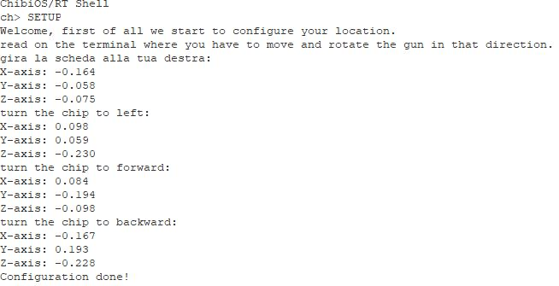
After the configuration phases the user can lunch the Play command, the system doesn’t give an error if the user lunch the play command before the SETUP command but since the initial coordinates aren’t set the games gives always the wrong direction. When the player lunches the play command the game starts.
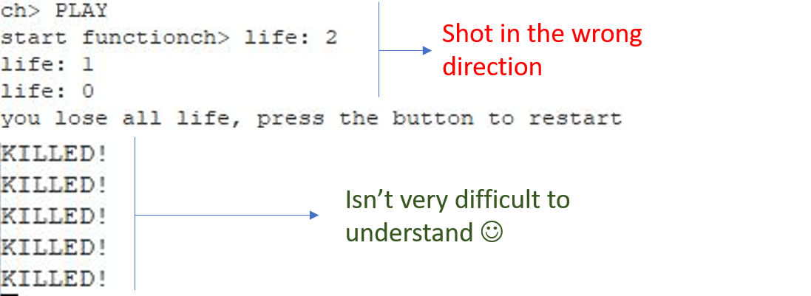

Since the game starts one LED is switched ON, the player must move in the direction of the LED and press the button when is in the right direction. When the button is pressed the coordinates are updated with the new coordinates refers to the user position when he/she press the button.
Example: if the LED6 is switched ON the player moves to the right and press the button. The system updates the coordinate in such a way that the “new forward” is the “old right”.
When the player lost all the life, he/she can press the user button to restart the game, but the coordinates are initialized with the coordinates sets in the SETUP phases.
If the player has some problem during the game with the direction or position can press the reset button and reset the coordinates in the SETUP phase.
LEDs behavior:
- One led switched on → enemy
- Four LEDs switch on → player has lost a life
- ONE complete lap of LEDs on and off → player wins a life
- Two different LEDs at a time turn on continuously → player lost all the lives

