|  |  |
| --- | --- |
| **Date:** | 9/5/2019 |
| **Time:** | 9.00am |
| **Venue:** | SIS GSR 2-2 |
|  |  |
| **Attendees:** | Cha DaEun  Carecci Vittorio |
|  | Brendon Lim |
|  | Sim Sheng Qin |
|  | Tan Qiu Long Matthew Ian |
|  |  |
| **Agenda:** | 1. Go through Figma wireframes  2. Determine new user flow if any changes |
|  | 3. Finalize scheduling for code  4. Determine pair programmers |

|  |  |  |  |
| --- | --- | --- | --- |
|  |  |  | **Due Date** |
| 1 | To complete sprint | All pairs | 14 September 2019 |
|  |  |  |  |

**Figma Design**

Vittorio looking to see if any framework can be set.

Figma designs as shown in the following link:

<https://www.figma.com/file/2zZwOYTVp6beTRATpd5a0j/Version-02>

Changes to Figma:

* Remove “Pending” button
* Remove a database of completed lessons on the “lesson” page
* Clarified flow for admin page, changes to screens have been done

**Sprint Planning**

Trello accounts opened and shared with other members

Initial sprint planning completed as shown below:

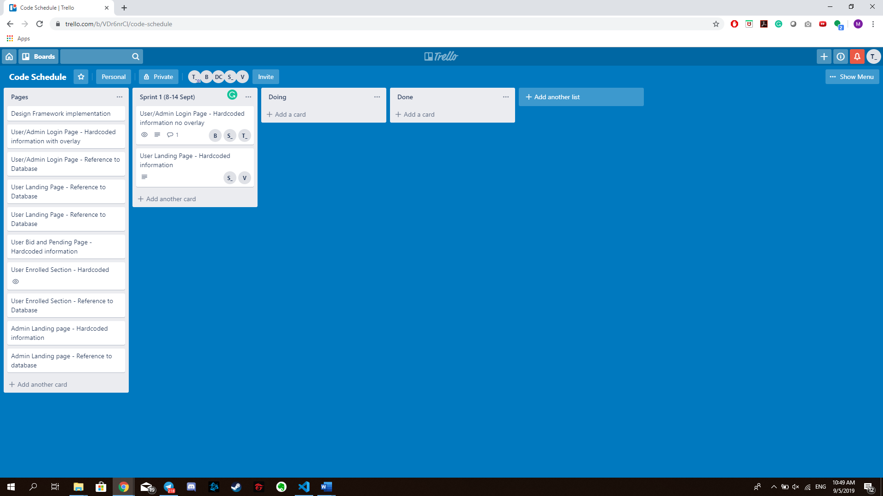

**Git Space Initialization**

Unable to find the Git link so will hold off now until class starts

**Pair Programmers**

Program pairs are shown in the table below:

|  |  |
| --- | --- |
| Pair 1 | Tan Qiu Long Matthew Ian  Cha DaEun |
| Pair 2 | Carecci Vittorio  Sim Sheng Qin |

The meeting was adjourned at 10.50 am. These minutes will be circulated and adopted if there are no amendments reported in the next 24 hours.

Prepared by,

Matthew Tan

Vetted and edited by,

Brendon Lim