|  |  |
| --- | --- |
| **Date:** | 19/9/2019 |
| **Time:** | 9.00 am |
| **Venue:** | SIS 2-6 |
|  |  |
| **Attendees:** | Cha DaEun,  Carecci Vittorio,  Brendon Lim,  Sim Sheng Qin,  Tan Qiu Long Matthew Ian |
|  |  |
| **Agenda:** | 1. Update functionalities for wireframe  2. New sprint  3. Help with any coding problems |

|  |  |  |  |
| --- | --- | --- | --- |
|  |  |  | **Due Date** |
| 1 | Vittorio to redo wireframe | Vittorio Carecci | 19 Sep |
|  |  |  |  |

Coding issues

Sheng Qin requires help with the bid and pending page. Team helped as well.

Design changes

* Added “Add bid” page
* Restyled navigation. Vittorio to redo wireframe
  + 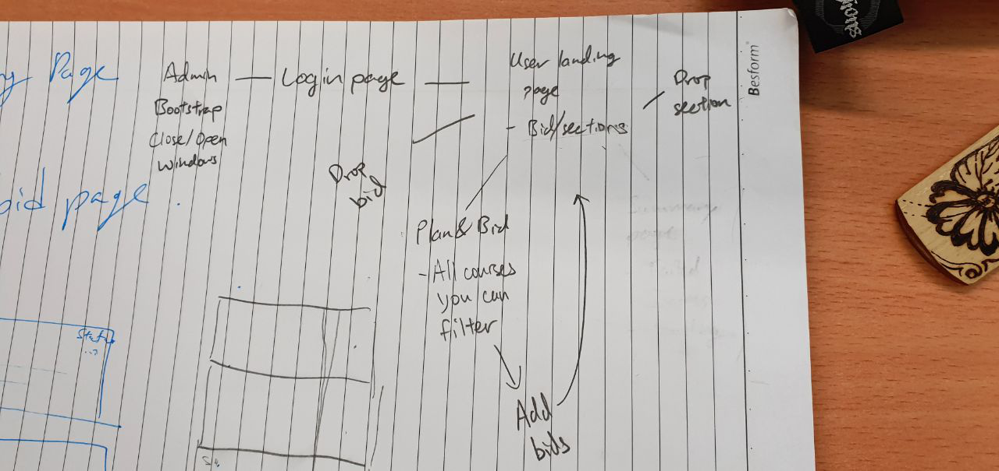

Next Sprint

* 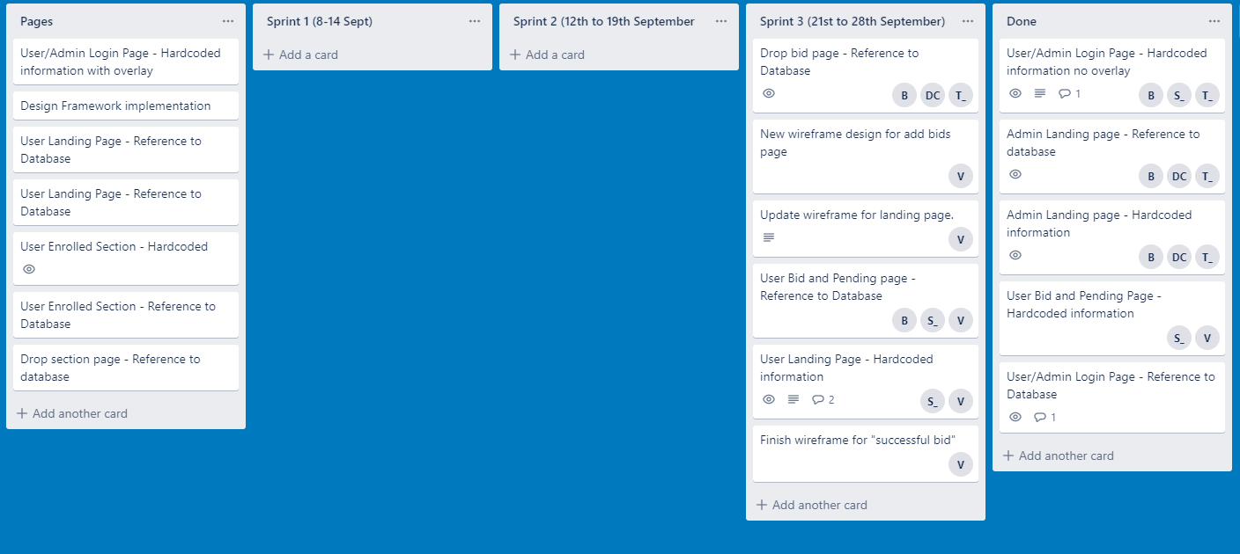

The meeting was adjourned at 10.30 am. These minutes will be circulated and adopted if there are no amendments reported in the next three days.

Prepared by,

Matthew Tan

Vetted and edited by,