**Submission 1 of 14: Progress mark (5) Screen shot of notebook with code and result**

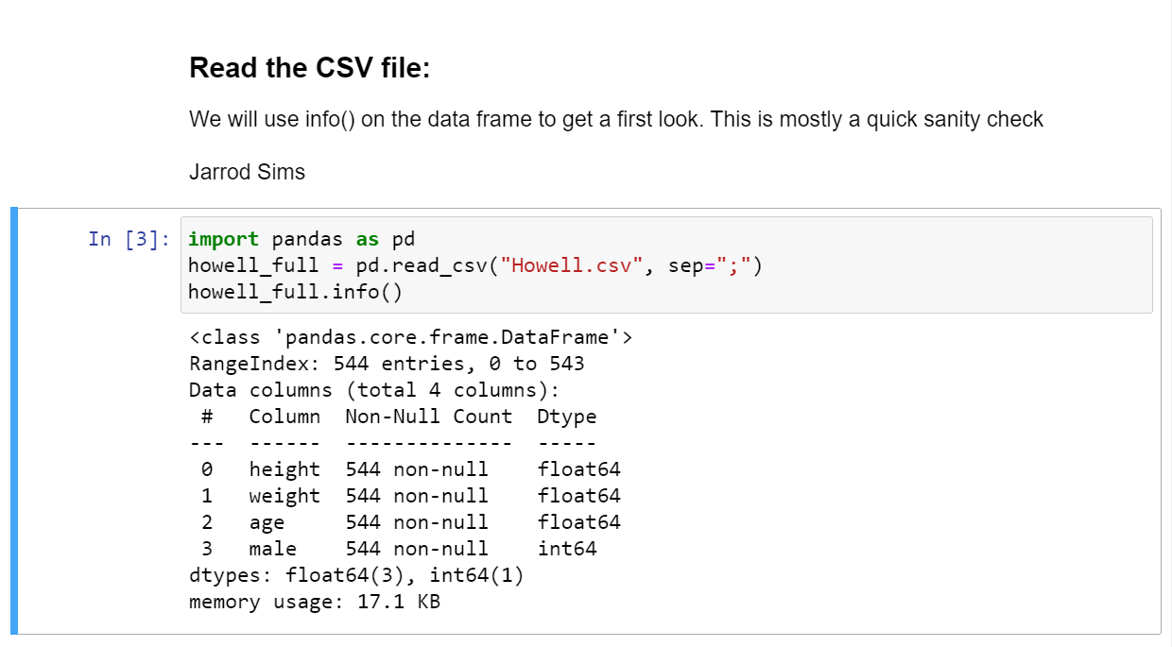

**Submission 2 of 14: Analysis (15) from info() determine**

1) How many data instances are there? **There are 544 instances.**

2) How many features are there? **There are four features.**

3) What are the names? **: The names are height, weight, age, and male.**

4) Are there any missing values? **There are no missing values.**

5) Are there any non-numeric features? **The only non-numeric feature is sex which was transformed to a numeric Boolean of 1 for male and 0 for not-male.**

**Submission 3 of 14: Progress mark (5) Screen shot of notebook with code and result for distribution**

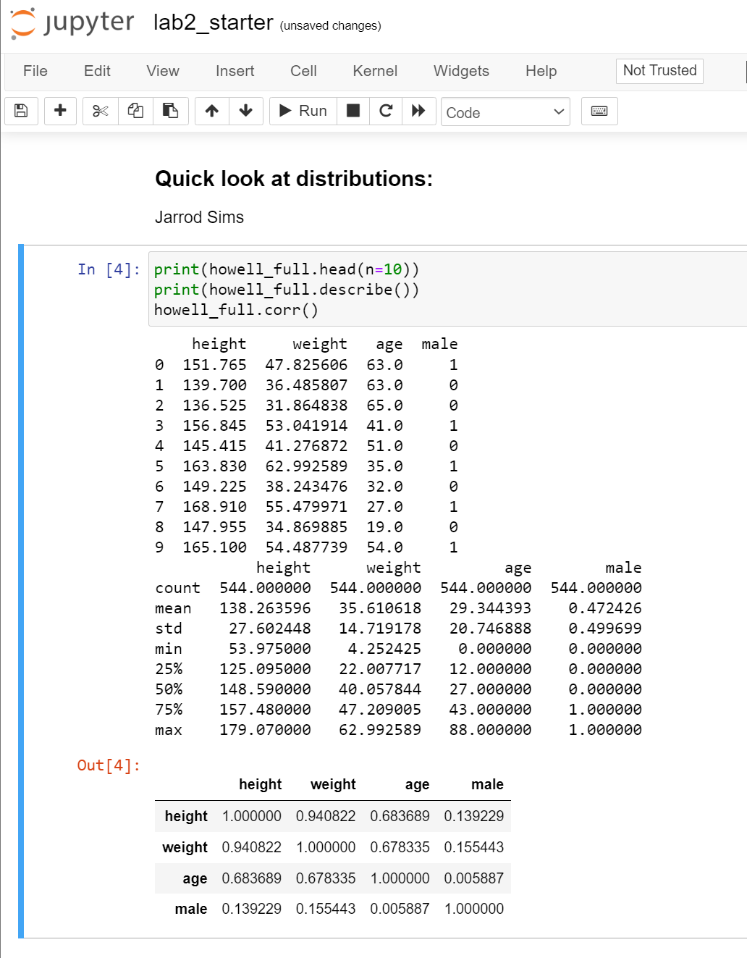

**Submission 4 of 14: Analysis (15) from the results determine**

6) Are the data instances sorted on any of the attributes? **No they do not appear sorted by any attribute.**

7) What are the units of height? **The units are centimeters.**

8) What are the units of weight? **The units are kilograms.**

9) What are the minimum, median and max age? **The minimum age is 0.0, the median age is 29.3, and the maximum age is 88.0**

10) What two different features have the highest correlation? **The two features with the highest correlation are height and weight.**

**Submission 5 of 14: Progress mark (5) Screen shot of graph**

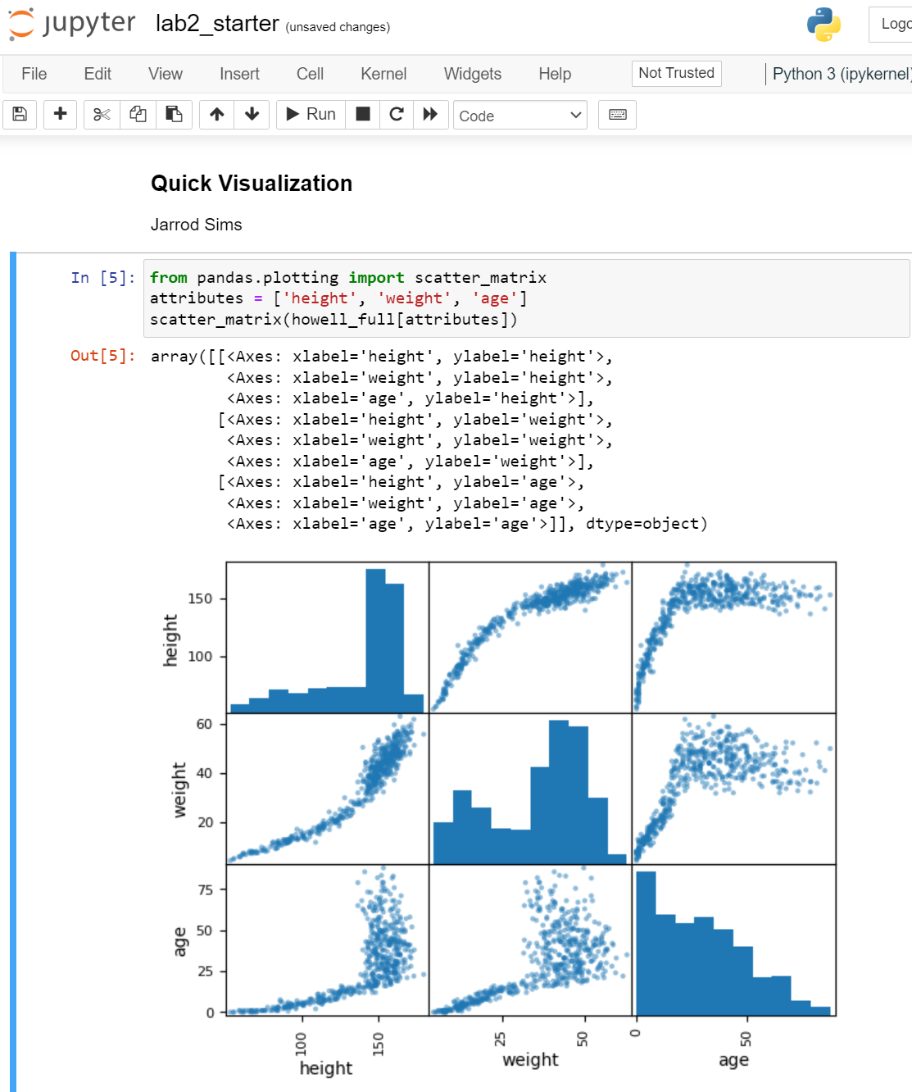

**Submission 6 of 14: Analysis (15) from the results determine**

11) Describe each distribution as skew, uniform, bimodal, or gaussian. **Height = skewed negative, weight = bimodal, age = skewed positive.**

12) Look at the age-weight scatter plot and explain the character of the graph. **The relationship between age and weight looks to be logarithmic. Weight increases in a nearly linear fashion until around the age of 25 but levels off as individuals reach adulthood.**

13) What does the age histogram tell us about this group of people? **The age histogram is skewed in the positive direction meaning there are more individuals on the young end of the spectrum than the old.**

14) How does the age histogram compare with that of people living in modern times? **Individuals are living longer in modern times.**

**Submission 7 of 14: Code and Analysis (10) 1) Screen shot of age vs height scatter plot.**

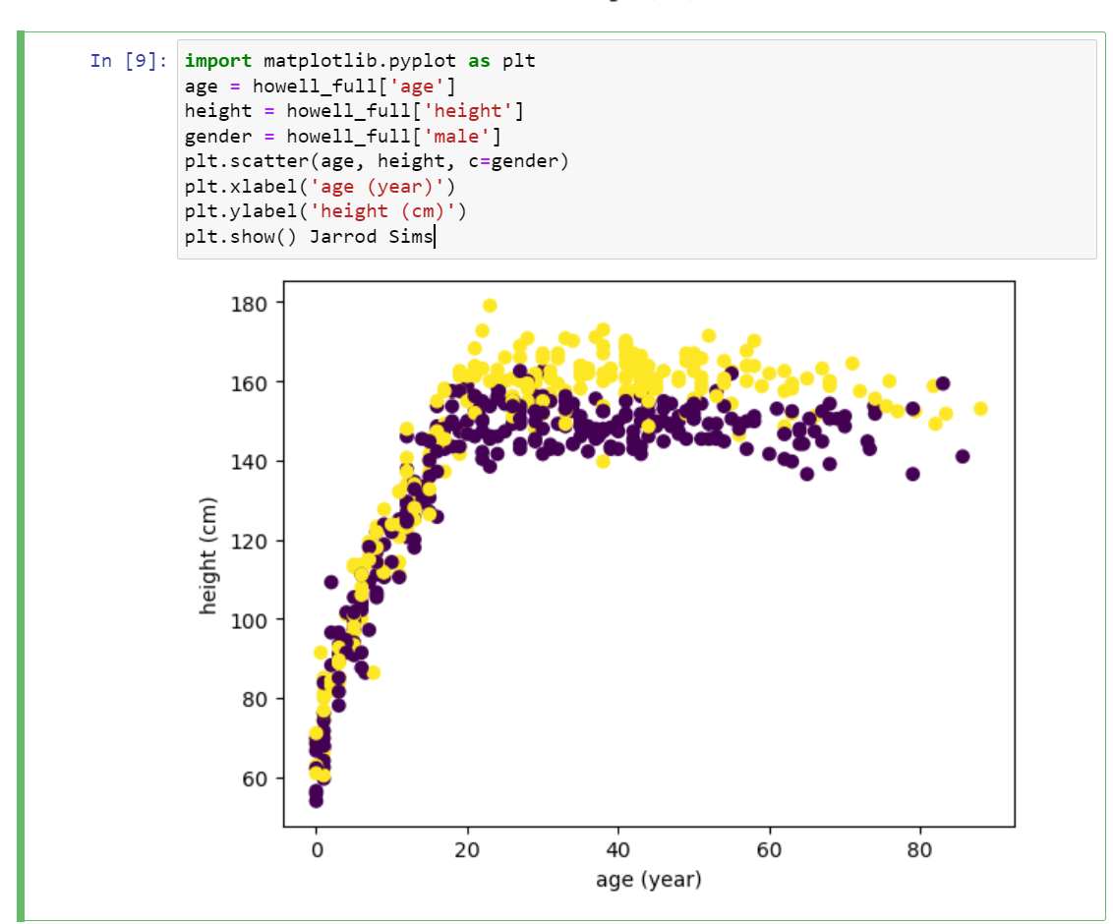

2) At what age does the character of the plot change? **The character of the plot changes at about an age of around 20 years when individuals reach adulthood.**

**Submission 8 of 14: Progress Mark (10) Screen shot of the head of the data set with bmi.**

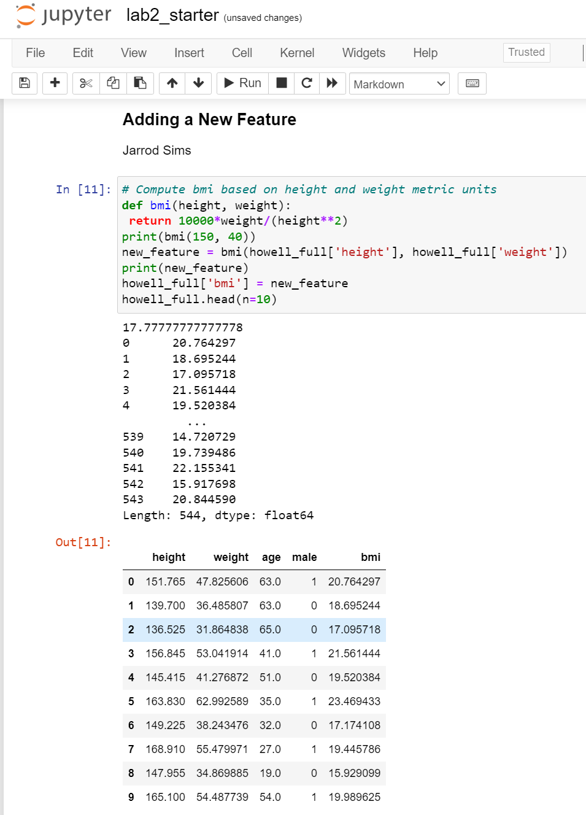

**Submission 9 of 14: Progress mark (10) Screen shot of head and value counts**

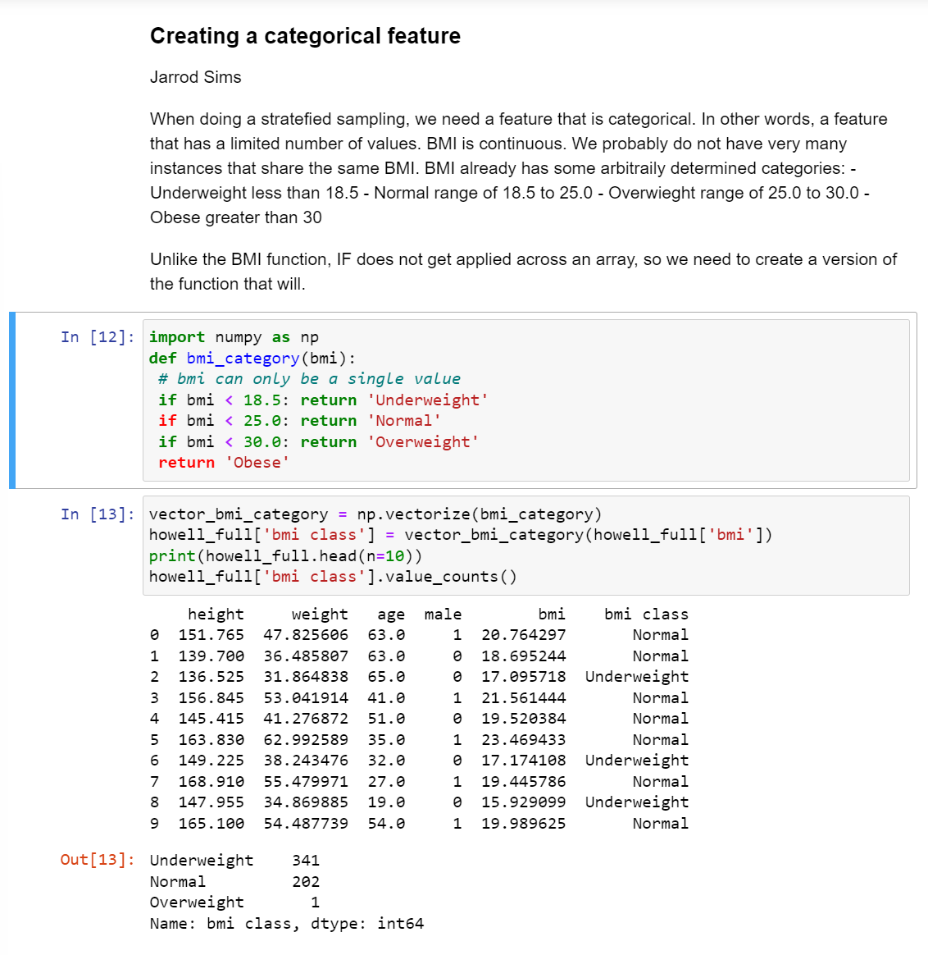

**Submission 10 of 14: Progress mark (10) Screen shot of age vs bmi scatter plot**

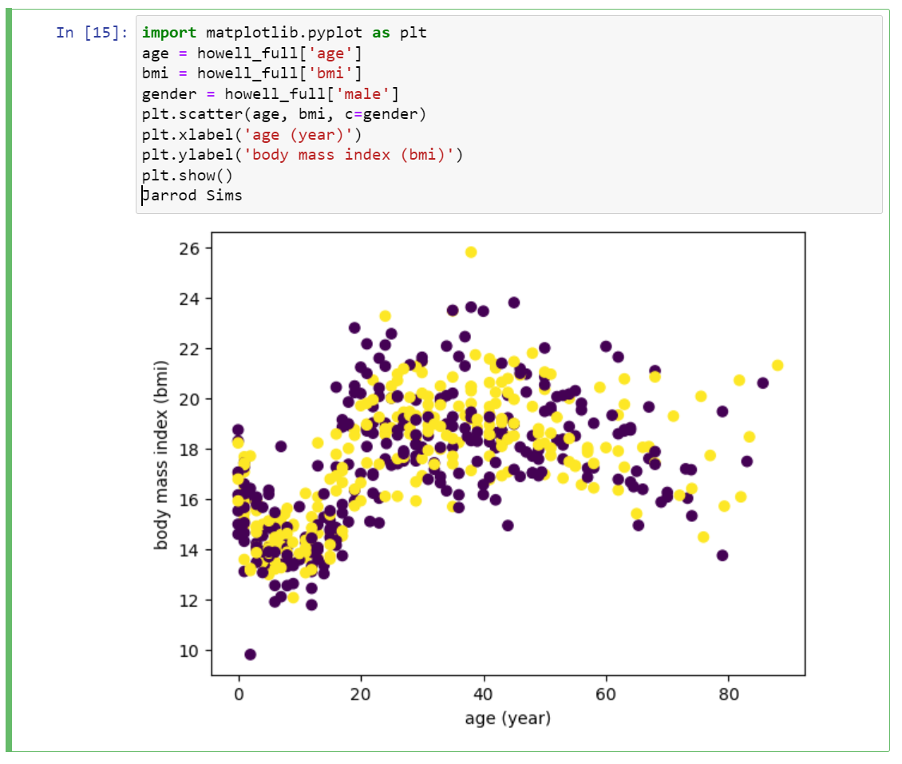

**Submission 11 of 14: Progress mark (10) Screen shot of data set prints**

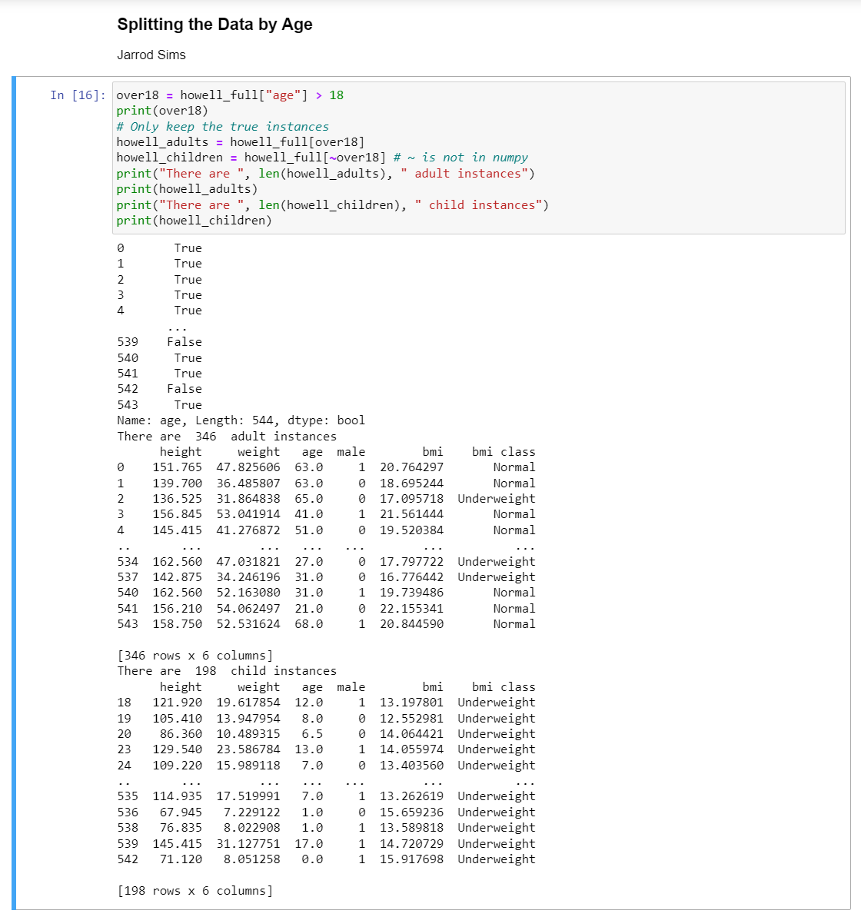

**Submission 12 of 14: Progress mark (10) Screen shot of plot**

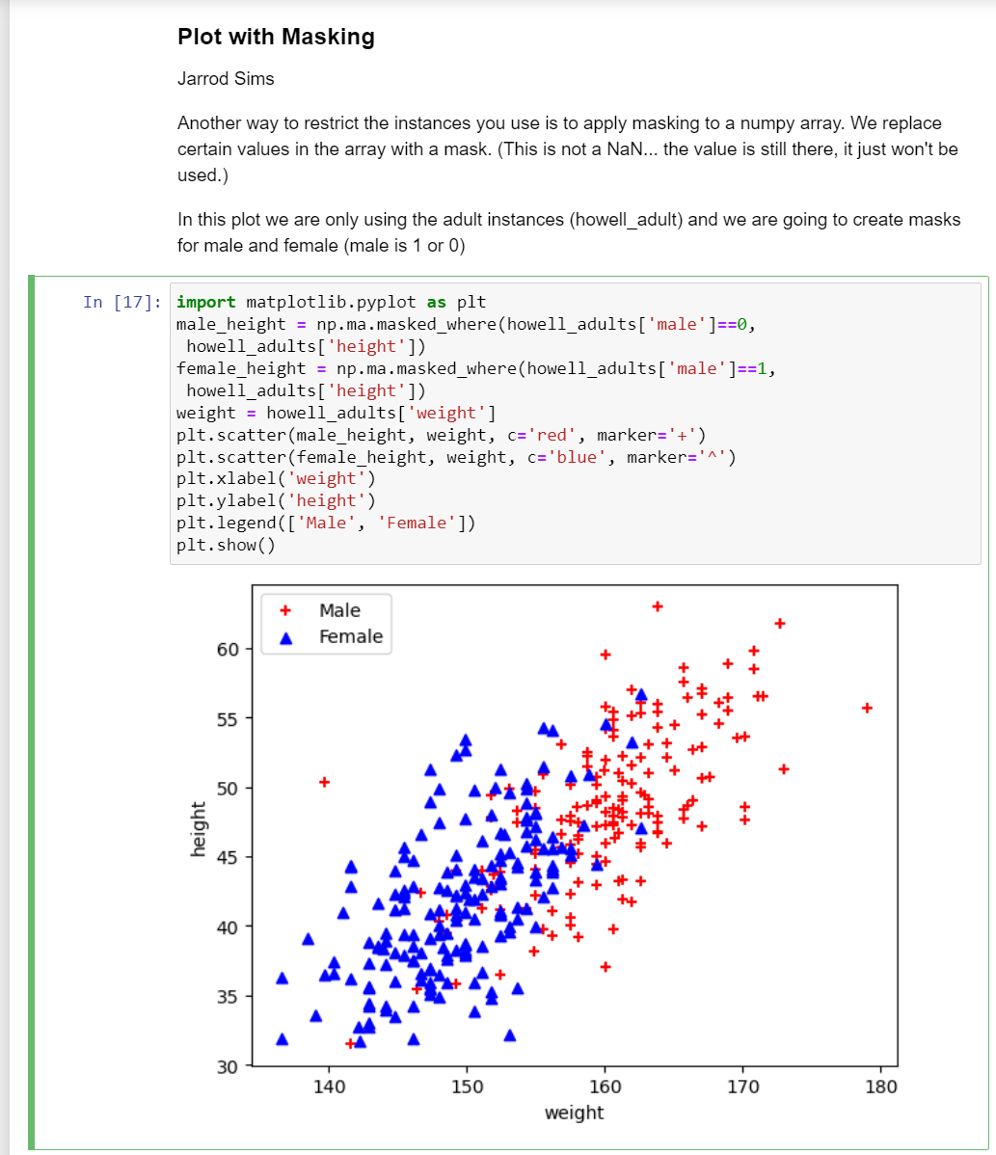

**Submission 13 of 14: Computation (5) Compute the ratio of male/female for 1) Adults data frame 2) Training data frame 3) Test data frame**

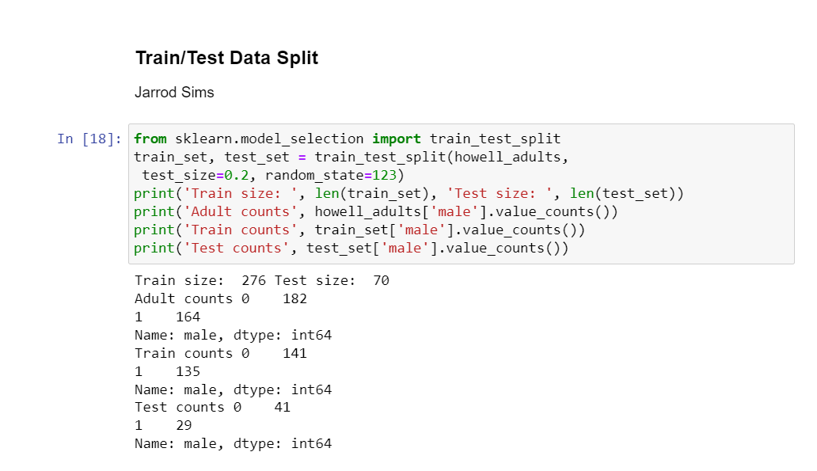

**Submission 14 of 14: Computation (5) Compute the ratio of male/female for 4) Adults data frame 5) Training data frame 6) Test data frame**

