Progress 1 - package installation report for numpy, jupyterlab, pandas, matplotlib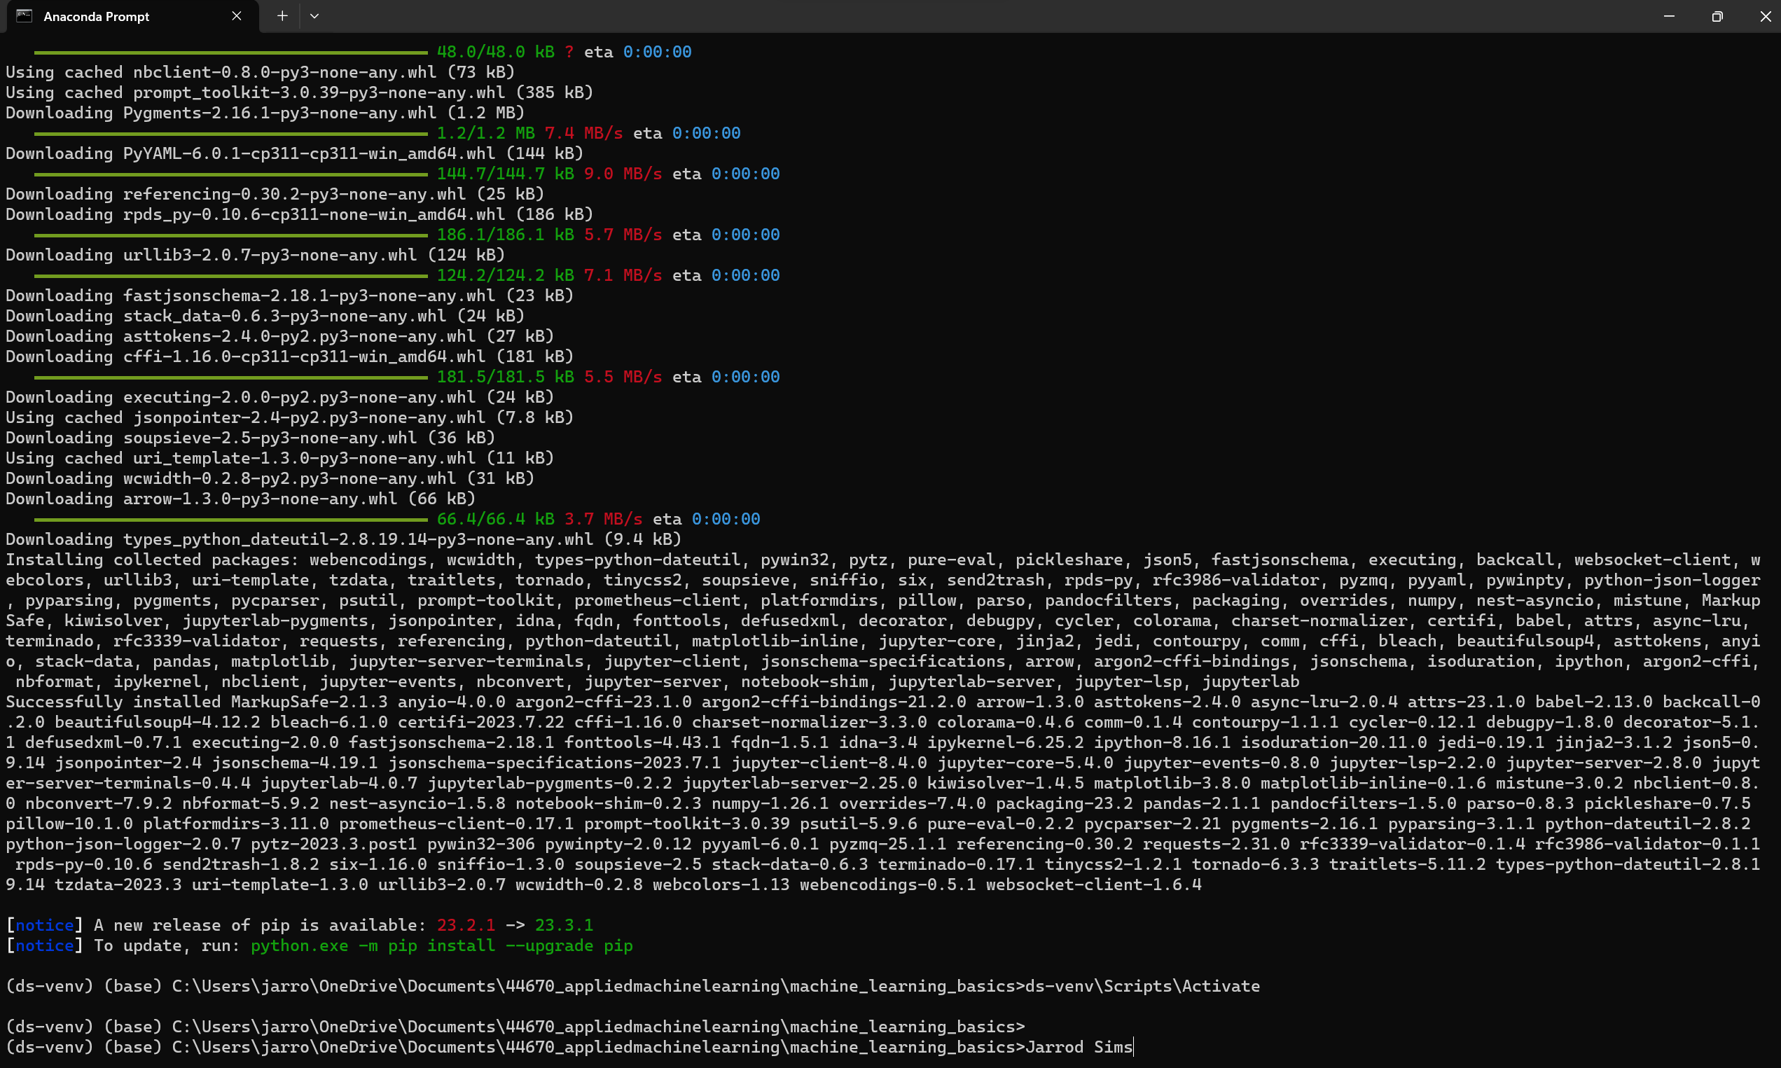

Progress 2 - Running JupyterLab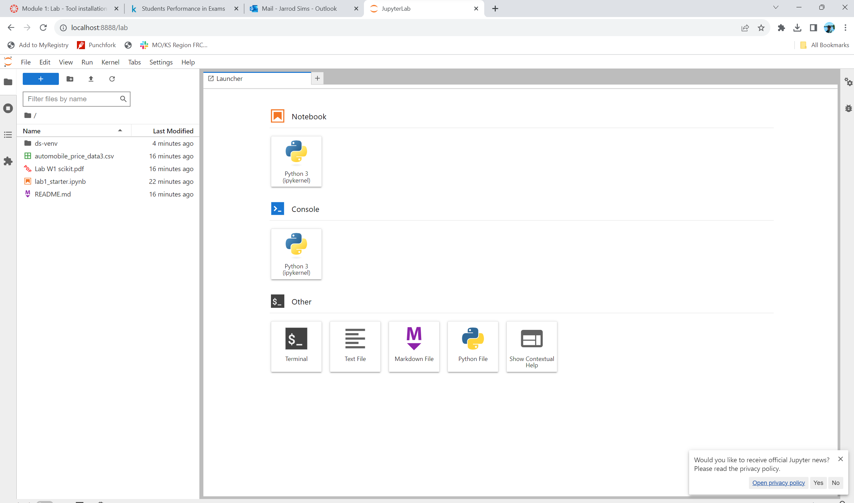

Progress 3 - JupyterLab with notebook running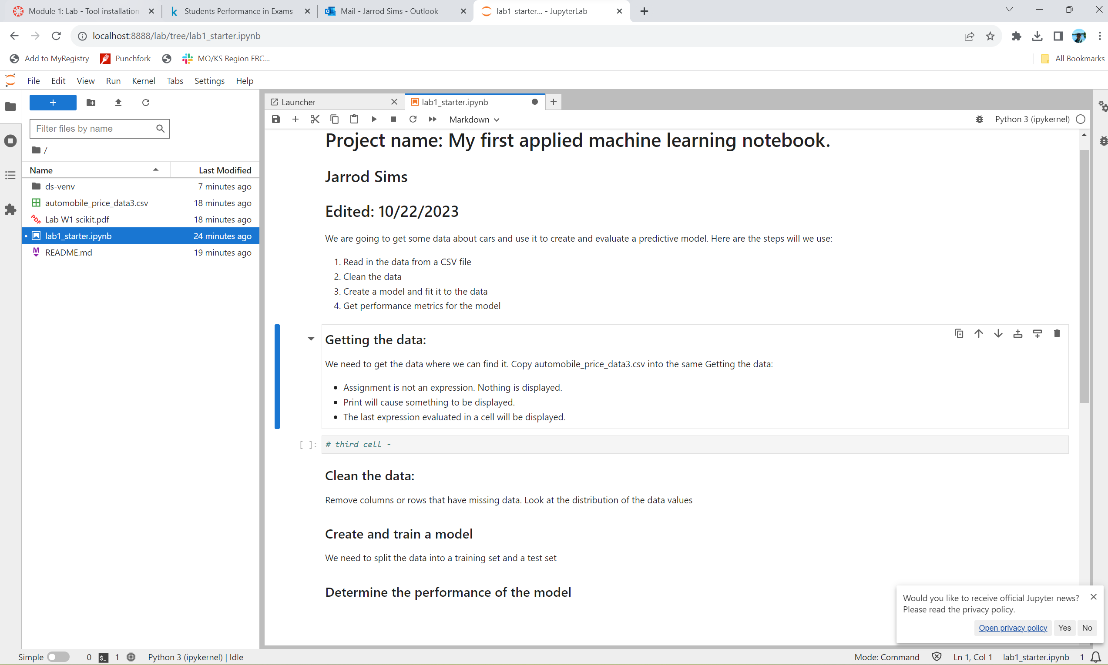

Progress 4 - Dataframe keys displayed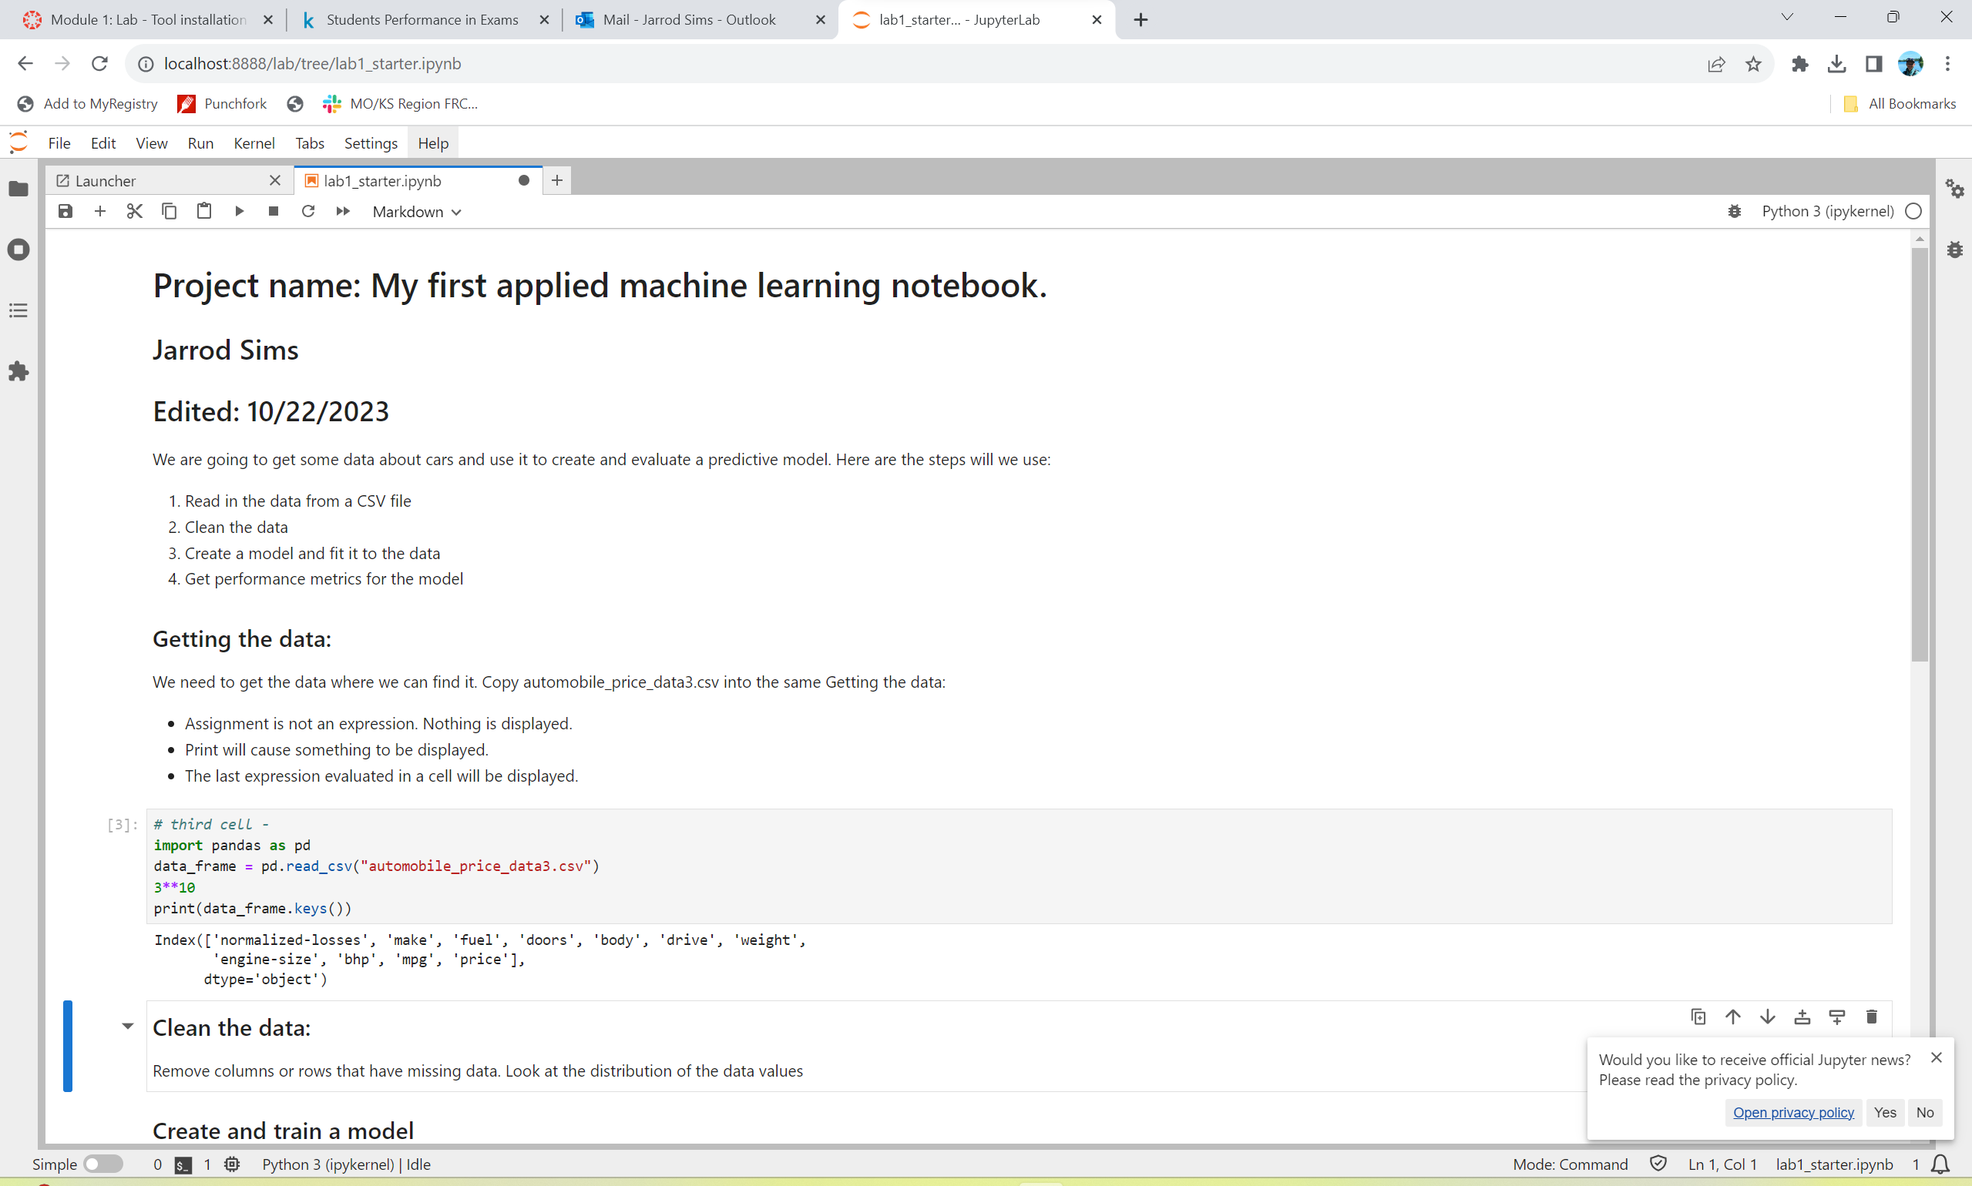

Progress 5 - histograms for features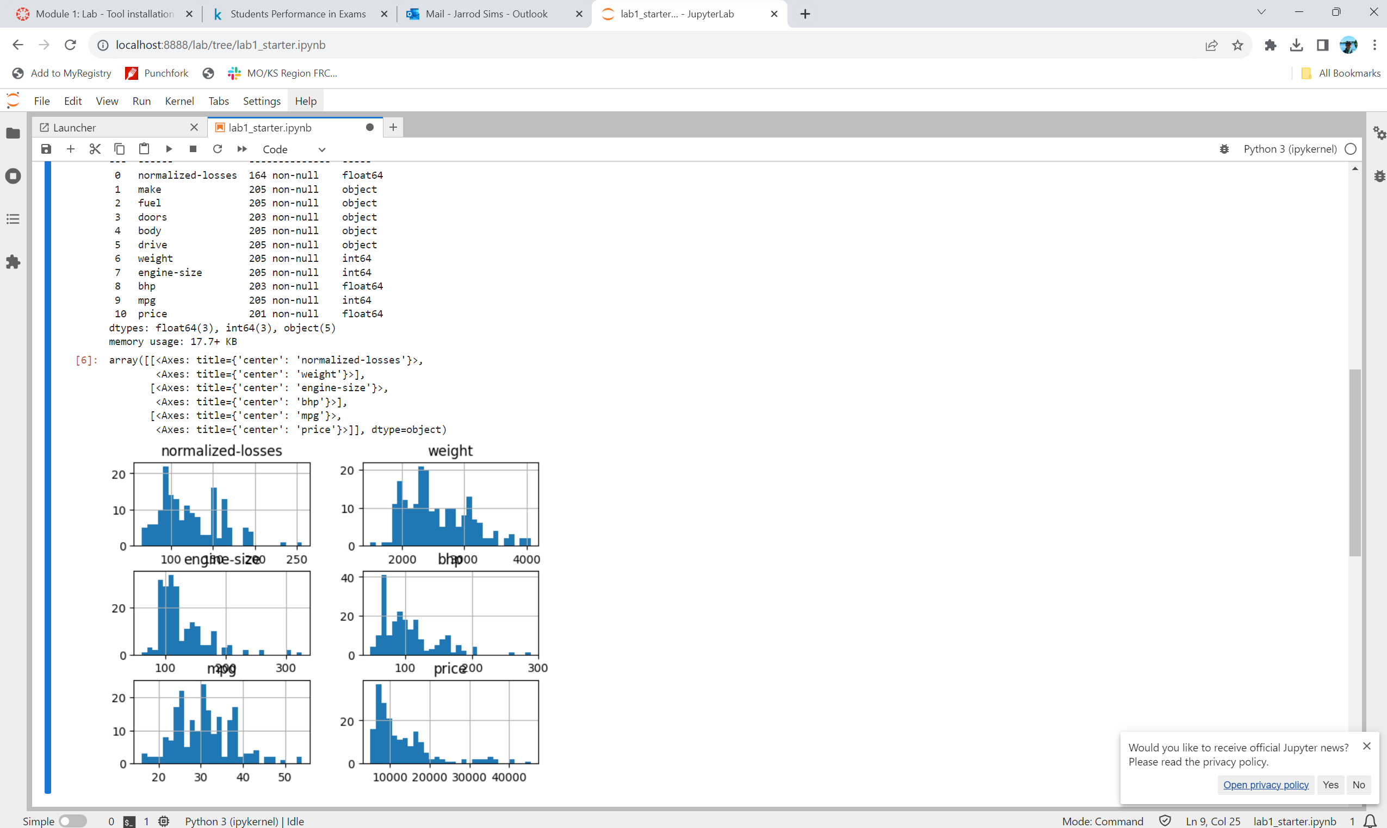

Progress 6 - Error on accessing removed feature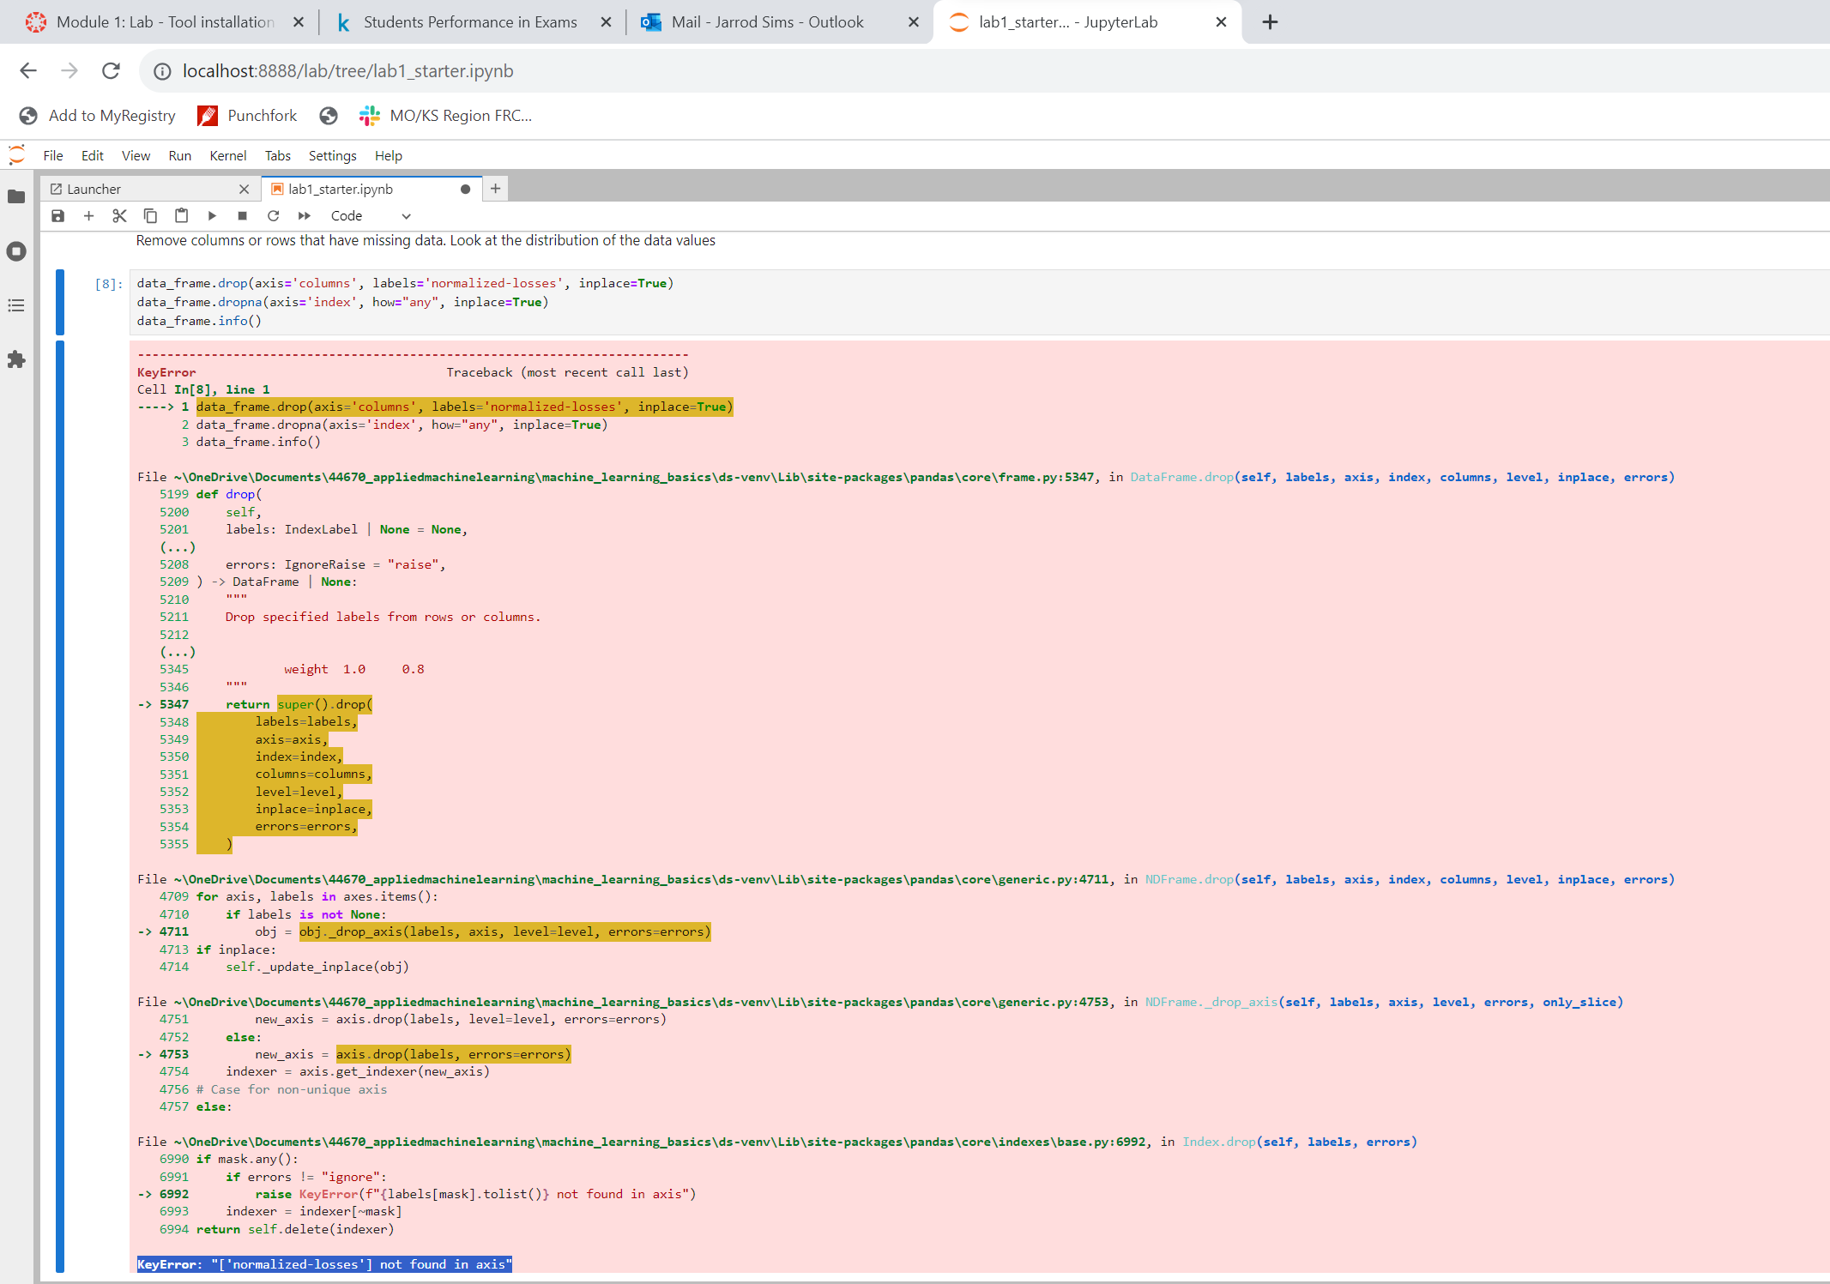

Progress 7 - Split code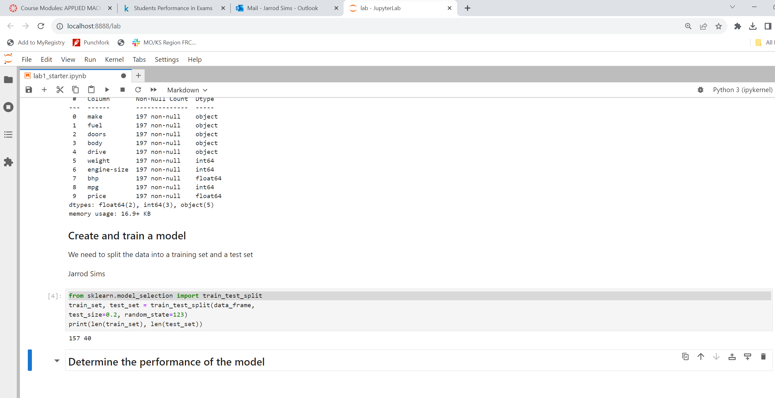

Progress 8 - Training code and results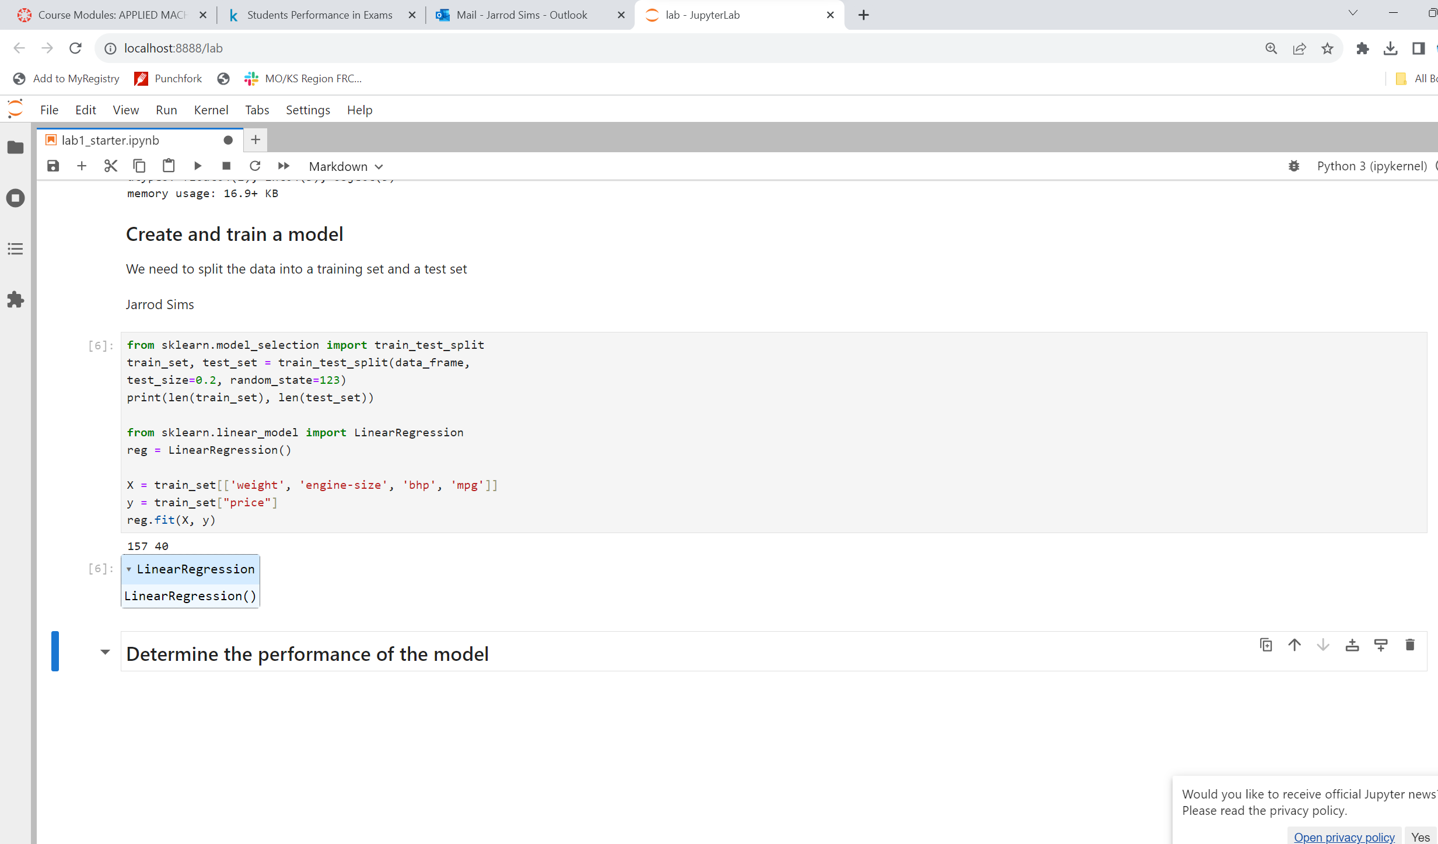

Progress 9 - Screen shot of internal parameters for trained model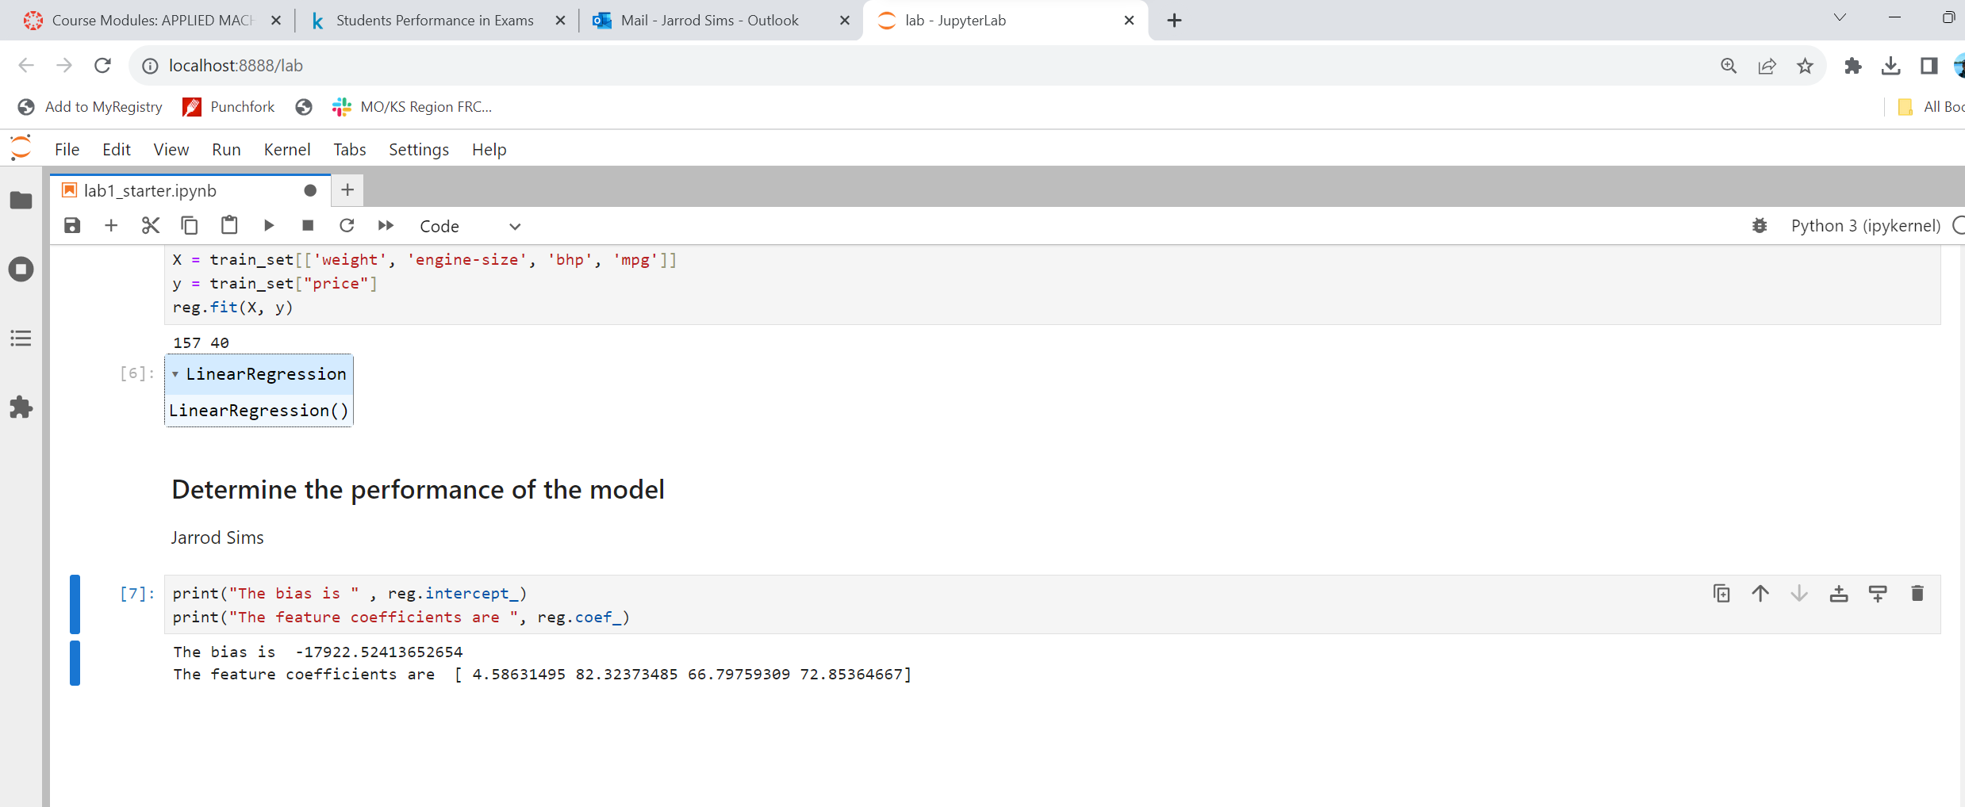

Progress 10 - Screen shot of performance values