**Submission 1 of 12: Progress mark (10) Screen shot preparation code.** 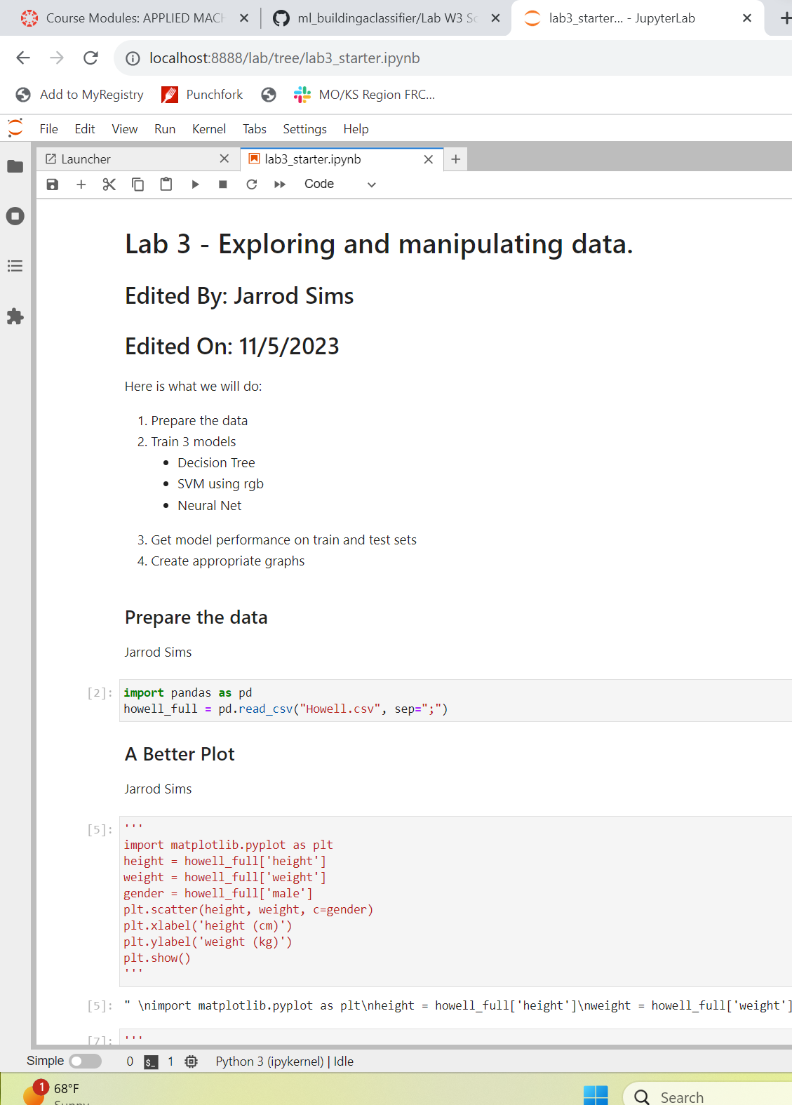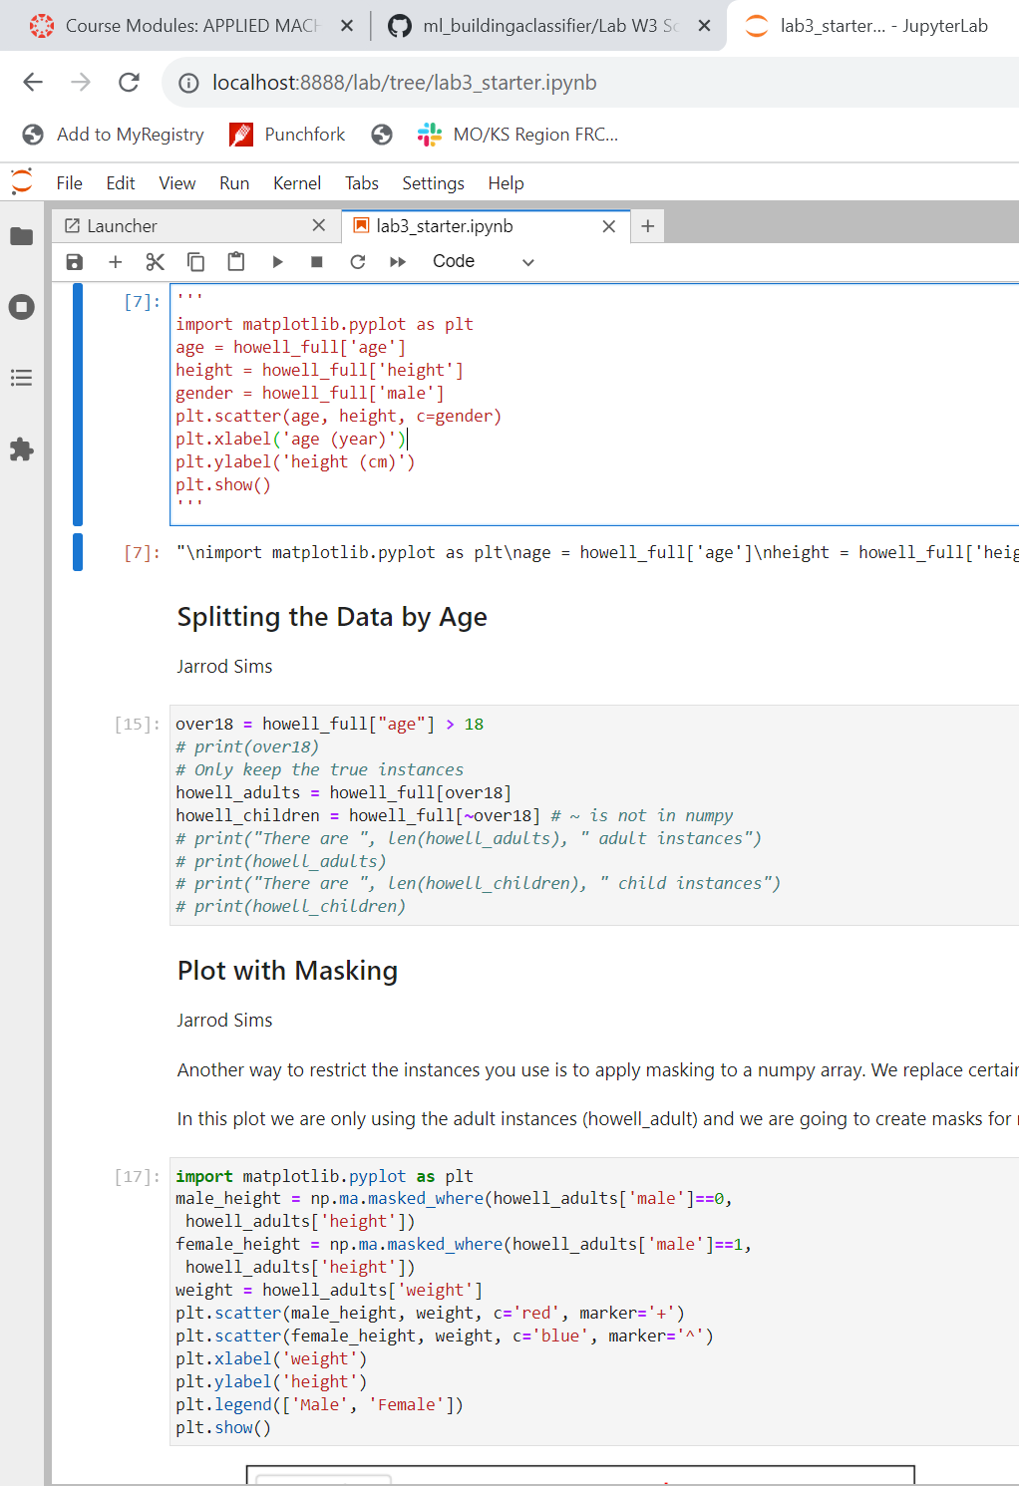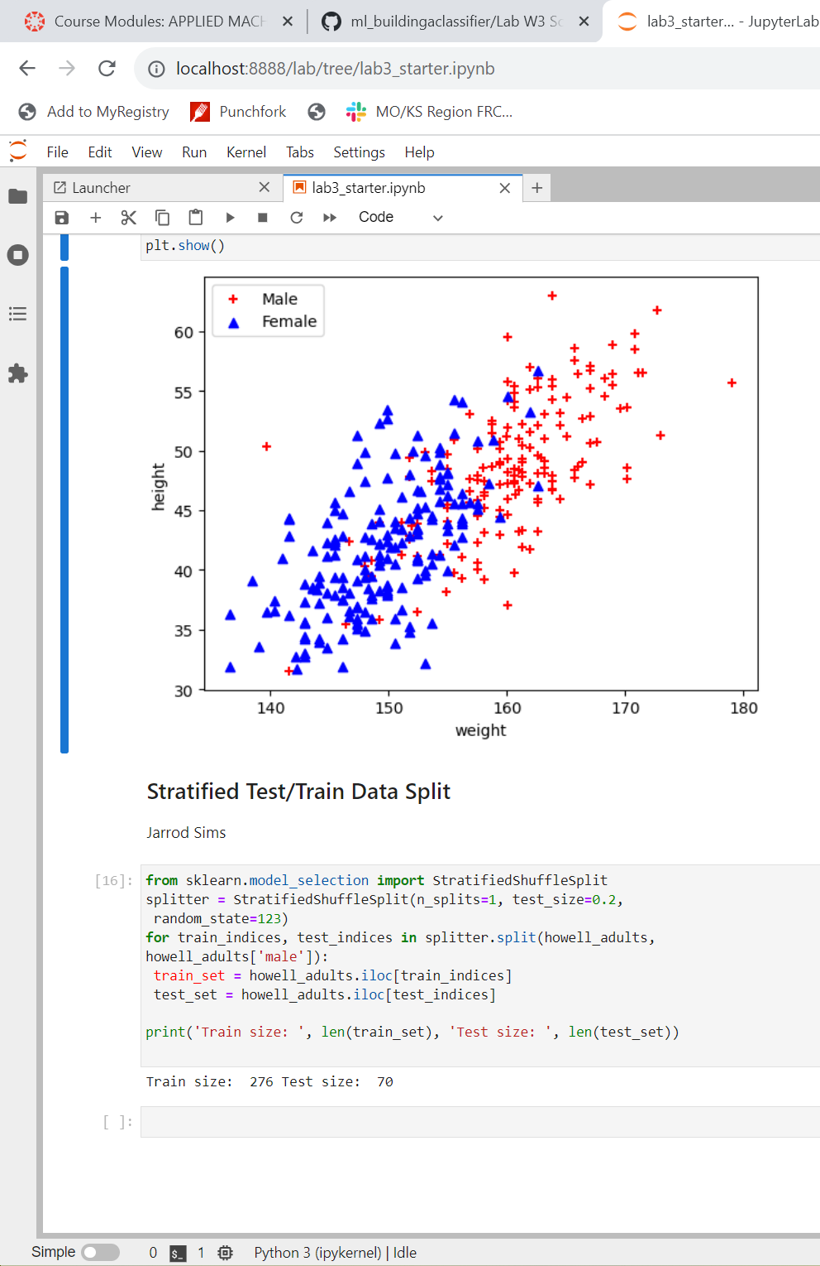

**Submission 2 of 12: Progress mark (10) Screen shot of train/test performance.**

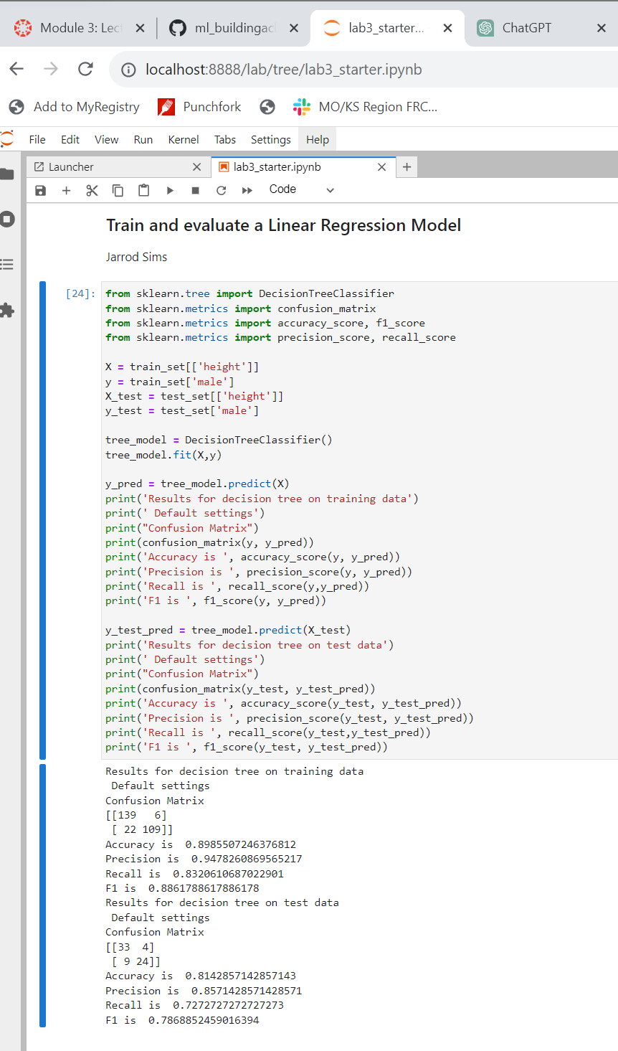

**Submission 3 of 12: Analysis (5) Looking at the performance of the model on the training and test sets and make an argument on whether the model is overfitting the training set.**

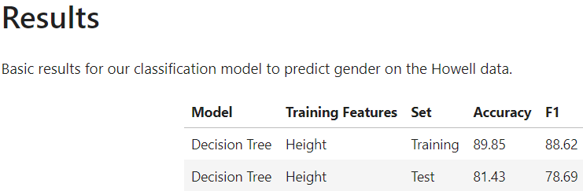

The model is likely overfitting the training set as the accuracy and the F1 score degraded from the training to the test set.

**Submission 4 of 12: Analysis (10)**

* **Look at the performance of the models and state which model you prefer**
* **Propose an explanation of why one feature was better than the other**

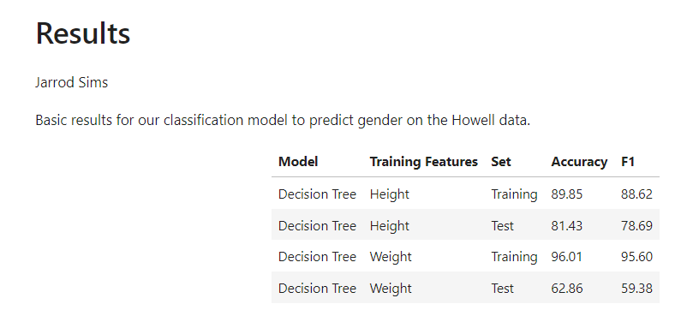

While neither model seems to be performing well on the test set, when height is used as the training feature the accuracy and F1 score are higher in the test set. This means that this training feature would be a better choice than weight for use on other test sets.

**Submission 5 of 12: Analysis (5) Which features would you propose are the best to train on?**

**Something to explore later: Does age improve the predictive power of our decision tree?**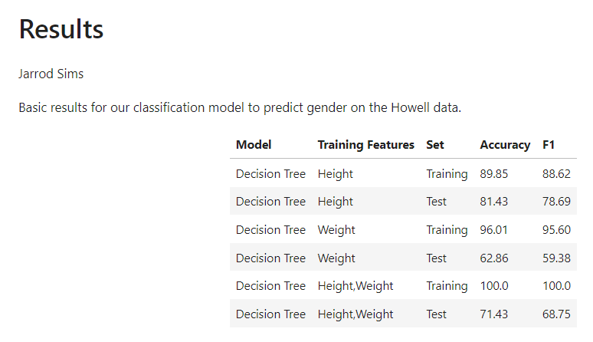

The model performs perfectly on the training data when training with height and weight but even wors than either individual variable on the test set. Based on these data, I would recommend using height alone as it performs the best on the test set.

**Submission 6 of 12: Progress Mark (10) Screen shot of the scatter plot**

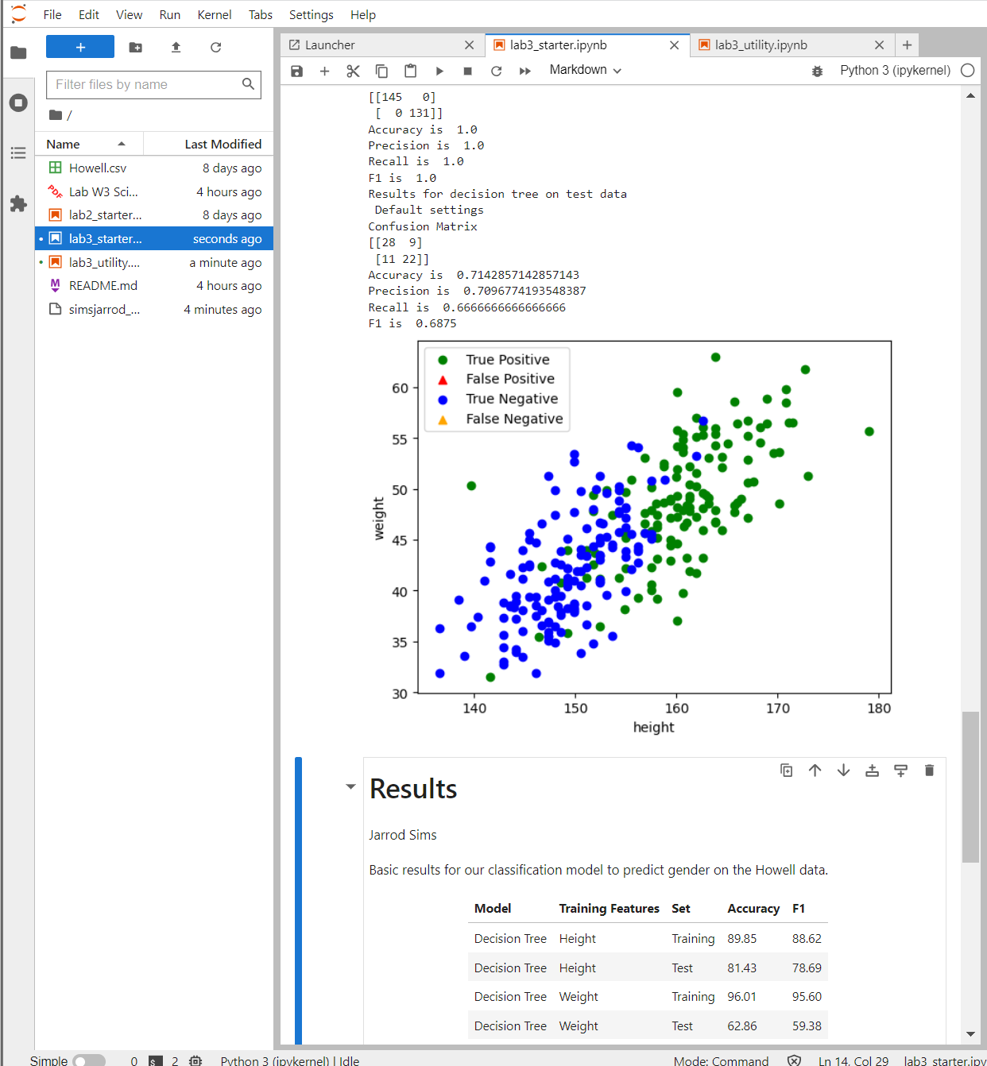

**Submission 7 of 12: Progress Mark (5) Screen shot of the tree plot.**

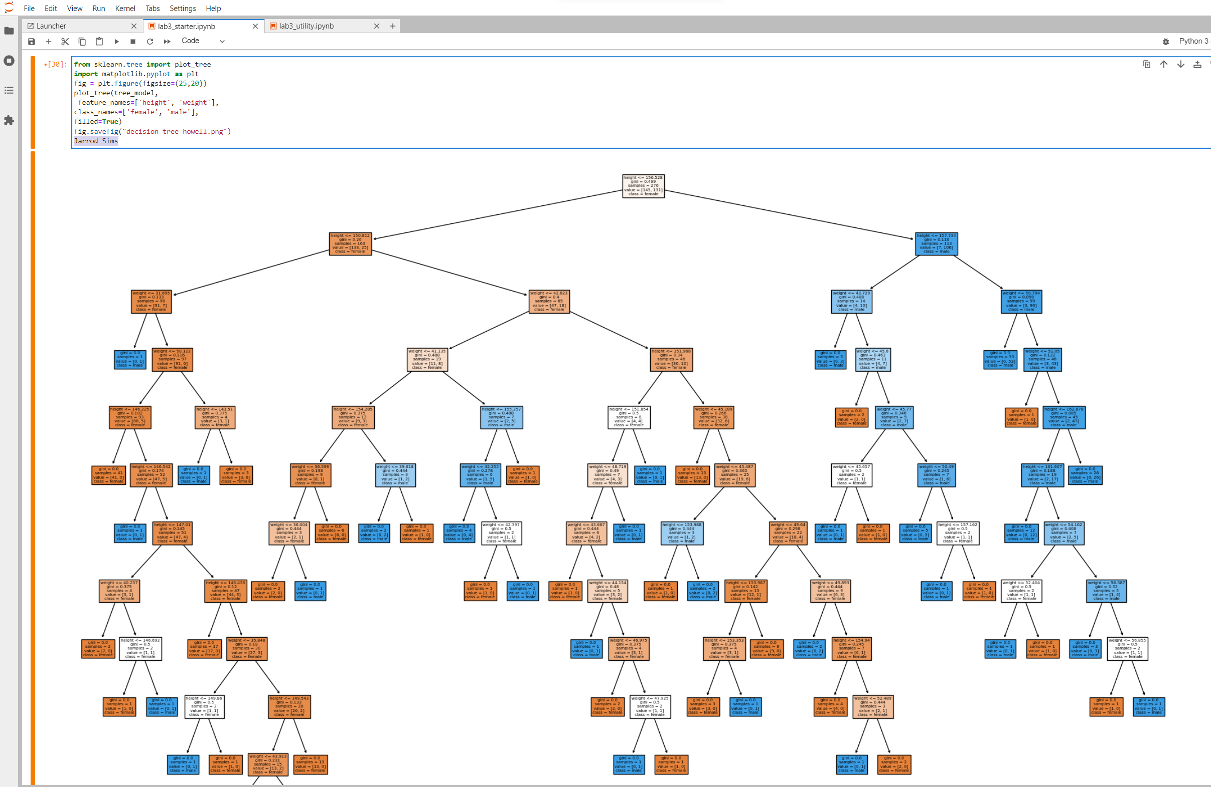

**Submission 8 of 12: Progress mark (10) Screen shot of train/test performance for svc.**

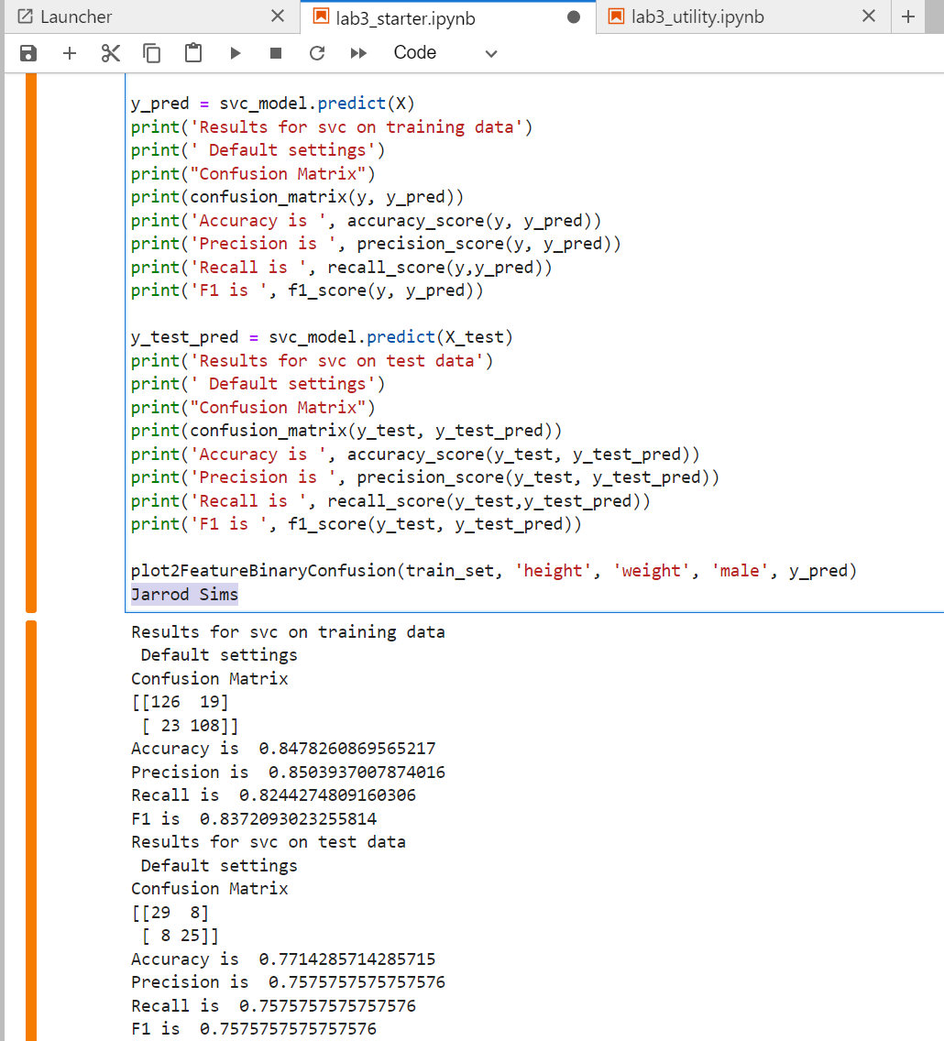

**Submission 9 of 12: Analysis (5) How does the SVC model (using RBF by default) performance compare with the other models on the data set?**

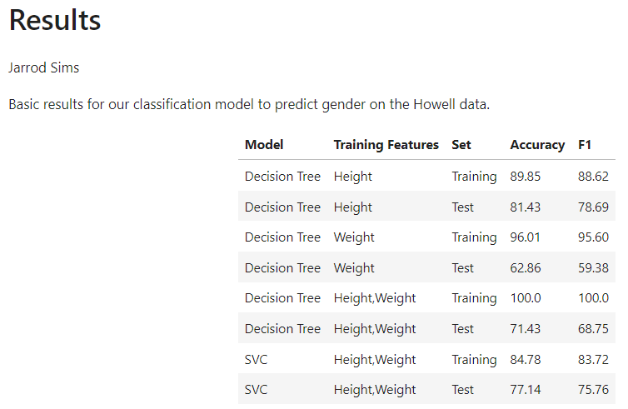

The SVC model performs reasonably well on both the training set as well as the test and seems to have less overfitting than the decision tree models with less degradation of accuracy and F1 Score between the training and test sets.

**Submission 10 of 12: Analysis (10) Screen shot graph with support vectors.**

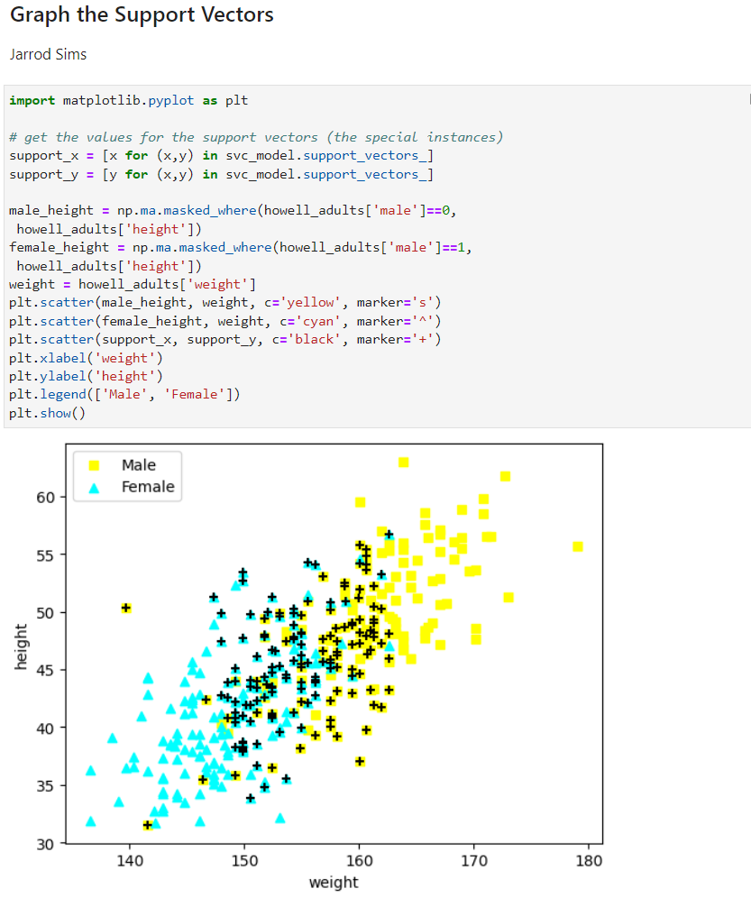

**Where are the boundaries of the positive/negative regions?**

Since these data are not linearly separable, the hyperplane would best be drawn somewhere through the center of the support vectors from around (160,35) to (155, 55).

**Where is the region that predictions should be considered tentative?**

We should place less confidence in data points near the hyperplane should these be considered tentative.

**Submission 11 of 12: Progress mark (10) Screen shot of train/test performance for NN.**

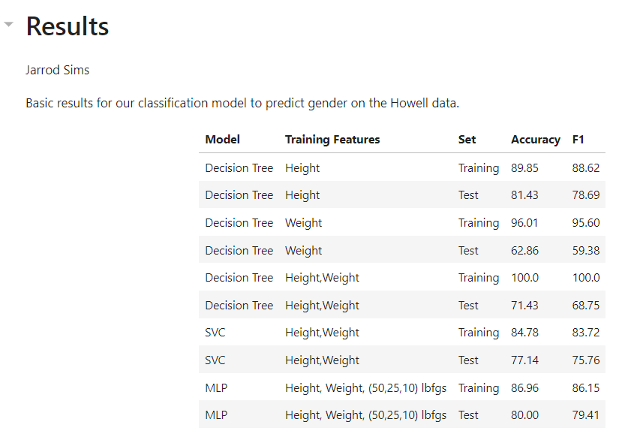

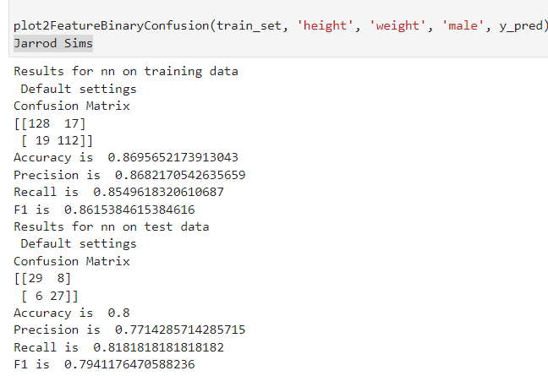

**Submission 12 of 12: Analysis (5) How does the NN model performance compare with the other models on out data set?**

The NN model performs the best of any of the other models. It has the least overfitting problem, and has good performance in the training set as well as the test set.