Types of possible molecules and known mechanisms
Cyclohexane
Chair → Half-chair (TS) → Twist-boat (secondary minimum, here is one extra Twist-boat pseudorotation: twist boat to boat TS to another twist boat) → Half-chair (TS) → Chair
The half-chair is the high-energy TS region; twist-boat is a real local minimum; boat itself is higher than twist-boat and can distort toward twist-boat. Cyclohexane has several symmetry-equivalent boat/twist-boat/half-chair forms because the ring atoms can be permuted around the pseudorotation cycle.
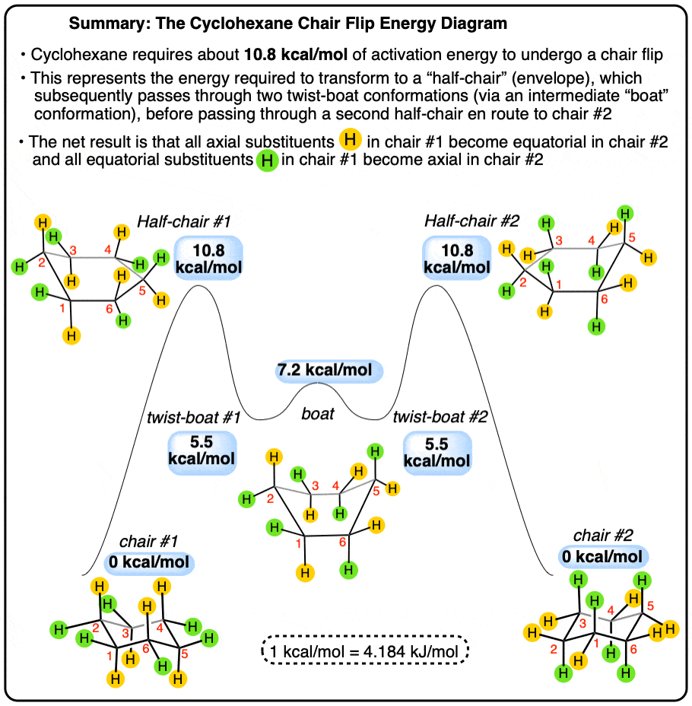
Benchmark is here (and many interesting parameters and several substitions):
https://doi.org/10.1002/poc.1689

Piperidine derivatives (very relevant industrially)
See that paper: https://www.sciencedirect.com/science/article/pii/S0009261422005176 (about 1-phenylpiperidin-4-one, we can use our workflow to see if it reproduces their conformational landscape, but there is no TS)
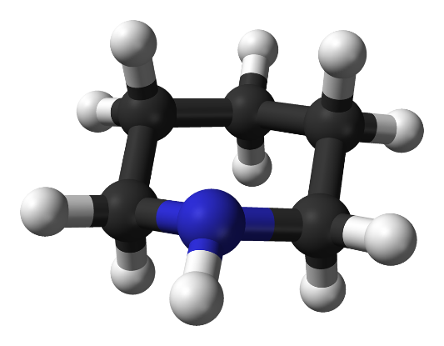
I still want to check the literature of what is known and mechanisms

Cyclohexanone
I still want to check the literature of what is known and mechanisms

Cyclooctane / cyclodecane – more complex
There are many conformers: chair-chair, boat-chair, crown, twist, boat-boat, with several competing pathways.
I still want to check the literature of what is known and mechanisms

Scripts for conformer search and TS guess for psi4
- Conformer analysis
I generated several scripts for cyclohexane-like structures, the best for the INITIAL step are under points 3)+4). I am keeping the older ones just if smth crashes. I have not tested them.

1) classify_auto_rings.py that should find 6-membered rings in xyz files (many conformers after CREST/xTB), classify chair/boat/half-chair, RMSD-filter within each family and write separate outputs. It performs Cremer–Pople puckering analysis for the chosen six-membered ring. The puckering angle θ:
chair-like: θ ≤ 30° or θ ≥ 150°
boat-like: 60° ≤ θ ≤ 120°
half-chair-like: everything in between

To list rings: python classify_auto_rings.py --list-rings
If several are detected, to run the one we need: python classify_auto_rings.py --ring-id 1 --rmsd 0.5
to remove extreme outliers: python classify_auto_rings.py --ring-id 1 --rmsd 0.5 --energy-window 50

2) A similar script but based on dihedral angle scans is as: make_boat_chair_scan.py

3) More advanced script with RMSD/classification script: should distinguish
chair-like / twist-boat-like / boat-like / half-chair-like, so boat and twist-boat are separated using φ. 1_classify_ring_conformers_v2.py --- Automatic classification
*.xyz
→ detect six-membered rings
→ classify by Cremer–Pople θ and φ
→ sort by energy
→ RMSD-filter within each family
→ write folders:
chair-like/
twist-boat-like/
boat-like/
half-chair-like/
ts-candidates/
→ write conformer_summary.csv

chair: θ ≈ 0° or 180°
boat/twist: θ ≈ 90°
half-chair: intermediate θ
boat-like: φ close to 0°, 60°, 120°, 180°, 240°, 300°
twist-boat-like: φ close to 30°, 90°, 150°, 210°, 270°, 330°

4) and a continuation of 3) for structures in folder “all-sorted/”. 2_dihedral_puckering_filter_v2.py It should re-check the full classified ensemble and keep additional representatives if they differ in ring dihedrals, θ, or φ, even when RMSD is small. ---- Diversity filter
So it does that:
all-sorted/
→ read already classified structures
→ calculate six ring dihedrals
→ compare structures within each family
→ keep a structure if it is different by:
RMSD OR θ OR φ OR ring dihedrals
→ write diversity-preserved representatives
It should give:
dft-minima-candidates/ structures to optimize in Psi4
conformer_database.csv full descriptor database
pathway_pair_suggestions_xtb.csv suggested chair↔twist pairs

The rule should be: Two conformers are duplicates only if all are similar:
- ring RMSD < cutoff
- Δθ < cutoff
- Δφ < cutoff
- all/sufficient ring dihedrals similar
If RMSD says “same” but φ or ring dihedrals say “different,” Script 2 keeps both. Recommended cutoffs --rmsd 0.5 --theta-cutoff 12 --phi-cutoff 20 --dihedral-cutoff 25 :
RMSD: 0.5 Å
θ cutoff: 10–15°
φ cutoff: 15–20°
dihedral cutoff: 20–30°
See that paper, sounds interesting: https://pubs.acs.org/doi/10.1021/acs.jctc.2c00081 and https://pubs.acs.org/doi/10.1021/acs.jcim.5c02794 (we can use some of ideas there to refine the TS after DFT by generating closer ones and an extra check of its correctness)
After running scripts in points 3) and 4) we have conformer analysis only.
We should do DFT optimization for all relevant representative minima to confirm them (!) and later do TS guesses, e.g., as I suggest below. As for now, it is not clear if CREST can give a good TS search, because some papers tell that some suggestions are going back to minima.

- TS guesses
- direct TS guess script make_ts_guesses_from_dft_minima.py (easier, good especially if the mechanism is known). It uses DFT-optimized chair minimum and DFT-optimized twist-boat minimum and generates several half-chair-like TS guesses by interpolation / puckering analysis. Later, we need to run psi4 for TS optimization, freqs and IRC.
chair minimum + twist-boat minimum
→ align on ring atoms
→ interpolate between them
→ calculate Q, θ, φ for every image
→ select half-chair-like images
→ rank them as TS guesses
→ write XYZ files
→ optionally write Psi4 TS input files
To run:
python make_ts_guesses_from_dft_minima.py \
--chair-folder dft-confirmed-minima/chair-like \
--twist-folder dft-confirmed-minima/twist-boat-like \
--ring 12,13,14,15,16,17 \
--pair-csv pathway_pair_suggestions_xtb.csv \
--charge 0 \
--mult 1 \
--method b3lyp-d3bj \
--basis def2-svp \
--make-psi4
If you do not trust the old xTB pair suggestions after DFT optimization, omit --pair-csv.

- fallback: geomeTRIC/NEB (only if direct TS optimization fails or gives the wrong TS):
prepare_geometric_neb_v2.py
It will prepare a NEB calculation between DFT chair minimum and DFT twist-boat minimum using Psi4 as the energy/gradient engine through geomeTRIC (ASE could be used too). Then, we need to take the highest-energy image and optimize in psi4...
For that script, we need to have:
python -m pip install geometric numpy
geometric-neb
To run it:
python prepare_geometric_neb_v2.py \
--chair-folder dft-confirmed-minima/chair-like \
--twist-folder dft-confirmed-minima/twist-boat-like \
--ring 12,13,14,15,16,17 \
--charge 0 \
--mult 1 \
--method b3lyp-d3bj \
--basis def2-svp
Later:
cd geometric_neb_jobs/path_001_...
./run_neb.sh
Let’s see if we reach that step and what is the result of psi4. We should have also psi4 IRC. We can later add additional step to validate the TS as in racerTM (the publication I mentioned above)

For IRC:
- exactly 1 imaginary frequency, and the imaginary mode should look like ring puckering / chair↔twist motion, not only side-chain rotation.
- Run IRC in Psi4
Use the optimized TS geometry as input:

memory 16 GB
set_num_threads(16)
molecule mol {
0 1
# paste TS geometry here
}
set {
basis def2-svp
reference rhf
scf_type df
guess sad
e_convergence 1e-8
d_convergence 1e-8
opt_type irc
geom_maxiter 200
}
irc("b3lyp-d3bj")
- Get the IRC endpoints: Psi4 should produce forward/backward IRC geometries. Take the final geometry from each direction.
- Optimize the IRC endpoints
- Compare endpoints with your known DFT minima. Check whether endpoint A matches a chair minimum and endpoint B matches a twist-boat minimum.
- If IRC connects the wrong structures, then the TS is real, but not the one you wanted. Try another TS guess or use NEB fallback.

As for now, the workflow looks like:

Molecule.xyz

│

▼

CREST / GFN2-xTB

│

▼

Script Classify conformers

(Chair, Twist-boat, Boat, Half-chair)

│

▼

Script Diversity filtering

+

Conformer database

+

Suggested chair↔twist pairs

│

▼

Psi4

DFT optimization

B3LYP-D3(BJ)/def2-SVP

│

▼

Frequency

0 imaginary frequencies

│

▼

Confirmed minima

│

├───────────────┐

▼ ▼

Script Direct TS Script geomeTRIC/NEB

guesses (fallback)

│ │

└──────┬────────┘

▼

Psi4 TS optimization

│

▼

Frequency

1 imaginary frequency

│

▼

IRC

│

▼

Optimize IRC endpoints

│

▼

Script Compare endpoints

to DFT minima

│

▼

Final validated pathway

