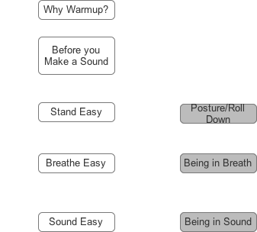
Getting Started

[Key – white button = text
grey button = sound file]

