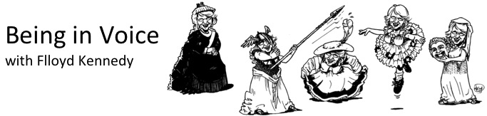
Roll Down and up the Spine (with physical awareness)

First check your posture, leave your arms loose, legs straight but not locked

- release your head first, allowing it to float gently forward and downwards till your chin nearly touches your chest
- allow your shoulders to follow the head, and gently float down with your arms and shoulders loosely dropping down, until you are hanging upside down, your spine completely curved with the weight of your head, arms and upper body falling towards the floor
- return slowly to upright by initiating the movement in your centre. Draw your belly button in towards the small of your back, and notice that your spine begins to unroll itself from the base of your tail-bone
- allow your shoulder-blades to slide down your back, make sure your head is the last thing to return to upright. Your arms are still completely loose. Notice if you feel the need to drop, or relax your shoulders after you have straightened up, and make a mental note to catch yourself next time, in the act of tensing the shoulders either on the way down, or the way up. Once you notice it happening, you can choose to relax them – as many times as you notice it!
- If you have arrived back in the upright position with hair across your face, resist the temptation to shake your head. Instead, brush it gently back with your hands, and return your hands to their relaxed position at your sides.
- Observe how your body feels now, and how you feel about it. There is no ‘right’ or ‘wrong’. The important part of the exercises is your awareness of what you actually notice, and what is actually there.
- Move around the room, and observe how easily, or with what degree of difficulty, you maintain any sensation of lightness, freedom of movement – or not! - as you go. Stop and do the Spinal Roll whenever you want to find it again.

You can develop this further by adding in a regular count, for example a count of six to roll down and a count of six to roll back up. This takes a certain amount of practice and experimentation to coordinate all the muscles, with spatial awareness involved. You need to explore your own innate sense of pacing to find the balance between speed and distance. This exercise will help you to develop your powers of focus, and your ability to free your body from unnecessary tensions in stressful situations.

