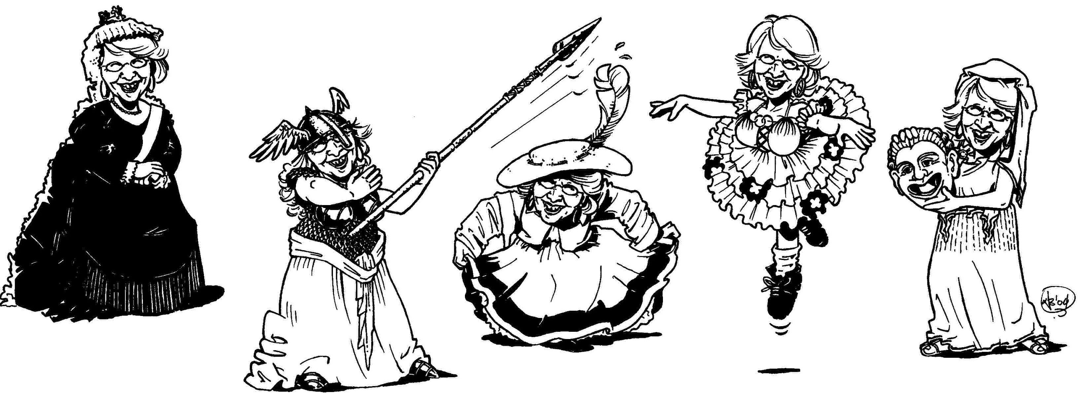

Welcome to Being in Voice, training for the speaking voice.
Here are some fun, easy to follow and easy to do exercises to help you keep your voice healthy and toned up as you increase your power, range, flexibility and clarity.
Use the exercises for regular practice, or as warmups before you speak publicly, whether you are teaching, acting, making a pitch or presenting a seminar.
Play with your voice as you explore your vocal potential without strain or pain. Enjoy BEING creative IN your VOICE.
www.being-in-voice.com

