Quantifying the role of liquid hydrocarbons in the current and future energy balance of a self-sufficient Denmark
Ali Akbar Eftekhariª
ª Technical University of Denmark, Lyngby, Denmark, aliak@dtu.dk
Abstract:
Denmark is a pioneer in the large-scale extraction of the sustainable energy of the wind, especially in the electricity sector which supplies most of the Danish electricity consumption. A combination of these recent Danish successes, and the increased societal demand for the reduction of carbon dioxide emission in light of the recent IPCC report, has created the expectation of a fast transition from fossil fuel to sustainable energy resources in all energy sectors. Although this transition is inevitable due to the unsustainable nature of fossil fuels and the declining Danish oil and gas production, there is still an ongoing discussion, sometimes supported by qualitative evidence, on its possibility, extent, and urgency.
This paper that is inspired by a true story of an unsuccessful date between a petroleum engineering colleague and a Danish environmentalist has a quantitative look at the future energy balance of Denmark by estimating the future energy consumption of a typical Dane and comparing it with the available renewable and non-renewable energy resources. It also suggests and compares different scenarios for a self-sufficient Denmark with 100% renewable energy, considering the available land and shallow sea and the footprint of the energy extraction and storage methods in Denmark. The results show that if the intermittency problem of the wind energy is addressed in the future, there is still a large demand, mostly from the transport sector, for liquid fuels with high energy-density, which needs to be addressed by a paradigm shift in transport technologies or large scale implementation of power to fuel technologies with a sustainable carbon source.
Keywords:
Sustainable energy, transition, wind energy, Denmark, power-to-fuel.
- Introduction
Mette is an imaginary Danish girl. The creation of her character is inspired by a real life event: refusal of a Danish girl to go out with a friend of mine, who happens to be –according to her- in the “unethical” Petroleum-Engineering-related research. I don’t know about the rest of the arguments they might have had, but I imagined instead of standing on arbitrarily-made moral grounds, they could have had a constructive fact-based quantitative discussion. This paper tries to make a foundation for those arguments. Being a technical paper, this article is not trying to find an answer to the “ethics of fossil-fuel research” but tries to come up with some numbers that can lead to an answer to the real concern: “why, when, and how are we going to be independent of fossil fuels?” This eventually (and hopefully) leads to an answer to the ultimate question for Mette: “is it ethical to date a Petroleum Engineer?”
The ‘why’ question is the easiest to answer. Figure 1 shows the natural cycle of fossil fuel production. Atmospheric CO₂ is adsorbed by plants and converted to carbohydrates with the aid of solar energy. The carbohydrates are then buried and undergone (bio)chemical conversion over millions of years to make fossil fuels in different forms, i.e., coal, oil, and gas. Their consumption, however, is happening very fast, and by some estimations, almost all the conveniently-extractable resources will be consumed over a few hundreds of years. This huge difference between the production and consumption rates of fossil fuel is what makes this valuable resource unsustainable. More importantly, sudden release of so much carbon dioxide that has been accumulated over millions of years disturbs the natural cycles. The aftermath of these events, although of utmost importance, is not the subject of this work. Figure 1 gives us some important clues to answer the ‘how’ question: how are we going to be independent of fossil fuels? The answer lies in the time scales that are outlined in the figure: slowing down the consumption by reducing the energy demand or finding alternative energy resources, and/or accelerating the natural processes of CO₂-recycling and fossil fuel production, e.g., by making synthetic fuels in large-scale fast processes that are driven by solar energy. The growing population of the earth and the increasing energy demand of the developing countries make it difficult to reduce or even keep the current level of consumption, although the rate of growth is somewhat slowed down by, e.g., improving energy efficiency. Accelerating the CO₂-recycling or finding renewable alternatives to supply the increasing energy demand seems to be the ultimate and inevitable answer. The focus of the rest of this paper is to outline the energy demand of Mette, a typical Dane, and the renewable resources at her disposal, and to find out if there is a balance between her demands and the current and future energy supply in Denmark.

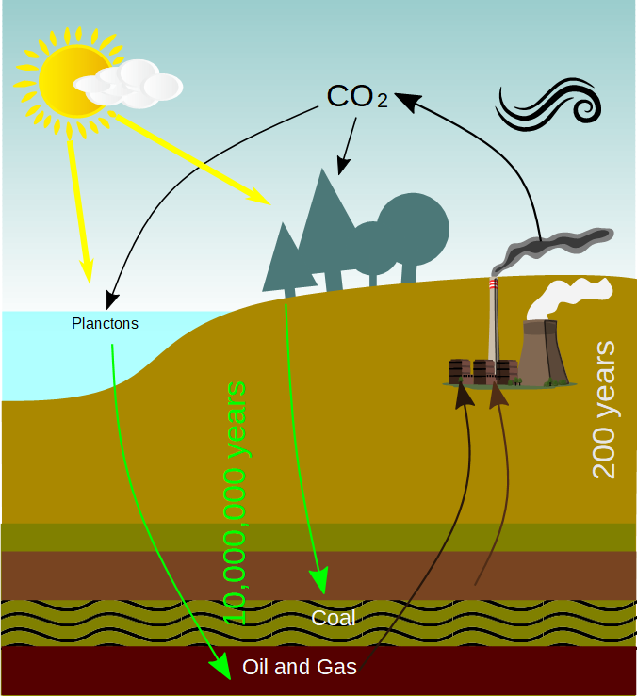Fig. 1. Fossil fuel cycle and natural recycling of CO₂.
Several valuable studies have addressed the possibility of running Denmark on 100% renewable energy [1–3] by increasing the efficiency of energy conversion and extraction, better exploitation of the current energy resources, e.g., combined heat and power (CHP), and tapping into the lower quality energy sources, e.g., low temperature heat of geothermal energy [4,5]. The large scale and complex nature of energy supply and demand (even for a small country) leads to the creation of large databases and computer packages to keep track of all the computational details and numerous assumptions and estimations. This, inevitably, causes the procedures and results to be understandable and -intellectually- accessible only to the domain experts or those with at least some backgrounds in energy analysis. There are several efforts to make these studies more accessible to a wider audience, e.g., Mette, such that they can be used by general public. The valuable book of late David MacKay “sustainable energy without the hot air” is one of the most reputable ones [6]. One of the aims of this work is to make these large-scale complex studies more accessible by combining their data and results with the simplified procedures either suggested by MacKay or developed here based on the laws of thermodynamics and principles of transport phenomena. I hope that eventually, instead of numbers such as 200 PJ annual heat consumption in buildings, or 100 PJ of potential in geothermal energy, Mette can have understandable, relatable, and memorable numbers that can be utilized by her and my colleague, to come up with a mathematical answer to an emotional dilemma. Last but not least, I hope that these calculations can help voters and decision makers to come up and vote for better energy policies.
This paper is structured as follows: first, the main energy requirements of Denmark, i.e., heat, liquid fuel, food, and electricity are estimated and compared and tuned to the published data. Then, the promising sustainable solutions and their land footprint and fossil fuel dependency for providing this energy requirement are presented. Finally, a combination of these solutions based on the available land and shallow seawater in Denmark is determined and discussed.
- Energy consumption of Denmark
In this section, I utilize simplified computational procedures to estimate the annual energy consumption of a typical Dane. Then, the estimated values are compared with the reported number in the official statistical data and peer-reviewed publications.
  - Heat
The main consumer of heat in Denmark –and other Nordic and North European countries with a mildly cold climate– is the residential sector. The heat demand can be calculated by estimating the heat loss from the buildings, which can be done using the following equation:
(1)
where U [W/(m².K)] denotes the overall heat transfer coefficient, A [m²] is the heat transfer area of an average house, T_{house} [K] is the desirable temperature in a Danish house, and T_{ambinet} [K] is the ambient temperature which changes during the year. The average heat transfer coefficient depends on the type of insulation and material, with which a house is built. This is often dictated by a set of standards and regulations. The 2018 Building Regulation [7] suggests a heat transfer coefficient of 0.6 W/(m².K) for the insulated sections in glazed external walls and windows, and a range of somewhat higher values for the windows and doors and similar or lower values for other heat transfer areas. Here, I use an average value of 0.4 W/(m².K). According to Statistics Denmark, the total area of Denmark occupied by buildings is 1.6% of the land [8], which is equivalent to 118 m² per person. I assume that a one-storey building with a 3 m height is built on this 118 m² square-shaped land, which gives a total heat transfer area of 249 m². I also assume a desirable temperature of 22ºC inside the house. For the ambient temperature, which changes during the year and in different locations of Denmark, I used the average monthly temperature of Copenhagen obtained from the weather atlas [9], that is shown in Fig. 2. Clearly, not all the buildings are kept warm, e.g., some of them are empty. Moreover, during the summer, the heating systems are usually off although the hot water is still consumed for, e.g., shower. These can cause inaccuracies in the estimation. Using the higher ambient temperature values, I obtained a heat demand of 25.2 kWh/(day.p), which is in agreement with the reported value of 56.8 TWh/year [2] that is equivalent to 26.8 kWh/(day.p). It must be notes that the reported value includes the heat demand of the industrial processes. The heat demand of households is reported as 163 PJ/year (21.4 kWh/(day.p) by the Danish Energy Agency [10], which shows that the simple estimation method here overestimates the heat demand by around 20%, probably due to the overestimation of the heat transfer area per building. However, the estimation can be improved by providing more data on the number and layout of occupied houses in Denmark. An important advantage of the above formulation is that it considers the environmental conditions. For instance, a harsh winter can increase the heat demand considerably, which can be easily estimated using Eq. (1).
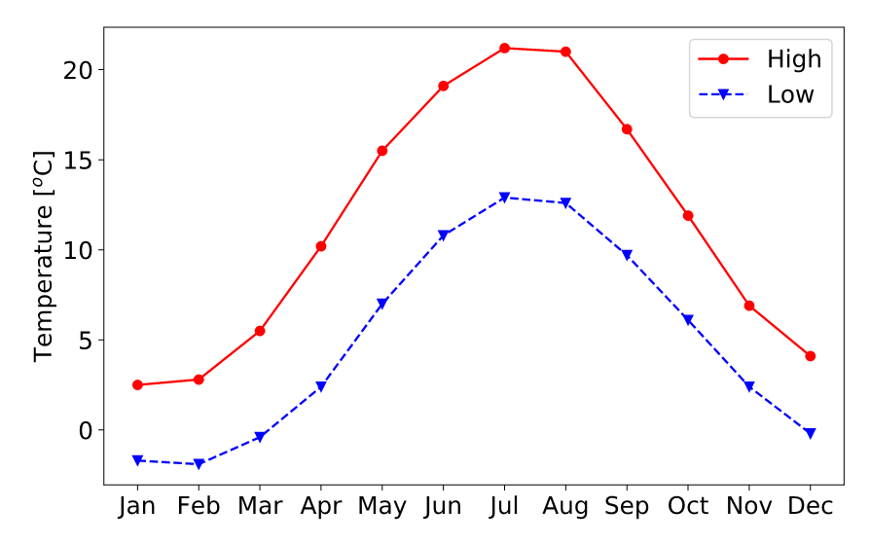Fig. 2. Average monthly temperature of Copenhagen.
  - Electricity
Although it is not too difficult to estimate the explicit electricity consumption of a typical Dane, e.g., refrigerator, TV, lights, washing, cooking, etc, estimating the total electricity consumption of one person is not straightforward since a major fraction of electricity consumption is in fact implicit. If only the common household usage is considered, then the electricity consumption is estimated to be between 1.75 kWh/(day.p) for a family with a low consumption to a value of 7.0 kWh/(day.p) for a single person with a high consumption. However, in reality, the current consumption in Denmark according to different sources is between 16.0 to 22.0 kWh/(day.p) [1,10].
  - Liquid fuels
Following MacKay, the liquid fuel demand can be estimated by estimating the transport in cars and airplanes. I assumed a 20 km commute per day (close to the average home to work commuting distance in 2018) in a personal car and one intercontinental flight per year for Mette. Following MacKay, I estimated the total liquid fuel energy requirement for transport, that is 15 kWh/(day.p) and 30 kWh/(day.p) for the car and air travel, respectively. This is inline with the total oil consumption of 287 PJ/year in 2018 [10] equivalent to 37.6 kWh/(day.p), although it seems that I have overestimated the fuel requirements. This might be due to the fact that only the fuel consumption of the airports in Denmark is included in the published data and not all the fuel consumption of the airplanes. All in all, the fuel consumption of the industries is not included in these calculations, but the estimation seems to be close to the actual consumption.
  - Food
The energy requirement of a young active female is reported as 3100 kcal/day [11], which is equal to 3.6 kWh/day. This value is slightly different for (in)active males or females and also changes with age. Here, I use an average value of 3.5 kWh/(day.p). MacKay considers an average value of 3.0 kWh/(day.p) and by considering the amount of plants that is required to produce a European diet with dairy and meat, he estimates a total plant energy requirement of 15 kWh/(day.p) [6]. The human food is not the only food demand in Denmark. There are more than ten million pigs in Denmark, i.e., roughly two pigs per person. Assuming an average wight of 250 kg for a pig, it requires more than three times of the energy requirement of a human body, i.e., 10.5 kWh per day per pig or 21 kWh/(day.p) considering two pigs per human in Denmark. Adding one and a half million cattle (or ¼ of cattle per person), with an average weight of 500 kg per cattle, an extra 7 kWh/(day.p) must be added to the food requirement. Overall, it gives a total plant food demand of 3.5 kWh/(day.p) for humans and 28 kWh/(day.p) for domestic animals, ignoring the chicken farms.
- Renewable energy resources in Denmark
With the exception of nuclear and geothermal energy, the main source of all other types of energy on earth is the solar radiation. The solar radiation, i.e., the first-hand solar energy [6] that is received in Denmark is in average 1000 kWh/(m².year) [12,13]. Denmark has a population of 5,800,000 living in a 42933.0 km² land, which gives an average area of 7402 m² of land per person, i.e., an average football pitch. Considering an average 4 km shallow water in the coastal areas [14], Denmark has 4000 m² shallow water area per person, roughly half a football pitch. This football pitch receives more than 20,000 kWh/(day.p) of solar radiation. Moreover, assuming an average wind speed of 10 m/s in the sea and 5 m/s onshore, the kinetic energy of wind is more than 90,000 kWh/(day.p). These values are orders of magnitude higher than the average energy demand of our average Dane, Mette. However, there are fundamental and practical limits to the amount of energy that can be extracted from these two resources, as discussed in the following sections.

  - Wind and solar energy
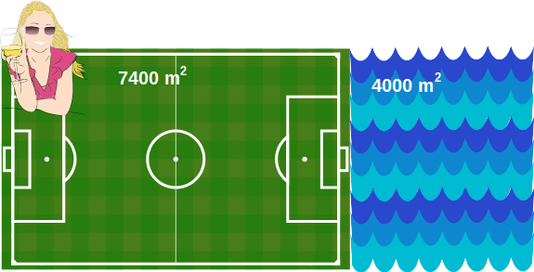Fig. 3. Available land and shallow water area per capita in Denmark.
According to Betz’s law, irrespective of the design of the wind turbines, only 59.3% of the kinetic energy of the wind can be extracted. Moreover, for an optimum operation, the windmills need to be installed within a certain distance from each other, which is around 5 to 7 times the blade diameter. Moreover, the windmills cannot operate at too high or too low wind speeds. The following equation can be used to calculate the power that can be extracted by a windmill per unit area of land (E_{wind}),
(2)
where η_{Betz} =0.593 denotes the Betz efficiency, η_{turbine} is the turbine mechanical efficiency (70%), d [m] is the blade diameter, v [m/s] is the average wind speed, ρ [kg/m3] is the density of air (1.2 kg/m³ at standard condition), and the factors 5d and 7d specify the minimum distances between the windmills. The average offshore wind speed is 8-9 m/s in the Danish windmills in the North Sea [15], which gives an average value of 3.7 W/m² for the offshore wind farms. For an onshore windmill operating at an average wind speed of 6 m/s, the power density is 1.3 W/m².
For an offshore 4 MW windmill, the amount of steel consumption is reported in [16]. The total steel requirement for one windmill with a 100 m blade diameter is 450 tonnes. I assumed 200 tonnes of cement consumption and 50 MJ/kg and 5 MJ/kg for the exergy of steel and cement, respectively [17]. Assuming a lifetime of 20 years for the windmill, the total embodied exergy -ignoring the transportation, maintenance, and installation exergy consumption- is 0.1 W/m². This is almost entirely provided from the fossil fuel resources.
Solar cells, although can convert the solar radiation with efficiencies as high as 28% [18], usually have an average efficiency of around 10% in practice, since the efficiency and/or total produced electricity declines with temperature and also in cloudy days with lower light intensity. With an average solar radiation of 1000 kWh/(m².year) [13] (114 W/m²), a power density of 11.4 W/m², or in average 10 W/m² is expected for solar panels in Denmark.
  - Food and biomass
Figure 4 shows a simple process flow diagram for the production of food and biomass (as a byproduct). The bottleneck of the process is the photosynthesis efficiency, i.e., the fraction of solar energy that is adsorbed and converted by the plants. Besides solar energy, plants also need fertilizers, which are synthesized in processes fed and/or driven by fossil fuels, and then added to the soil.

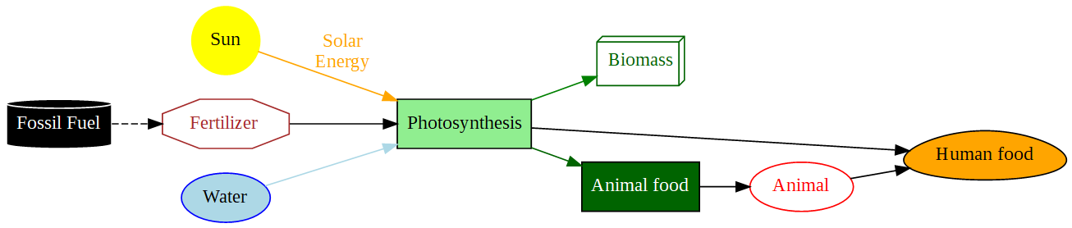Fig. 4. A simplified flow diagram of the food and biomass production
Denmark imported around 200,000 tonnes of nitrogen-, phosphorous-, and potassium-based (NPK) fertilizers in 2017 [19]. Table 1 shows the breakdown of the imported NPK fertilizer by chemical formula [19], and the average value of exergy that is required for the production of each fertilizer [20]. By multiplying the exergy value of each product by its fraction, the average exergy of the imported fertilizers is estimated to be 25.7 MJ/kg. World bank reports 131.1 kg/ha (13.11 g/m²) of fertilizer consumption in Denmark in 2016 [21], or 0.09 kWh/m². Given the fact that 61.1% of total land in Denmark is agricultural, the total fertilizer consumption is estimated to be 350,000 tonnes, which is equivalent to an exergy consumption of 1.18 kWh/(day.p) of which 0.74 kWh/(day.p) is imported. Currently, it is safe to assume that this energy is almost entirely provided by fossil fuels.
Table 1. Imported NPK fertilizers to Denmark in 2017; note that the total values on the left column are rounded [19].
Total (tonnes) | Chemical (tonnes) |  |  |  | Exergy (MJ/kg) [20]
Nitrogen products | Urea | Ammonium nitrate | Ammonium sulphate | Potassium nitrate | 48.0
103800 (47%) | 41000 | 13500 | 48700 | 103800 | 48.0
Potassium (K) products | Potassium sulphate | Potassium chloride |  |  | 7.9
75100 (34%) | 17500 | 57600 |  |  | 7.9
Phosphor products | super-phosphate | Mono-ammonium phosphate | Diammonium phosphate |  | 4.8
41000 (19%) | 19500 | 380 | 21000 |  | 4.8

The efficiency of photosynthesis, which is the bottleneck of converting the solar energy to food and biomass is controlled by several factors including the supply of nutrients, atmospheric CO₂ concentration, solar radiation, type of plant, and the environmental conditions. The maximum theoretical efficiency is discussed in several papers, e.g., see [22–26]. MacKay reports an average efficiency of 2%, which he has then reduced to a more realistic value of 0.5% in Northern Europe due to various factors, e.g., higher solar radiations that reduces the photosynthesis efficiency. To validate this number, I looked at the crop yields in Denmark [27], specifically at total cereals and its straw, grass and green fodder, and root crops in 2018, shown in Table 2. These crops are chosen due to their high yield in Denmark. The efficiency is calculated as the percentage of the solar radiation that is converted to carbohydrate in a unit area of land. The average solar radiation is assumed to be 1000 kWh/(m².year) in average [12,13]. One important number in Table 2 is the yield of straw which is a by-product of cereals crop production. Since this is not an edible product, it is argued that it can be consumed as fuel without damaging the agricultural activities for the food production. The mass ratio of straw to wheat is reported to be between 1.3 to 1.7 for the fields in the United States [28], which is in agreement with the value that is obtained from the statistical data of Denmark, shown in Table 2. These values will be discussed further later in the biofuel section.
Table 2. Annual crop yield and exergy value of different crops in Denmark in 2018 [27]
Crop | Yield [kg/m²] | Exergy [MJ/kg] | Efficiency (%) | Energy density [W/m²] | Exergy per unit area [kWh/m²]
Cereals (winter wheat) | 0.64 | 17.4 [29] | 0.31 | 0.35 | 3.1
Fodder beets | 5.95 | 4.2 (for sugar beet [29]) | 0.69 | 0.79 | 6.9
Straw from cereal | 1.14 | 15.0 from ref. [30] | 0.12 | 0.13 | 1.2
Green fodder (lucerne) | 3.96 | 13.0 from ref. [31] | 1.43 | 1.63 | 14.3

  - Low-temperature heat
Several studies are conducted to investigate the possibility of using low temperature heat sources (or stored heat) combined with heat pumps to reduce the exergy destruction of heating in Denmark [4]. Here, I assume that all the residential heating systems will be replaced by heat pumps with an average coefficient of performance (COP) of 2.0. Higher COP’s are possible by using a heat source with a higher temperature, that can be used to update these estimations; see, e.g., [32–34].
- Energy balance for a 100% renewable supply
Table 3 summarizes the energy demand and available renewable energy resources in Denmark.
Table 3. Energy demand and renewable energy resources in Denmark
Energy type | Demand, kWh/(day.p) | Updated demand | Renewable resource | Energy density, W/m²
Heat | 25.2 |  | Onshore wind | 1.3
Liquid fuel | 15 (cars) |  | Offshore wind | 3.7
Liquid fuel | 30 (air travel) | 30 | Offshore wind | 3.7
Electricity | 22 | 22+15+25.2/2 | Solar panel | 10
Food | 3.5 (human) |  | Food | 0.35 (human)
Food | 28 (animal) |  | Food | 0.79-1.63 (animal)
 |  |  | Biomass | 0.13

First, I assume that all the heat is provided from a combination of low-temperature heat resources and electricity-driven heat pumps with a COP of 2.0. Moreover, I assume that all the short and medium distance car travels will be in electric cars. Also, all the required fertilizers for the food production can be produced in electricity-driven processes without any fossil fuel feed stream. I assume that this will reduce the efficiency by a factor of three, i.e., an extra electricity demand of 3 kWh/(day.p). This will increase the electricity demand to 22+15+25.2/2+3.0=52.6 kWh/(day.p) renewable electricity. The air travel, however, requires high-energy-density liquid fuels, that need to be synthesized in a process that only consumes renewable energy and material streams. In the next section, I will discuss some of these alternative fuels.
  - Synthetic fuels
There are several chemicals that are considered as possible replacements for gaseous and liquid fossil fuels, i.e., methanol, ethanol, ammonia, hydrogen, and methane. Synthesizing all of these fuels requires hydrogen, and (with the exception of ammonia) carbon, which are not available in free form in nature. The minimum required energy for the production of these fuels is equal to their chemical exergy, shown in Table 4.
Table 4. Chemical exergy of the selected synthetic fuels [35] at 298.15 K and 101325 Pa and the estimated synthesis exergy consumption.
Fuel | Chemical exergy [kJ/mol] | Practical exergy [kJ/mol] | Exergetic efficiency (%)
CH₃OH (l) | 718 | 1808 | 40
NH₃ (l) | 337.9 | 1443 | 45
CH₄ (g) | 831.2 | 2295 | 36
H₂ (g) | 236.09 | 440 | 70
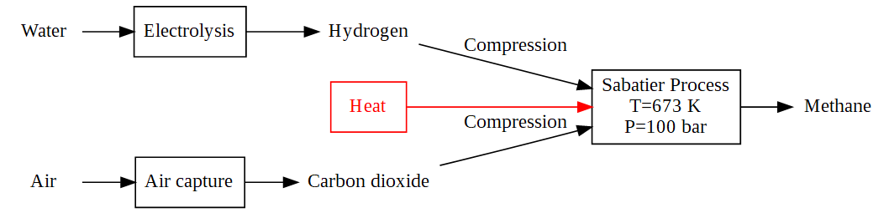Fig. 5. Process flow diagram for the production of methane through the Sabatier reaction.
Carbon dioxide can be extracted from the atmosphere, where it is available at a concentration of 400 ppm (and increasing). The separation is usually done by reacting CO₂ with a weak base, e.g., amine components. The chemisorbed CO₂ is then separated from the amine by heating up the solution. For the capture of CO₂ from a stream of air that enters the separation process at 400 ppm and leaves at 200 ppm, the minimum capture energy is 20 kJ/mol CO₂ for an ideal process [36]. With a second law efficiency of 5%, the process requires 400 kJ/mol of captured CO₂ [36] (also see [37,38] for further discussions). This energy must be provided from a CO₂-neutral electricity source, such as windmills or solar panels [36]. Note that neither the windmills nor the solar panels are currently produced in CO₂-neutral processes [39], but I assume that in the future it will be the case.
Unlike CO₂, nitrogen is available in a higher concentration in the atmosphere. However, it is not a reactive component and separating it by chemisorption is not possible. The physical separation method that is currently employed for the separation of nitrogen and oxygen from other atmospheric gases is the cryogenic, i.e., low temperature distillation, which relies on the difference between the vapour pressure (or volatility) of the species in the liquefied air. Different values of exergy requirement for the cryogenic distillation of air is reported in the literature from 1.6 kJ/mol [40] to 15.57 kJ/mol [41] of air distilled depending on the product purity and the number of distillation columns in the process. Van der Ham and Kjelstrup suggest an average value of 6.0 to 7.5 kJ/mol air [42]. Simply assuming an air composition of 79% N₂ and 21% O₂, the exergy required for producing nitrogen is approximately 7.5/0.8 = 9.5 kJ/mol N₂.
Hydrogen is mostly produced from natural gas. However, in the absence of fossil fuels, one possible path for its production is the electrolysis of water. The current electrolysis technologies are alkaline (AEC) [43] and proton exchange membrane [44] electrolysis cells. The electricity consumption of these processes is between 4.5 to 5.5 kWh/m³ hydrogen at standard condition (397 to 485 kJ/mol H₂, respectively), or 60% to 80% with respect to the higher heating value (HHV) of the produced hydrogen (286 kJ/mol) [45]. Although it is expected that these efficiencies will be increased, pressurization of the produced hydrogen is another energy-intensive step in the production and storage of hydrogen as an alternative fuel [45].
After producing the above raw materials, they can be combined in one of the following reactions to produce a synthetic fossil fuel:
(3)
(4)
(5)
Equations (3) and (2) are called Sabatier and Haber reactions, respectively. These reactions are catalysed by metals and are usually performed at high pressures and temperatures. A simple process flow diagram for the Sabatier reaction is shown in Fig. 5. The details of this reaction and process is discussed elsewhere [46]. Here, I simply calculated the compression and heat consumption to compress and heat up the feed streams to 100 bar and 400ºC, respectively. Then, by dividing the chemical exergy of methane by the total exergy consumption for the production of the raw materials and heating/compression, I estimated an exergetic efficiency of 36%, 45%, and 40% for the Sabatier, Haber, and methanol processes, respectively. The details of the calculations that are performed with open-source software CoolProp is available online at http://github.com/simulkade/energystorage. The low exergetic efficiency of the Sabatier reaction is due to the large energy demand of the air capture process. If the required carbon can be obtained from another sustainable source with a lower energy demand, e.g., biomass or waste food products, the efficiency increases substantially. However, the availability and the sustainability of biomass are still under debate. Also note that the above calculations are performed assuming a complete chemical reaction that requires little purification of the final product. These assumptions need to be revisited in the future work. Using the efficiency factors, one can calculate the amount of electricity that is required to produce these synthetic fuels. These values are reported as practical exergy in Table 4.
  - Energy scenarios and land use
The first energy demand that needs to be supplied is food. The minimum requirement of 3.5 kWh/(day.p) can be supplied by wheat with an energy density of 0.35 W/m². This requires 3.5×41.7/0.35=417 m² of arable land per person. Here, 41.7 is the conversion factor from kWh/day to W, i.e., 1 kWh/day = 41.7 Watt. This is however only enough food for survival. The required land for producing food for cattle and pigs in Denmark is 28×41.7/0.8=1459 m² land per person. This means that with approximately 2000 m² of land per person, it is possible to provide food to the whole population of Denmark including the domestic animals. This is an underestimation of the actual land requirement. According to Pimentel [47], a minimum of 5000 m² of land is required to provide a European diet for one person. This is in agreement with the food import and export data of Denmark that shows a net positive import for both human and animal food. Currently, 61% of Denmark is covered by arable land, which gives 0.61×7400=4514 m² per person. This means that Mette has barely enough arable land to support a European diet, unless greenhouses and artificial solar radiation is employed to produce food. This also means that all the Danish arable land needs to be utilized for the food production and only the by-products, e.g., straw can be used as a source of biomass for energy production. Considering the energy density of 0.13 W/m² for straw from cereal crops, Mette can produce around 4514×0.13/41.7=14.1 kWh/(day.p) of biomass without compromising the food production. If this biomass is used in electricity production in a power plant with an efficiency factor of 30%, the biomass only covers 0.3×14.1/22 = 0.19 or 19% of the current electricity demand in Denmark. This is without including the exergy cost of fertilizers, processing, and transport of biomass which under certain condition can be even higher than the energy of biomass itself [30,47,48].
The current electricity consumption of 22 kWh/(day.p) can be supplied by 22×41.7/1.3=705 m² of onshore, or 22×41.7/3.7=247 m² of offshore windmills per person, i.e., 9.5% of the land or 6% of the shallow sea area. It is also possible to use a combination of the two. Using 22×41.7/10 = 91.7 m² of the land, i.e., 1.2% of the football pitch.
However, by switching to an electricity-based energy supply in which all the heating, transport, and fuel synthesis is driven by renewable electricity, a total amount of 49.6 kWh/(day.p) must be supplied. This does not include the electricity demand for the liquid fuel production. Considering the efficiency factors of 40% and 45% for the production of methanol and ammonia from the atmospheric ingredients, the extra electricity demand is between 30/0.45=66.7 to 30/0.45=75 kWh/(day.p). This gives a total renewable electricity demand of approximately 125 kWh/(day.p). This can be supplied by covering 7% or 54% of the land with solar cells or windmills, respectively, or by covering 35% of the shallow sea with windmills. Here, I assume that the intermittency of the solar and wind electricity is already addressed, e.g., by subsurface storage of compressed air or chemical energy [49]. However, I have not included the energy loss due to storage and subsequent extraction. Including the storage scenarios will increase the electricity demand even further due to the energy losses that must be compensated.
- Conclusions
A model, mostly based on simplified thermodynamic and transport phenomena concepts, is presented for the estimation of the energy supply and demand in Denmark. It is shown that with the current state of technology, it is possible to supply most of the energy demand in Denmark with renewable electricity from the wind and solar panels. The available land and shallow sea area per person, a football pitch and half a football pitch, respectively, and the available arable land in Denmark is enough to provide a European diet and host enough windmills and/or solar panels to supply the energy demand. However, the land is not enough to produce sufficient biomass to supply all the required carbon source for the production of liquid fuels or production of electricity in a power plant (it only covers 19% of the current electricity demand in an optimistic scenario). If the intermittency problem of the wind and solar energy is addressed, e.g., by large-scale subsurface storage, it is possible to synthesize enough liquid fuel (methanol or ammonia) from the atmospheric gases that covers the current demand, mostly for long-distance transportation; although, this requires a considerable fraction of the land and/or the shallow sea to be covered by windmills.

Acknowledgments
AAE thanks the Danish Hydrocarbon Research and Technology Centre at the Technical University of Denmark for the permission to spend part of his time on this research and publish the results.

Nomenclature
A heat transfer area of an average house, m2
d wind turbine diameter, m
E_{wind} windmill power per unit area, W/m²
T_{house} desirable temperature in a Danish house, K
T_{ambinet} ambient temperature, K
U overall heat transfer coefficient, W/(m² K)
v wind velocity, m/s
Greek symbols
η efficiency
ρ air density, kg/m³
Subscripts and superscripts
ambinet environment outside a house
Betz Betz’ law
turbine wind turbine

References
[1] Hansen K, Breyer C, Lund H. Status and perspectives on 100% renewable energy systems. Energy 2019;175:471–480.
[2] Lund H. Renewable energy systems: a smart energy systems approach to the choice and modeling of 100% renewable solutions. Academic Press; 2014.
[3] Meyer NI, Hvelplund F, Karnø P, Lund H, Mathiesen B, Morthorst PE. Transition to 100% renewable energy systems in Denmark. Solutions 2019.
[4] Bühler F, Holm FM, Huang B, Andreasen JG, Elmegaard B. Mapping of low temperature heat sources in Denmark. 28th International Conference on Efficiency, Cost, Optimization, Simulation and Environmental Impact of Energy Systems, 2015.
[5] Bühler F, Petrović S, Karlsson K, Elmegaard B. Industrial excess heat for district heating in Denmark. Applied Energy 2017;205:991–1001.
[6] MacKay D. Sustainable Energy-without the hot air. UIT Cambridge; 2008.
[7] Danish Energy Agency. Energy Requirements of BR18. A quick guide for the construction industry on the Danish Building Regulations 2018 2018.
[8] StatBank.dk. Statistics Denmark n.d. https://www.dst.dk/en (accessed February 9, 2020).
[9] Yu Media Group. Copenhagen, Denmark - Detailed climate information and monthly weather forecast. Weather Atlas n.d. https://www.weather-atlas.com/en/denmark/copenhagen-climate (accessed February 9, 2020).
[10] Danish Energy Agency. Denmark’s Energy and Climate Outlook 2018: Baseline Scenario Projection Towards 2030 With Existing Measures (Frozen Policy) 2018.
[11] Pellett PL. Food energy requirements in humans. The American Journal of Clinical Nutrition 1990;51:711–722.
[12] SolarGIS. Solar resource maps of Denmark n.d. https://solargis.com/maps-and-gis-data/download/denmark (accessed February 12, 2020).
[13] World Bank Group. Global Solar Atlas n.d. https://globalsolaratlas.info/map (accessed February 12, 2020).
[14] Danish Energy Agency. Fakta om vindenergi. Energistyrelsen 2016. https://ens.dk/ansvarsomraader/vindenergi/fakta-om-vindenergi (accessed February 12, 2020).
[15] Sørensen P, Cutululis NA, Vigueras-Rodríguez A, Madsen H, Pinson P, Jensen LE, et al. Modelling of power fluctuations from large offshore wind farms. Wind Energy: An International Journal for Progress and Applications in Wind Power Conversion Technology 2008;11:29–43.
[16] Energinet. Horns Rev 3- Technical Project Description for the large-scale offshore wind farm (400 MW) at Horns Rev 3 n.d.
[17] Eftekhari AA, Van Der Kooi H, Bruining H. Exergy analysis of underground coal gasification with simultaneous storage of carbon dioxide. Energy 2012;45:729–745.
[18] Green MA, Hishikawa Y, Dunlop ED, Levi DH, Hohl-Ebinger J, Ho-Baillie AW. Solar cell efficiency tables (version 52). Progress in Photovoltaics: Research and Applications 2018;26:427–436.
[19] Knoema database. Denmark NPK fertilizers import, 2002-2019 - knoema.com. Knoema n.d. https://knoema.com//atlas/Denmark/topics/Agriculture/Fertilizers-Import-Quantity-in-Nutrients/NPK-fertilizers-import (accessed February 13, 2020).
[20] Clausen LR, Houbak N, Elmegaard B. Technoeconomic analysis of a methanol plant based on gasification of biomass and electrolysis of water. Energy 2010;35:2338–2347.
[21] Worldbank. Fertilizer consumption (% of fertilizer production) | Data n.d. https://data.worldbank.org/indicator/AG.CON.FERT.PT.ZS (accessed February 13, 2020).
[22] Zelitch I. Improving the efficiency of photosynthesis. Science 1975;188:626–633.
[23] Zhu X-G, Long SP, Ort DR. Improving photosynthetic efficiency for greater yield. Annual Review of Plant Biology 2010;61:235–261.
[24] Sun J, Yang L, Wang Y, Ort DR. FACE-ing the global change: opportunities for improvement in photosynthetic radiation use efficiency and crop yield. Plant Science 2009;177:511–522.
[25] Sinclair TR, Muchow RC. Radiation use efficiency. Advances in agronomy, vol. 65, Elsevier; 1999, p. 215–265.
[26] Patzek TW. Thermodynamics of the corn-ethanol biofuel cycle. Critical Reviews in Plant Sciences 2004;23:519–567.
[27] Statistics Denmark. Crop production n.d. https://www.dst.dk/en/Statistik/emner/erhvervslivets-sektorer/landbrug-gartneri-og-skovbrug/vegetabilsk-produktion (accessed February 16, 2020).
[28] Engel R, Long D, Carlson G, Wallander R. Estimating straw production of spring and winter wheat. Fertilizer Facts Montana State University Extention Bulletin 2005.
[29] Wall G, Sciubba E, Naso V. Exergy use in the Italian society. Energy-The International Journal 1994;19:1267–1274.
[30] Nguyen TLT, Hermansen JE, Nielsen RG. Environmental assessment of gasification technology for biomass conversion to energy in comparison with other alternatives: the case of wheat straw. Journal of Cleaner Production 2013;53:138–48. https://doi.org/10.1016/j.jclepro.2013.04.004.
[31] Ptasinski KJ. Efficiency of biomass energy: an exergy approach to biofuels, power, and biorefineries. John Wiley & Sons; 2016.
[32] Kofler R, Elmegaard B, Madsen C, Olsen L, Markussen WB. Screening of heat pump performance improvements obtained through gradual heating using a tank system. 25th IIR International Congress of Refrigeration (ICR 2019), International Institute of Refrigeration; 2019, p. 4608–4615.
[33] Ommen T, Jensen JK, Meesenburg W, Jørgensen PH, Pieper H, Markussen WB, et al. Generalized COP estimation of heat pump processes for operation off the design point of equipment. 25th IIR International Congress of Refrigeration (ICR 2019), International Institute of Refrigeration; 2019, p. 648.
[34] Pieper H, Ommen T, Elmegaard B, Markussen WB. Assessment of a combination of three heat sources for heat pumps to supply district heating. Energy 2019;176:156–170.
[35] Szargut J. Exergy method: technical and ecological applications. vol. 18. WIT press; 2005.
[36] House KZ, Baclig AC, Ranjan M, Nierop EA van, Wilcox J, Herzog HJ. Economic and energetic analysis of capturing CO2 from ambient air. PNAS 2011;108:20428–33. https://doi.org/10.1073/pnas.1012253108.
[37] Realff MJ, Eisenberger P. Flawed analysis of the possibility of air capture. PNAS 2012;109:E1589–E1589. https://doi.org/10.1073/pnas.1203618109.
[38] Herzog HJ, House KZ, Baclig AC, Nierop EA van, Wilcox J. Reply to Realff and Eisenberger: Energy requirements of air capture systems. PNAS 2012;109:E1590–E1590. https://doi.org/10.1073/pnas.1204448109.
[39] Dincer I, Rosen MA. Exergy: Energy, Environment, and Sustainable Development. Elsevier Science; 2007.
[40] Agrawal R, Woodward DW. Efficient cryogenic nitrogen generators: An exergy analysis. Gas Separation & Purification 1991;5:139–50. https://doi.org/10.1016/0950-4214(91)80012-T.
[41] Cornelissen RL, Hirs GG. Exergy analysis of cryogenic air separation. Energy Conversion and Management 1998;39:1821–1826.
[42] Van der Ham LV, Kjelstrup S. Exergy analysis of two cryogenic air separation processes. Energy 2010;35:4731–4739.
[43] Zeng K, Zhang D. Recent progress in alkaline water electrolysis for hydrogen production and applications. Progress in Energy and Combustion Science 2010;36:307–326.
[44] Carmo M, Fritz DL, Mergel J, Stolten D. A comprehensive review on PEM water electrolysis. International Journal of Hydrogen Energy 2013;38:4901–4934.
[45] Schmidt O, Gambhir A, Staffell I, Hawkes A, Nelson J, Few S. Future cost and performance of water electrolysis: An expert elicitation study. International Journal of Hydrogen Energy 2017;42:30470–30492.
[46] Vogt C, Monai M, Kramer GJ, Weckhuysen BM. The renaissance of the Sabatier reaction and its applications on Earth and in space. Nature Catalysis 2019;2:188–197.
[47] Pimentel D, Patzek TW. Biofuels, solar and wind as renewable energy systems. Benefits and Risks, New York: Springer 2008.
[48] Nilsson D. Energy, exergy and emergy analysis of using straw as fuel in district heating plants. Biomass and Bioenergy 1997;13:63–73. https://doi.org/10.1016/S0961-9534(97)00025-1.
[49] Kabuth A, Dahmke A, Beyer C, Bilke L, Dethlefsen F, Dietrich P, et al. Energy storage in the geological subsurface: dimensioning, risk analysis and spatial planning: the ANGUS+ project. Environmental Earth Sciences 2017;76:23.

