Figure 1 compares the simulation results with and without ZVI nanoparticles. Due to the high concentration of hexadecane in oil and its high solubility in the aqueous phase (log*Keq=*-5), the addition of iron nanoparticle not only does not improve the conversion of oil to methane and the methane/CO2 ratio, but slightly reduces the conversion rate. However, in reality the amount of available biodegradable species, e.g. long chain alkanes will quickly react and therefore the reactions will be controlled by the flux of these components to the reaction zone. This flux can be diffusion controlled. We can simulate this condition (i.e., lower flux of substrate) by specifying a lower equilibrium coefficient for hexadecane. Figure 2 shows the simulation results for the same system with an equilibrium constant of log*Keq=*-6 for the hexadecane. The simulation is done for 100 days. The results show that the addition of ZVI particles can reduce the amount of produced CO2 to zero and enhance the production of methane.

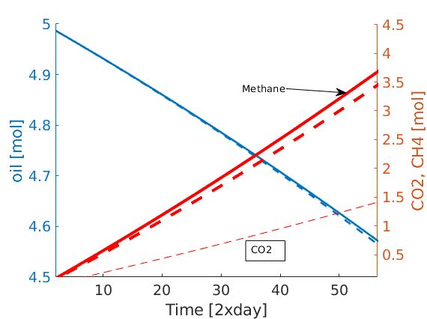Figure 1. simulation result when the process is controlled by the flux of hexadecane to the aqueous phase; No CO2 is produced when ZVI is added to the reaction medium (solid lines)

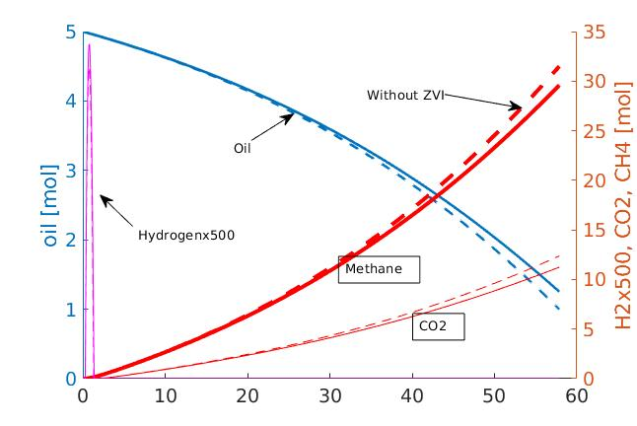Figure 2: the simulation results of batch biodegradation of oil in the presence (solid line) and absence (dashed line) of ZVI; x axis shows time in days.