Introduction:

There are exceeding scientific evidence for the role of anthropological carbon dioxide emission in an accelerated climate change, with potentially disastrous -although uncertain- aftermath. This has increased the societal pressure for a faster transition from hydrocarbon-based to renewable-based energy. Besides these political and societal motivations, the declining conventional oil resources has reduced the efficiency of oil and gas recovery operations and increased the costs, leading eventually to the cessation of production and abandonment of the fields. The infrastructures, e.g. wells, platforms, topside equipment for transport and processing, and transport pipelines, even though still functional, will have to be removed as part of the abandonment operation.

At the same time, the renewable energy resources will grow in many areas of the world. Offshore wind energy plays a key role in the energy transition. The offshore wind energy is considered as the cheapest large-scale source of renewable energy due to significant operational cost decrease in recent years. In the North Sea region, several new windfarms are planned or under construction, which will quadruple the capacity of renewable electricity production. This capacity that is several times more than the electricity demand in Denmark, is variable and intermittent and thus will not replace the reliable fossil-fuel power plants. Despite improvements over the last few years, a significant problem remains: the fluctuating wind energy struggle to match supply and demand. The key factor in the transition to a fully renewable energy infrastructure is a large scale energy storage that can act as a buffer to provide a continuous power stream to the grids. The electricity is stored when production is higher than the demand and is consumed when the demand is higher than the production. The stored energy is extracted and converted to electricity or consumed as clean fuel for transportation. More importantly, storage decreases the CO2 emission by limiting the consumption of biomass in power plants.

Using the subsurface for the continuous storage and extraction cycles especially with synthetic fuels, and its capacity and response time as a part of a larger dynamic energy supply system requires further attention. The flexibility of the energy storage scenarios has a significant effect on the future energy transition. The storage medium can be either physical (e.g., hot and compressed fluids) or chemical (e.g., synthetic fuel). In this paper, we studied the possibility of the subsurface storage of the future surplus electricity that is produced from offshore wind farms in the form of physical, i.e. synthetic fuels (compressed air) to address the intermittency of the renewable wind power. A disadvantage of converting electricity to gas (synthesize hydrogen or methane gas) is that, if the gas is used to regenerate electricity, the cycle efficiency is relatively low (20-66% for hydrogen fuel cells) (Barton and Infield, 2004; Chen et al., 2009; Schaber et al., 2004; Sopher et al., 2019). Another option as mentioned is chemical production or fuel for transportation, however It is not possible generate electricity when required (Sopher et al., 2019).

Compressed air storage is a relatively mature technology (Giramonti et al., 1978; Jarvis, 2015; Oldenburg and Pan, 2013; Stottlemyre, 1978; Succar and Williams, 2008). In the US, large tanks are used for the compression of air during the off-peak time to store cheap electricity in the form of high pressure air. The air is later used to drive a turbine and produce electricity during the peak time. This approach, although not energy efficient, is economical due to the special model of electricity pricing that encourages the consumers to shift their electricity demand to the off-peak hours. The large scale storage of electricity in the subsurface was first suggested as a method to reduce the waste energy of the large fossil fuel power plants. Many of the power plants are designed for a continuous operation and therefore their efficiency is significantly reduced if they operate under the design condition. It is not convenient to shut down the power plants when there is no consumer for the produced electricity because the start-up is time consuming, expensive, and inefficient.

Compressed air storage is one way of storing the surplus energy of a power plant that operates at its design condition. Two projects that have been in operation for decades are in Huntorf, Germany and McIntosh, Alabama, USA (Kaldemeyer et al., 2016) (Raju and Khaitan, 2012) (Nakhamkin et al., 2010). However, the technology was not developed due to economic and technical risks in the projects. The type of formation utilized by two mentioned compressed air storage projects is salt formation (Luo et al., 2016). Compressed Air Energy Storage has the potential of storing relatively large amounts of energy at a relatively low cost (Luo et al., 2015). The large amount of stored energy can provide extra electricity during the peak time to balance the demand. The same idea can be used with the offshore windfarms, utilizing the abandoned gas fields as a storage space. Other optional geological formations for compressed air storage rather than salt caverns can be hard rock formations and porous reservoir formation (Jarvis, 2015). Figure 1 shows an schematic of the compressed air energy storage that is also similar to any other gas storage processes. Air is injected in to the reservoir through a compressor. The amount of stored energy depends on the subsurface properties (for example, storage pressure) and volume of the storage container. Since the input electricity to the process is variable, the efficiency of the injection compressor will vary since it does not always operate at its design condition. It has been shown that the loading schedule has the greatest control on the cycle efficiency (Jarvis, 2015).

The injected air is produced during the electricity shortage to flow through a gas turbine that rotates a generator and produces electricity. If all the friction losses in the reservoirs and in the well are ignored, the efficiency of this process can be as high as 50% (simply multiplying the efficiency of the compressor and the gas turbine). The efficiency drops in the dynamic operation due to the variable power input and also the friction and heat losses in the reservoir.

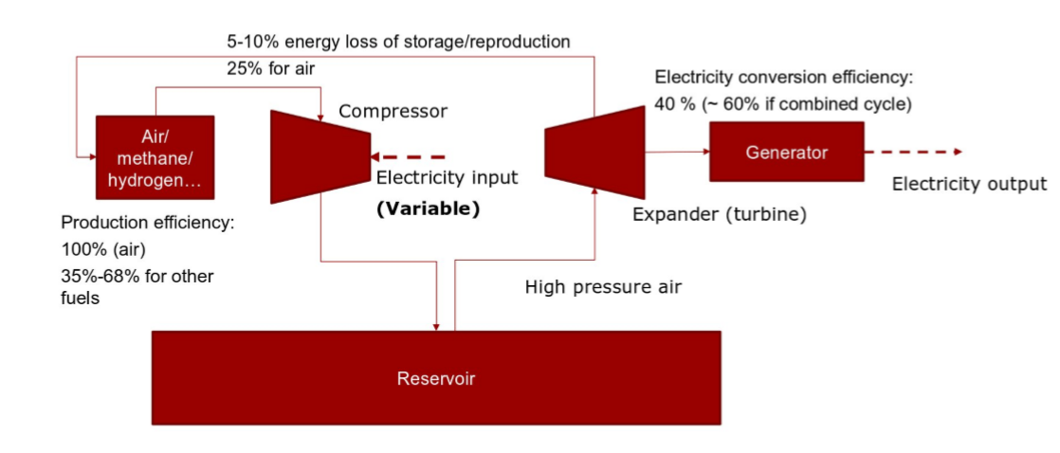

Figure 1: A block ow diagram of the subsurface gas storage process and the important efficiency factors

In this paper, we will investigate the feasibility of the alternative use of the to-be-abandoned fields of the North Sea and their infrastructure as a large compressed air subsurface storage project that can address the intermittency of the wind energy in the North Sea region. The objective of this paper is to quantify the amount of energy that can be stored and effectively recovered from a depleted offshore gas reservoirs. There are three major questions that will be answered in this paper. First, how much energy storage is needed in Denmark? Secondly, to what extent can the compressed air subsurface storage be helpful? Thirdly, what are the promising technologies from a technical point of view. This paper provides simple, reproducible, and realistic procedures and quantitative answers to these questions.

Barton, J.P., Infield, D.G.J.I.t.o.e.c., 2004. Energy storage and its use with intermittent renewable energy. 19, 441-448.

Chen, H., Cong, T.N., Yang, W., Tan, C., Li, Y., Ding, Y.J.P.i.n.s., 2009. Progress in electrical energy storage system: A critical review. 19, 291-312.

Giramonti, A.J., Lessard, R.D., Blecher, W.A., Smith, E.B.J.A.E., 1978. Conceptual design of compressed air energy storage electric power systems. 4, 231-249.

Jarvis, A.-S., 2015. Feasibility study of porous media compressed air energy storage in South Carolina, United States of America.

Kaldemeyer, C., Boysen, C., Tuschy, I.J.E.P., 2016. Compressed air energy storage in the German energy system–status quo & perspectives. 99, 298-313.

Luo, X., Wang, J., Dooner, M., Clarke, J.J.A.e., 2015. Overview of current development in electrical energy storage technologies and the application potential in power system operation. 137, 511-536.

Luo, X., Wang, J., Krupke, C., Wang, Y., Sheng, Y., Li, J., Xu, Y., Wang, D., Miao, S., Chen, H.J.A.E., 2016. Modelling study, efficiency analysis and optimisation of large-scale Adiabatic Compressed Air Energy Storage systems with low-temperature thermal storage. 162, 589-600.

Nakhamkin, M., Chiruvolu, M., Daniel, C.J.E., 2010. Available compressed air energy storage (CAES) plant concepts. 4100, 81.

Oldenburg, C.M., Pan, L.J.T.i.p.m., 2013. Porous media compressed-air energy storage (PM-CAES): Theory and simulation of the coupled wellbore–reservoir system. 97, 201-221.

Raju, M., Khaitan, S.K.J.A.E., 2012. Modeling and simulation of compressed air storage in caverns: a case study of the Huntorf plant. 89, 474-481.

Schaber, C., Mazza, P., Hammerschlag, R.J.T.E.J., 2004. Utility-scale storage of renewable energy. 17, 21-29.

Sopher, D., Juhlin, C., Levendal, T., Erlström, M., Nilsson, K., Soares, J.P.D.S.J.E.E.S., 2019. Evaluation of the subsurface compressed air energy storage (CAES) potential on Gotland, Sweden. 78, 1-17.

Stottlemyre, J., 1978. Preliminary stability criteria for compressed air energy storage in porous media reservoirs. Battelle Pacific Northwest Labs., Richland, WA (USA).

Succar, S., Williams, R.H.J.P.e.i.r., 2008. Compressed air energy storage: theory, resources, and applications for wind power. 8, 81.