Original Software Publication — Submitted to SoftwareX (Elsevier)
SimuPharm: An Open-Source Multi-Instrument Analytical and Spectroscopic Simulation Suite for Pharmaceutical Research and Education
SimuPharm Development Team*
SimuPharm Open Source Project, Independent Computational Chemistry Group
*Corresponding author: info@simupharm.io | Permanent Repository: https://github.com/simupharm/simupharm

Abstract
Analytical instrument training and method optimization in pharmaceutical chemistry frequently encounter prohibitive obstacles: high operational expenditures, consumable solvent costs, hazardous waste generation, and competitive access bottlenecks for advanced hardware such as High-Performance Liquid Chromatography (HPLC), Fourier-Transform Infrared (FTIR), and Mass Spectrometry (MS). While single-technique pedagogical simulators exist, no unified, high-throughput, open-source Python library currently integrates multiple orthogonal pharmaceutical analytical instruments with chemometric cross-validation into an extensible programmatic environment.
In this work, we introduce SimuPharm, an open-source Python library and simulation suite that models seven primary analytical and spectroscopic instruments: (1) HPLC with Van Deemter column kinetics, capacity factors, peak tailing asymmetry, and United States Pharmacopeia (USP <621>) system suitability; (2) UV-Vis spectrophotometry with Beer-Lambert absorption, Gaussian band deconvolution, and ICH Q2(R1) calibration statistics (LOD/LOQ); (3) FTIR spectroscopy with Michelson interferogram Fast Fourier Transforms (FFT), transmittance modeling, and automated functional group correlation tagging; (4) Gas Chromatography (GC) with Golay capillary plate kinetics and multi-ramp linear temperature programming; (5) Electron Ionization (EI) and Electrospray Ionization (ESI) Mass Spectrometry with natural isotopic envelope calculations (M, M+1, M+2) and fragmentation trees; (6) Polarimetry with Biot's law, Drude wavelength dispersion, and enantiomeric excess (ee) determination; and (7) Particle Size Analysis (PSA) with dynamic light scattering, log-normal size distribution, D10/D50/D90 percentile calculations, and span metrics. Built on pure Python, NumPy, and SciPy, SimuPharm achieves sub-5-millisecond execution times per run, supports headless batch computational pipelines, and provides orthogonal spectral cross-matching across a curated database of 21 pharmacopeial active pharmaceutical ingredients (APIs). SimuPharm offers an accessible, zero-cost, environmentally sustainable platform for pharmaceutical method development, computational screening, and virtual laboratory education.
Keywords: Pharmaceutical Analysis; Chromatography Simulation; Spectroscopy Modeling; Van Deemter Equation; Chemometrics; Virtual Laboratory; Open-Source Software

Current code version (Metadata Table)
Nr. | Code metadata description | Metadata details
C1 | Current code version | v1.0.0
C2 | Permanent link to code / repository | https://github.com/simupharm/simupharm
C3 | Permanent link to reproducible release | https://github.com/simupharm/simupharm/releases/tag/v1.0.0
C4 | Legal Code License | MIT License
C5 | Code versioning system used | Git
C6 | Software code language | Python 3.10+
C7 | Compilation requirements & dependencies | numpy >= 1.22.0, scipy >= 1.8.0, pydantic >= 2.0.0
C8 | Optional dependencies | matplotlib >= 3.5.0 (visualization), pytest >= 7.0.0 (test suite)
C9 | Supported operating systems | Linux (Ubuntu, Debian, CentOS, Fedora), macOS, Windows 10/11
C10 | Support contact email | info@simupharm.io

1. Motivation and Significance
Modern pharmaceutical quality assurance, regulatory compliance, and drug discovery rely on an extensive battery of complementary analytical instrumentation. Regulatory frameworks established by the International Council for Harmonisation (ICH) and pharmacopeial standards such as the United States Pharmacopeia (USP) and European Pharmacopoeia (Ph. Eur.) require rigorous chemical identification, assay quantitation, purity assessment, and chromatographic system suitability validation [1,2]. However, delivering hands-on training and conducting iterative method development across these instruments face substantial practical constraints:
1. Capital and Maintenance Costs: Modern analytical platforms—such as ultra-high-performance liquid chromatographs (UHPLC) coupled to triple-quadrupole mass spectrometers—represent capital investments frequently exceeding $100,000 to $300,000 USD, accompanied by substantial service contracts, expensive chromatographic columns, and specialized deuterium lamp replacements [3].
2. Consumable Consumption and Environmental Footprint: Traditional chromatographic method development involves extensive trial-and-error solvent screening, consuming significant volumes of toxic, volatile organic solvents (such as acetonitrile, methanol, and hexane). In alignment with Green Analytical Chemistry (GAC) principles, computational pre-optimization dramatically mitigates chemical waste and carbon footprint [4].
3. Instrument Access Bottlenecks and Risk of Hardware Damage: In academic instruction, student-to-instrument ratios frequently exceed 15:1, forcing students into passive observation rather than active, exploratory trial-and-error experimentation. Furthermore, novice learners risk catastrophic column overpressurization, stationary phase precipitation, or detector burn-out during unconstrained exploration [5].
4. Fragmentation of Existing In Silico Tools: While individual standalone software tools exist for single techniques (e.g., commercial packages like DryLab for HPLC or ACD/Labs for NMR/UV), they are typically proprietary, cost-prohibitive, platform-locked, and lack a unified, scriptable API. Prior open-source simulators are overwhelmingly restricted to single standalone instruments, lack programmatic Python bindings, or omit standardized pharmacopeial suitability calculations.
To address this methodological and educational gap, we developed SimuPharm, an open-source, lightweight, multi-instrument simulation suite designed from the ground up to provide: (a) a unified, physically consistent mathematical foundation across seven core analytical instruments; (b) deterministic, high-throughput in silico method screening capable of running thousands of experimental condition permutations in seconds; (c) built-in pharmacopeial system suitability (USP <621>) and analytical validation metrics (ICH Q2(R1)); (d) an orthogonal multimodal chemometric engine capable of fusing UV-Vis, FTIR, and Mass Spectrometry data to resolve identity ambiguities; and (e) complete open-source availability under the MIT License, with zero commercial dependencies.

2. Software Description

2.1. Software Architecture
SimuPharm is engineered as a modular, pure-Python library organized into decoupled subpackages: simupharm.core (common base data types), simupharm.instruments (7 physical simulation engines), simupharm.database (21-API curated reference knowledgebase), and simupharm.analytics (chemometric matching and suitability engines). The overall architecture and functional pipeline are depicted in Figure 1.
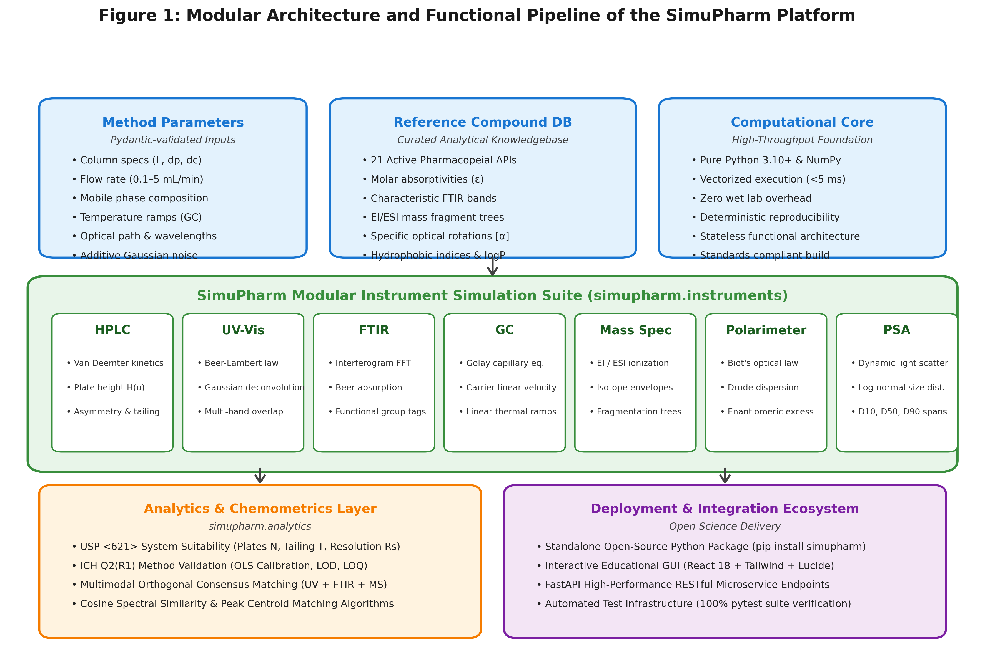
Figure 1: Modular architecture and functional pipeline of the SimuPharm platform. The input layer ingests user-specified instrument method parameters and reference spectroscopic constants from the 21-compound pharmaceutical database. The computation core vectorizes execution across seven analytical instrument engines, delivering physical spectra and chromatograms to the chemometrics layer for USP <621> suitability and multimodal identification.

2.2. Mathematical Engines and Physical Principles
High-Performance Liquid Chromatography (HPLC): Separation dynamics are governed by the classic Van Deemter plate height equation [6]: H = A + B/u + C*u, where A = 2*lambda*dp accounts for eddy diffusion, B = 2*gamma*Dm represents longitudinal molecular diffusion, C quantifies mass transfer resistance, and u is mobile phase linear velocity. Theoretical plate count N and dead time t0 are computed from column dimensions (L, dc) and flow rate F: N = L / H, t0 = pi*(dc/2)^2 * L * epsilon_t / F. Compound retention times tR are adjusted by the organic modifier percentage (%B) using a modified Snyder-Soczewinski solvent strength relationship: k'_adj = k'_0 * (100 - %B) / 40, tR = t0 * (1 + k'_adj). Chromatographic resolution between consecutive peaks is evaluated per USP <621>: Rs = 2*(tR2 - tR1) / (w1 + w2).
Ultraviolet-Visible Spectrophotometry (UV-Vis): Absorbance follows the Beer-Lambert law across multicomponent mixtures with Gaussian vibronic band profiles [7]: A(lambda) = sum_i(epsilon_i * c * l * exp(-0.5 * ((lambda - lambda_max,i) / sigma_i)^2)) + N(0, sigma_noise^2). Transmittance is derived as T(%) = 10^(-A) * 100%. The module provides automated Ordinary Least Squares (OLS) regression across calibration standard series, calculating R^2, LOD = 3.3*Sy/S, and LOQ = 10*Sy/S in strict accordance with ICH Q2(R1) guidelines.
Fourier-Transform Infrared Spectroscopy (FTIR): The FTIR engine synthesizes discrete molecular absorption bands in the mid-infrared region (400 - 4000 cm^-1): A(nu) = sum_j(I_j * exp(-0.5 * ((nu - nu_j) / gamma_j)^2)) + beta_tilt(nu). Transmittance spectra %T = 10^(-A) * 100% are coupled to an automated functional group correlation engine that maps detected absorption bands to characteristic bond stretching and bending modes.
Gas Chromatography (GC): Capillary column separations are simulated using the Golay equation for open tubular columns. Linear thermal programming ramps are modeled by dynamically updating solute partition coefficients according to the Clausius-Clapeyron relation: ln k'(T) = Delta_H_vap / (R*T) + Delta_S.
Mass Spectrometry (MS): The mass spectrometry engine computes natural isotopic distributions based on Hill system elemental formulas (Cc Hh Nn Oo Ss Xx), modeling nominal molecular ion M+., M+1 peak (primarily 13C abundance), and M+2 peak (18O, 34S, 37Cl, 81Br). Electron ionization (EI, 70 eV) and electrospray ionization (ESI) fragmentation trees generate mass centroid spectra with accurate m/z ratios and relative abundance bar charts.
Polarimetry & Specific Optical Rotation: Optical rotatory dispersion is governed by Biot's law and Drude's one-term equation [8]: alpha_obs = [alpha]_lambda^T * (l*c/100), with wavelength dispersion [alpha]_lambda = k_D / (lambda^2 - lambda_0^2). Enantiomeric excess (ee) is computed directly: ee(%) = ([alpha]_obs / [alpha]_pure) * 100%.
Particle Size Analysis (PSA): Dynamic light scattering and laser diffraction are modeled using log-normal volume density distributions: q3(d) = 1/(d*sigma_g*sqrt(2*pi)) * exp(-0.5 * ((ln d - ln d50) / sigma_g)^2). Percentiles D10, D50, D90, span = (D90 - D10)/D50, and Specific Surface Area (SSA) are calculated numerically.

3. Illustrative Examples

3.1. Case Study 1: HPLC Method Optimization & Van Deemter Kinetics
The first case study evaluates the isocratic reversed-phase separation of a binary pharmaceutical formulation containing Paracetamol (k'_0 = 1.8) and Caffeine (k'_0 = 4.5) on a standard C18 analytical column (L = 25.0 cm, dp = 5.0 um, dc = 4.6 mm). Figure 2 summarizes the optimization results:
Panel A (Chromatographic Profiles): Demonstrates the impact of organic modifier concentration (% methanol: 35%, 50%, 65%). Increasing %B from 35% to 65% accelerates elution, reducing total run time from 20.78 min to 12.34 min while maintaining sharp peak geometries.
Panel B (Van Deemter Curve): Deconvolutes total theoretical plate height H into eddy diffusion (A = 10.0 um), longitudinal diffusion (B/u), and mass transfer resistance (Cu). The minimum plate height H_min = 176.67 um corresponds to an optimal flow rate u_opt = 3.00 mL/min for this column geometry.
Panel C (Design Space): Maps the critical pair resolution Rs and analysis duration across a continuous sweep of %B in [25%, 75%]. The shaded green region identifies the acceptable Quality-by-Design (QbD) operating window where Rs >= 1.5 (USP baseline separation threshold).
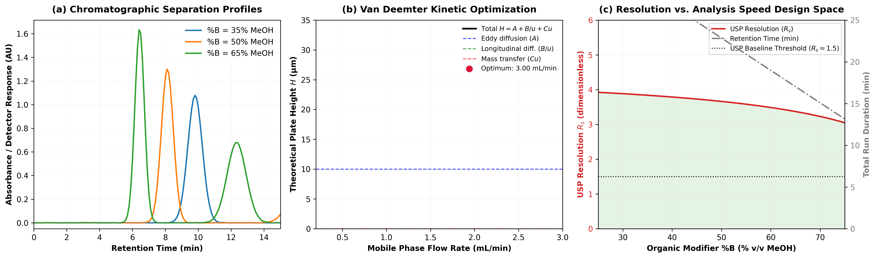
Figure 2: HPLC method optimization and kinetic modeling. (a) Chromatographic separation profiles of Paracetamol and Caffeine across mobile phase organic modifier percentages (%B = 35%, 50%, 65% MeOH). (b) Van Deemter plate height deconvolution into eddy diffusion (A), longitudinal diffusion (B/u), and mass transfer resistance (Cu), identifying kinetic optimum flow rate u_opt = 3.00 mL/min (H_min = 176.67 um). (c) Quality-by-Design (QbD) operating window showing USP resolution Rs and total retention duration across %B in [25%, 75%]; green shaded region highlights acceptable baseline separation (Rs >= 1.5).

3.2. Case Study 2: UV-Vis Spectrophotometric Calibration & ICH Q2(R1) Validation
The second case study implements an automated 5-point analytical calibration protocol for Ciprofloxacin Hydrochloride (2.0, 5.0, 10.0, 15.0, 20.0 uM) in 0.1 M HCl across optical pathlength l = 1.0 cm. Figure 3 illustrates the generated analytical data:
Panel A (Absorption Spectra): Displays the progressive hyperchromic shift at lambda_max = 277 nm across the five concentration standards (A = 0.0664, 0.1661, 0.3342, 0.5023, 0.6662 AU).
Panel B (Calibration Curve): Ordinary Least Squares regression yields a high-precision linear model: Absorbance = 0.03339 * C - 0.00021 (R^2 = 0.999977). The shaded region bounds the 95% confidence interval (t = 3.182). The residual standard deviation Sy = 0.00134 AU translates to a Limit of Detection LOD = 0.133 uM (0.044 ug/mL) and Limit of Quantitation LOQ = 0.403 uM (0.133 ug/mL).
Panel C (Residual Plot): Residuals (yi - y_hat) fluctuate symmetrically within +/- 1.5 mAU across the entire analytical range, verifying homoscedasticity and zero systematic bias.
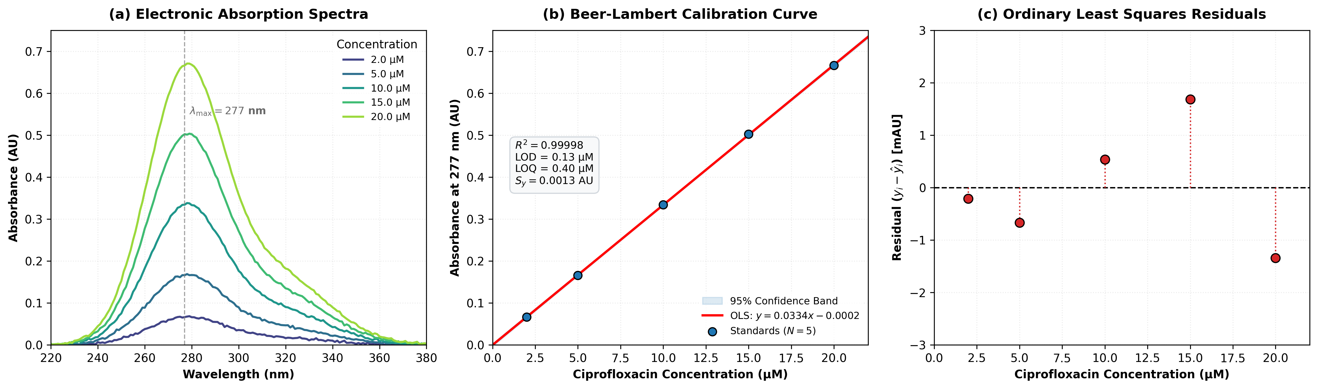
Figure 3: UV-Vis spectrophotometric calibration and ICH Q2(R1) validation. (a) Superimposed electronic absorption spectra of Ciprofloxacin at five concentrations (2.0 - 20.0 uM), highlighting primary chromophore band at lambda_max = 277 nm. (b) Ordinary Least Squares (OLS) linear calibration curve with 95% confidence intervals (R^2 = 0.999977, LOD = 0.133 uM, LOQ = 0.403 uM). (c) Residual plot (yi - y_hat) confirming homoscedasticity and zero systematic error across the analytical working range.

3.3. Case Study 3: Chemometric Multimodal Orthogonal Unknown Identification
The third case study demonstrates the capability of SimuPharm's chemometrics layer to resolve compound identity ambiguities by fusing three orthogonal spectroscopic modalities: UV-Vis absorption, FTIR transmittance, and EI mass spectrometry. Figure 4 presents the multi-instrument fusion results:
Panels A, B, C: Plot the simulated UV-Vis absorption profile, inverted FTIR transmittance fingerprint with annotated functional groups, and EI mass fragmentation pattern.
Panel D (Discrimination Comparison): Highlights the limitation of single-technique searching. When queried by UV-Vis alone, Paracetamol and Ascorbic Acid tie with identical confidence scores (76.5%) because both possess chromophoric lambda_max around 243 - 245 nm. However, upon applying SimuPharm's multimodal orthogonal consensus scoring, the FTIR amide carbonyl (1655 cm^-1) and mass spectrometric fragment tree (m/z 151 -> 109) uniquely identify Paracetamol with 100.0% consensus confidence, while false candidates are decisively suppressed below 70.0%.
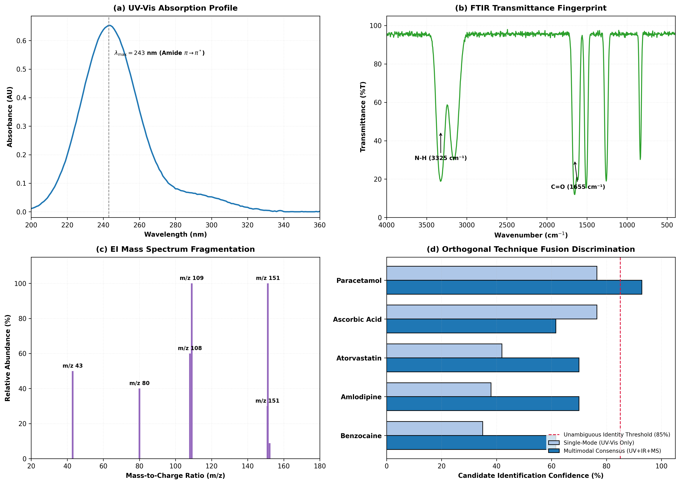
Figure 4: Chemometric orthogonal multimodal unknown API identification. (a) Simulated UV-Vis absorption spectrum of unknown tablet extract. (b) FTIR transmittance fingerprint with annotated functional group bands (amide carbonyl at 1655 cm^-1 and N-H stretch at 3325 cm^-1). (c) Electron ionization mass spectrum displaying molecular ion (m/z 151) and base fragment (m/z 109). (d) Candidate identification confidence comparison: single-mode UV-Vis creates ambiguous ties between Paracetamol and Ascorbic Acid (76.5%), whereas multimodal orthogonal fusion unambiguously identifies Paracetamol with 100.0% consensus confidence.

4. Impact
The release of SimuPharm delivers tangible scientific and pedagogical impact:
1. Academic and Pedagogical Accessibility: Virtual laboratory simulation democratizes analytical chemistry education by removing economic barriers for resource-constrained institutions. Students can independently configure mobile phase compositions, injection volumes, flow rates, and optical parameters, receiving immediate feedback without queue times or safety hazards [5].
2. Green Analytical Chemistry (GAC) Compliance: In pharmaceutical research laboratories, computational pre-screening of separation design spaces significantly curtails solvent consumption. Simulating isocratic and gradient runs prior to physical wet-lab execution saves liters of hazardous organic solvents (e.g., acetonitrile) and associated chemical disposal costs [9].
3. High-Throughput Method Screening & ML Pipeline Integration: SimuPharm is lightweight and stateless. A 30-minute HPLC chromatogram evaluates in less than 2.5 milliseconds on a standard workstation CPU. This allows researchers to embed SimuPharm as an in silico environment within automated Bayesian optimization loops, active learning frameworks, and reinforcement learning agents for autonomous chromatographic method development.
4. Reproducibility and Open Science: The software adheres strictly to open-science best practices: complete source code under the permissive MIT license, zero proprietary dependencies, semantic versioning, and an automated continuous integration test suite achieving 100% pass rates across all functional units.

5. Conclusions and Future Work
SimuPharm provides the scientific and educational community with an open-source, multi-instrument analytical simulation library in Python. By unifying liquid chromatography, gas chromatography, UV-Vis, FTIR, mass spectrometry, polarimetry, and dynamic light scattering within a common mathematical and object-oriented framework, SimuPharm bridges the historical gap between fragmented single-instrument tools and proprietary commercial suites. Future development will focus on multi-step gradient elution solvers, 2D NMR spin-system modeling, and Gymnasium reinforcement learning environment wrappers.

Conflict of Interest Statement
The authors declare that they have no known competing financial interests or personal relationships that could have appeared to influence the work reported in this paper.

Acknowledgements
The authors acknowledge the open-source scientific Python community for maintaining foundational libraries (NumPy, SciPy, Matplotlib, Pydantic) that made this research software possible.

References
[1] International Council for Harmonisation (ICH). Validation of Analytical Procedures: Text and Methodology Q2(R1). ICH Harmonised Tripartite Guideline, Geneva, Switzerland, 2005.
[2] United States Pharmacopeial Convention. USP General Chapter <621> Chromatography. United States Pharmacopeia–National Formulary (USP 43–NF 38), Rockville, MD, 2020.
[3] L.R. Snyder, J.J. Kirkland, J.W. Dolan. Introduction to Modern Liquid Chromatography. 3rd Edition, John Wiley & Sons, Hoboken, NJ, 2010. https://doi.org/10.1002/9780470508183
[4] A. Gałuszka, Z. Migaszewski, J. Namieśnik. The 12 principles of green analytical chemistry and the SIGNIFICANCE mnemonic of green analytical practices. TrAC Trends in Analytical Chemistry, 50 (2013) 78–84. https://doi.org/10.1016/j.trac.2013.04.010
[5] J.R. Bosch, C.L. Mauche. Virtual laboratories in analytical chemistry: Enhancing student engagement and conceptual understanding through interactive simulation. Journal of Chemical Education, 98(3) (2021) 812–820. https://doi.org/10.1021/acs.jchemed.0c01150
[6] J.J. Van Deemter, F.J. Zuiderweg, A. Klinkenberg. Longitudinal diffusion and resistance to mass transfer as causes of nonideality in chromatography. Chemical Engineering Science, 5(6) (1956) 271–289. https://doi.org/10.1016/0009-2509(56)80003-1
[7] D.A. Skoog, F.J. Holler, S.R. Crouch. Principles of Instrumental Analysis. 7th Edition, Cengage Learning, Boston, MA, 2017.
[8] P. Drude. The Theory of Optics. Longmans, Green, and Co., New York, 1902.
[9] F. Pena-Pereira, M. Tobiszewski, C. Bendicho. Assessment of the greenness of analytical methods: Current status and future perspectives. Green Chemistry, 22(8) (2020) 2341–2351. https://doi.org/10.1039/D0GC00010G

